 |  | 

🌌 अंतरिक्ष समाचार | Space News
बुधवार, ०२/०९/२०२६ | Wednesday, 02/09/2026

1. With Rocket Model, ISRO Chief Prays At Tirumala Temple Ahead Of Crucial Launch - NDTV
Read more
With Rocket Model, ISRO Chief Prays At Tirumala Temple Ahead Of Crucial Launch NDTV

2. ISRO EOS-05 Mission | India's New Eye in Space Launches on September 4 - Kanak News Odisha
Read more

ISRO EOS-05 Mission is set to mark another major step in India's Earth observation capabilities, with the GSLV-F17 mission scheduled to launch EOS-05 on September 4, 2026, at 2:55 AM IST. ISRO says EOS-05 is a state-of-the-art Earth observation spacecraft and India's first imaging satellite from geosynchronous orbit. The mission is designed to provide valuable Earth observation data, with potential applications across disaster management, agriculture, environmental monitoring and other strategic areas. The satellite will be placed into a sub-geosynchronous transfer orbit by GSLV-F17 before reaching its intended geosynchronous orbit. The upcoming launch highlights India's growing space-based observation capabilities and the expanding role of satellite imagery in national applications. Watch the full report for the latest ISRO EOS-05 launch updates. Like, Share & Subscribe for more India space and science news. Advertisment #ISRO#EOS05#GSLVF17#ISROMission#SpaceMission#IndiaInSpace#EarthObservation#SpaceNews Kanak News is Odisha's leading 24x7 news and current affairs TV channel from Eastern Media Limited. Odisha's largest media house that also publishes the daily 'Sambad'. Get the latest updates on news, politics, sports, business, current affairs, entertainment, technology and health updates from Kanak News. Breaking News, Live news updates, Odia News Live, Live Odia News, odisha news, latest odisha news, odisha news today, odisha politics, odisha latest updates Join us on WhatsApp to get the latest updates: https://whatsapp.com/channel/0029Va9qLIDAYlUKjL5iF90c For the latest Odisha News, follow us: Website: https://kanaknews.com/ Instagram: https://www.instagram.com/kanaknewsofficial/ LinkedIn: https://www.linkedin.com/company/kanak-news Facebook: https://www.facebook.com/KanakNews App Kanak :- https://play.google.com/store/apps/details?id=com.kanak__news.app&hl=en Twitter: https://twitter.com/kanak_news Telegram: https://t.me/kanaknewsofficial WhatsApp: https://whatsapp.com/channel/0029Va9qLIDAYlUKjL5iF90c

3. ISRO Chief V Narayanan Visits Tirumala With GSLV-F17, EOS-05 Rocket Models - Deccan Chronicle
Read more
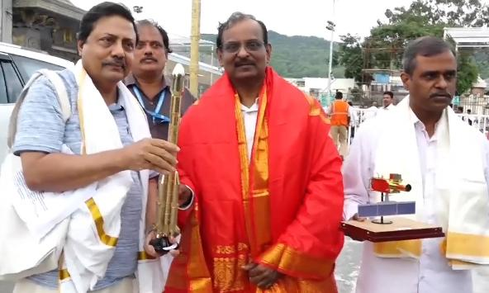
Tirumala: ISRO Chairman V. Narayanan visited the Tirumala Tirupati Devasthanams (TTD) on Wednesday and offered prayers at the Sri Venkateswara Swamy temple. During his visit, Narayanan placed rocket models of GSLV-F17 and EOS-05 near the sacred feet of Lord Venkateswara and performed special pujas. The ISRO Chairman sought the blessings of Lord Venkateswara for the success of the upcoming space missions. After offering prayers, the ISRO Chairman received Veda Ashirvachanam from Vedic scholars at the Ranganayakula Mandapam. Temple officials felicitated him with the sacred temple cloth and presented Srivari Theertha Prasadam. The GSLV-F17/EOS-05 mission is scheduled for launch at 2:55 am on September 4 from the Satish Dhawan Space Centre at Sriharikota.

4. GSLV-F17 carrying EOS-05 was moved from the Vehicle Assembly Building (VAB) to the Umbilical Tower (UT) on 28th August 2026 at Satish Dhawan Space Centre, SHAR, Sriharikota, as preparations continue for the scheduled launch on: 🗓️ 04 Sept 2026 | - x.com
Read more
ISRO @isro GSLV-F17 carrying EOS-05 was moved from the Vehicle Assembly Building (VAB) to the Umbilical Tower (UT) on 28th August 2026 at Satish Dhawan Space Centre, SHAR, Sriharikota, as preparations continue for the scheduled launch on: 🗓️ 04 Sept 2026 | ⏰ 02:55 AM IST Livestreaming starting from 02:25 AM IST onwards: youtube.com/live/Q9OdYc3Kp… For more information: isro.gov.in/Mission_GSLVF1… #GSLVF17 #EOS05 #ISRO 00:00 4:29 PM · Sep 1, 2026 219.7K Views 423 2.9K

5. ISRO chairman Narayanan visits Tirumala; presents models of GSLV-F17, EOS-05 satellite to deity - newsmeter.in
Read more
Tirumala: ISRO Chairman V. Narayanan visited the Tirumala temple on Wednesday and offered prayers to Lord Venkateswara along with his team during the VIP break darshan. Narayanan reached Ananda Nilayam through the Vaikuntha Q Complex and placed miniature models of the GSLV-F17 launch vehicle and EOS-05 satellite at the feet of the deity as part of the traditional prayers. The models symbolically represented the upcoming mission and were presented at the sanctum sanctorum, seeking the Lord's blessings for its successful launch. The GSLV-F17 model is a miniature representation of ISRO's Geosynchronous Satellite Launch Vehicle, a three-stage heavy-lift rocket designed to place satellites into geostationary transfer orbit. The mission's EOS-05 satellite model represents the Earth observation spacecraft that the rocket is scheduled to carry. Following the darshan, temple priests blessed Narayanan and the ISRO team at the Ranganayakula Mandapam and presented them with theertha prasadam and Lord Venkateswara's offerings.

6. Two astronauts replace ISS camera and docking aid on 6th-ever all-female spacewalk (video)
Read more
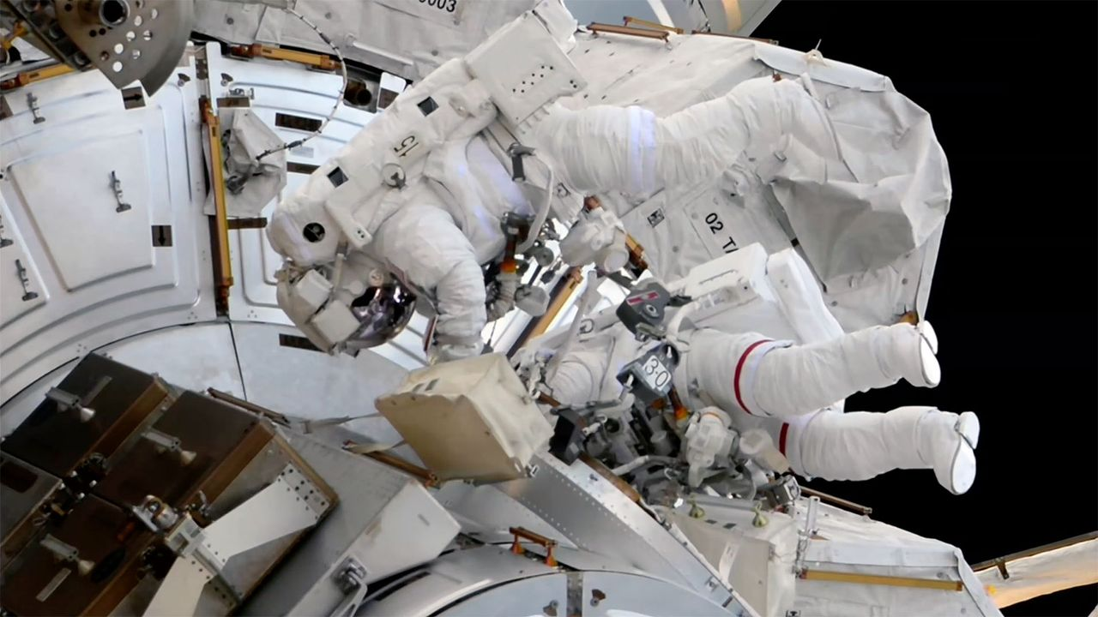
Click for next article Two astronauts replaced a spacecraft docking aid and a video camera during a successful spacewalk outside of the International Space Station on Tuesday (Sept. 1). NASA astronaut Jessica Meir and ESA ( European Space Agency ) astronaut Sophie Adenot got through most of the tasks set out for them even in light of Adenot's spacesuit developing a mobility issue late in the extravehicular activity (EVA), which lasted six hours and 49 minutes. After beginning the spacewalk from the U.S. Quest airlock at 8:40 a.m. EDT (1240 GMT), Meir and Adenot set about the first and most important activity of the outing: replacing the planar deflector on the forward port of the station's Harmony Node 2. The retroreflector is used to support navigation during rendezvous and docking operations by visiting spacecraft. The older reflector that they replaced had become coated in thruster residue from earlier spacecraft arrivals and departures. NASA astronaut Jessica Meir (at left) and ESA astronaut Sophie Adenot (in spacesuit with red stripes) are seen outside the Quest airlock during a spacewalk at the International Space Station on Tuesday, Sept. 1, 2026. (Image credit: NASA) They also replaced the Camera Port 3 (CP3) high-definition (HD) camera on the station's truss. "And it's off!" reported Meir after freeing the spent camera assembly that was swapped out for spare. Her words were met by applause in Mission Control at NASA's Johnson Space Center in Houston. "That worked, great!" she said. From there, Adenot headed off to continue an ongoing scientific study by swabbing areas on the exterior of the airlock and her gloves for possible microorganisms. Meir, meanwhile, rode one end of the Canadarm2 robotic arm to a site near the Alpha Magnetic Spectrometer (AMS), torquing 46 bolts in preparation for future maintenance of the particle physics detector. Get the Space.com Newsletter Breaking space news, the latest updates on rocket launches, skywatching events and more! Contact me with news and offers from other Future brands Receive email from us on behalf of our trusted partners or sponsors Meir also relocated power and thermal jumper cables and an articulating portable foot restraint for use on a later spacewalk. There were some other tasks planned, time permitting, but toward the end of the EVA, Adenot reported losing mobility in her left shoulder joint. Erring on the side of caution, Mission Control called for Adenot to wait where she was until Meir could follow her back to the airlock. Once there, Meir was able to unzip a portion of Adenot's extravehicular mobility unit's (EMU's) upper arm assembly to inspect what was happening. In doing so, she freed the kink that had limited Adenot's motion. "I think it was where the cable got caught in between the shoulder MLI [multi-layer insulation] and the rotation [joint]. I don't think it was held up by anything but some friction," said Meir. The two Expedition 75 crewmates then proceeded back into the airlock to complete the EVA at 4:29 p.m (2029 GMT). In a view from her helmet-mounted camera, NASA astronaut Jessica Meir holds a spent HD video camera before installing its replacement outside of the International Space Station on Tuesday, Sept. 1, 2026. (Image credit: NASA) Tuesday's spacewalk was Meir's seventh and Adenot's third. Meir, who has a total of 49 hours and 22 minutes on EVA, now ranks third among all women astronauts at NASA for total number of spacewalks. She trails only Peggy Whitson with 10 and Suni Williams at 9. Adenot now has spent 19 hours and 42 minutes working in the vacuum of space.

7. Nonprofit wants to launch 80,000-year mission to Alpha Centauri in 2029 (video)
Read more
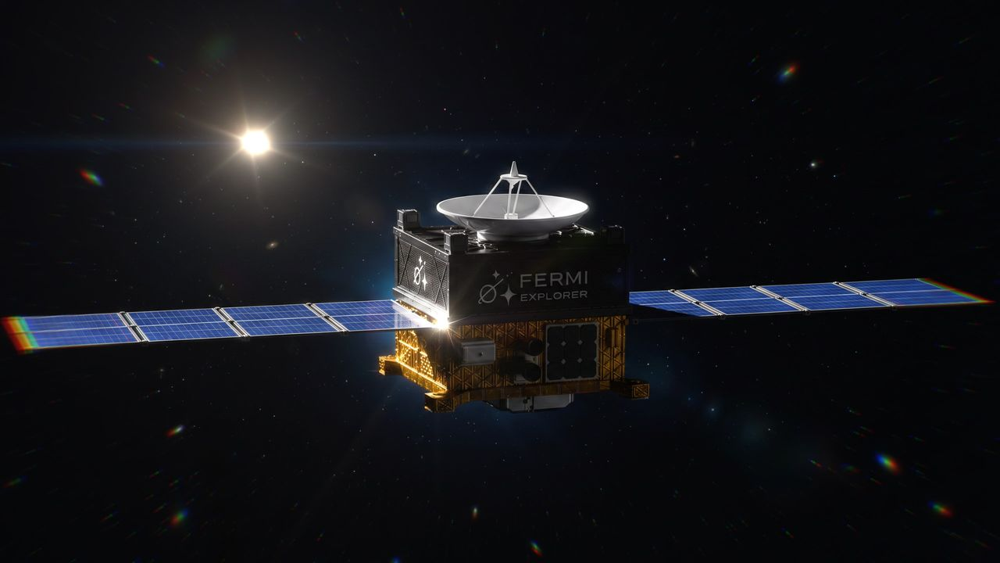
Click for next article The first dedicated mission to another star will launch before the end of the decade, if all goes according to plan. A nonprofit called the Fermi Explorer Mission announced today (Sept. 1) that it plans to send a small probe toward Alpha Centauri by 2029. But none of us will live to see the interstellar spacecraft 's historic arrival; its journey is expected to take about 80,000 years. "We hope to be both the first to leave and the last to arrive at Alpha Centauri," Philip Johnston, co-founder and president of the Fermi Explorer Mission, said in a statement today. "None of us will be here when this journey ends, and that is the point. It's about taking the first achievable step and inspiring future generations to keep pushing beyond the limits we inherited." Artist's impression of the planned Fermi Explorer Mission spacecraft, which is targeted to launch toward Alpha Centauri by 2029. (Image credit: Fermi Explorer Mission) Johnston is also co-founder and CEO of Starcloud, a company that plans to operate data centers in space . He started the Fermi Explorer Mission with fellow Starcloud co-founders Ezra Feilden and Adi Oldean. Former U.S. Air Force officer Garrett Jamison leads day-to-day execution of the project. Some big names in the spaceflight world have signed on as advisors, including former Blue Origin president Rob Meyerson and Matt Gialich, co-founder and CEO of the asteroid-mining company AstroForge . The Fermi Explorer project is ambitious but achievable, according to Johnston and his colleagues. They want to launch a spacecraft to the three-star Alpha Centauri system - the sun's nearest stellar neighbor, at about 4.4 light-years away - by 2029. This directed trajectory will be a first. Though NASA's Voyager 1 and Voyager 2 spacecraft are in interstellar space , they're not headed toward any particular star; rather, they're journeying outward on the path they took to complete their "grand tour" of Jupiter , Saturn, Uranus and Neptune. The Fermi Explorer spacecraft will carry at least 2.2 pounds (1 kilogram) of payload, and its entire mission will cost less than $15 million, according to the team. If all goes to plan, the returns on that investment will be considerable. Get the Space.com Newsletter Breaking space news, the latest updates on rocket launches, skywatching events and more! Contact me with news and offers from other Future brands Receive email from us on behalf of our trusted partners or sponsors "The mission is intended to make the idea of interstellar travel real, and to encourage more people to confront one of humanity's biggest unanswered questions when we look beyond our planet: 'Where is everybody?' (the Fermi Paradox)," the Fermi Explorer team said via X today. The proposed path of the Fermi Explorer Mission spacecraft. (Image credit: Fermi Explorer Mission) The Fermi Paradox takes its name from the famed physicist Enrico Fermi, who posited the "Where is everybody?" question in 1950. It has taken on greater significance in the past decade or so, as scientists have realized how common exoplanets - potential abodes for life - are throughout our Milky Way galaxy. There are just three possible explanations for the paradox, according to the Fermi Explorer team: Human-like intelligence is rare throughout the universe It's not rare, but intelligent species don't survive for long It's common and long-lasting, but intelligent aliens generally don't make themselves known to their cosmic colleagues (either by choice or by circumstance) Launching a directed interstellar mission won't solve the paradox, but it will give us some data that we didn't have before. "After the Fermi Explorer Mission, we will have more confidence both that is possible for intelligent species to leave for their nearest star in a way that isn't resource prohibitive, and that there are least some species that try to do it (namely us!)," team members wrote in an FAQ about the mission . "This has the effect of throwing the Fermi Paradox into even greater focus." The Fermi Explorer Mission wants its spacecraft to be the first ever launched to Alpha Centauri, and the last to arrive. (Image credit: Fermi Explorer Mission) The team says it envisions a small spacecraft, one that weighs just 220 to 440 pounds (100 to 200 kilograms) here on Earth. It will also likely employ electric propulsion , which is more efficient than traditional chemical thrusters. Electric propulsion is also a proven system, meaning the Fermi Explorer team isn't relying on futuristic tech to travel to the stars. This has been a stumbling block for other interstellar projects, such as the apparently defunct Breakthrough Starshot , which wanted to blast tiny sailcraft to Proxima Centauri - part of the Alpha Centauri system - using powerful lasers. (That futuristic tech would be great if it worked, however; Breakthrough Starshot aimed to accelerate its nanoprobes to about 20% the speed of light, which equates to a roughly 20-year trip to Proxima Centauri.) The details - who will build the spacecraft, for example, and what payloads it will carry - will be nailed down in the coming months. The project says it already has a proposal from one major satellite manufacturer that comes in under the $15 million cap.

8. NASA's Roman Space Telescope is just one of a few missions named after real-life women
Read more
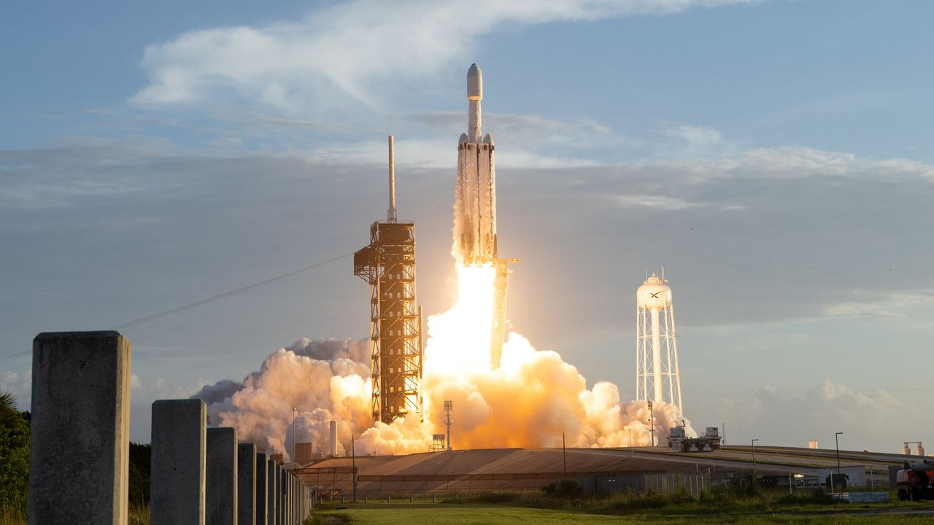
Click for next article NASA's next big space telescope is not only meant to unlock some of the mysteries of dark energy. It also is a pioneer in the naming of missions. Scientific American recently said that the observatory, which launched on Aug. 30 , is the first ever space telescope ever named after a real-life woman: American astronomer Nancy Grace Roman , who supported development of the iconic Hubble Space Telescope and was NASA's first head of astronomy in the 1960s. The story is very different when it comes to men. For example, NASA's "Great Observatories," which launched between 1990 and 2003, were all named after famous U.S. male astronomers or physicists: the Hubble Space Telescope (Edwin Hubble), the Compton Gamma-Ray Observatory (Arthur Compton), the Chandra X-ray Observatory (Subrahmanyan Chandrasekhar) and the Spitzer Space Telescope (Lyman Spitzer). Nancy Grace Roman briefs Edwin (Buzz) Aldrin on celestial objects in Washington, D.C. in 1965. Aldrin would go on to complete three spacewalks and become the second person to walk on the moon. (Image credit: NASA) Indeed, relatively few spacecraft of any kind have borne female names over the years - and most of the ones that did were not honoring actual, real-life people. For instance, a number of missions with female names took them from mythology (e.g., NASA's Europa Clipper and China's Chang'e moon probes ). Others used female names not attached to particular individuals (such as NASA's Clementine moon mission, and the European Space Agency 's LISA, which is an acronym for "Laser Intraferometer Space Antenna.") A notable exception is Sojourner , the mini-rover on NASA's Mars Pathfinder lander mission that was made famous again by the 2015 film "The Martian;" it's named after Sojourner Truth , a Civil War-era abolitionist. Sojourner's name was selected in 1995 from a worldwide naming contest for students and suggested by 12-year-old Valerie Ambroise of Bridgeport, Connecticut. Some other notable examples of missions honoring real-life women include: ESA's long-delayed ExoMars rover Rosalind Franklin , which is now set to launch to Mars in 2028. It's named after a British scientist who contributed to discovering the structure of DNA. (Part of the rover's mission is to analyze potential biosignatures on the Red Planet's surface.) rover , which is now set to launch to Mars in 2028. It's named after a British scientist who contributed to discovering the structure of DNA. (Part of the rover's mission is to analyze on the Red Planet's surface.) The Cygnus International Space Station (ISS) resupply program, which is managed by Northrop Grumman. Multiple Cygnus freighters have been named after female NASA astronauts, including Janice E. Voss, Sally Ride and Kalpana Chawla, and one of them honored the American mathematician and "hidden figure" Katherine Johnson . (ISS) resupply program, which is managed by Northrop Grumman. Multiple Cygnus freighters have been named after female NASA astronauts, including Janice E. Voss, and Kalpana Chawla, and one of them honored the American mathematician and "hidden figure" . Satellogic's ÑuSat/NewSat series. It has commonly named satellites after female historical figures in science, such as Black American chemist Alice Ball, Polish physicist-chemist Marie Curie and Australian radio astronomer Ruby Payne-Scott. after female historical figures in science, such as Black American chemist Alice Ball, Polish physicist-chemist Marie Curie and Australian radio astronomer Ruby Payne-Scott. Canada's GHGSat has a program in which employees name the company's Earth-orbiting satellites after family members, which has generated names from real-life people like Eleonore and Penny . and . The U.S. Space Force nicknamed its GPS III Space Vehicle-08 "Ms. Creola Katherine Johnson," another nod to the mathematician What this means Throughout history, the names of ocean-going ships - ships on the water, not spaceships - often have associations with women. The U.K.'s Imperial War Museums (IWM) suggests that women's names are used due to two traditions. The first is that, very generally speaking, the word "boat" is a "female" word in some languages that use gendered nouns, but that is by far not universal, even among the imperial sailing powers of the 1400s to 1600s. The second association, which seems more likely, is the notion of a mother, goddess or similar "female figure" guiding a crew, which we see in theaters right now with "The Odyssey:" Athena helps Odysseus, reflecting the ancient Greek epic story. (For example, figureheads - sculptures on sailing ship prows - were often, although not always, carved in the likeness of women, Royal Museums Greenwich states .) There are famous sailing ships with female names that many Americans can cite, such as the nicknames for the three Spanish ships - the Niña, Pinta and Santa María - used by Christopher Columbus during his famed first voyage to the New World in 1492. "There's always been a tradition to name ships - and oftentimes after women," Valerie Neal, emerita curator in the Smithsonian National Air and Space Museum's department of space history, told Space.com. Neal's research includes extensive work on female astronauts . The U.S. space program has historically leaned upon mythological names of both genders for its missions, she noted, citing the Mercury , Gemini and Apollo human spaceflight programs as examples of male monikers. These days, Neal added, the education system is less tilted toward introducing children to old Greek or Roman myths, which may explain why it's now more common to name missions after real-life individuals. In the 1970s and 1980s, for example, "there was a big debate at the time of the space shuttle naming whether to name the space shuttles after historic figures, or after concepts," Neal said. "One idea was even after Native American tribes." (For example, Tafuna High School in American Samoa recommended the name "Hōkūle'a" for shuttle, as noted in NASA's 1991 monograph "From Ship to Shuttle: NASA Orbiter-Naming Program") The Cygnus spacecraft " USS Janice Voss ," which flew to the ISS in 2014, was the first U.S. orbital mission known to Neal to be named after a woman. "She had had an affiliation with the Orbital Sciences Corporation, and so they wanted to honor her," said Neal, referring to a previous company that managed the Cygnus program. The flock of Cygnuses named after women - at least six of them, according to Neal - is "a good sign that people are starting to think of contemporary figures, or more contemporary, [and] naming spacecraft as a tribute to them, and to their contributions in science and exploration and discovery." Naming a flagship space telescope after Nancy Grace Roman is another good sign, of course. And choosing her for this honor makes sense; she was in "a class by herself - because her name is so directly associated with astronomy and large space telescopes" like Hubble, Neal said. "It is recognizing her significance in the history of space exploration as a leader who made so much possible, through her own work as an astronomer, but then as an administrator and manager at NASA made possible the orbiting solar observatories, the orbiting astronomical observatories - and then Hubble and the other great observatories that followed." Roman's name on the telescope, she added, is "elevated" because "her name coincides exactly with the spacecraft and its purpose, whereas the names of the astronauts that are attached to the [ISS] resupply missions … not all of them had any connection to the International Space Station. Several did, but not all." Neal said she's hopeful that more women will see their names attached to space missions, including both those historical astronomers who saw "their bosses were getting all the credit" as well as the numerous non-male scientists making impacts in the field today. "I think it's entirely possible that, in time, there will be another major observatory named for a woman," Neal added. She noted that recommendations from the science community every 10 years form the basis of new space missions, and that the next such " decadal survey " in astrophysics is expected to wrap up around 2030. In the nearer term, NASA is considering ideas such as an ultraviolet telescope, an advanced X-ray imaging satellite, and the Habitable Worlds Observatory for launch in the 2030s or early 2040s, presenting more opportunities to attach female names to flagship space missions. Artist's illustration of Europe's ExoMars rover, named Rosalind Franklin, on the surface of the Red Planet. (Image credit: ESA/ATG medialab) Sidebar: Female mission names With thousands of flown or planned missions to space, and numerous parts making up each spacecraft, it is difficult to compile a comprehensive list of probes or instruments that have had female names. The following is therefore a partial list, though an extensive one. In no particular order, it includes: Telescopes/observatories: NASA's Roman, ESA's Gaia, NASA's Pandora, the British-American Ariel V telescope, ESA's NewAthena, ESA's Ariel, ESA's LISA, NASA's TESS (Transiting Exoplanet Survey Satellite). NASA's Roman, ESA's Gaia, NASA's Pandora, the British-American Ariel V telescope, ESA's NewAthena, ESA's Ariel, ESA's LISA, NASA's (Transiting Exoplanet Survey Satellite). Human spacecraft: Mercury Aurora 7, SpaceX 's Crew Dragon Grace. Mercury Aurora 7, 's Crew Dragon Grace. Satellites/ISS missions: ESRO-1A and 1B's nicknames of Aurora and Boreas, multiple Cygnus ISS resupply spacecraft, much of the Satellogic NuSat/NewSat constellation, several GHGSat spacecraft, Space Force 's GPS III Space Vehicle-08 (nicknamed Ms. Creola Katherine Johnson), and the Russian Resurs-DK1 satellite's multinational cosmic-ray module PAMELA (Payload for Antimatter Matter Exploration and Light-nuclei Astrophysics). ESRO-1A and 1B's nicknames of Aurora and Boreas, multiple Cygnus ISS resupply spacecraft, much of the Satellogic NuSat/NewSat constellation, several GHGSat spacecraft, 's GPS III Space Vehicle-08 (nicknamed Ms. Creola Katherine Johnson), and the Russian Resurs-DK1 satellite's multinational cosmic-ray module PAMELA (Payload for Antimatter Matter Exploration and Light-nuclei Astrophysics). Moon: China's Chang'e series, the Soviet Union's Luna series, NASA's Artemis program and missions, Intuitive Machines' IM-2 lander Athena, JAXA's Selene/Kaguya, NASA's Clementine, the NASA ARTEMIS moon-orbiting probe. China's Chang'e series, the Soviet Union's Luna series, NASA's and missions, Intuitive Machines' IM-2 lander Athena, JAXA's Selene/Kaguya, NASA's Clementine, the NASA ARTEMIS moon-orbiting probe. Venus: ESA's Venus Express, the Soviet Union's Venera series. ESA's Venus Express, the Soviet Union's Venera series. Mars: ESA's Rosalind Franklin rover, NASA's Sojourner rover, JAXA's failed Nozomi orbiter. ESA's Rosalind Franklin rover, NASA's Sojourner rover, JAXA's failed Nozomi orbiter. Jupiter/moons: NASA's Juno , NASA's Europa Clipper. NASA's , NASA's Europa Clipper. Asteroids: NASA's Lucy, ESA's Hera. NASA's Lucy, ESA's Hera. Other hardware: Some spacecraft/rocket parts have female names (e.g. the US military's Juno II rocket, Firefly Aerospace's Miranda engine, ESA's Europa and Ariane rockets). The following at first glance appear to have female names, but either were not confirmed before this story's deadline or were confirmed to have other origins:

9. Repairing the ISS 250 miles above Earth | Space photo of the day for Sept. 1, 2026
Read more
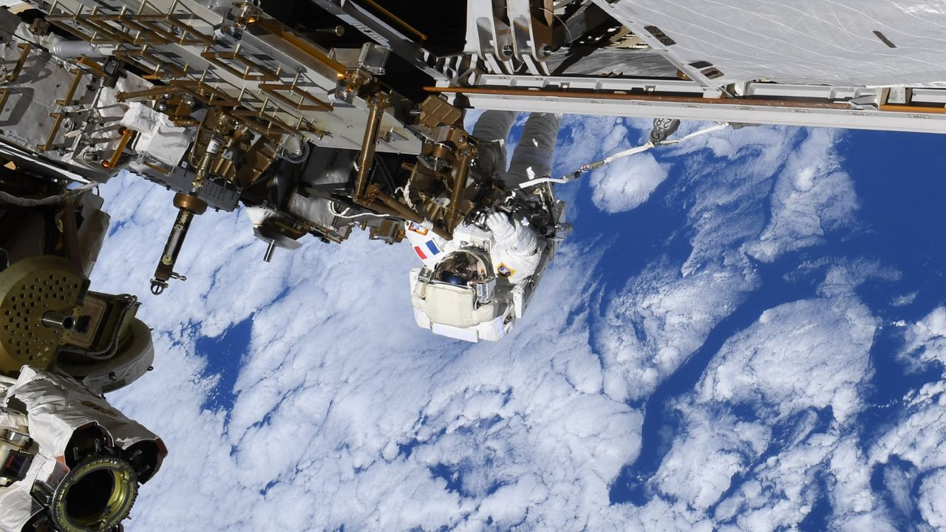
Click for next article ESA astronaut Sophie Adenot on the outside of the International Space Station during an extravehicular activity on Aug. 25, 2026. (Image credit: ESA/NASA) Repairing an engineering marvel like the International Space Station is no easy feat by itself, but it's even more impressive when it's done 250 miles (400 kilometers) up. What is it? In this photograph, European Space Agency (ESA) astronaut Sophie Adenot works on the exterior of the International Space Station on Aug. 25, 2026. The photo was taken while Adenot and NASA astronaut Anil Menon were conducting a 6.5-hour spacewalk, or extravehicular activity (EVA), to replace one of two Space-to-Ground antennas on the outside of the ISS. This was the second EVA that Adenot and Menon performed to replace the antenna. During a previous spacewalk a week earlier, the pair ran out of time before the new antenna could be installed. With that first spacewalk, Adenot became the first woman from France to ever conduct an EVA. Why is it incredible? It can be hard to conceptualize just how high up the ISS orbits until you see a photo like this one; few people on Earth have ever flown as high as 250 miles (400 km), so that altitude can feel a bit abstract. Seeing an astronaut like Adenot clinging to the space station with the clouds and blue oceans of Earth below puts things into perspective. At that height, the ISS orbits at quite a high rate of speed. The orbital laboratory zips around Earth at 17,500 mph (28,000 kph), meaning it circles the planet 16 times a day. This photo was taken on day 194, or orbit 3010, of Adenot's mission, which began in February when she launched to the ISS as part of NASA's Crew-12 mission.

10. 'Orbitals' is a co-op sci-fi adventure that recaptures the magic of Saturday morning cartoons
Read more

Click for next article Growing up, the best Saturday morning cartoons were the ones we re-enacted with our friends on the playground. Whether it was screaming at the top of our lungs to go Super Saiyan like in Dragon Ball Z, or sleuthing around the school as Darkwing Duck. In the years since our childhood, we've often bonded with both strangers and friends over memories of Saturday morning cartoons, remembering the quaint stories and characters that influenced our lives in surprisingly profound ways. Those stories have a unifying power, and that's at the heart of developer Shapefarm's debut, Orbitals, which seeks to combine that rich heart with the gameplay style of Hazelight Studios' co-op games like It Takes Two and Split Fiction. Will Orbitals be looked back on quite as fondly as those cartoons years down the road? Probably not, but this Switch 2 exclusive is a no-frills co-op smorgasbord that's delightful from start to finish. Disclaimer Editor's Note: Since Orbitals requires two players to complete, this feature is co-authored by George Yang and Hayes Madsen. Name a more iconic duo. You play as Maki and Omura, two space explorers tasked with finding power cores to power up their home ship and prevent it from being destroyed by a cosmic storm. Orbitals is very similar to co-op games like It Takes Two and Split Fiction, both from Hazelight Studios. Strictly a two-player game, you and a friend have to work together to solve environmental puzzles while communicating with each other. This dynamic complements the friendly camaraderie between Maki and Omura, the former of whom is a bubbly girl and the latter a more laidback, blue-skinned male humanoid with horns. Perhaps what's most remarkable about Orbitals is its sense of lightness. This is a game laser-focused on fun, evoking that through smart puzzle design, cooperation, collectibles that are all tied to fun little minigames, and more. Experiencing Orbitals was just like marathoning an entire season worth of anime. The 80s and 90s anime art direction emphasizes thick lines and simple shading, as opposed to modern standards of meticulous detail and cinematic lighting. This retro aesthetic permeates every facet of Orbitals. The splash screen that appears when loading up Orbitals, showing Shapefarm and publisher Kepler Interactive's logos, is soaked in retro-futuristic bright neon like Apple's back in the 80s. The amazing opening song, " Accelerating Destiny ," is sung by legendary 80s anime vocalist Mami Ayukawa. Each decision feels intentional, like a love letter to this era. Orbitals - Main Theme "Accelerating Destiny" Official Music Video - Nintendo Switch 2 - YouTube Watch On It's an absolutely gorgeous journey through space that lasts a brisk 5 hours. There are 12 chapters lasting around 20-25 minutes, with each feeling like a separate TV episode, and we know what you're thinking; that seems like a short game. And it is. Compared to Split Fiction, which lasted way too long, Orbitals finds itself on the other end of the spectrum. The pacing quickly picks up into the finale, making it feel a bit rushed. There's a middle ground that both games missed, which is a shame. Despite that, although hastily, Orbitals wraps itself up in a satisfying way. Shows like Cowboy Bebop had a ragtag team of underdogs exploring the solar system, instilling lessons about loneliness and existentialism. Mobile Suit Gundam Wing had heavier ethical themes about war. These ideas flew over our heads as kids, and we were mostly occupied by the pretty lights and awesome fight scenes. But rewatching them as adults allowed us to grasp them better. Orbitals follows in these classics' footsteps, tackling subjects like agency of choice and forgiveness. Orbitals has its fair share of battles, with one player controlling the guns while the other steers the ship to take down turrets and incoming asteroids. It's not too difficult, since each of you only has to focus on one task, but the real challenge comes from communicating. In a few boss fights, the battles can suddenly change into a completely different format. In one instance, the pilot had to dodge enemy projectiles like a bullet-hell game, while the other player's perspective shifted inside the ship, with them putting out fires before heading back to the guns. It's these unexpected moments that make Orbitals a blast to play. As the designated pilot of the duo, Hayes quickly felt the burden of protection weigh upon his shoulders. He didn't just have to get us from point A to point B, but also had to dodge enemy attacks in frenetic battles, pilot through the sudden bullet-hell segment, use a microwave to possess creatures and shift the stage, and so much more. George, on the other hand, had to quickly dispatch enemies before they depleted the ship's HP, while also frantically navigating through lava while Hayes cooled it from underneath, creating a path to the other side of the level. Despite a runtime that feels like it ends when the game is really picking up, Orbitals is an incredibly smartly designed little game. One that consistently weaves different gameplay styles and genres together into something effortlessly distinct, even though it clearly is trying to emulate the magic of It Takes Two and Split Fiction. The good news is that it largely succeeds at what it does. The story is breezy, but punctuated by shockingly good performances and that whimsical Saturday morning cartoon feel. The main duo instantly feel like lifelong friends, with the game knowing it doesn't need to take the time to lay out that backstory. Equally, gameplay mechanics are briefly explained but then further explored through experimentation and context clues, rather than lengthy tutorials. Those two aspects combine into a game that, ultimately, makes every hour feel distinctly different, just like a Saturday morning cartoon. It's those differences that make Orbitals more than the sum of its parts, alongside how much the experience of the game's two players actually differs. While the game likely felt more like a shooter for George, Orbitals was essentially a platformer and vehicular exploration game. That inherently adds a bit of a different tinge to each experience, even in how Orbitals relates to those Saturday morning cartoons it tries to evoke. For Hayes' part, it transported him back to his favorite shows like Gundam and Code Lyoko. This also adds some much-needed replay value, as you can swap roles and dive back in once the credits have rolled. Orbitals may be short, but there's a lot to love. The kind of dessert that satisfies your craving, but doesn't taste too sickly sweet. Orbitals launches on September 3 exclusively for Nintendo Switch 2.

11. SpaceX to launch Starlink mission from West Coast
Read more
A SpaceX Falcon 9 will liftoff from the company's West Coast launch facility early Wednesday morning to add another batch of satellites to SpaceX's Starlink constellation. Liftoff from Vandenberg Space Force Base in California is currently scheduled for 1:18 a.m. PDT (4:18 a.m. EDT / 0818 UTC). Spaceflight Now will have live coverage starting 30 minutes prior to launch. The Falcon 9 first stage booster, B1063, making its 35th flight, will take a south-easterly trajectory on departure from Space Launch Complex 4-East. After second stage separation, the booster will target a landing on the drone ship 'Of Course I Still Love You' stationed in the Pacific Ocean off the coast of Baja California. If all goes according to plan, 27 Starlink V2 Mini satellites will be deployed from the Falcon 9 upper stage just over an hour into flight. SpaceX is now basing its Starlink launch operations on the West Coast as it focuses efforts at Cape Canaveral on preparing for the East Coast debut of its Starship vehicle.

12. Many space missions are searching for life beyond Earth, but are we prepared for the fallout if they succeed?
Read more
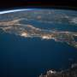
Microbes from space have fueled the plots of science fiction mainstays like "Project Hail Mary" and "The Andromeda Strain." But with more space missions launching each year, finding extraterrestrial life in a microbial form is becoming more plausible. What will the response be back here on Earth if-or when-scientists discover extraterrestrial microbes? Will the international po...

13. AI tool detects unusual satellite behavior to improve space safety
Read more
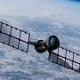
A new AI model can monitor satellites and spot anomalies in their behavior, reducing the risk of in-orbit collisions, according to new research published in the journal Expert Systems.

