 |  | 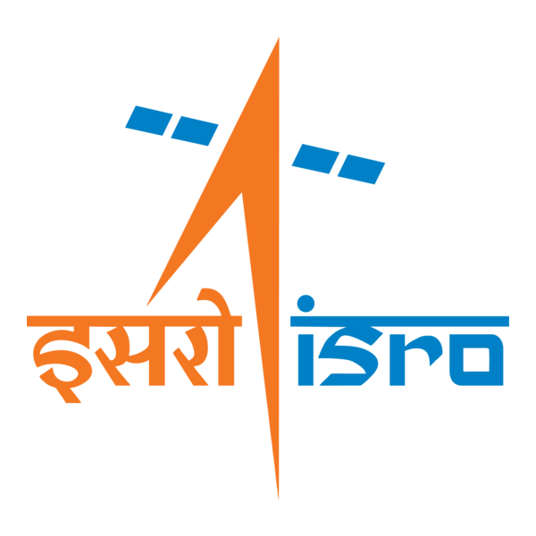

🌌 अंतरिक्ष समाचार | Space News
रविवार, २०/०९/२०२६ | Sunday, 20/09/2026

1. ISRO Scientist Exam Date 2026 Announced, Check Here - PW
Read more
The Indian Space Research Organisation Centralised Recruitment Board conducts the Scientist/Engineer recruitment process to hire technical personnel. The latest schedule introduces a remarkably compressed timeline between application closure and test dates, presenting preparation challenges for aspirants while attempting to resolve pressing institutional manpower needs for key space missions. The ISRO Scientist/Engineer 'SC' Exam Date 2026 has been announced for the latest Centralised Recruitment (ICRB) recruitment. According to the official ISRO notification, the Computer-Based Test (CBT) is scheduled for 19 October 2026. Also Check - ISRO Scientist Through GATE ISRO Scientist/Engineer (ICRB) Recruitment Highlights The Indian Space Research Organisation (ISRO) Centralised Recruitment Board (ICRB) has announced the schedule for the Computer Based Test (CBT) for the recruitment of Scientist/Engineer posts. However, the condensed schedule poses substantial preparation challenges for aspirants. Key Timeline Dates: Notification Release Da te: August 27 Application Deadline: S eptember 16 Scheduled Examination Date: October 19 2026 Preparation Window Constraints: Candidates have been provided with an effective window of approximately 45 days from the notification date and less than one month from the application closing date. A technical examination of this scale typically requires three to four months to complete syllabus coverage, analyze Previous Year Questions (PYQs), perform comprehensive revisions, and attempt mock test series. Examination Overlap: The rapid scheduling creates overlapping examination timelines with other major recruitment tests, including the RRB JE examination, leading to logistical and strategic difficulties for aspirants. ISRO Scientist Recruitment Comparative Analysis: Past Cycles Vs. Current Recruitment Process The current administrative cycle deviates sharply from historical recruitment trends conducted by ISRO: Evaluation Parameter Past Recruitment Cycles Current Recruitment Cycle Preparation Window Provided at least 3 to 5 months between notification and examination; frequent postponements allowed extended study periods. Compressed into approximately one month post-application deadline. Recruitment Frequency Periodic gaps of 2 to 3 years without active notification cycles. Expedited, fast-tracked timeline with immediate test scheduling. Syllabus Coverage Feasibility Adequate time allocation to thoroughly cover extensive technical syllabi. Highly restricted timeframe, making full-length syllabus completion and testing difficult. Drivers Of The Fast-Tracked Timeline of ISRO Scientist Recruitment 2026 The accelerated examination timeline is linked to underlying structural and operational factors within the organization: Acute Staff Shortages: Recent reports indicate widespread personnel deficits, compounded by the resignation of over 100 scientists. Factors Contributing to Attrition: Compensation Constraints: Lower comparative salary scales relative to industry standards, previously highlighted during recruitment drives at premier institutions such as the IITs. Project Privatization: The outsourcing and privatization of various operational project segments to third-party commercial entities, which has influenced staff retention. Urgent Mission Deliverables:

2. NASA Official Praises ISRO's Growing Space Capabilities, Eyes More Collaboration - 10net.in
Read more

NEW YORK, SEP 20: NASA's Indian-American senior official Amit Kshatriya has praised the growing capabilities of the Indian Space Research Organisation (ISRO), saying the US space agency is looking forward to expanding its cooperation with India in science missions and human spaceflight. Kshatriya, NASA's Associate Administrator and Chief Engineer, said the agency already has an "incredible collaboration" with ISRO and highlighted India's expanding capabilities in space exploration. "The capability that ISRO is developing, both in science missions as well as in human spaceflight, is incredible to watch," Kshatriya said during an interaction at New York's Intrepid Museum. He specifically referred to NISAR (NASA-ISRO Synthetic Aperture Radar), a joint Earth-observation mission launched in July 2025. The satellite is designed to monitor changes in the Earth's land, ice, water and vegetation. According to Kshatriya, NISAR benefited from a joint effort between the two space agencies. He added that NASA also works with ISRO on human spaceflight initiatives and shares experience and lessons learned from its programmes. Kshatriya also highlighted the importance of international cooperation in space exploration, saying that leadership in space should involve shared values, norms and standards rather than simply competition over technology and equipment. He noted that India is among the countries that have signed the Artemis Accords, a set of non-binding principles for peaceful and responsible civil space exploration. The comments came during a panel discussion at the Intrepid Museum marking the 50th anniversary of the public rollout of Enterprise, NASA's prototype space shuttle orbiter. Former NASA Administrator and astronaut Charles F. Bolden Jr. and veteran astronaut Peggy Whitson also participated in the discussion. Whitson spoke positively about her experience working with Group Captain Shubhanshu Shukla, who served as pilot of Axiom Mission 4 (Ax-4) to the International Space Station. Shukla became the first Indian to visit the International Space Station and only the second Indian citizen to travel to space, following Wing Commander Rakesh Sharma's 1984 mission. Bolden also highlighted India's achievements in planetary exploration, pointing to the success of Mangalyaan, India's Mars Orbiter Mission. Launched in November 2013, the mission made ISRO the fourth space agency to successfully place a spacecraft in Mars orbit. He also noted NASA's role in supporting the mission through its Deep Space Network, which assisted with spacecraft tracking and navigation.

3. AMU's NRSC Organises Two-Day Calligraphy Workshop 'HARF' - India Education Diary
Read more
AMU's NRSC Organises Two-Day Calligraphy Workshop 'HARF' India Education Diary

4. Department of Posts, Karnataka, unveils commemorative postage stamps on ISRO's human spaceflight programme - News On AIR
Read more
The Department of Posts, Karnataka Postal Circle, today unveiled two commemorative postage stamps and souvenir sheets celebrating the remarkable progress of India's human spaceflight programme led by the Indian Space Research Organisation. The stamps, released at a function in Bengaluru, trace India's inspiring journey in space exploration, from the launch of Aryabhata to its ambitious future plans in human spaceflight and orbital infrastructure. The design also highlights India's rich scientific heritage, symbolised by the iconic Jantar Mantar. Addressing the gathering, ISRO Chairman V. Narayanan outlined the organisation's growth trajectory across various states and detailed upcoming milestones. He said ISRO is preparing for the Gaganyaan mission, which will include three crewed missions followed by a fully safe crewed mission. He also revealed plans for establishing an Indian Space Station with 52-tonne flight modules, with the first module targeted for launch by 2028. Additionally, studies are underway for a future crewed lunar mission. Group Captain Subhanshu Shukla, who was present at the event, shared his experiences in space with students, inspiring young minds about careers in space science and exploration. The programme was presided over by K. Prakash, Chief Postmaster General of the Karnataka Circle.

5. Mysuru Dasara Expo to feature defence and ISRO models | Tap to know more | Inshorts - Inshorts
Read more
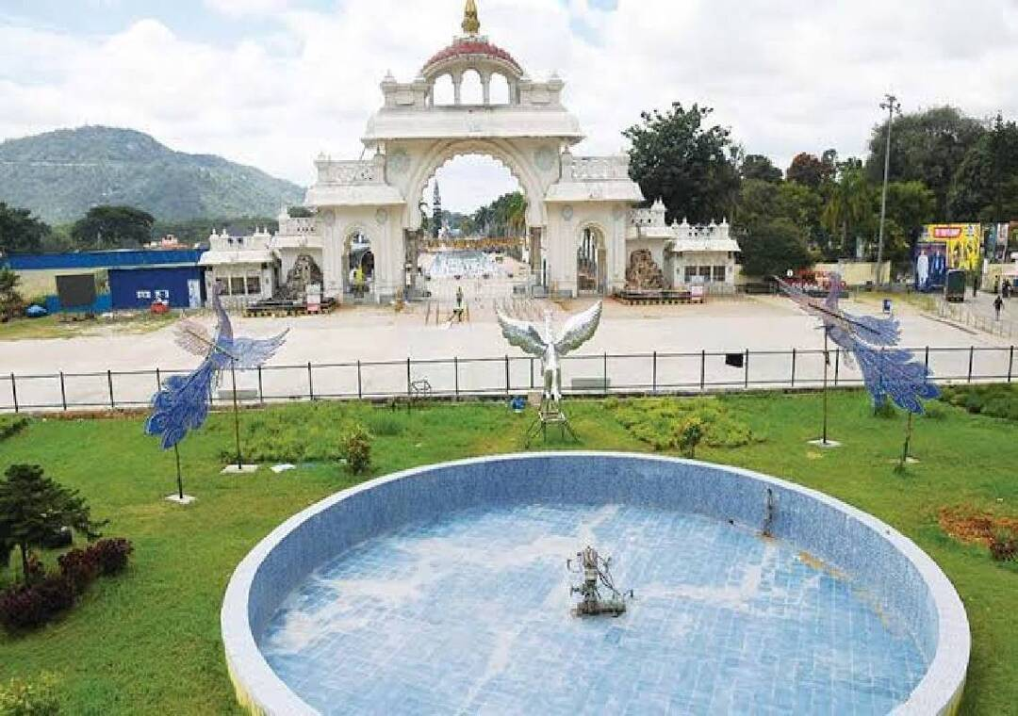
- - - Mysuru Dasara Expo to feature defence and ISRO models - - - - - - - - inshorts Mysuru Dasara Expo to feature defence and ISRO models The Karnataka Exhibition Authority (KEA) is preparing an expanded and more innovative Mysuru Dasara Exhibition this year, with models showcasing the achievements of the Indian Defence Forces and the Indian Space Research Organisation (ISRO) among the major attractions. The annual exhibition at Doddakere Maidana, opposite Mysuru Palace, will open to visitors on October 11. tap for more at News Karnataka yesterday Tap to know more readmore Share Load More

6. Russian Progress cargo ship arrives at International Space Station
Read more
An unpiloted Russian Progress cargo ship arrived at the International Space Station Saturday carrying supplies and equipment for the orbiting outpost. The Progress M-25 docked at the space-facing port of Russia's Poisk module at 9:44 a.m. EDT (1344 UTC). It circled the station before making its final approach using the automated Kurs rendezvous system. Russian cosmonauts Pyotr Dubrov and Anna Kikina were standing by to take manual control of the approach using remote controls, but everything went smoothly as the craft closed in, 260 miles above the Black Sea. A series of hooks inside the docking mechanism were driven closed to complete the docking operation. Making up the rest of the station crew, dubbed Expedition 75, are NASA's Jessica Meir, Anil Menon, and Jack Hathaway, Russia's Andrey Fedyaev, and the European Space Agency's Sophie Adenot. The freighter, operated by the Russian space agency Roscosmos, lifted off from the Baikonur Cosmodrome on Wednesday, Sept. 16, 2026, at 9:33 a.m. EDT (1333 UTC). It was delayed a week due to a problem with the Soyuz-2-1b rocket's third stage. Roscosmos did not disclose the nature of the technical issue, which required the rocket to be rolled off the launch pad and returned to its hangar. It was the first time the Soyuz-2-1b variant had been used to launch a Progress mission. The docking came three days after liftoff, longer than the more typical two-day rendezvous sequence. "Uncommon but not unprecedented," said Rob Navias, NASA's commentator in mission control. "The orbital mechanics for this particular launch date of September 16th drove the Progress to a three-day, 49-orbit rendezvous profile." The cargo mission, which NASA refers to as Progress 96, carried 2.8 tons of food, fuel and supplies to the station. The craft is expected to remain docked for about five months.

7. SpaceX launches 27 Starlink V2 Mini satellites on Falcon 9 rocket from Vandenberg
Read more
Update Sept. 19, 10:09 p.m. EDT (0209 UTC): SpaceX landed its booster on the droneship. An early-evening Falcon 9 launch from Vandenberg Space Force Base Saturday will add another 27 satellites to SpaceX's Starlink constellation. Liftoff of the Falcon 9 rocket from Space Launch Complex 4 East happened at 6:47 p.m. PDT (9:47 p.m. EDT / 0147 UTC). The rocket hugged the Californian coast line and should've been visible to millions as it soars on southeasterly trajectory upon leaving the pad. It was the 81st Starlink mission of the year. <span data-mce-type="bookmark" style="display: inline-block; width: 0px; overflow: hidden; line-height: 0;" class="mce_SELRES_start"></span> The Falcon 9 booster, B1093, made its 17th flight to space and back after previously launching two missions for the U.S. Space Force's Space Development Agency (SDA), Transporter-16, and 13 batches of Starlink satellites. About 8.5 minutes after liftoff, B1093 landed on the droneship, Of Course I Still Love You, positioned in the Pacific Ocean. This was the 225th landing on this vessel and the 662nd Falcon booster landing to date. The 27 Starlink V2 Mini Optimized satellites onboard the Starlink 15-27 mission are set to deploy a little more than an hour after liftoff.

8. Decoding the fiery engineering challenge behind scramjet-powered missiles
Read more
A hypersonic cruise missile must do more than briefly reach an extreme speed. It needs an engine capable of sustaining powered flight through the atmosphere while traveling at least five times the speed of sound (Mach 5). That is where the scramjet comes in. Short for "supersonic combustion ramjet," this air-breathing engine uses the missile's forward motion to compress air before mixing it with fuel and producing thrust. The idea sounds simple. Making it work while a vehicle covers more than a mile every second is anything but. How does a scramjet engine work? Unlike the turbofan engines used by commercial aircraft, a scramjet does not rely on rotating compressor blades. Instead, the shape of its inlet and the missile's tremendous speed force the incoming air into a narrower space, raising its pressure and temperature. Fuel, commonly a hydrocarbon or hydrogen, is then injected into this compressed stream. The mixture ignites inside the combustor, releases energy, and expands through a nozzle at the rear to generate thrust. The crucial detail is that air remains supersonic as it passes through the combustion chamber. Conventional ramjets slow incoming airflow to subsonic speeds before combustion, but this becomes increasingly inefficient at higher Mach numbers. Keeping the flow supersonic allows scramjets to operate at speeds where ordinary jet engines cannot. However, the design also means a scramjet cannot produce useful thrust while stationary or moving slowly. A rocket booster or another aircraft must first accelerate the missile to the required speed. Once the scramjet reaches its operating conditions, it can ignite and take over the powered portion of the flight. Why are scramjets suited to cruise missiles? Rockets carry both fuel and an oxidizer because they must operate independently of the atmosphere. A scramjet draws oxygen directly from the surrounding air, removing the need to carry a separate oxidizer during cruise. That can reduce weight and leave more internal space for fuel, sensors, or a payload. It also enables sustained powered flight within the atmosphere rather than providing only a short burst of acceleration. This separates scramjet-powered cruise missiles from hypersonic boost-glide weapons. A boost-glide vehicle is accelerated by a rocket before gliding toward its target, while a hypersonic cruise missile continues generating thrust with an air-breathing engine. Powered flight can give cruise missiles greater flexibility to alter their route or maneuver during an engagement. Their speed, lower atmospheric flight path, and potential maneuverability can also shorten reaction times and complicate detection and interception. Scramjets are not unlimited, however. Because they depend on atmospheric oxygen, their operation is restricted by altitude, air density, and speed. The engine must remain within a relatively narrow set of conditions to keep producing reliable thrust. Why is scramjet technology so difficult? Combustion inside a scramjet has been compared to lighting a match in a hurricane. Air races through the engine in milliseconds, giving injected fuel very little time to mix, ignite, and burn efficiently. Engineers must prevent the flame from being blown out while managing shock waves moving through the inlet and combustor. A disruption in airflow can produce an event known as an "unstart," causing a sudden loss of thrust and potentially destabilizing the vehicle. Heat presents another serious challenge. Air friction and compression expose a hypersonic missile's exterior and engine to extreme temperatures, requiring heat-resistant materials, protective coatings, and carefully designed cooling systems. Even minor changes in the vehicle's altitude can alter airflow entering the engine. This makes the missile's body, inlet, combustor, and nozzle parts of one tightly integrated propulsion system rather than separate components. NASA demonstrated the potential of the technology in 2004 when its uncrewed X-43A research vehicle reached approximately Mach 9.6 during an experimental flight. The test established a speed record for an air-breathing aircraft and showed that scramjet combustion was possible at nearly ten times the speed of sound. Scramjets have since become central to several military research programs. Yet achieving one successful test is different from producing a weapon that can start reliably, navigate, maneuver, and survive demanding operational conditions.

9. 7 legendary missiles that reshaped aerospace engineering during Cold War
Read more
The Cold War was a contest not only of military power but also of engineering ability. Each side needed missiles that could travel farther, react faster, and operate more accurately under unforgiving conditions. Meeting those demands produced advances in propulsion, navigation, computing, materials, and structural design. Some missiles even became launch vehicles for satellites and astronauts, carrying their military engineering into the emerging Space Age. 1. R-7 Semyorka The Soviet R-7 became the world's first intercontinental ballistic missile to complete a successful flight in 1957. Designed under Sergei Korolev, it used a central core surrounded by four strap-on boosters to generate the thrust needed for intercontinental travel. All its major engines ignited before liftoff, reducing the uncertainty involved in starting engines during flight. A modified R-7 launched Sputnik 1 in October 1957, and descendants of the same basic design later carried Vostok, Voskhod, and Soyuz spacecraft. 2. SM-65 Atlas America's SM-65 Atlas pursued extreme weight reduction through pressure-stabilized propellant tanks made from thin stainless steel. Internal pressure gave the missile its structural rigidity, meaning the vehicle could buckle if insufficiently pressurized. Atlas also employed an unusual "stage-and-a-half" propulsion arrangement in which all three primary engines ignited before launch. Its two outer booster engines were discarded during flight, while the central sustainer continued operating and later helped the converted Atlas launch John Glenn into orbit. 3. Polaris A-1 Wikimedia Commons The Polaris A-1 turned the nuclear-powered submarine into a mobile ballistic-missile launch platform. In July 1960, USS George Washington successfully fired Polaris missiles while submerged off the coast of Florida. Engineers developed a weapon that could survive extended underwater deployment, exit a sealed launch tube, and travel through water before beginning powered flight. Its two solid-propellant stages eliminated complex pre-launch fueling and established an engineering foundation later developed through the Poseidon and Trident missile families. 4. LGM-30 Minuteman Minuteman changed ballistic-missile operations by combining solid propulsion with highly automated launch control. Its three solid-fuel stages allowed the missile to remain stored inside a silo in a launch-ready condition, avoiding the lengthy fueling procedures associated with earlier liquid-powered systems. The missile also carried a compact digital computer connected to an inertial guidance system. Its development pushed advances in solid-state electronics, miniaturized computing, automated diagnostics, and reliable rocket motors capable of remaining dormant for years before operating. 5. AIM-9 Sidewinder The AIM-9 Sidewinder demonstrated that guided weapons could achieve remarkable effectiveness through mechanical simplicity. Developed at the US Navy's China Lake facility, it used a passive infrared seeker to follow the heat emitted by an aircraft without requiring continuous guidance from the pilot. One of its most inventive features was the rolleron, a small toothed wheel mounted on each rear fin. Airflow spun the wheels so they acted like gyroscopes, controlling unwanted rolling without complicated powered equipment, while the missile's modular construction made later upgrades comparatively straightforward. 6. Titan II Titan II was a two-stage American ICBM powered by storable hypergolic propellants that ignited automatically upon contact. Although highly toxic and dangerous to handle, the propellants allowed the missile to remain fueled and launch faster than systems dependent on cryogenic liquids. NASA subsequently converted Titan II into the Gemini Launch Vehicle by reducing vibration and adding equipment designed to protect its astronauts. Between 1964 and 1966, Titan II launched Gemini missions that demonstrated orbital rendezvous, docking, spacewalking, and other procedures required for the Apollo lunar program. 7. BGM-109 Tomahawk Wikimedia Commons The BGM-109 Tomahawk combined the aerodynamic characteristics of an aircraft with the compact packaging of a ship- or submarine-launched missile. After launch, its booster separated, its wings unfolded, and a small turbofan powered it through sustained low-altitude flight. Its Terrain Contour Matching system compared radar measurements of the ground with stored elevation maps, allowing the missile to determine its position without continuous external commands. Later versions added image-matching guidance near the target, helping establish the modern architecture of an autonomous precision cruise missile. Engineering beyond the battlefield These seven missiles represent different answers to the demanding engineering problems created by the Cold War. Together, they advanced lightweight structures, solid and liquid propulsion, digital computers, inertial guidance, infrared seekers and autonomous navigation. Their influence also extended beyond their original military missions and into satellite launches, human spaceflight and unmanned aviation.

