 |  | 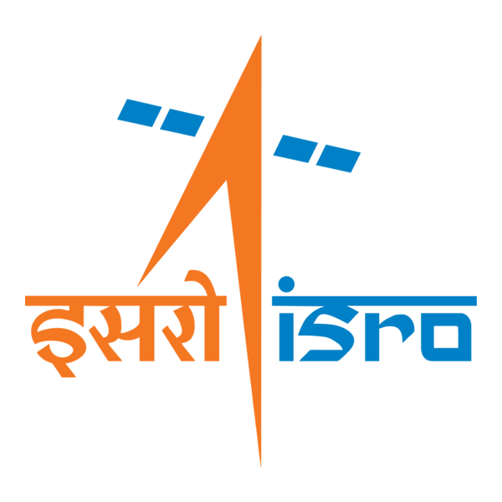

🌌 अंतरिक्ष समाचार | Space News
सोमवार, १९/१०/२०२६ | Monday, 19/10/2026

1. Isro tests methane rocket engine similar to SpaceX-style tech: Why it's a big deal - India Today
Read more
Isro tests methane rocket engine similar to SpaceX-style tech: Why it's a big deal India Today

2. SpaDeX sats re-enter Earth's atmosphere after nearly 21 months in orbit - The Times of India
Read more
SpaDeX sats re-enter Earth's atmosphere after nearly 21 months in orbit The Times of India

3. SpaDeX Satellites Re-enter Earth's Atmosphere Seven Hours Apart - GK Today
Read more
SpaDeX Satellites Re-enter Earth's Atmosphere Seven Hours Apart GK Today

4. An 'open or shut' case dogging the launch of a navigation satellite - BusinessLine
Read more
An 'open or shut' case dogging the launch of a navigation satellite BusinessLine

5. ISRO conducts 1st full-scale ignition test for LME-1100 gas generator - NewsBytes
Read more
ISRO conducts 1st full-scale ignition test for LME-1100 gas generator NewsBytes

6. Astronomers want your help finding 'missing' black holes in the Milky Way
Read more
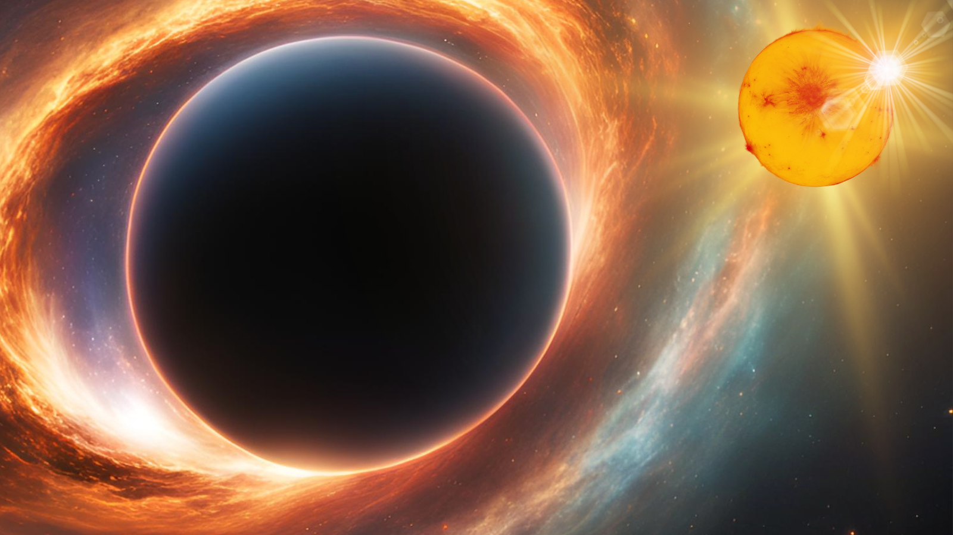
Click for next article Astronomers estimate that our home galaxy, the Milky Way, has churned out more than 10 million black holes over its 13-billion-year history. Yet so far, they have found only 70. Now, a group of astronomers in the U.K. is trying to close that vast gap by enlisting the public. Their project, called Black Hole Hunters , is looking for volunteers with a computer and a few spare minutes to sift through troves of data gathered by a NASA space telescope. By flagging recognizable patterns that could point to a "missing" black hole , volunteers can help fast-track a search that would otherwise take years, the team says. "You'll be narrowing down precisely where we need to point our telescopes next," project co-lead Adam McMaster, an astronomer at the University of Southampton in the U.K., said in a statement , "and you might be the one to discover a black hole." Cosmic magnifying glasses Black holes form when massive stars roughly 20 times heavier than our sun run out of fuel and collapse, leaving behind an abyss with gravity so immense that even light cannot escape. While invisible themselves, these cosmic behemoths reveal their presence by bending the light of nearby objects, and the Black Hole Hunters project is searching for one specific manifestation of this effect. It happens thanks to the fact that massive stars often form in pairs , and a star can sometimes survive the violent supernova explosion that turns its companion into a black hole. When that happens, the two bodies continue to orbit each other. If such a duo aligns just right with Earth, the black hole will periodically pass directly between its companion star and our planet. And when it does, the black hole's gravity acts like a cosmic magnifying glass , bending and magnifying the star's light, causing it to briefly appear brighter to watchful telescopes. To find these hidden giants, the project relies on data from NASA's Transiting Exoplanet Survey Satellite, or TESS . Although the satellite's primary mission is to hunt for planets beyond our solar system , its method of data collection - tracking tiny, continuous changes in a star's brightness over time - is ideally suited for identifying black hole magnification events, the project description notes. "It's a simple task with no expertise required," McMaster said in the statement. "We will show volunteers examples of what to look for so all they have to do is recognise the right patterns." Automated algorithms conduct a preliminary sweep of the TESS data, screening millions of potential stars for the most obvious black hole candidate locations, according to the project description. But, the researchers say, artificial intelligence struggles with the messy realities of the cosmos, such as stellar flares and the natural pulsations of stars that can trick the algorithms into false positives. The human touch That makes human volunteers a key part of the search. To keep errors in check, each graph is shown to multiple volunteers, and their answers are combined so that individual mistakes average out, according to the project's website. "I can search for black holes on my laptop from my bedroom - and could make a real impact on real space science," Grace Clarke, an undergraduate student of physics and astronomy at the University of Southampton who's involved with the project, said in the same statement. "The data's easy to understand - it's just pattern recognition - and you don't need a degree in astronomy to read it." The crowdsourced shortlist of promising signals lets astronomers aim follow-up observations at specific stars, such as precise measurements of whether a star is being tugged at by an unseen companion. Those measurements take time and are expensive, so a good shortlist helps researchers spend scarce telescope time wisely, the team says. Since launching on the Zooniverse platform in October 2021, the project has attracted nearly 23,000 volunteers, who have completed more than 12 million classifications, according to its website. Before turning to TESS, the team ran a similar search using data from SuperWASP, a ground-based survey that, like TESS, monitored stars for signs of planets from 2004 to 2016. Those results are still being analyzed and are expected to be published soon. The team also plans to widen its search with observations from other instruments, including the European Space Agency's Euclid mission and NASA's recently launched Nancy Grace Roman Space Telescope . "With potentially thousands of new discoveries, we need all the help we can get," McMaster said in the statement.

7. 'Let's all choose to make tomorrow better', Artemis II astronauts honored with Stephen Hawking Medal at Starmus
Read more

Click for next article Artemis 2 astronauts Jeremy Hansen, Victor Glover and Reid Wiseman collecting their Stephen Hawking Medals at Starmus VIII. Alongside Brian May (left), Garik Israelian (center right) and Chris Hadfield (right). TENERIFE, CANARY ISLANDS - The Artemis II astronauts may have traveled hundreds of thousands of miles away from Earth to the moon, but they made sure the rest of us didn't miss out on the adventure. Now, their efforts to bring the wonders of space exploration back down to Earth have earned them one of science communication's most prestigious honors: the Stephen Hawking Medal. NASA astronauts Reid Wiseman and Victor Glover , alongside Canadian Space Agency astronaut Jeremy Hansen , accepted the award on Saturday (Oct. 17), during the opening ceremony of the Starmus VIII festival. The honor recognizes all four crew members, including NASA astronaut Christina Koch , who wasn't in attendance. For Wiseman, the experience of seeing our home planet from the vicinity of the moon carried a powerful message. "If we could take each of you 250,000 miles away from this planet, 400,000 kilometers away from planet Earth, and you would see Earth the size of your thumb. It's tiny," Wiseman told the audience. "When you're there looking through the moon, back at this tiny Earth, the only thing you feel is love, peace, hope, unity", he continued. "Those aren't the right words, but that is all you feel." Reid Wiseman delivered a powerful message during the awards ceremony. (Image credit: Daisy Dobrijevic/Future) During their historic Artemis II mission, the astronauts did far more than put NASA's Orion spacecraft through its paces. Through live communications, interviews and glimpses into life aboard the spacecraft, not to mention the jaw-dropping photos that just keep on coming , they helped turn an extraordinarily complex mission into something people worldwide could experience and connect with. And that's exactly what the Stephen Hawking Medal is designed to celebrate. Established in 2016 by physicist Stephen Hawking and Starmus, the award honors those who have gone above and beyond to make science accessible, engaging and inspiring. The Artemis II crew joins some pretty impressive company. Previous recipients include Apollo 11 moonwalker Buzz Aldrin , naturalist David Attenborough, primatologist Jane Goodall and astrophysicist Neil DeGrasse Tyson. This year's ceremony marks the medal's 10th anniversary, with filmmaker Ridley Scott also among the 2026 honourees. "It's a special thrill for us at Starmus to be able to honor the intrepid Artemis II crew members in the same way that we honored the Apollo astronauts who paved the way to the moon over 50 years ago," Starmus co-founder and Queen guitarist Brian May said in a statement ahead of the ceremony. Wiseman left the audience with one final thought. "When you come home to this beautiful planet, you realise that it's in every single one of us to choose to make tomorrow better," he said. "So let's all choose to make tomorrow better". Starmus VIII runs from Oct. 17-22 across Tenerife and La Palma in the Canary Islands. This year's festival, themed "The Search for Truth", brings together leading scientists, astronauts, musicians and artists to celebrate scientific discovery and explore the importance of evidence and scientific thinking.

8. Live coverage: SpaceX to launch Starfall reentry capsule, 31 customer payloads on Bandwagon-5 rideshare mission
Read more
SpaceX will fly its uncrewed reentry Starfall capsule aboard the Bandwagon-5 rideshare mission from Cape Canaveral Space Force Station, scheduled for launch before dawn on Monday. The 32 payloads onboard the Falcon 9 rocket will take flight from Space Launch Complex 40 during an hour-long window that opens at 6:30 a.m. EDT (1030 UTC). The rocket will fly on a southeasterly trajectory upon leaving the pad. Spaceflight Now will have live coverage beginning about an hour prior to liftoff. <span data-mce-type="bookmark" style="display: inline-block; width: 0px; overflow: hidden; line-height: 0;" class="mce_SELRES_start"></span> The 45th Weather Squadron forecast a 55 percent chance for acceptable weather during the launch window, stating that a cold front along southern Florida will bring gusty winds at liftoff that are "approaching constraints" to launch. There is also a moderate to high risk that weather at the recovery site for the first stage booster won't be acceptable. "Occasional coastal showers are also possible within the persistent onshore flow, although these are expected to be shallow and low-topped, with some more stratiform in nature," launch weather officers wrote in a prelaunch forecast. "Therefore, the Cumulus Cloud Rule is a secondary concern." SpaceX will launch the mission using the Falcon 9 first stage booster with the tail number B1085. This will be its 19th flight following the launches of NASA's Crew-9, Fram2, Firefly Blue Ghost Mission 1, RRT-1, SXM-10, SXM-11, MTG-S1, EchoStar25, and 10 batches of Starlink satellites. Nearly nine minutes after liftoff, B1085 will target a landing on the droneship, A Shortall of Gravitas. If successful, this will be the 167th landing on this vessel and the 672nd Falcon booster landing to date. Beyond SpaceX's Starfall capsule, 20 of the remaining 31 payloads to be deployed were manifested by multinational mission management company, Exolaunch. Those include four radio-frequency monitoring satellites from Virginia-based, HawkEye 360; four communications satellites for Finnish micro satellite company, Iceye; and six navigation satellites from California-based, Xona Space Systems. Return of Starfall SpaceX first debuted its reentry capsule called Starfall back in June. During that mission, SpaceX played its cards close to the vest, not revealing that its spacecraft was onboard the rocket until fairly close to flight. Even at that, the company just shared a rendering of the vehicle and didn't disclose during its launch broadcast when it would be deployed. "SpaceX has developed a new spacecraft called Starfall, which at its core is a microgravity lab researchers and entrepreneurs can leverage to develop their products and innovations, said Zachary Luppen, an avionics supply chain engineer at SpaceX and the commentator during the June 23 broadcast. "As we have seen demonstrated on the International Space Station, there is a huge opportunity to benefit life here on Earth through microgravity research and in-space manufacturing" The Federal Aviation Administration noted in an environmental assessment of Starfall that the vehicle is about 0.75 meters (2.5 feet) tall, 3.1 meters (10.2 feet) in diameter, and has a mass of about 2,100 kilograms (4,600 pounds). The FAA said a single Starfall capsule has the ability to support up to 1,000 kilograms (2,200 pounds) of payload mass. SpaceX didn't state what, if any, payloads were onboard this Starfall mission. SpaceX's Starfall isn't the only reentry vehicle onboard the Bandwagon-5 mission. Varda Space Industries, which focuses on pharmaceutical research missions, is launching its W-Series 7 spacecraft, which is about three times smaller than Starfall. Despite the name, W-7 will be Varda's ninth reentry capsule launched to date. W-8 and W-9 were launched earlier this month on the Transporter-18 mission. W-7 features the cancer drug called Protac and will study whether microgravity can improve its solubility. "In microgravity, molecules can crystallize differently than they do on Earth, potentially producing crystal forms with improved properties, including better solubility," Varda wrote on its website prior to launch. "If successful, the experiment could help turn powerful protein-degrading molecules into more practical and effective cancer treatments." Also onboard Bandwagon-5 is the Starburst-1 demo mission from Portal Space Systems Inc. The 260 kg spacecraft is designed to perform orbital maneuvers and support a customer payload of up to 50 kg. This first demonstration of the Starburst spacecraft is "fully funded by Portal to prove capability ahead of customer missions," the company said on its website. Customer flights are advertised as starting in 2027.

9. Japan's MMX mission aims to swipe soil samples from Mars's moon Phobos
Read more
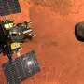
A Japanese space mission is about to launch towards Mars. But it will not land on the planet itself. Instead, the Martian Moons Exploration (MMX) mission will focus on Phobos, the bigger of Mars's two small moons.

10. Explained: How China's 'carrier killer' missile threatens moving warships
Read more
Aircraft carriers allow navies to move air power across oceans without relying on nearby air bases. China developed the DF-21D missile to threaten the ships that make those operations possible. Known as a "carrier killer," the DF-21D is a land-based anti-ship ballistic missile designed to strike large warships at sea. Its reputation comes from a combination of long range, a maneuverable reentry vehicle, and the challenge it presents to carrier defenses. The nickname, however, describes its intended mission. Whether it can successfully strike a moving carrier in wartime depends on much more than the missile itself. A ballistic missile built to attack ships The DF-21D belongs to China's Dong Feng, or "East Wind," missile family. Unlike variants intended to attack targets on land, it carries a conventional warhead for strikes against ships, including aircraft carriers. According to the Congressional Research Service, the missile has a range exceeding 1,500 kilometers (roughly 932 miles). That gives China a way to threaten naval vessels far from its coastline using land-based launchers. The distinction from an anti-ship cruise missile is important. Cruise missiles typically use powered flight within the atmosphere. A ballistic missile follows a high, arcing trajectory before its reentry vehicle descends toward the target. For naval planners, this introduces another direction and type of attack to defend against. CRS notes that before these weapons emerged, the US Navy had not faced highly accurate ballistic missiles capable of hitting moving ships at sea. A warhead that can adjust its approach Range alone cannot explain the "carrier killer" label. An aircraft carrier can change course and speed, making its position at launch different from its location when a missile arrives. The Pentagon's 2024 China Military Power Report identifies a maneuverable reentry vehicle as a feature of the DF-21D. This vehicle carries the warhead back through the atmosphere and can adjust its flight path during the approach. That maneuverability supports the missile's anti-ship role, although publicly available information does not establish its accuracy against a defended carrier under combat conditions. The DF-21D also operates from road-mobile launchers. These vehicles can relocate, making them harder to find and target than fixed launch sites. Mobility adds another complication for forces attempting to eliminate the threat before launch. Together, these features explain why the missile attracts attention: it combines a long-distance strike capability with a system intended to engage ships that do not remain stationary. Why sinking a carrier remains a difficult task A missile cannot attack a carrier effectively without reliable targeting information. China must first detect the ship, identify it, determine its position, and maintain sufficient tracking information to support the strike. That information must reach the launch unit, and the reentry vehicle must then find the intended ship. This sequence is commonly called the targeting "kill chain." Failure at any stage can undermine the attack.

