 |  | 

🌌 अंतरिक्ष समाचार | Space News
गुरुवार, ०६/०८/२०२६ | Thursday, 06/08/2026

1. Tourism dept issues notices to 20 unregistered homestays
Read more
PIONEER EDGE NEWS SERVICE/Dehradun The district tourism development office of Dehradun has issued notices to 20 unregistered homestays in the district. These homestays have allegedly been operating without mandatory registration under the Uttarakhand Tourism and Travel Business Registration Rules 2026. The officials said that some of the identified homestays have allegedly been operating for nearly two years without registration. The notices direct the operators to submit a written explanation along with supporting documents within seven working days and appear before the DTDO office. They also warn that if no reply is received within the stipulated period, penalties would be slapped and legal actions would be taken.

2. RBI to soon launch draft guidelines on on-tap licences for urban cooperative banks: Malhotra
Read more

- Governance - 1 min read Meanwhile, Malhotra also announced a review of guidelines on concentration risk management for Rural Co-operative Banks on Wednesday. - PTI - Published On Aug 5, 2026 at 11:52 AM IST Select ETGovernment as Preferred Choice on Google Copy Link Share on WhatsApp Share on Linkedin Share on X Share on Telegram Share on Facebook Representational image The Reserve Bank will soon come out with draft guidelines for 'on-tap' licensing for urban cooperative banks , Governor Sanjay Malhotra said on Wednesday. The central bank had earlier decided to lift the over two-decade-old pause on fresh licences to urban cooperative banks and resume the 'on-tap' basis licensing, just as it does for universal banks. Malhotra said it had launched a discussion paper on the move in January this year, and will be following up with the next steps shortly. "The draft guidelines will be issued shortly for stakeholder consultation," the Governor said, in the statement on development and regulatory policies, announced alongside the third bi-monthly monetary policy review of FY27. Advt Risks around governance in the urban cooperative banks that are controlled or dominated by political leaders, and which had been leading to episodic stress at such lenders, was presumed to be one of the reasons for the freeze on new licences for UCBs. He said the Credit Monitoring Arrangement (CMA) instructions issued in 2008 govern the norms. "As the banking sector in general, and co-operative banking sector in particular, have undergone significant expansion and changes since then, it has been decided to review these instructions, keeping in view the objectives of developing a vibrant co-operative sector," he said. Prudential concerns arising from concentrated lending will be taken on board in the draft amendment directions which are being issued for wider stakeholder consultations, the Governor assured. - See more on: - RBI , - urban cooperative banks , - on-tap licensing , - Sanjay Malhotra , - draft guidelines Telegram Facebook Comments What are your thoughts? Comment Now --> Comment Now Read Comment (1) All Comments By commenting, you agree to the Prohibited Content Policy Post Find this Comment Offensive? Choose your reason below and click on the submit button. This will alert our moderators to take actions REASONS FOR REPORTING Foul Language Defamatory Inciting hatred against a certain community Out of Context / Spam Others Report Join the community of 2M+ industry professionals. Subscribe to Newsletter to get latest insights & analysis in your inbox. --> All about ETGovernment industry right on your smartphone! - Download the ETGovernment App and get the Realtime updates and Save your favourite articles. Scan to download App -->

3. RBI targeting polymer currency notes launch in early FY28: Sanjay Malhotra
Read more

- Economy - 1 min read Commenting on the Foreign Currency Non-Resident (Bank) scheme, Malhotra said the flows have been "robust", and the RBI expects healthy movement of funds going forward till the closure of the limited-period scheme. - PTI - Published On Aug 5, 2026 at 03:03 PM IST Select ETGovernment as Preferred Choice on Google Copy Link Share on WhatsApp Share on Linkedin Share on X Share on Telegram Share on Facebook Image for representational purpose only Governor Sanjay Malhotra on Wednesday said the Reserve Bank of India is targeting to launch long-lasting polymer currency notes at the beginning of the next financial year. Speaking to reporters at the customary briefing after the monetary policy review, Malhotra said the polymer currency notes have lasted for over 30 years in some jurisdictions and will come in handy, especially for the lower denomination notes which have high velocity. "We are targeting that they are in circulation, if everything goes as per plan, in the beginning of the next financial year," Malhotra said. Advt Malhotra said the next move of the Reserve Bank of India ( RBI ) on the crucial aspect of interest rates and also the stance of the policy will be data-dependent, and underlined that the prime focus of the central bank is to align the headline inflation with its target of 4 per cent over the medium term. When asked if the central bank is looking to close the scheme prematurely, given that there is a cost which the RBI is committed to bear for the fund inflows, Malhotra said there is no such proposal at this point of time. After being pointed out that the rupee has not appreciated as intended despite the high flows from foreign shores, Malhotra said a further strengthening in the rupee is possible if geopolitical tensions de-escalate. It will be the RBI's endeavour that the trajectory for the rupee remains orderly, he added. - See more on: - RBI , - polymer currency notes , - Sanjay Malhotra , - financial year 2028 , - interest rates policy Telegram Facebook Comments What are your thoughts? Comment Now --> Comment Now Read Comment (1) All Comments By commenting, you agree to the Prohibited Content Policy Post Find this Comment Offensive? Choose your reason below and click on the submit button. This will alert our moderators to take actions REASONS FOR REPORTING Foul Language Defamatory Inciting hatred against a certain community Out of Context / Spam Others Report Join the community of 2M+ industry professionals. Subscribe to Newsletter to get latest insights & analysis in your inbox. --> All about ETGovernment industry right on your smartphone! - Download the ETGovernment App and get the Realtime updates and Save your favourite articles. Scan to download App -->

4. Are Space Tech Startups Poaching ISRO Scientists? Well, It's Complicated - analyticsindiamag.com
Read more
Are Space Tech Startups Poaching ISRO Scientists? Well, It's Complicated analyticsindiamag.com

5. Abdul El-Sayed is the Most Radical Candidate in America - NRSC.org
Read more
WASHINGTON, D.C. - Following Abdulrahman Mohamed El-Sayed's victory in Michigan Democrats' messy primary, the National Republican Senatorial Committee (NRSC) released a new digital ad exposing his socialist tax hike agenda, ties to terrorist sympathizer Hasan Piker, and praise for a designated terrorist organization. "El-Sayed is the most radical Democrat Senate nominee ever. His support of terrorist organizations, socialist policies, and the defunding of law enforcement makes him dangerous and ultimately disqualified from serving," said NRSC Chairman Tim Scott. "Michigan has had two Democrat Senators for decades, so we cannot take anything for granted, but we will do everything we can to make sure El-Sayed never steps foot in the U.S. Senate." Transcript: Voice Over: "Abdulrahman Mohamed El-Sayed: The most radical Senate candidate in America." El-Sayed: "I'm pretty damn dangerous." Voice Over: "El-Sayed pledged support for the leader of the Muslim Brotherhood, a designated foreign terrorist group. "He wants to hike taxes on Michigan waitresses, delivery drivers, and seniors on Social Security. "He joined a sex offender and a murder to demand the mass release of dangerous prisoners. "And when his ally claimed America deserved 9/11…" Hasan Piker: "America deserved 9/11, dude." Voice Over: "… El-Sayed refused to disavow." El-Sayed: "I'm not here to disavow people's views." Voice Over: "Abdul El-Sayed. Too radical. Too dangerous. Wrong for Michigan." ###

6. ISRO carried out 29 collision avoidance manoeuvres to protect Indian satellites in last 18 months - Deccan Herald
Read more

New Delhi: With the majority of Indian satellites in the low earth orbit, the Indian Space Research Organisation (ISRO) has carried out 29 "collision avoidance manoeuvres" in the last one and half years for securing the space assets. These include 20 manoeuvres in 2025 and nine in 2026 so far, the Union government informed the Parliament on Wednesday. Twenty out of 22 active Indian satellites are in the populated low earth orbits of 2000 km or less. The collision avoidance manoeuvre is a targeted trajectory adjustment executed by the ISRO to steer an operational spacecraft safely away from space debris or other active satellites when a critical close approach is predicted. The Indian space agency monitors such close approaches by combining global alerts with indigenous tracking data.

7. A SpaceX rocket just crashed into the moon. Now, the race is on to get a look at the impact site
Read more
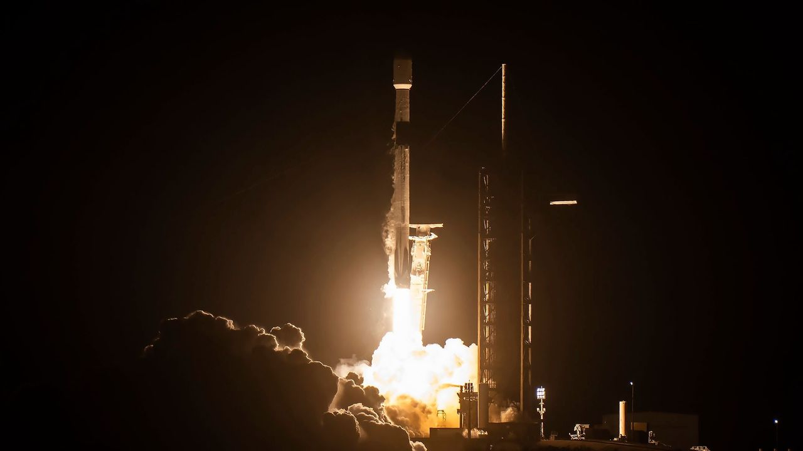
Click for next article A SpaceX Falcon 9 rocket launches the Blue Ghost and Resilience lunar landers on Jan. 15, 2025. The rocket's upper stage slammed into the moon on Aug. 5, 2026. Early this morning, a SpaceX rocket slammed into the moon at seven times the speed of sound. Now, lunar orbiters are trying to get a look at the aftermath. This morning (Aug. 5) at about 2:35 a.m. EDT (0635 GMT), the upper stage of a SpaceX Falcon 9 rocket crashed into the moon . To dissect what exactly happened, scientists are looking for imagery of the crash site, with the help of a couple of moon probes. "NASA's Lunar Reconnaissance Orbiter and NASA's ShadowCam instrument on the Korea Pathfinder Lunar Orbiter will look for opportunities to capture before‑and‑after imagery of the impact site," NASA spokesperson Rob Garner, of NASA's Goddard Space Flight Center in Maryland, told Space.com. "Image availability depends on several factors, including the impact location, lighting conditions, and when each spacecraft's orbit next carries it over the area, which may take a few days to receive any imagery." While you've likely seen the first stages of Falcon 9 rockets gracefully land back on Earth for reuse, the rocket's 9,000-pound (4,000 kilograms) upper stage is disposable. Typically, it's sent to burn up in our atmosphere after its missions are over. However, that wasn't possible with this rocket, which launched two private lunar landers - Firefly Aerospace's Blue Ghost and Tokyo-based ispace's Resilience - to a high, moon-crossing Earth orbit in January 2025 . The Falcon 9 upper stage used most of its fuel getting to this distant location and couldn't make it back to deorbit in Earth's atmosphere . So the company performed a different maneuver to take care of this upper stage, Julianna Scheiman, director of NASA science and Dragon programs at SpaceX , said during a press conference on Aug. 3. "For high-energy missions, we need to perform a different maneuver to ensure the second stage itself is safe per the appropriate rules and regulations, and so we did that here," she said. But the rocket body was still subject to natural forces, which acted on it over time. "What has happened is, essentially, a mixture of solar activity and gravity forces have put it on a path towards the moon," Scheiman said. The Falcon 9 upper stage ended up slamming into the moon this morning at about 5,400 mph (8,690 kph). It likely blasted out a crater up to 89 feet (27 meters) wide, according to scientists' calculations. This was certainly not the original intended outcome for this rocket. But it presents an opportunity for researchers, who plan to take advantage of it to learn more about the moon. "NASA's Meteoroid Environments Office will attempt to image the impact around the predicted time using ground‑based telescopes at the agency's Marshall Space Flight Center in Huntsville [Alabama]," Garner added. "Because the impact flash and plume are expected to be faint, the chance of seeing anything from Earth remains low, and local weather can affect observations as well. Any data collected will help scientists better understand impacts from artificial objects and the potential effects on future lunar exploration." Today's impact took place on the sunlit side of the moon, the brightness of which made observations difficult for skywatchers hoping to watch the crash from afar with telescopes. But the two lunar orbiters might be able to see not just the crash and impact crater but also the plume of dust kicked up by the rocket's death dive. So far, observations from Earth have revealed some information. Scientists at the Lowell Observatory in Flagstaff, Arizona reported detections of a lunar plume from the impact. "We can safely say that we measured a response from the rocket stage impact as a sodium and lithium gas plume a few 10's of kilometers in size lasting between 5 and 10 minutes after impact," Carl Schmidt told Inside Outer Space's Leonard David. Detections by the Lowell Observatory in Flagstaff, Arizona, show evidence of a plume on the moon caused by the impact of a SpaceX rocket on Aug. 5, 2026. (Image credit: Carl Schmidt/Lowell Observatory) Such images of the event would provide "an opportunity to test pipelines for measuring flash properties to locate impact events seismically, and to better understand the multi-modal hazards posed to future lunar infrastructure and astronauts from space debris impacting the moon," researchers led by Benjamin Fernando of Los Alamos National Laboratory in New Mexico wrote in a recent paper discussing the then-upcoming event. So hold tight, as researchers are now eagerly collecting and analyzing the images captured by these orbiters, and we might get images of the rocket crash, the lunar plumes and remaining aftermath soon.

8. On this day in space! Aug. 5, 2011: NASA's Juno spacecraft launches to Jupiter
Read more
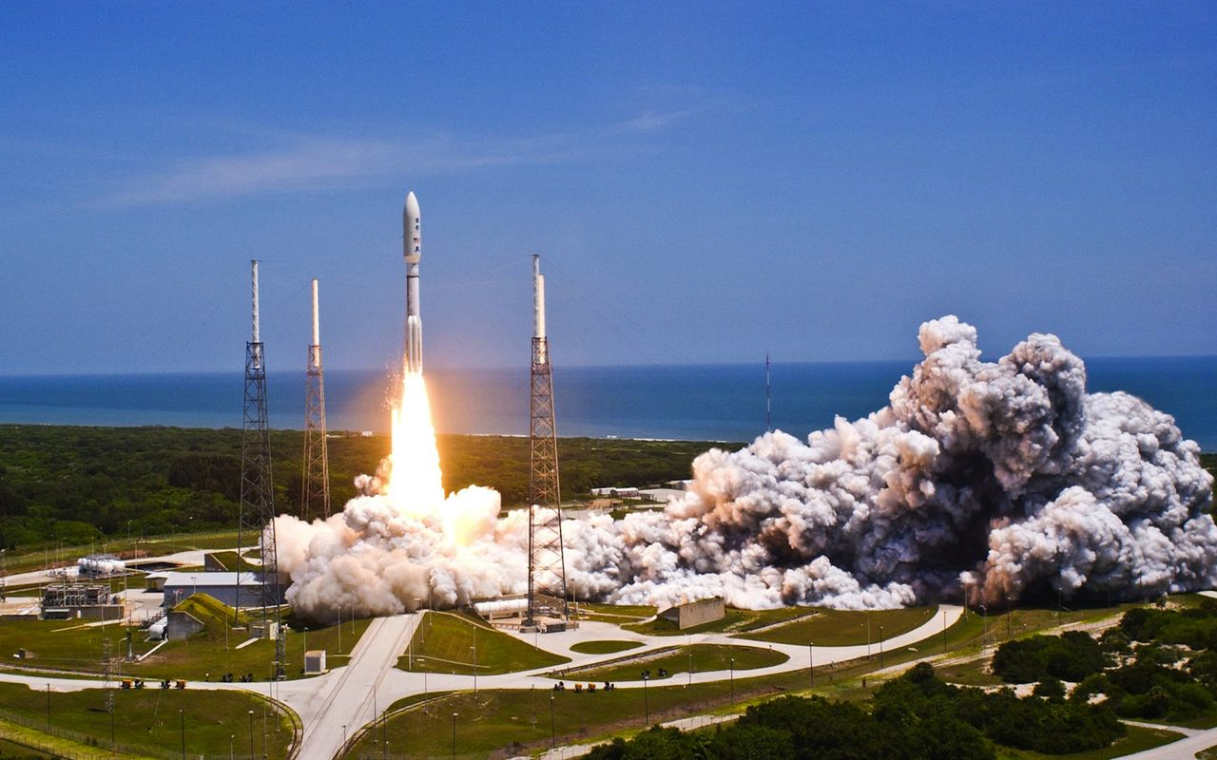
Click for next article On Aug. 5, 2011, NASA launched the Juno spacecraft on a mission to study Jupiter, the largest planet in the solar system. The robotic spacecraft lifted off on an Atlas V rocket from what is now Florida's Cape Canaveral Space Force Station and spent the next five years making the 1.74-billion-mile trek to Jupiter. Since it arrived in Jupiter's orbit in 2016, the Juno spacecraft has taken the most amazing photos of Jupiter anyone has ever seen! But it has also taken plenty of scientific measurements to study Jupiter's composition, magnetic fields, weather patterns and more. Image 1 of 3 A United Launch Alliance Atlas V rocket blasts off carrying NASA's Juno mission. The launch marks the second of five launches for NASA in 2011. (Image credit: Patrick H. Corkery/United Launch Alliance) This artist's rendering shows NASA's Juno spacecraft making one of its close passes over Jupiter. (Image credit: NASA/JPL-Caltech) Juno captured stunning look at Jupiter on April 10, 2020. (Image credit: NASA/JPL-Caltech/SwRI/MSSS; image processing by Kevin M. Gill © CC BY) Image 1 of 3 View Original Image 2 of 3 View Original Image 3 of 3 View Original Why it mattered Juno is an interesting mission. It was the first dedicated orbiter at Jupiter since NASA's prolific Galileo mission , which ended in 2003, and is the first solar-powered spacecraft to the gas giant. Indeed, each of its three 30-foot-long solar wings is as long as a semi truck to collect enough sunlight to power its systems. But it's the science that makes Juno stand out. When Galileo orbited Jupiter, its high-gain antenna did not fully deploy, meaning the probe was never able to record detailed video of Jupiter's atmosphere as hoped. While Juno was initially built to study the inner workings of Jupiter, its camera recorded the first detailed video of the planet's clouds and atmosphere . The Juno spacecraft's primary mission ended just 20 months after entering orbit, but NASA extended the orbiter's mission several times, most recently in 2021. That most recent extension sent Juno on multiple flybys of three of Jupiter's largest moons, Ganymede , Europa and the volcanic moon Io . Juno's observations are already helping the science planning of future missions to Jupiter, including science targets for the European Space Agency's Jupiter Icy Moon Explorer , or JUICE, and NASA's Europa Clipper probes, which are currently en route to the giant planet.

9. Mars dust is toxic. How will future astronauts deal with it?
Read more
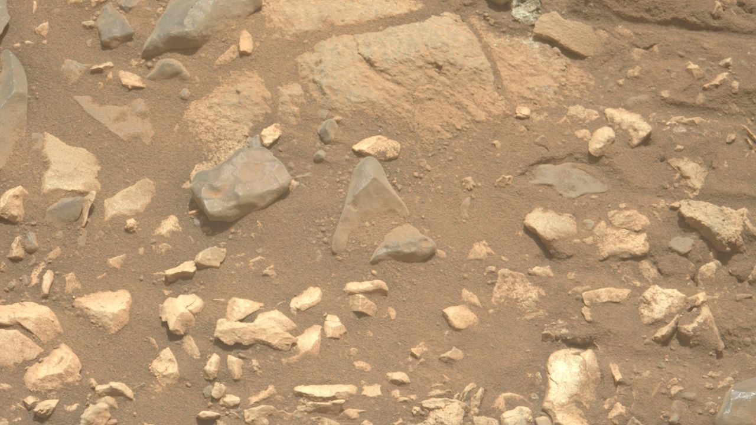
Click for next article Dust and rocks on Mars as seen by NASA's Perseverance rover. Planting boots on Mars is hard enough. But getting "breathing room" on the Red Planet without inhaling toxic dust is yet another issue. Given NASA's plans to eventually put astronauts on the Red Planet , the agency assembled a Martian Dust Limit Working Group earlier this year to review what's known and unknown about the toxicological hazard to human crews from exposure to Mars dust. The ultimate goal was to establish a permissible exposure limit for humans on the Red Planet by compiling a comprehensive set of expert perspectives regarding Martian dust toxicology, exposure pathways and mitigation strategies. The working group's conclusions reinforced the view that an initial Martian dust standard "must balance conservatism with operational feasibility while accommodating architectural and scientific uncertainty," the report states. Furthermore, the report explains, "as additional Martian data and toxicological research become available, this standard should be periodically revisited to ensure continued protection of crew health during human exploration of Mars." Unique study A panel member for that study was Brian Hynek professor in the Department of Earth Science and a research associate at the Laboratory for Atmospheric and Space Physics, both at the University of Colorado, Boulder. "It was a unique study," Hynek told Space.com, conducted by NASA specialists, space medicine experts, habitat designers, including toxicologists, volcanologists and geologists. "The task was to help gauge health hazards to humans, both for short and long-term stays," he said. Just highlighting the differences between the moon and Mars played a role, said Hynek. "The moon is worse in some ways and Mars is worse in other ways." Disneyland of dust To be sure, one outcome from Apollo moonwalkers - the "dusty dozen" - is that dealing with lunar dust proved to be troublesome, much more than expected. The aged moon is a Disneyland of dust and crews that went there attested to that fact. Once out and about, moonwalkers coped with very fine, tiny particles composed of sharp, glassy material. Lunar dust stuck to everything it came in contact with; dust eroded their spacesuits, caused overheating on equipment and instrumentation, compromised seals on their spacesuits, even irritated the eyes and lungs of moonwalkers. "On Mars, dust particles are a little more rounded, not as jagged and cutting into you. But then you have all the extra chemical components and minerals that you don't have on the moon, like really unhealthy perchlorates," Hynek said. "We can use the lunar knowledge, but Mars is a totally different place," he added. At the conclusion of Apollo 17's mission in December 1972, moonwalking suits and space helmets are covered by lunar dust. (Image credit: NASA) Heavy metals Hynek noted that Martian dust is known to contain various carcinogens, such as silica and numerous heavy metals. He co-authored a recent paper on "Potential Health Impacts, Treatments, and Countermeasures of Martian Dust on Future Human Space Exploration." "There's talk about growing crops on Mars," Hynek observed. "The martian soil is full of all these nasty chemicals. So the astronauts might get more exposure from what they are growing on Mars than the actual airborne dust," said Hynek. Then there's the dust that will assuredly find its way into the habitat, Hynek said, so engineers are looking at filtering systems and just how much time will be required to clean the inside of the habitat. "It's good to have the forethought and to start considering the Martian dust and its hazards. It poses a lot more health hazards than the lunar dust," Hynek concluded. Learned our lesson Joel Levine, a research professor in applied science at William and Mary in Williamsburg, Virginia, is a leading expert on lunar dust, engineering and safety concerns. He was not a panel member of the NASA report. Levine cited earlier thinking from a recent National Academy of Sciences report on human exploration of Mars. Two goals noted in that 2026 report are Mars dust-related: Determine what controls the onset and evolution of major dust storms, which dominate present-day atmospheric variability. Characterize the effects of Martian dust on human physiology and hardware lifetime. "This indicates that Mars dust is on the minds of mission planners! This is good news based on our experience with lunar dust on the Apollo landings," said Levine. "It looks like we learned our lesson about dust at future human landing sites." Levine stated that Mars sample returns would be very helpful to characterize Martian dust samples for chemical composition and other qualities. "Unfortunately, it does not look like the Mars samples already collected will ever be returned to the Earth for analysis," he said. Martian dust seen on NASA's Perseverance rover on July 27, 2026 (Sol 1932) by the rover's Right Mastcam-Z camera. (Image credit: NASA/JPL-Caltech/ASU) Major takeaways Shaunna Morrison, an associate professor in the Department of Earth and Planetary Sciences at Rutgers University in New Jersey, served as a panel member on the Martian Dust Limit Working Group. "One of the major takeaways from the Mars dust working group is that martian dust is a real crew-health and engineering issue, but it is also a tractable one if it is treated as a design requirement from the beginning," Morrison emphasized. The worry is not that Mars dust is uniquely or catastrophically toxic based on what we know now, Morrison told Space.com. "The concern is that future crews will be living and working in a closed habitat, repeatedly going outside, bringing dust back in on suits and equipment, in a low-humidity environment," said Morrison. That's a condition in which small particles are more prone to becoming airborne and potentially inhaled, she said, and potentially crew members being exposed to fine respirable particles over many days. A region-wide seasonal dust storm obscures the Jezero Crater in this image from NASA's Mars Perseverance rover, acquired using its Left Mastcam-Z camera on Aug. 20, 2024 (Sol 1244, or Martian day 1,244 of the rover's mission). (Image credit: NASA/JPL-Caltech/ASU) Prevention first Morrison said that a key point is that we do not have as yet returned samples of authentic airborne martian dust. So NASA has to build a conservative standard using the best available evidence: lunar dust toxicology, Mars simulant studies, and the very extensive chemical and mineralogical datasets from Mars rovers and landers, she pointed out. "The best strategy is prevention first," Morrison said. "Keep as much dust as possible outside the habitat, remove it quickly when it gets in, monitor airborne particles, and design the system so crews are not relying on medical countermeasures after exposure," she advised.

10. SpaceX launches 3 AST SpaceMobile BlueBird satellites on Falcon 9 rocket from Cape Canaveral
Read more
Update Aug. 5, 6:09 a.m. EDT (1009 UTC): SpaceX confirmed deployment of the three BlueBird satellites. SpaceX launched the latest trio of AST SpaceMobile's BlueBird satellites from Cape Canaveral Space Force Station in the predawn hours of Wednesday morning. The Falcon 9 rocket carried satellites numbered 11, 12, and 13 in to orbit. The mission came about a month-and-a-half after SpaceX launched the BlueBird 8-10 mission. Liftoff from Space Launch Complex 40 happened at 3:49 a.m. EDT (0749 UTC). The rocket flew on a northeasterly trajectory upon leaving the pad. The 45th Weather Squadron forecast an 85 percent chance for favorable weather during liftoff. Meteorologists are tracking the possible interference from anvil, thick, and cumulus clouds. "A weak mid-level low centered over Georgia this morning will begin to dissipate through the overnight period," launch weather officers wrote. "Lingering influence from this feature will promote continued light southwesterly low-mid level flow during the primary launch window." SpaceX launched the mission using the Falcon 9 first stage booster with the tail number B1077. It became the fifth Falcon booster to achieve at least 30 flights, with four out of those five boosters are still in operation. More than 8.5 minutes after liftoff, B1077 landed on the droneship, A Shortfall of Gravitas, positioned in the Atlantic Ocean. This was the 162nd landing on this vessel and the 645th Falcon booster landing to date. The trio of BlueBird satellites were deployed several minutes apart beginning about 54 minutes after liftoff. Because of the size of the payload adaptor, SpaceX didn't broadcast the deployment live, but rather confirmed the release on social media. The 2,400-square-foot sized satellites will take a couple of weeks to deploy to their full size and complete checkouts before entering into the broader constellation. In late July, AST SpaceMobile CEO Abel Avellan said on social media that the next trio of satellites following this launch are not too far behind the three satellites launching on Wednesday morning. He said they have production in flow through satellite 42. "We invented a new way to design, manufacture at scale, deploy, and fly lightweight composite stackable architecture combined, with the world's largest and most advanced direct-to-device and radar phased-array with the ability to launch them in groups of 3, 5, 6, or 8 on a single launch," Avellan wrote. SpaceX's Falcon 9 is able to launch three satellites at most with its Falcon 9 rocket with the eight-satellite configuration reserved for Blue Origin's New Glenn rocket, which has a seven-meter diameter payload fairing. However, the latter rocket is grounded for an undetermined amount of time following the May 28 pad explosion.

11. SpaceX aims to use rockets to quickly transport cargo across the Earth and into orbit
Read more

You might think of rockets as powerful vehicles that blast astronaut crews and robotic missions into space. But what if they could be used to send cargo from one side of Earth to the other in a fraction of the time it would take a plane? The company SpaceX recently announced a project that aims to use its rockets to do just that.

12. SpaceX rocket stage believed to have slammed into the moon
Read more

A piece of a SpaceX rocket weighing four tonnes (4.4 tons) was believed to have unintentionally crashed into the moon on Wednesday, a collision that posed no danger to Earth but is expected to leave behind a lunar crater.

13. US plans new air taxi infrastructure across 4 states as Joby nears launch
Read more
Atoms, an industrial AI and infrastructure company, and Joby Aviation have formed a strategic partnership to acquire and develop vertiports across the United States. The companies will initially target Florida, New York, Texas, and California as Joby prepares to introduce early electric air taxi operations. Announced as Joby approaches commercial readiness, the plan is intended to provide aircraft with strategically located places to land, recharge, receive servicing, and connect passengers with ground transportation. Atoms will develop the sites as multimodal hubs combining electric aircraft, autonomous vehicles, ridesharing services, passenger facilities, and on-site power. Infrastructure for electric flight Joby is preparing early operations in Florida, New York, and Texas through the White House-backed eVTOL Integration Pilot Program. California, where the company has conducted piloted flights across the San Francisco Bay Area, is also included in the initial development strategy. The partnership addresses an infrastructure challenge facing electric aviation. Commercial services will require facilities supporting flight operations and connections to wider transport systems. Joby has flown its first FAA-conforming aircraft and entered the final stage of type certification. It has also completed piloted flights in the San Francisco Bay Area and New York City. Multimodal hubs for US cities Atoms plans to treat vertiports as urban infrastructure rather than simple landing sites. The hubs will combine air taxis, autonomous vehicles, ridesharing, charging, servicing, and last-mile connections. "Smart cities require innovative real estate and infrastructure development," said Travis Kalanick, Founder and CEO of Atoms. "As new transport modes and smart city services become available, designing and deploying a new asset class to support them is critical. We're focused on serving city stakeholders with inspired, efficient buildouts that deliver great experiences for residents and communities alike," he added. Atoms Real Estate will lead the work using its architects, engineers, construction specialists, and technology teams. Its approach targets power-intensive projects combining physical infrastructure with transportation services. Connecting aircraft with communities The partners have not disclosed the number of sites, construction schedule, or investment involved. Their four-state focus targets markets that could support early demand for electric air travel. "Thoughtful urban planning can take a decade or more, and making electric flight part of everyday life will require a new generation of transportation hubs connecting aircraft, ground transportation, and communities," said JoeBen Bevirt, Founder and CEO of Joby Aviation. "As air taxis move closer to early commercial service in the U.S., the right infrastructure becomes increasingly important, not just where aircraft land and charge, but how cities embrace this new form of transportation," he added. "Atoms has a vision of building ambitious infrastructure projects that combine technology, operations, and customer experience, making them a natural partner for Joby," Bevirt said. For Joby, the partnership extends preparations beyond aircraft certification toward the physical network required for passenger service. For Atoms, it creates an opportunity to develop infrastructure intended to link emerging aerial mobility with existing urban transportation systems. The planned network could therefore determine how quickly Joby moves from certification milestones to practical, connected passenger operations in major American cities.

14. DOE launches supercomputing effort to recycle 95,000 metric tons of used nuclear fuel
Read more
SHINE Technologies has been selected for the U.S. Department of Energy's Genesis Mission to develop an AI-enabled system for designing more efficient nuclear fuel recycling processes, while also joining a national consortium focused on applying AI across the nuclear sector. The Janesville, Wisconsin-based fusion energy company will lead a Phase I project called "AI-Guided Fuel Cycle Facility Optimization," with Argonne National Laboratory as its technical partner. The project will use AI to help engineers evaluate fuel recycling facility designs by considering performance, product quality, and waste at the same time. The effort targets a significant US nuclear waste challenge. According to the company, the country has accumulated roughly 95,000 metric tons of used nuclear fuel, and SHINE is developing technology intended to recycle that material and recover usable components. Rather than assessing individual process decisions separately, the new system is intended to examine multiple design options and weigh competing factors together. This could help engineers identify more effective recycling configurations while keeping a record of how the system arrived at its recommendations. Smarter designs for fuel The project builds on two modeling tools developed by Argonne. AMUSE models the chemistry involved in separating used nuclear fuel, while ARTEMIS models how an entire recycling facility can be configured. SHINE and Argonne will add an AI layer to these tools, allowing engineers to explore a much larger range of possible designs. The company said the technology could help identify stronger options by assessing several engineering tradeoffs simultaneously. "Energy and AI are tied together. Advanced technology needs abundant, affordable power, and AI is helping us improve the systems that can provide it, starting with the chemistry behind nuclear fuel recycling," said Greg Piefer, founder and CEO of SHINE. "Our Genesis Mission Project will attempt to bring AI technology into our fuel recycling technology. It's our belief we can accelerate progress by combining our commercial radiochemistry operational data with the best of AI technology." SHINE will also participate in Prometheus, a Phase II Genesis Mission project led by Idaho National Laboratory. The national consortium brings US national laboratories and industry together to develop and apply AI across nuclear energy. From chemistry to recycling Through Prometheus, SHINE will contribute data from its fuel recycling work and receive early access to tools developed by the consortium. This gives the company a role in both developing a specialized system for fuel recycling and contributing to a broader platform for nuclear applications. The work builds on SHINE's existing recycling program. The company is developing a commercial pilot that uses process chemistry already demonstrated at its Chrysalis medical isotope facility. Chrysalis has completed the Nuclear Regulatory Commission's full operating license review, providing SHINE with experience relevant to the regulatory pathway expected for a future recycling facility. The Genesis Mission project is planned to run over the coming months. If successful, SHINE says the approach could eventually be applied to additional stages of the fuel recycling process. The DOE's Genesis Mission is a more-than-$5-billion initiative designed to combine AI, supercomputing, quantum systems and advanced scientific instruments to accelerate scientific discovery and energy innovation.

