 |  | 

🌌 अंतरिक्ष समाचार | Space News
रविवार, ०९/०८/२०२६ | Sunday, 09/08/2026

1. PWD suspends three engineers, contractor's registration after Nanda Ki Chowki approach road collapse
Read more
PIONEER EDGE NEWS SERVICE/Dehradun The Public Works Department (PWD) has suspended three engineers over damage to the approach road of newly constructed Tons river bridge at Nanda Ki Chowki. Executive engineer Rajesh Kumar, assistant engineer Amit Kumar Tyagi and junior engineer Naveen Gairola were suspended following the incident, as ordered by PWD secretary Pankaj Pandey. The authorities also suspended the registration of the contractor following the collapse of the approach road on July 28. According to the office order issued by the authorities on Friday, the preliminary probe revealed various serious technical shortcomings. The inquiry found that the design consultant was required to prepare the design for diversion of the river, which was not done. The flow of the Tons river became concentrated towards a single span of the bridge, causing heavy scouring upstream of the abutment and creating a cavity beneath the approach road. The bridge was constructed at a cost of around Rs 16 crore and opened to traffic on July 12. According to the suspension order issued by Pandey, Kumar failed to ensure proper technical supervision, quality control and compliance with contractual conditions. He has been suspended under Rule 4(1) of the Uttarakhand Government Servants (Discipline and Appeal) Rules 2003 and attached to the office of the PWD chief engineer Dehradun. The department also acted against the contractor on Saturday. In an office memorandum dated August 8, the PWD suspended the registration of M/s Himalayan Construction Dehradun which was executing the bridge reconstruction and strengthening work. The firm has also been barred from participating in PWD tenders until further orders. The order says that the inquiry found that the scour depth at the site had not been properly assessed. The inquiry officer recommended Ground Penetration Radar (GPR) and Electrical Resistivity Test (ERT) to assess the extent of the scouring. The registration of Himalayan Construction has been suspended with the immediate effect till the assessment is completed and further orders are issued.

2. ISRO Scientist recruitment 2026: Applications open for 93 posts, selection based on GATE score - The Times of India
Read more

ISRO Scientist recruitment 2026: Applications open for 93 posts, selection based on GATE score The Times of India

3. India's Orbital Safety Strategy: How ISRO is tackling space debris through collision avoidance & advanced tracking - organiser.org
Read more
India's Orbital Safety Strategy: How ISRO is tackling space debris through collision avoidance & advanced tracking organiser.org

4. ISRO Scientist Recruitment 2026: Registrations begin; check details - Education Times
Read more

The Indian Space Research Organisation (ISRO) has announced 92 Scientist/Engineer 'SC' vacancies in various engineering disciplines. Candidates with a valid GATE score are eligible to apply through the official website. The last date to apply online is August 17, 2026. Candidates belonging to unreserved categories need to pay the application fee of Rs 250. The final merit list will be based on the interview and GATE score. Candidates are advised to complete the registration before the deadline. Eligibility Criteria Scientist/Engineer Recruitment: Candidates must hold a BE/BTech or equivalent degree in the relevant discipline with a minimum of 65% aggregate marks or a CGPA of 6.84 out of 10. The GATE 2025 or GATE 2026 score is required in the corresponding paper. Candidates must be 28 years or below as of 17 August 2026. How to Apply Visit the official website at: https://isro.gov.in/ Click on Careers. Open the Scientist/Engineer notification. Click on the apply link. Register with the email ID and mobile number. Fill in all the required details. Upload the required documents. Pay the application fee (if applicable). Submit the application form Download and save it for future reference. Vacancy Details

5. ISRO-NRSC study uses satellite data, AI to map soil health in Andhra farmland - The Times of India
Read more
ISRO-NRSC study uses satellite data, AI to map soil health in Andhra farmland The Times of India

6. SpaceX launches 24 Starlink satellites to orbit from California (video)
Read more
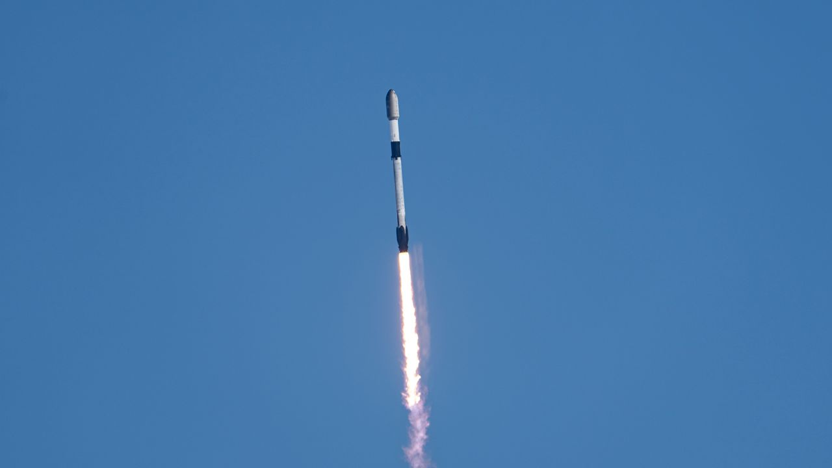
Click for next article SpaceX launched another batch of its Starlink broadband satellites to orbit today (Aug. 8) from California's scenic central coast. A Falcon 9 rocket lifted off from Vandenberg Space Force Base today at 12:35 p.m. EDT (1635 GMT; 9:35 a.m. local time), carrying 24 of the internet-beaming spacecraft to low Earth orbit (LEO). The rocket's first stage returned to Earth as planned about 8.5 minutes later, landing in the Pacific Ocean atop the SpaceX droneship "Of Course I Still Love You." It was the 16th flight for this particular booster, which is designated B1093. A SpaceX Falcon 9 rocket launches 24 Starlink internet satellites from California's Vandenberg Space Force Base on Aug. 8, 2026. (Image credit: SpaceX) B1093's most recent flight before today was on July 14 , when it launched 27 Starlink satellites to LEO from Vandenberg. Meanwhile, the Falcon 9's upper stage continued carrying the 24 Starlink satellites toward LEO today, deploying them about 61 minutes after liftoff as planned. Previous Booster B1093 launches SDA-T1TL-B | SDA-T1TL-C | Transporter-16 | 12 Starlink missions Today's launch was the 92nd Falcon 9 liftoff of 2026, and the 71st of the year devoted to building out the Starlink megaconstellation. Starlink, by far the largest orbiting network ever assembled, currently consists of more than 10,900 active satellites - and it's growing all the time.

7. On this day in space! Aug. 8, 1977: Soviet Union's Salyut 5 reconnaissance space station burns up in Earth's atmosphere
Read more
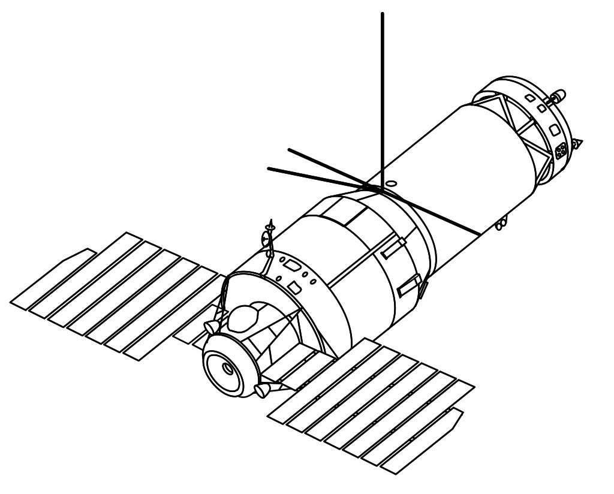
Click for next article On Aug. 8, 1977, the Salyut 5 space station fell out of space and burned up in Earth's atmosphere. Salyut 5 was a Soviet space station and part of the highly-secretive Almaz military space station program . It launched in 1976 and housed two crew of cosmonauts as they conducted military experiments and other scientific research in orbit. Originally, four crewed missions were supposed to go to Salyut 5. However, the third crew was unable to dock their spacecraft and had to return home. The fourth mission had to be canceled because Salyut 5 was starting to run low on propellant for its main engines and attitude control system. Salyut 5 couldn't be refuelled, so it was deorbited and left to burn up in Earth's atmosphere . A diagram of a Soviet Almaz military space station, such as Salyut 3 and Salyut 5. Salyut 5 was the last of the secretive space station series. (Image credit: NASA) Why it mattered When it comes to space stations, Salyut 5 was the last of its kind. While it was the Soviet Union's fifth Salyut station, Salyut 5 was actually the third and final space station dedicated primarily to Earth reconnaissance from space, and was part of the Almaz military space station program, the Soviet Union's counterpart to the U.S. Manned Orbiting Laboratory spy station . Salyut 5 launched in June 1976 and was expected to host at least four cosmonaut crews during its time in orbit, but only three missions were ultimately launched. The first mission, Soyuz 21, arrived at Salyut 5 a month after its launch, but returned to Earth early due to a noxious smell (possibly due to a fuel leak) on the station. A second mission, Soyuz 23, failed to dock at the station in October 1976 when their rendezvous system experienced a malfunction. After using too much propellant, they abandoned the docking attempt and returned to Earth, only to splash down in a frozen lake, making it the only Soyuz ever to land in water , according to RussianSpaceWeb.com . The third and final Salyut 5 crew , Salyut 24, visited the station in February 1977, venting its air to avoid any lingering contamination before spending about 18 days in space. After the cosmonauts' departure, a small reentry capsule carrying the film from their reconnaissance photography separated from Salyut 5 and returned to Earth, RussianSpaceWeb reported . By mid-1977, Salyut 5 was running low on propellant and couldn't be refueled. A fourth crewed mission was canceled and it was ultimately deorbited. Two more Salyut stations, Salyut 6 and 7, would eventually fly as science stations.

8. Don't miss the crescent moon shine close to the red light of Mars before dawn on Aug. 9
Read more
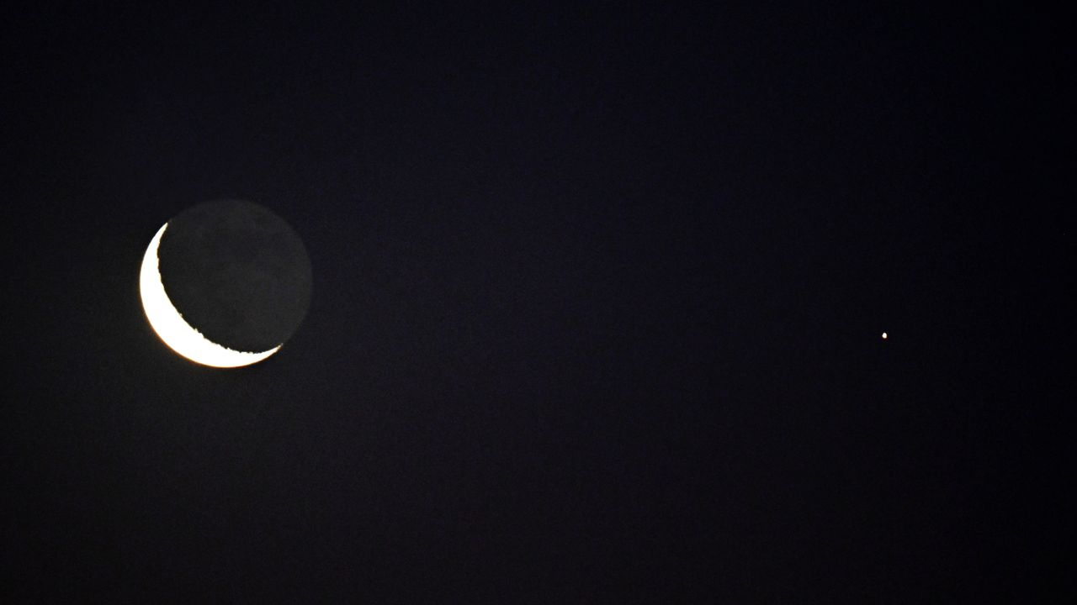
Click for next article Early risers will catch a spectacular sight in the predawn hours of Aug. 9, as the slender crescent moon shines close to the red light of Mars among the stars of the constellation Taurus. The 17%-lit crescent moon will rise around four hours before sunrise, or shortly after 2 a.m. for viewers in New York. The Red Planet will be visible as a steady crimson light less than 5 degrees to the lower right of the moon - close enough to share the field of view of a pair of 10x50 binoculars. Both Mars and the moon will appear to race one another over the eastern horizon in the hours that follow, with the Red Planet gaining a slight lead over its competitor as dawn breaks. The stars of the constellation Orion will glitter to the right of the pair throughout the race, while the Bull of Taurus watches on from above and Gemini watches from below, giving us a sneak peak at the starscape that will shine high overhead in the long winter nights a few months from now. Celestron UpClose G2 10x50 (Image credit: Celestron) Want to get a closer look at the moon? For around $50 you can grab these beginner binoculars for better views of craters and seas on the lunar surface. 10x is enough for a closer look without worrying about excessive shakes during handheld observation. _ Celestron UpClose G2 10x50 review Look out for the subtle glow of earthshine illuminating the night side of the moon on Aug. 9, as sunlight scattered off our planet's surface and atmosphere reflects onto the nearby lunar disk, revealing the ghostly outlines of its dark lunar seas. It's one of the last chances we'll get to gaze at Earth's satellite ahead of its new moon phase on Aug. 12, when it will cross the face of the sun in the daytime sky to trigger a spectacular total solar eclipse , which will be visible across parts of Greenland, Iceland and Spain. Be sure to read our explainer article to discover everything you need to know about the Aug. 12 total solar eclipse . We'll also be bringing you live reports of totality as the moon's shadow sweeps over Greenland, where skywatching editor Daisy Dobrijevic will be watching from the deck of a HX Expeditions cruise ship. Skywatching writer Anthony Wood will also be observing from central Spain, where he's embedded with a group of citizen scientists from the Dynamic Eclipse Broadcast initiative . Editor's Note: If you would like to share your astrophotography with Space.com's readers, then please send your photo(s), comments, and your name and location to spacephotos@space.com.

9. SpaceX West Coast launch surge continues with Starlink mission
Read more
Update Aug. 8, 2:31 p.m. EDT (1831 UTC): SpaceX confirms deployment of the 24 satellites. SpaceX's West Coast surge in Starlink launches continued Saturday with another batch of satellites for its internet service set to go into orbit atop a Falcon 9 rocket. Liftoff of the Starlink 17-38 mission from Vandenberg Space Force Base in California happened at 9:35 a.m. PDT (12:35 p.m. EDT / 1635 UTC). It was SpaceX's 50th launch from the West Coast this year as it ramps up launches there while the flight rate from the East Coast has fallen as the company focuses on ramping up Starship preparations. SpaceX assigned first stage booster B1093 to this mission. It joined the Falcon 9 fleet in April 2025 and has flown 15 previous missions: SDA-T1TL-B and SDA-T1TL-C for the Space Development Agency, the Transporter-16 rideshare mission and 12 Starlink deliveries. The booster took a south-south-westerly trajectory after departing Space Launch Complex 4E. It landed on the drone ship 'Of Course I Still Love you' in Pacific Ocean about eight minutes, 19 seconds after liftoff. The 24 Starlink satellites stacked atop the second stage of the Falcon 9 were deployed just over an hour into flight. It was the 71st operational Starlink delivery mission of the year.

10. China's missiles that can damage aircraft carriers could pose threat to US in Taiwan conflict
Read more
China is expanding and diversifying its anti-ship missile arsenal, strengthening its ability to keep US and allied naval forces at a distance in the western Pacific, analysts say. The growing range of launch platforms and the introduction of hypersonic weapons could complicate US and allied operations in a potential conflict over Taiwan. The latest demonstration came last week, when Chinese state broadcaster CCTV released footage showing a Type 052D destroyer launching a YJ-20 hypersonic anti-ship missile from its vertical launch system. The weapon is among the first sea-based hypersonic anti-ship missiles to enter mass production in China. The development is part of a broader military modernization effort focused on anti-access/area denial, or A2/AD, capabilities designed to make it harder for adversaries to operate close to China's coast and throughout the first island chain. Growing network of anti-ship weapons The first island chain stretches from Japan through Taiwan and toward the Philippines and Borneo, forming a key geographic barrier across the western Pacific. China has increasingly focused on deploying anti-ship missiles from multiple platforms, including surface ships and submarines. Analysts say this creates a layered defensive network capable of attacking naval forces from different directions and at varying distances. James Holmes, professor of strategy at the US Naval War College, said China's objective is to keep US forces at a distance while allowing the People's Liberation Army to concentrate its forces on a conflict closer to China's territory, the South China Morning Post reported. If US forces based farther away cannot quickly combine with the Seventh Fleet and other forward-deployed units, Holmes argued, China could potentially concentrate a larger share of its military power against a smaller portion of the opposing force. Liselotte Odgaard, a senior fellow at the Hudson Institute, said deploying anti-ship missiles on both surface vessels and submarines gives China multiple attack vectors and makes its maritime strike capabilities more resilient. Hypersonic weapons add another challenge The YJ-20 is not the only hypersonic anti-ship missile China has introduced - during a military parade in Beijing last September, China also unveiled the YJ-19, a weapon powered by an air-breathing scramjet engine that can reportedly travel at speeds above Mach 5. The missile can be launched from submarine torpedo tubes. In February, the Chinese navy announced that the YJ-19 had entered service aboard its Type 039B diesel-electric submarine. That would make the submarine the only non-nuclear submarine currently known to carry such a weapon, according to the report. Collin Koh, a senior fellow at the Institute of Defence and Strategic Studies at Singapore's S. Rajaratnam School of International Studies, said China has made significant progress in developing different platforms capable of launching anti-ship missiles. Unlike conventional ballistic trajectories, hypersonic weapons can maneuver during flight, potentially complicating efforts to predict their path and engage them before they reach a target. Aircraft carriers are particularly important in this context because they serve as mobile platforms for air power and are central to US naval operations. The growing Chinese arsenal could therefore force US and allied navies to devote greater resources to defending major surface ships, potentially changing how they deploy during a Taiwan contingency.

11. Lockheed Martin's new defense vision connects satellites, F-35s and missiles
Read more
Dominance in future wars will likely depend more on data sharing than on capable weapons, Lockheed Martin has declared in a press release. In its view, the exchange of information should be quick so that commanders can understand and respond to an attack before the enemy gains the advantage. This concept is called a "sensor-to-shooter" network, and Lockheed Martin is working to make it a reality. Such a network effectively sees many different platforms from space to the sea acting as nodes in an enormous chain. According to Lockheed Martin, one of the most important "nodes" will be overhead persistent infrared (OPIR) satellites. Such satellites will act as continuous watchdogs, monitoring large areas for signs of missile engine activity. In the network, they could provide early warnings about potential threats. The Space Force describes OPIR as providing missile warning plus "tipping and cueing" to missile-defence forces. Other sensors like radar, ships, and aircraft (like the F-35) would also be used to contribute data to the network. For example, an F-35's infrared and radar sensors might see the missile from another angle and help establish its location, trajectory, and probable target. The need for speed At the center of the network, a sort of "nervous system" called the Command and Control, Battle Management and Communications (C2BMC), would combine, analyze, and distribute information where needed. In the case of a missile launch, the system would help humans determine what was launched, where from, and where it is likely headed. It would also help commanders determine which "node" in the chain is best set to engage it, and what should be used to neutralize the threat. This could range from Terminal High Altitude Area Defense (THAAD) for short- to intermediate-range ballistic missiles to the in-development Next Generation Interceptor (NGI) for things like intercontinental ballistic missiles (ICBMs). Above all, Lockheed Martin stresses, speed of decision-making will be make-or-break. Ballistic missiles are problematic enough, but the rise of hypersonic missiles will leave commanders potentially just minutes to make a decision. If every system is isolated, people must manually pass information between separate networks. That wastes time and can produce contradictory tracks. Lockheed's pitch is that an integrated architecture automates much of that movement and gives everyone the same information sooner. "Speed-to-decision" therefore doesn't primarily mean faster missiles. It means reducing the delay between seeing something and taking the correct action. Lockheed Martin taking on more than it can chew? But to work effectively, every link in the chain needs to exchange usable data without unnecessary delays. For a system developed by Lockheed Martin, this should be simpler, but for third-party weapons systems, this could prove trickier. Add in the fact that different nodes could be in different services (Army, Navy, Air Force, Space Force) and different countries, and the problem becomes much clearer. Different systems tend to have different formats and security needs, especially if trying to network decades-old legacy hardware with cutting-edge systems. And that is before issues around rules of engagement and electronic warfare interference (e.g., jamming) are taken into account. Consequently, the real engineering challenge is not just connecting cables; it is ensuring that the information is fast, accurate, secure, and sufficiently trustworthy to support firing a weapon. Not a simple problem to overcome, but Lockheed Martin is confident it is up to the challenge of solving it.

