 |  | 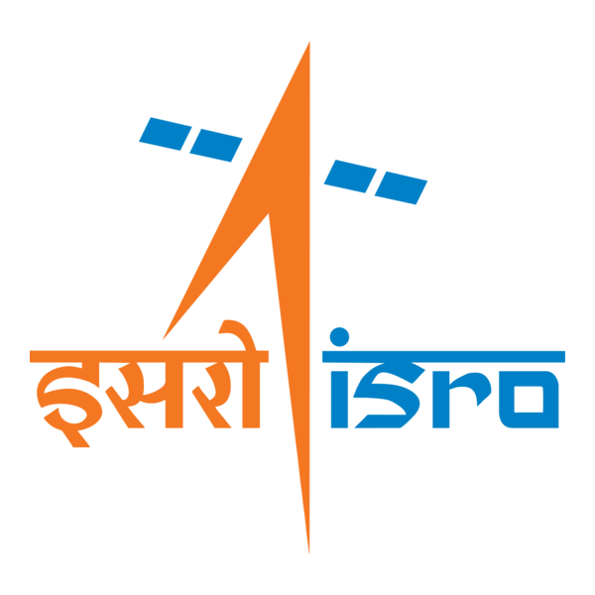

🌌 अंतरिक्ष समाचार | Space News
बुधवार, १६/०९/२०२६ | Wednesday, 16/09/2026

1. IN-SPACe's Growing Role Raises ISRO Concerns - Rediff
Read more
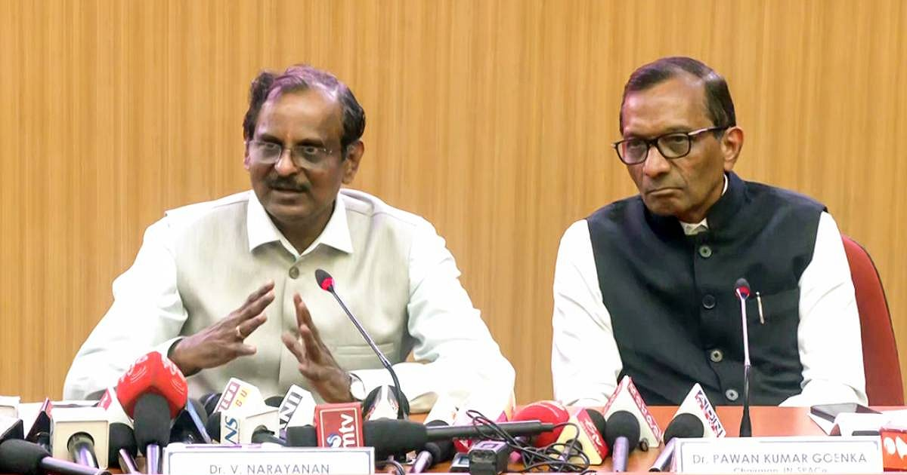
'IN-SPACe like an octopus is stretching its tentacles everywhere and choking ISRO.' IMAGE: ISRO Chairman Dr V Narayanan, left, addresses a press conference. On the right: IN-SPACe Chairman Dr Pawan Goenka. Photograph: ANI Photo/Video Grab Key Points ISRO scientists are baffled by IN-SPACe officials reportedly sitting on their promotion interview panels, a move described as unprecedented. Former ISRO chairman G Madhavan Nair stated that IN-SPACe Chairman Dr Pawan Kumar Goenka was part of an interview panel for senior scientists' promotions. IN-SPACe Chairman Goenka reportedly interviewed a candidate for the chairman and managing director post of NewSpace India Ltd (NSIL), ISRO's commercial arm. Concerns are raised about IN-SPACe's expanding role, as its mandate is primarily to promote and authorise private-sector space activities, not interfere with ISRO's internal affairs. Indian Space Research Organisation scientists -- current and retired -- are baffled, and for good reason. Not because of the entry of private players and the competition, but because IN-SPACe officials are reportedly sitting on interview panels for the promotion of ISRO scientists and publicly announcing what ISRO would and would not do. "It is unprecedented in the Indian space sector history. The interview panels for senior scientists are always chaired by the ISRO chairman. But a few months back IN-SPACe Chairman (Dr Pawan Kumar Goenka) was part of the interview panel," G Madhavan Nair, former chairman, ISRO, told this correspondent. According to Nair, IN-SPACe officials were on the interview panels for the promotion of scientists to the 'SG' cadre -- those who have put in 15 or more years of service. "IN-SPACe like an octopus is stretching its tentacles everywhere and choking ISRO," Nair charged. "IN-SPACe is purely a parallel vertical to promote and authorise space activities of the private sector. It has no role to interfere with ISRO's activities." "Officials of IN-SPACe are there in ISRO employees promotion committees. How can IN-SPACe decide on the promotion of ISRO employees? How this has happened is not clear," fumed another retired ISRO chairman, not wanting to be quoted. Speaking to this correspondent on the condition of anonymity, a leader of an employee association said IN-SPACe officials sitting on promotion interview panels had started this year. "Whether their presence is official or unofficial is not known," he said. External Experts Vs IN-SPACe Involvement Having external domain experts on its interview panels is not new for ISRO. The space agency also maintains a database of such experts. The issue, therefore, is not whether an outsider can sit on an ISRO promotion panel, but whether an official of IN-SPACe -- whose mandate is centred on promoting, enabling and authorising private-sector space activities -- should be involved in evaluating the career progression of ISRO scientists. If the presence of IN-SPACe officials is official, the question is who authorised it and under what rules. If it is unofficial, the question is how an IN-SPACe official became part of the promotion process in the first place, Nair and others wonder. That distinction assumes significance as IN-SPACe's role in the wider Department of Space ecosystem appears to be expanding. IN-SPACe's Expanding Mandate According to a news report, IN-SPACe Chairman Goenka interviewed a shortlisted candidate for the post of chairman and managing director of NewSpace India Ltd (NSIL), the Department of Space's commercial arm mandated to commercialise ISRO's rocket technologies. And the search for another candidate to head NSIL has restarted. The reported involvement in the selection of the head of NSIL, coupled with the reported presence of IN-SPACe officials in ISRO promotion panels, raises a larger question about the expanding role of the organisation within the Department of Space. IN-SPACe was set up as a single-window nodal agency, with its own cadre, to promote, enable and authorise space activities of non-government private entities (NGPEs). Even where regulators have a role in senior appointments, that role is defined by the regulatory framework. IN-SPACe has not been formally designated as the regulator for the Indian space sector. The question here is whether its mandate provides any institutional basis for its officials to participate in ISRO's internal promotion process. IN-SPACe Chairman Dr Goenka didn't respond to queries from this correspondent on the issues raised by the two former ISRO chairmen and the leader of an employee association. ISRO Chairman Dr Narayanan too did not respond to the questions sent by this correspondent. For ISRO scientists, the immediate question is more specific: Who decides their professional future, under what authority, and why should an organisation created to promote and authorise privatesector space activity have a role in that decision? Venkatachari Jagannathan can be reached at venkatacharijagannathan@gmail.com Feature Presentation: Rajesh Alva/Rediff

2. ISRO recruitment 2026: Applications open for 22 posts, check eligibility and selection process - India Today
Read more
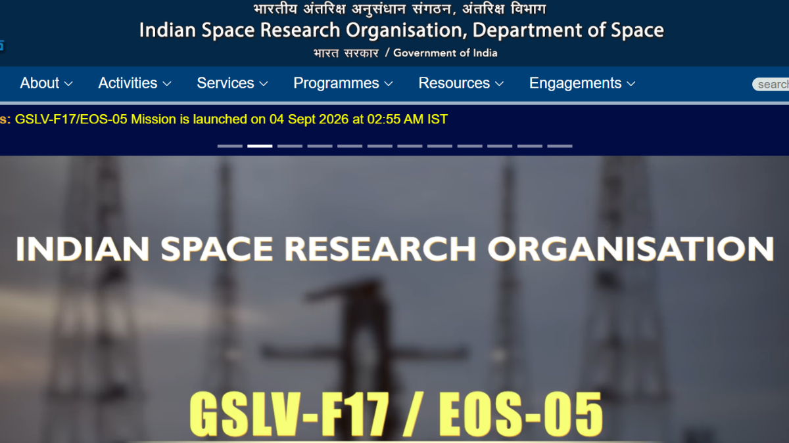
The recruitment drive aims to fill 22 vacancies across these posts. Image: Website photo The Indian Space Research Organisation (ISRO) has started the application process for recruitment to Technical Assistant, Technician, Cook and Fireman posts. Eligible candidates can apply online through the official ISRO website, isro.gov.in. The recruitment drive aims to fill 22 vacancies across these posts. Candidates should check the official notification for details on educational qualifications and age limits before submitting their applications. ISRO recruitment 2026: Vacancy details ISRO recruitment 2026: Eligibility criteria Candidates must meet the prescribed educational qualification and age requirements for the post they wish to apply for. ISRO has provided the detailed eligibility conditions in the recruitment notification. Applicants should read the notification carefully and check whether they meet the requirements before completing the application process. ISRO recruitment 2026: Selection process The selection process will include a written examination followed by a skill test for the posts. Candidates applying for the Fireman post will also have to clear a medical examination after the written and skill tests. ISRO will conduct the written examination offline using the Optical Mark Recognition (OMR) method. The examination centres will be located in Tirunelveli and Chennai. Candidates will have to choose their preferred examination city while filling in the online application form. The skill test will follow a 'GO/NO-GO' format and will assess whether candidates have the required skills for the post. Among candidates who qualify in the skill test, ISRO will consider marks obtained in the written examination for final selection. ISRO Fireman selection process Candidates shortlisted for the Fireman post will have to take the Physical Efficiency Test (PET). The PET will take place in two stages. Candidates who clear Stage 1 can appear for Stage 2. Those who qualify in both stages will then undergo a Detailed Medical Examination. ISRO recruitment 2026: Application fee The application fee is Rs 750. Candidates must pay the fee online through the State Bank of India (SBI) e-Payment gateway after submitting their application. Applicants can use internet banking, domestic debit cards, domestic credit cards or UPI to make the payment. Candidates should complete the application process carefully and refer to the official ISRO website for the recruitment notification and further updates.

3. Artemis: Isro-led talks spur wider push to open up moon science data - The Times of India
Read more

Artemis: Isro-led talks spur wider push to open up moon science data The Times of India

4. ISRO Recruitment 2026: Apply For 22 Technical Assistant, Technician And Other Posts - NDTV
Read more
ISRO Recruitment 2026: Apply For 22 Technical Assistant, Technician And Other Posts NDTV

5. ISRO Admit Card 2026 Out For UDC, PA and Stenographer, Hall Ticket Download Link - Adda247
Read more
ISRO Admit Card 2026 Out For UDC, PA and Stenographer, Hall Ticket Download Link Adda247

6. NASA Ames Stars of the Month: September 2026
Read more

The NASA Ames Science Directorate recognizes the outstanding contributions of (pictured left to right) Steve Ormsby, Aphrodite Kostakis, Alejando Borlaff, Sarah Nickerson, Martina Caussi, Keiko Nomura, and Stephen Broccardo. Their commitment to the NASA mission represents the entrepreneurial spirit, technical expertise, and collaborative disposition needed to explore this world and beyond. Space Biosciences Star: Steve Ormsby Steve Ormsby is a project engineer for the Space Biosciences Division with Amentum in the Center Operations Directorate. He is recognized for his perseverance, dedication and initiative in overseeing the safety of division facilities and infrastructure maintenance, as well as exceptional diligence as a property custodian. Space Biosciences Star: Aphrodite Kostakis Aphrodite Kostakis is the Facility Service Manager with Amentum for building N239 in the Space Biosciences Division. She is acknowledged for her exemplary work ethic in maintaining building safety, preparing for and leading VPP inspections with diligence and attention, and suggesting infrastructure improvements and ensuring they get implemented for everyone's benefit. Astrophysics Star: Alejandro Borlaff Alejandro (Alex) Borlaff, a research scientist in the Astrophysics Division with the Bay Area Environmental Research Institute, is recognized for his leadership in pioneering and developing image reduction pipelines for the Hubble Space Telescope (HST) and the Roman Space Telescope's Wide Field Instrument (WFI). These algorithms significantly advance the detection of ultra-low surface brightness features through rigorous modeling of background contamination, including scattered and zodiacal light, better maximizing the science derived from NASA flagship astrophysics missions. Astrophysics Star: Sarah Nickerson Sarah Nickerson, a research scientist in the Astrophysics Division with the Bay Area Environmental Research Institute, is recognized for exceptional work on the analysis and curation of data taken from the EXES instrument on NASA's Stratospheric Observatory for Infrared Astronomy (SOFIA) observatory. This provides high-level data products to the global astrophysics community for continued discovery and synergy with other NASA missions. Planetary Science and Exobiology Star: Martina Caussi Martina Caussi is a NASA Postdoctoral Program Fellow in the Planetary Science and Exobiology Division. Martina is recognized for her outstanding work using finite element simulations to determine that topographic relaxation has played a significant role in shaping Tegid, an unusually shaped impact crater on Europa. This work represents valuable precursory science in anticipation of the Europa Clipper mission, which will refine our understanding of this ocean world. Earth Science Star: Keiko Nomura Keiko Nomura is a research scientist for the NASA Earth Exchange (NEX) in the Earth Science Division with the Bay Area Environmental Research Institute. She is acknowledged for timely efforts in leadership, stakeholder engagement, coordination with NASA HQ management, and team building for the recently funded NEX-GeoAI project. This project is now being recognized as a key step forward to establishing NASA as the ground-truthing agency for federal and private sector GeoAI modeling activities for decision making. Earth Science Star: Stephen Broccardo Stephen Broccardo is a research scientist in the Earth Science Division with the Bay Area Environmental Research Institute. He is recognized for exceptional initiative and technical leadership in sustaining and advancing Ames' atmospheric remote-sensing capabilities. Stephen has maintained critical observational capabilities and developed thoughtful technical milestones for future satellite-validation and science activities.

7. NASA Invites Media to International Observe the Moon Night
Read more
NASA will host an International Observe the Moon Night celebration from 5:30 to 8 p.m. CST on Saturday, Sept. 19, at the U.S. Space & Rocket Center, the official visitor center for NASA's Marshall Space Flight Center in Huntsville, Alabama. International Observe the Moon Night celebrates the Moon, the science behind it, and its connection to space exploration and human culture. NASA's free public event will include agency experts delivering talks on lunar science and exploration and highlighting lunar observations made by the Artemis II crew in April. Media interested in covering the event should confirm their attendance with Joel Wallace, joel.w.wallace@nasa.gov, in the NASA Marshall newsroom by 3 p.m., Friday, Sept. 18. Media must report to the Davidson Center to participate in the event. Visitor parking is available at the U.S. Space & Rocket Center. NASA will have opportunities for media to capture visuals and interview agency experts. Activities available for coverage include hands-on STEM activities, a science stage show, an event photo booth, and face-painting. The event also features Janet Ivey, the host of the television children's series, "Janet's Planet." The Von Braun Astronomical Society will be on-site with telescopes, providing attendees with guided tours of the Moon, planets, and other celestial objects. The evening is presented by the Planetary Missions Program Office at NASA Marshall. For more information about International Observe the Moon Night, visit: https://science.nasa.gov/moon/observe-the-moon-night/overview Joel Wallace Marshall Space Flight Center, Huntsville, Ala 256-786-0117 joel.w.wallace@nasa.gov

8. Artemis III Crew Visits NASA Kennedy's Vehicle Assembly Building
Read more
NASA/Kim Shiflett NASA astronaut Randy Bresnik (left) and ESA (European Space Agency) astronaut Luca Parmitano view progress on the solid rocket booster integration in High Bay 3 inside the Vehicle Assembly Building at NASA's Kennedy Space Center in Florida on Wednesday, Sept. 2, 2026. Bresnik, Parmitano, and NASA astronauts Andre Douglas, Frank Rubio, and Bob Hines made the first visit to Kennedy by the entire crew and backup crew members of the Artemis III mission. Artemis III will launch four crew members aboard the Orion spacecraft to carry out a series of objectives in low Earth orbit designed to demonstrate critical systems needed for future lunar landings, beginning with Artemis IV. Image credit: NASA/Kim Shiflett

9. 22 years of science! NASA's Roman Space Telescope doubles its lifetime with super-precise engine burn
Read more
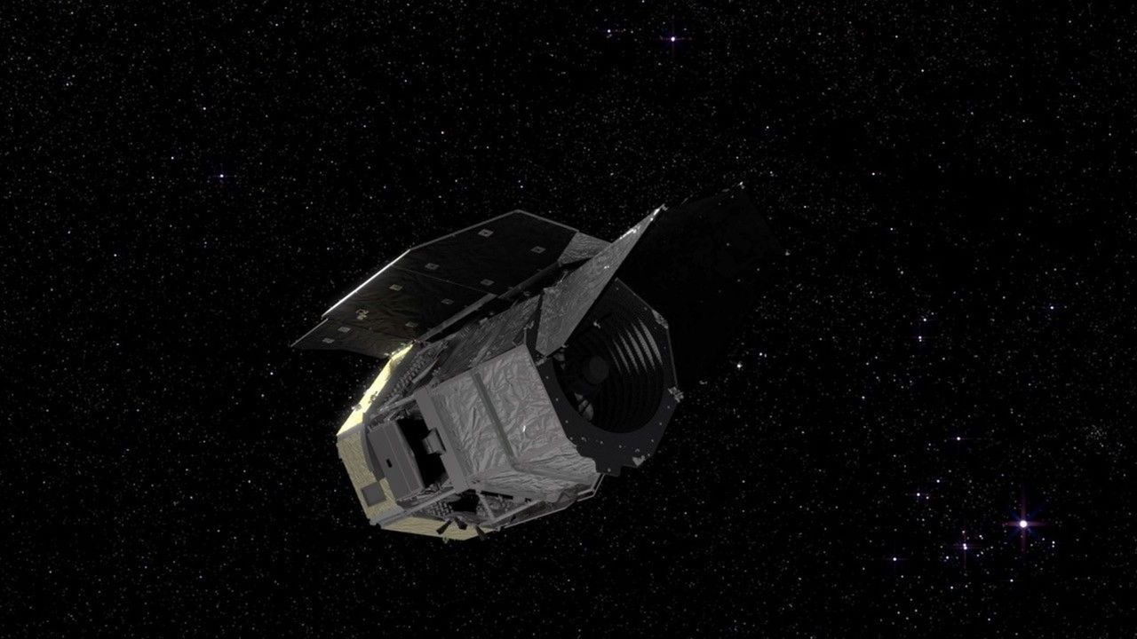
Click for next article NASA's newly launched Nancy Grace Roman Space Telescope is set to extend its lifespan and double its exciting potential for discovery thanks to an efficient use of fuel on its way to its final orbit. "As a result of exquisite planning by our orbital dynamics team, brilliant execution by the operations team, and a precise launch from SpaceX, Roman has fuel for at least 22 years of potential science operations," said Jamie Dunn, the center director at NASA's Goddard Space Flight Center, in a statement . The space telescope, which launched from Cape Canaveral on Aug. 30 on a mission to measure dark energy and search for exoplanets , is headed to the L2 Lagrange point . There, it will join the likes of the James Webb Space Telescope on the opposite side of Earth to the sun . Its primary mission will last five years, and scientists were hoping for an additional five years if funding allowed.. Now, however, that potential extended mission could go on for a lot longer - and it's all thanks to the spacecraft coming in less massive than the original design had projected. The Lagrange points depicted in a diagram. (Image credit: NASA Goddard Space Flight Center Scientific Visualization Studio) At the beginning of Roman's design process, the fuel capacity was chosen to permit a maximum mass of 21,605 pounds (9,800 kilograms), yet the finished spacecraft came in lighter at 17,760 pounds (8,065 kilograms). And because it was lighter, there was a surplus of available mass that could be used for more fuel. "A spacecraft's mass changes throughout the design and build process, so we base the propellant on a set maximum value so we won't come up short," Alison Rao, who leads Roman's propulsion systems at NASA Goddard, said in the statement. "We track the propellant needed based on actual mass throughout integration and testing as well, to make sure we have wiggle room. Since Roman's [mass] was lower than we budgeted for, we were able to fill the propellant tanks to their capacity rather than only filling them as much as we needed to for the 10-year requirement." The extra fuel loaded onto the telescope before launch meant it had enough for at least a 14-year mission. Then, within a day of launching, the space telescope had to fire its engine for three minutes to push it onto a trajectory to take it to L2. This engine burn was more precise and hence more efficient than anyone could have hoped for, sending Roman on its way to L2 with 99% accuracy. In doing so, it used only 40 pounds (18 kilograms) of fuel, which is less than 10% of the 441 pounds (200 kilograms) of fuel that had been budgeted for the maneuver. This is thought to have bought Roman an additional four years of life, bringing the tally to 18 years. Then there's the added bonus. The precision with which the Aug. 31 engine burn was conducted means that the second course correction, required to take Roman into its orbit at L2 in early December, will also now require much less fuel. This will add yet another four years to Roman's operational lifetime, so long as nothing goes wrong with the telescope. Once in orbit at L2, only minor burns once every 28 days are needed for station keeping - a negligible amount of fuel. In total, this observatory could be probing the final frontier and making incredible discoveries for at least the next 22 years, taking it up to 2048 at minimum. For the next two or three decades, we're going to be hearing a lot about the Nancy Grace Roman Space Telescope.

10. SpaceX launching 2nd classified mission for US Space Force in less than a week tonight: Watch it live
Read more
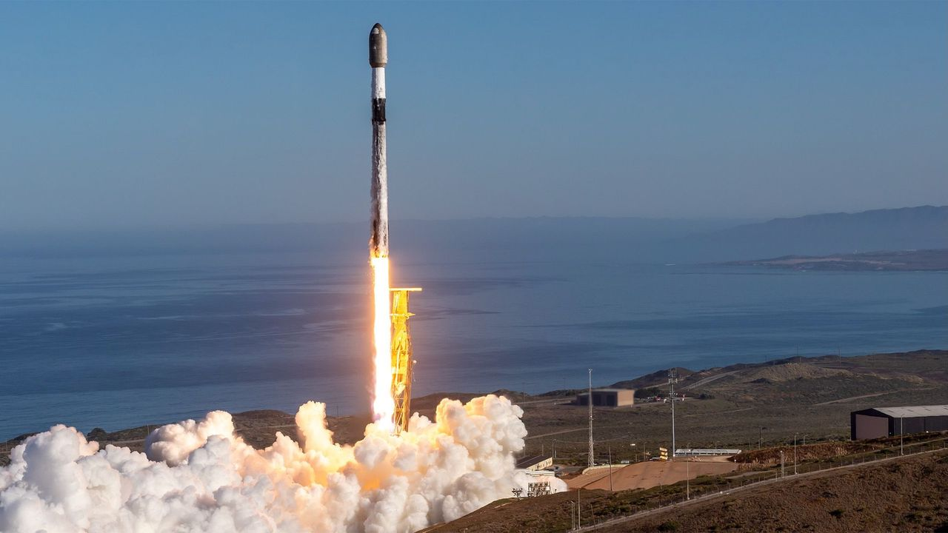
Click for next article A SpaceX Falcon 9 rocket launches the classified USSF-153 mission for the U.S. Space Force from California on Sept. 10, 2026. SpaceX will launch its second classified mission for the U.S. Space Force in less than a week tonight (Sept. 16), and you can watch the action live. A Falcon 9 rocket is scheduled to lift off from California's Vandenberg Space Force Base today, during a four-hour window that opens at 9 p.m. EDT (6 p.m. local California time; 0100 GMT on Sept. 17). You can watch it live via SpaceX beginning about 10 minutes before launch. We don't know much about tonight's mission, which is called USSF-259. And we're unlikely to learn much from the webcast, which is expected to end shortly after the Falcon 9's first stage returns to Earth for its drone-ship landing about 8.5 minutes after launch. That touchdown will be the 13th for this particular booster, which is designated 1097. One of the booster's recent landings was a big milestone for SpaceX . This past April, B1097 pulled off SpaceX's 600th touchdown of an orbital-class rocket , during a launch that sent 25 of the company's Starlink internet satellites to low Earth orbit . Tonight's mission will be the second that SpaceX flies for the U.S. Space Force in a five-day span: A Falcon 9 launched the similarly classified USSF-153 from Vandenberg on Sept. 10 . Previous Booster 1097 missions Sentinel-6B | Twilight | NROL-172 | Transporter-17 | 8 Starlink missions Tonight's launch will be SpaceX's 110th of 2026. The vast majority of the company's flights so far this year - 105 of them, in fact - have been performed by the workhorse Falcon 9. The powerful Falcon Heavy has launched twice in 2026, as has SpaceX's next-gen megarocket, Starship . Both Starship liftoffs this year have been suborbital test flights. The next Starship launch, which is expected to occur in the next two weeks, will apparently take the vehicle orbital for the first time. Editor's note: This story was updated at 11:50 p.m. ET on Sept. 15 with the new launch date of Sept. 16.

11. 'If I wanted to go to space, I would have stayed at NASA': What's next for Artemis II astronaut Victor Glover after his mission to the moon
Read more
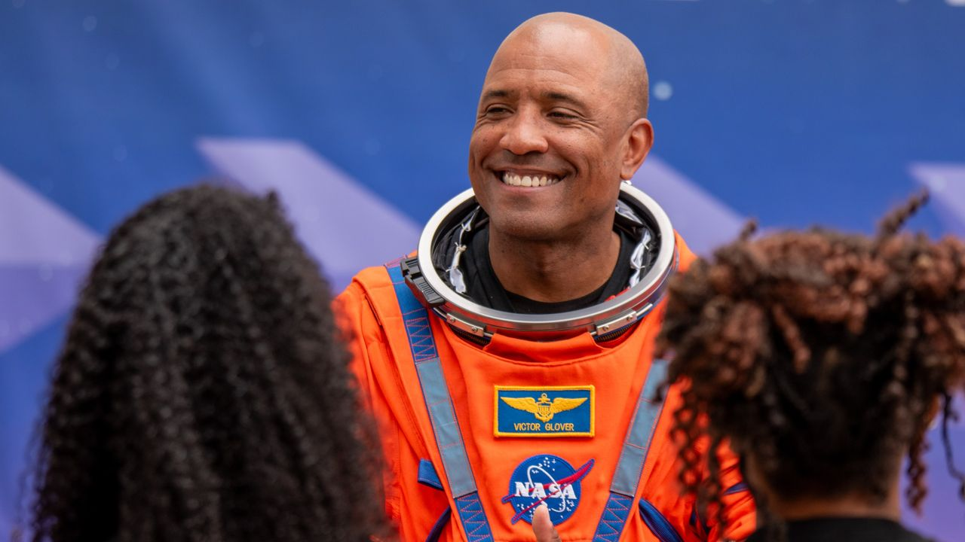
Click for next article NASA astronaut Victor Glover is now "astronaut emeritus." He's hanging up his spacesuit for a position he hopes can guide the future engineering and science leaders of tomorrow. Glover, who served as pilot on NASA's Artemis II mission that flew around the moon in April, officially began his new role as executive advisor to Jeff Armstrong, president of the California Polytechnic State University (Cal Poly),on Sept. 1, and is stepping away from the majority of his duties at the space agency. NASA announced on Sept. 9 that Glover, as well as Artemis II commander Reid Wiseman , are transitioning to emeritus status beginning this month, but are not retiring from the agency outright. Even astronauts who do fully retire from NASA are still retained "in the system," Glover told Space.com, "but I actually get to have a badge that is a little bit different. I can come back. I have a NASA email address. I still work closely with the agency. I'm considered a special government employee." "It allows me to have just a slightly more robust and meaningful relationship with NASA," Glover said - but "more robust" won't necessarily equate to the same daily commitment. His role at Cal Poly will be full-time, according to the university , but he's not exactly going to be putting in typical work hours there either. "We're still figuring it out," he said. "It's not going to be nine to five. I'm not a faculty member. I don't have a class I have to teach or a board that I oversee. It'll be where the school needs me the most and where I can highlight what great work they're already doing." Glover's connection to Cal Poly runs deep. He's a Cal Poly alum who graduated with an engineering degree in 1999. A two-sport athlete, he wrestled for the university and played on its football team. And it's where he met his wife, Dionna, who also graduated from Cal Poly. The two have since raised four daughters, all of whom have either graduated or are currently attending their parents' alma mater. With Glover's multifaceted connection to the university, Cal Poly sees his potential contributions as equally diverse. The university says that Glover, in his position as executive advisor, will work with the gamut of university leadership, including the president, provost and college deans. He will help "identify, develop and accelerate strategic initiatives, partnerships and philanthropy aimed at expanding the university's leadership in engineering, applied computing, aerospace, aviation, maritime, artificial intelligence, cybersecurity, autonomous systems and national defense," according to Cal Poly's statement. Victor Glover officially began his role at Cal Poly on Sept. 1. (Image credit: Cal Poly) How that will manifest into Glover's actual contributions is still being figured out. "There's just so much potential," he said, adding that he wants to serve in an additive role for Cal Poly where he can "get in and help, and do the most good." Cal Poly has been undergoing a period of significant change and expansion over the past several years. This fall, for the first time ever, the university transitioned from a quarter system to a semester-based one. It also recently completed its integration with the former California State University Maritime Academy, whose Vallejo campus is now Cal Poly's Solano Campus and home to the Cal Poly Maritime Academy. "They're hitting on all cylinders in so many areas," Glover said. "There's so many areas where Cal Poly is doing amazing things, and each of those things by themselves have been a big deal." The university operates on a "Learn by Doing" philosophy, which emphasizes hands-on, real-world experience alongside classroom instruction. Glover credits his professional successes to this system, and his experiences over a decade at NASA have reinforced his belief in that kind of educational approach. "Putting energy and time into building trust is just as important, or more important, as building technology, and so I think there's a lot of areas where my NASA experience will also feed back into Learn by Doing," Glover said. "I think everything I did at NASA has a place here." "At NASA we do some pretty challenging things, pretty risky things, but we have a really strong scientific and technical understanding of what we're doing," Glover said. "That kind of risk-informed decision making is an important part of what we do here [at Cal Poly], whether it's professional development or helping these students to become the next generation of leaders." Glover cited Charles Lindbergh 's book "We," and its perspective on learning to fly a plane, as an example for Learn by Doing's effectiveness. "You teach yourself to fly," Glover said. "An instructor is really there to keep you from having ultimate mistakes. But you teach yourself to fly. It's something that you have to work out yourself. And I think that this school really understands that … We want to make sure that these students can critically think and analyze, but we also want to make sure that they can do the work with their hands." Flying is something with which Glover has an extensive familiarity. Before he joined NASA in 2013, he was a U.S. Navy aviator and test pilot with 4,000 flight hours in more than 40 aircraft who flew 24 combat missions, though he is now best known for piloting NASA's Orion spacecraft around the moon on Artemis II. Victor Glover lands a T-38 jet at NASA's Kennedy Space Center in Florida on March 27, 2026, ahead of the launch of the Artemis II mission. (Image credit: Space.com / Josh Dinner) Glover launched aboard Orion on NASA's Space Launch System (SLS) rocket on April 1 with three crewmates - Wiseman, NASA astronaut Christina Koch and Canadian Space Agency astronaut Jeremy Hansen . The quartet spent approximately 10 days aboard the Orion capsule and flew a course around the moon's far side. Their mission was the first to fly a crew to lunar space since Apollo 17 in 1972, and it captured the attention of millions across the world as the astronauts sent back views of the moon unlike any humanity had ever seen. Artemis II was the first crewed mission in NASA's Artemis program , which has the ultimate goal of establishing a permanent base on the lunar surface. The next time Orion launches, on Artemis III, the spacecraft's crew will be tasked with testing out docking hardware with the program's lunar lander vehicles in Earth orbit. NASA is targeting mid-2027 for that mission. If it's successful, Artemis IV will follow in 2028 as the program's first lunar landing attempt, with subsequent missions with more crew and cargo to incrementally assemble an outpost on the surface of the moon in the 2030s. Victor Glover arrives at NASA's Kennedy Space Center in Florida on March 27, 2026, ahead of the launch of the Artemis II mission. (Image credit: Space.com / Josh Dinner) As the only people to fly aboard Orion in space so far, the Artemis II crew's experience and insight into the spacecraft, and how future Artremis astronauts can best train to fly it, are invaluable to NASA - hence Glover and Wiseman's emeritus status. Hansen, who trained at NASA's Johnson Space Center (JSC) and lived in Houston since his induction as a CSA astronaut in 2009, announced in July that he's stepping back from active astronaut duty beginning this month and moving back to Canada. On Sept. 8, the day before NASA made the announcement about Glover and Wiseman, Hansen posted a video on X stating that his Artemis II duties officially concluded on Sept. 2. The mission continues! pic.twitter.com/2R6Dwb63bSSeptember 8, 2026 That leaves Koch as the only Artemis II crew member on an active astronaut roster, but Glover and Wiseman, as emeritus flyers, aren't out of the agency entirely. "With our experience flying Orion in space, the agency knows that we can still make a meaningful contribution to Artemis and human spaceflight in general, without having to be there full time," Glover said. "We can still support our colleagues and their families and the mission while we go off and pursue other other opportunities." Supporting other astronauts on NASA's roster, and the teams that run the missions, are the parts of the job that Glover enjoyed the most. "[The emeritus status] allows us to still support our colleagues, which is the best part of being an astronaut. It's not flying in space," Glover said. "I told [NASA leadership], 'Nothing has really changed,'" Glover said. "If they call me and say, 'Hey, we need this,' they can count on me to be there because they are so fantastic. I will always be there to carry the water for them when they need it." From left: Canadian Space Agency astronaut Jeremy Hansen, and NASA astronauts Christina Koch, Victor Glover and Reid Wiseman at NASA's Kennedy Space Center during the Artemis II SLS rollout on Jan. 17, 2026. (Image credit: Space.com / Josh Dinner) Though he'll still be helping astronauts prepare for future missions every now and then, Glover said his own spaceflight days are behind him. Glover had flown to space once before, prior to Artemis II, as pilot of SpaceX 's Crew-1 mission to the International Space Station (ISS). Glover spent 168 days in orbit on that stint, serving as flight engineer for Expeditions 64 and 65, and completed four spacewalks . "I didn't make this move planning to go back to space," Glover said. "I was pretty satisfied after my first space mission, so I don't have this hole in my heart that needs to be filled by going to space again." A few NASA astronauts who've left and moved on to the private sector have ended up going back to space, like Peggy Whitson , who retired from NASA in 2018 before joining Axiom Space and later commanding the company's Ax-2 and Ax-4 private astronaut missions to the ISS. But Glover doesn't see a move like that in his future. Victor Glover stands at NASA's Kennedy Space Center during the rollout of the Artemis II Space Launch System rocket on Jan. 17, 2026. (Image credit: Space.com / Josh Dinner) "If I wanted to go to space, I would have stayed at NASA. It's the gold standard," Glover said. "I love our corporate partners and what they're doing. There's some really amazing things, including what Jared Isaacman himself has done … But I would have stayed at NASA full time as an active astronaut if I was trying to go back to space." Isaacman was sworn in as NASA administrator in December 2025. His spaceflight experience came before that: In September 2021, he commanded SpaceX's Inspiration4 mission, the first all-civilian orbital spaceflight, and later performed the first commercial spacewalk during the private Polaris Dawn mission in September 2024. In fact, Glover said it was harder walking away from his career flying fighter jets than it was to walk away from the opportunity to maybe one day fly in space again. Harder still might be leaving behind the place he's called home for more than a decade, but ultimately he said it was an easy choice. He's lived in Houston and worked at JSC since his selection into NASA's astronaut class in 2013, but expects he and his family will make the permanent move to the West Coast, to be closer to Cal Poly. "One of the reasons why this was just such an easy decision to make is that both NASA and Cal Poly … and everybody understands that we need time to get used to this new reality, and they're all giving us a lot of grace and space as we just kind of figure out what the right rhythm, what the right ops tempo is," Glover said. He thinks he and the family will make the move sometime after the New Year. In the meantime, though you may not see him quite as much on NASA's social media channels, he has made a few appearances in posts on his daughter Maya's TikTok profile. In posts celebrating his return from the moon and recent career shift, Glover can be seen performing dance routines with his family - but don't bother refreshing your feed to load more any time soon. "Don't expect to see a whole lot more of that, because I would do anything for my kids, but you know, well, I guess almost anything for my kids," Glover said jokingly. When asked which was harder to train for, between piloting Orion and the dance moves, he said, "Oh, clearly the dance moves."

12. SpaceX scrubs Vandenberg launch of national security payload, targets backup window on Wednesday
Read more
Update Sept. 15, 9:05 p.m. EDT (0105 UTC): SpaceX scrubbed the launch attempt for the mission prior to fueling; targets backup opportunity on Wednesday, Sept. 16. SpaceX is preparing to launch a Falcon 9 rocket from Vandenberg Space Force Base in California Wednesday night on a national security mission for the U.S. Space Force. The mission reset after a Tuesday launch attempt was scrubbed prior to fueling and without public explanation. Liftoff of the USSF-259 mission is scheduled during a four-hour window that opens at 6 p.m. PDT (9 p.m. EDT / 0100 UTC). The rocket will fly on a southerly trajectory upon leaving Space Launch Complex 4E. Spaceflight Now will have live coverage beginning about 30 minutes prior to liftoff. <span data-mce-type="bookmark" style="display: inline-block; width: 0px; overflow: hidden; line-height: 0;" class="mce_SELRES_start"></span> The mission's classified payload is expected to be deployed into a low Earth orbit, inclined roughly 80 degrees from the Equator. It will be SpaceX's third launch in a month procured by the U.S. Space Force's Space Systems Command (SSC) through the National Security Space Launch (NSSL) Phase 3 Lane 1 contract. To date, SSC has declined to confirm any details about these missions, which also included USSF-366 (launched Aug. 15) and USSF-153 (launched Sept. 10). Those missions were identified as R1 and R2 in public documents and each flight carried 23 satellites. USSF-259 is identified in the same documents as TH-1. A mission designated R-3 is scheduled for Sept. 27. SpaceX will launch the mission using the Falcon 9 first stage B1097. This will be its 13th flight after previously launching NROL-172, Twilight, Transporter-17, Sentinel-6B, and eight batches of Starlink satellites. Nearly 8.5 minutes after liftoff, B1097 will target a landing on the droneship, Of Course I Still Love You, positioned in the Pacific Ocean. If successful, this will be the 224th landing on this vessel and the 661st Falcon booster landing to date.

13. CubeSat instrument extends solar storm warnings 10x
Read more
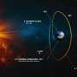
The sun is the reason life exists on our small, blue planet. It provides solar radiation that warms the planet and ignites intricate biochemical processes like photosynthesis, producing oxygen for life to breathe. However, while the sun is known for giving life, it can also take it away with solar flares, geomagnetic storms and solar radiation storms, collectively referred to a...

