**Lab3 | Sarah Aljamhan | 412205562**

**Task 4: Create a simple HTML template**

**Step 1:** Create a templates directory for bookmodule app, by doing the following:

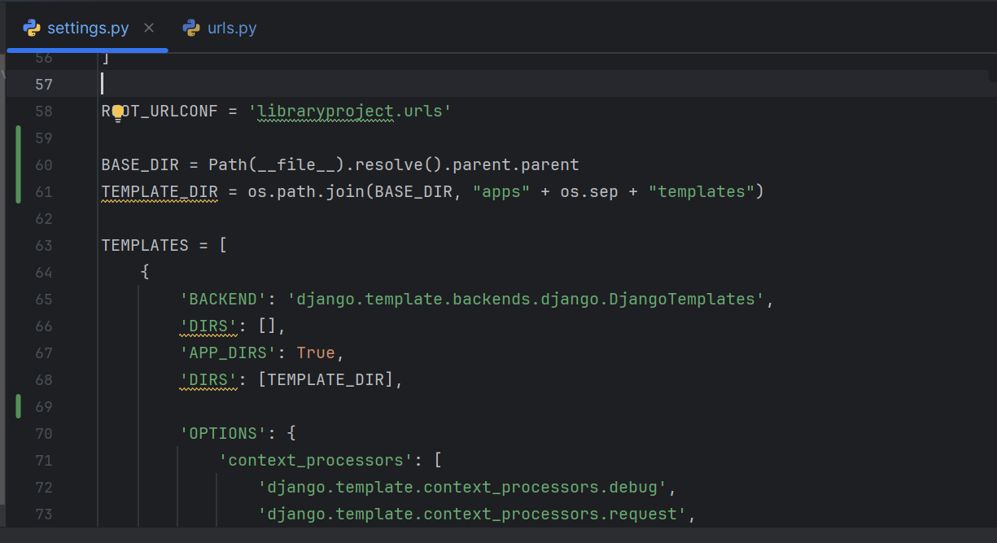

**Step 3:** Create a file with the name “index.html” within the templates directory ‘apps/templates/bookmodule’, and add the following html content:

<h1>Hello from a template!</h1>

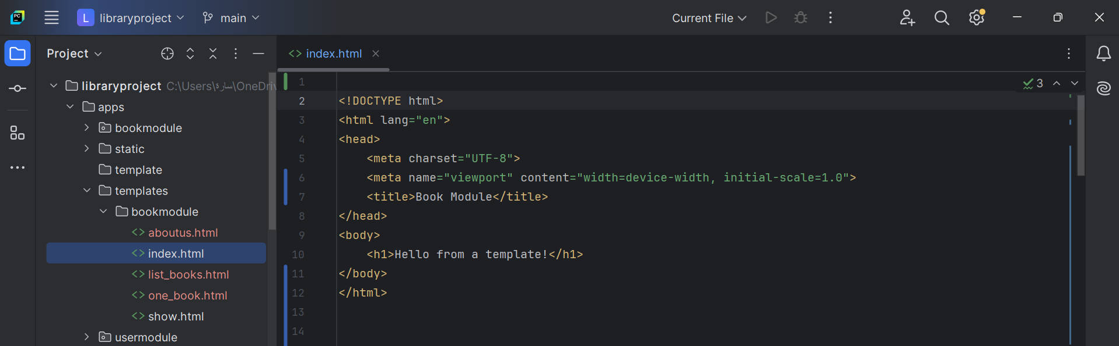

**Step 4:** Open views.py in the bookmodule directory. We no longer manually create HttpResponse, so you may remove the HttpResponse import line and add this line after the other existing imports:

from django.shortcuts import render

**Step 5:** Update the index function, in apps/bookmodule/views.py, so that, instead of returning HttpResponse, it’s returning a call to render, passing in request and the template name:

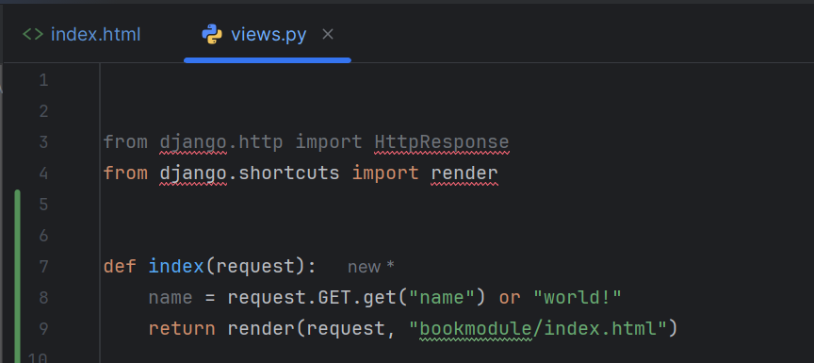

**Task 5: Rendering variables in the HTML template that processes a context**

**Step 1:** open the file “index.html”, and update the file so that it contains a place to render the name variable:

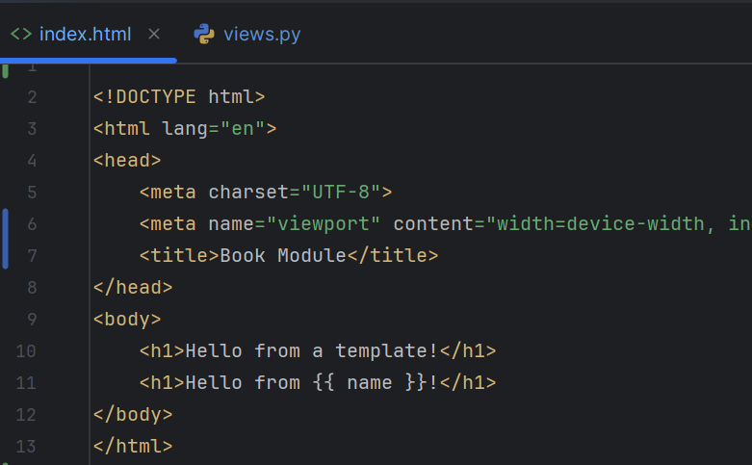

**Step 2:** Update the index function, in apps/bookmodule/views.py, and add the context dictionary as the third argument to the render function. Change your render line to this:

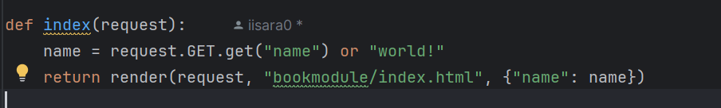

**Task 6: Define patterns globally (DjangoProjects/urls.py) with specific urls.py file for each app/module**

Note that it is common to keep one URL configuration per application in your Django project. Here, we will create a separate URL configuration for each app and add it to our project-level URL configuration.

**Step 1:** Create a new urls.py file for each app module(bookmodule and usermodule) in the same folder as the views.py file.

**Step 2:** move urls of bookmodule to apps/bookmodule/urls.py, and include newly created urls.py in core/urls.py using include module.

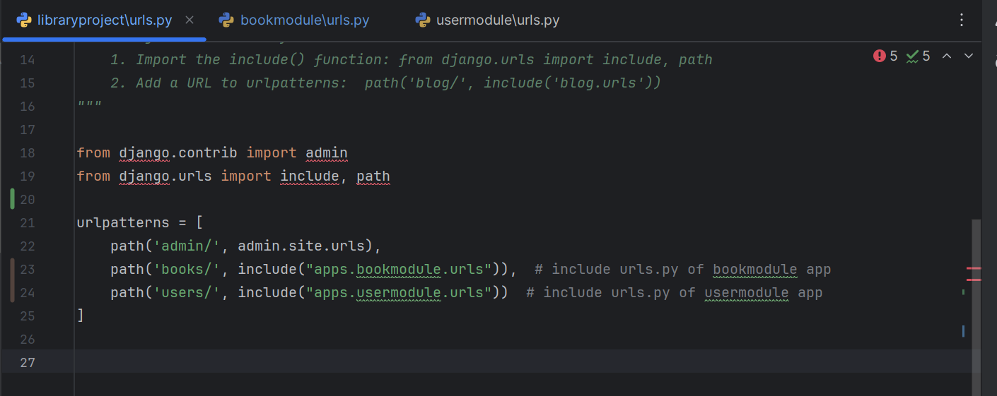

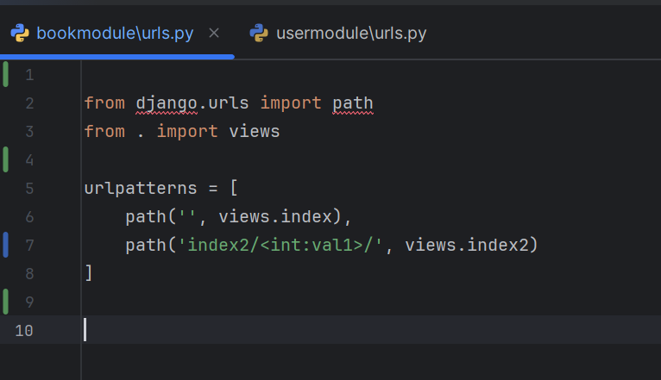

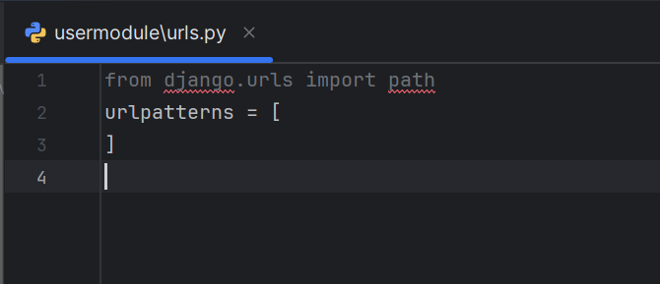

**Step 3:** Now from the browser navigate to the following urls:

<http://127.0.0.1:8000/books/>. You should see “Hello, world!”

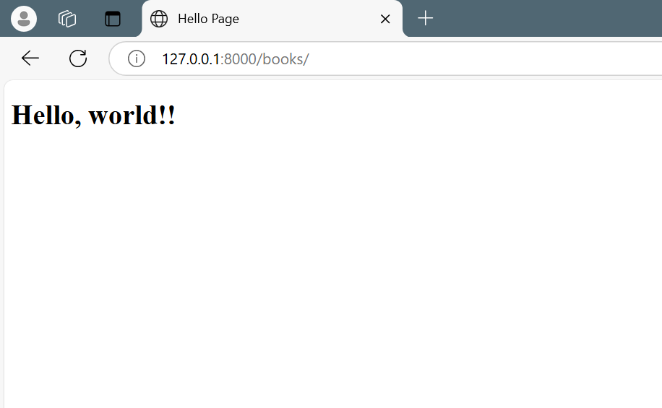

<http://127.0.0.1:8000/books/?name=world>!. You should see “Hello, world!”

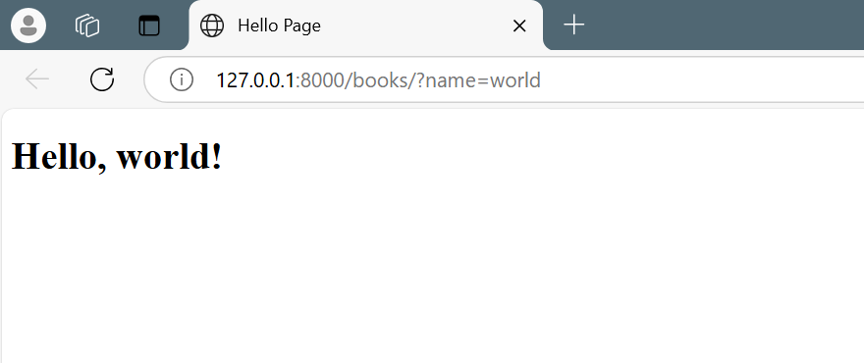

<http://127.0.0.1:8000/books/?name=Dr>.Faisal. You should see “Hello, Dr. Faisal”

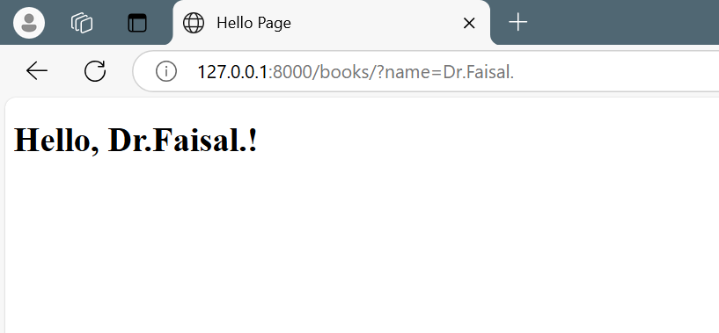

<http://127.0.0.1:8000/books/?name=Mousa>. You should see “Hello, Mousa”

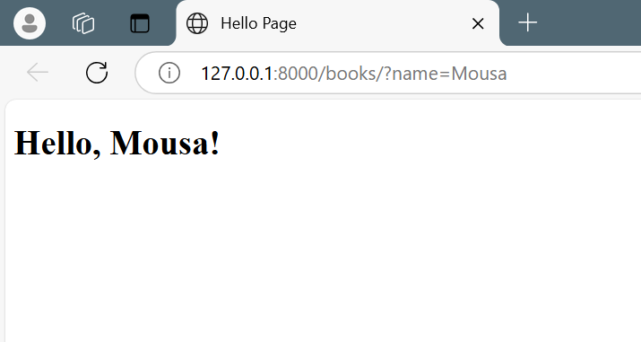

http://127.0.0.1:8000/books/index2/3/. You should see “value1 = 3”

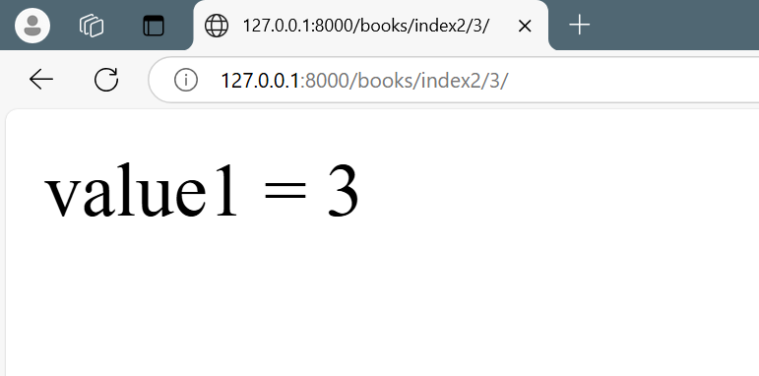

http://127.0.0.1:8000/books/index2/10/. You should see “value1 = 10”

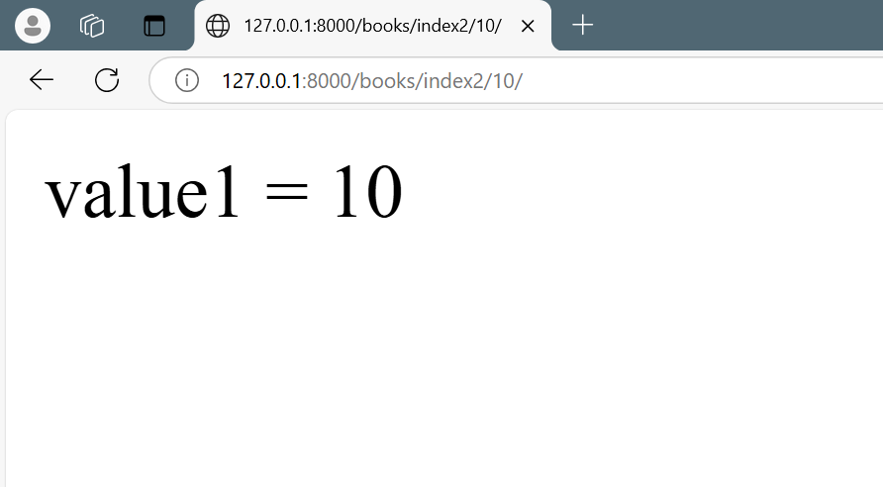

http://127.0.0.1:8000/books/index2/text/. You should see “error, expected val1 to be integer”

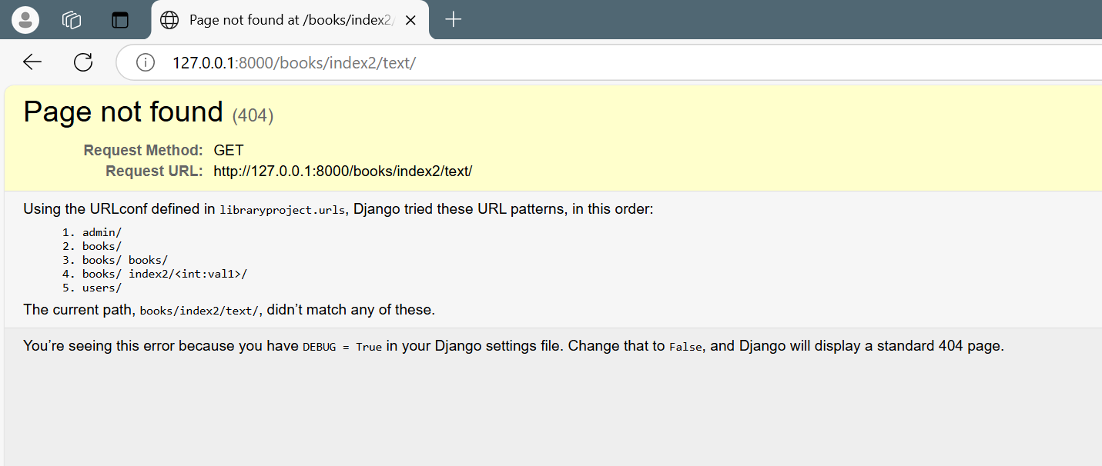

**Task7: Create a URL, view, and HTML to display one book details**

<http://127.0.0.1:8000/books/123>

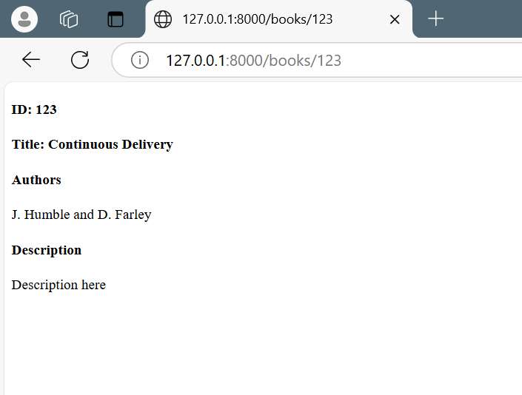

<http://127.0.0.1:8000/books/456>

