**Task 2: Style the previous HTML files with CSS in three ways (inline CSS, internal style element, and separated CSS file)**

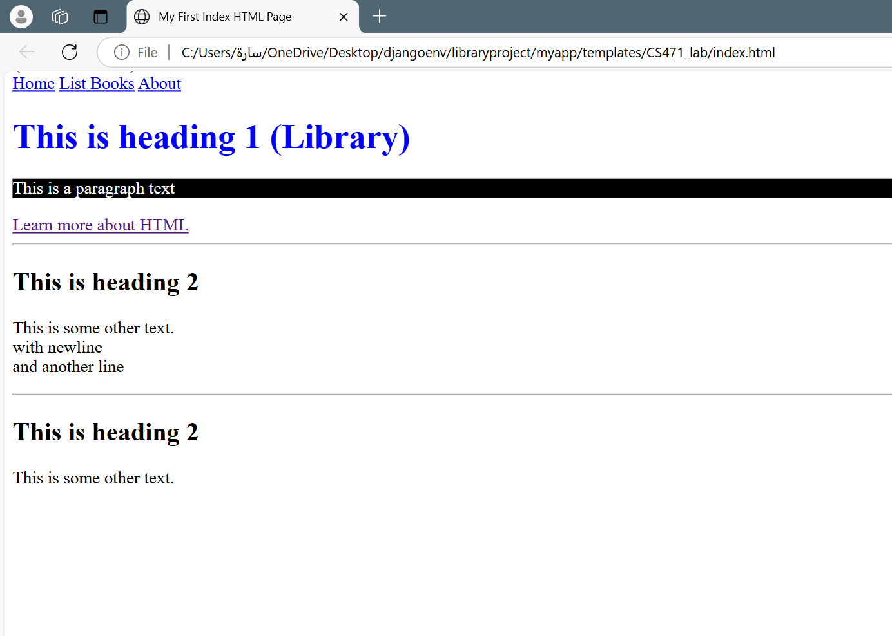

**Task 3: W3C HTML5 Validation Service[1] to use proper HTML5 syntax to ensure that browsers process your documents properly.**

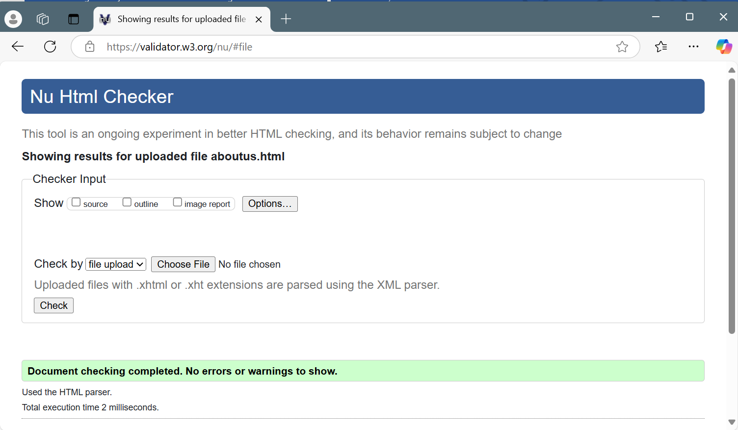

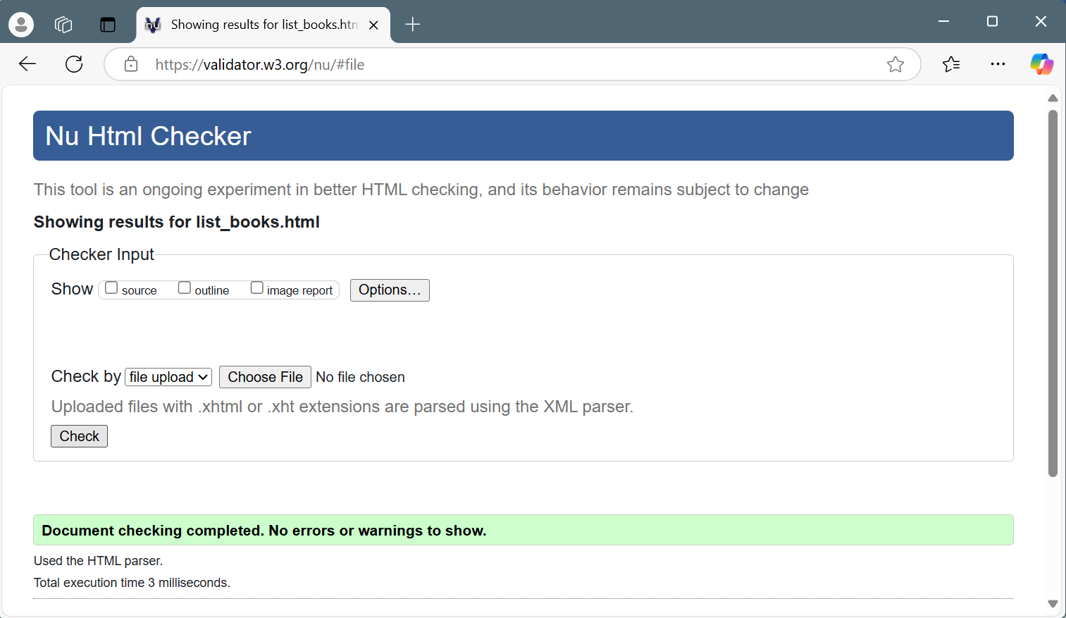

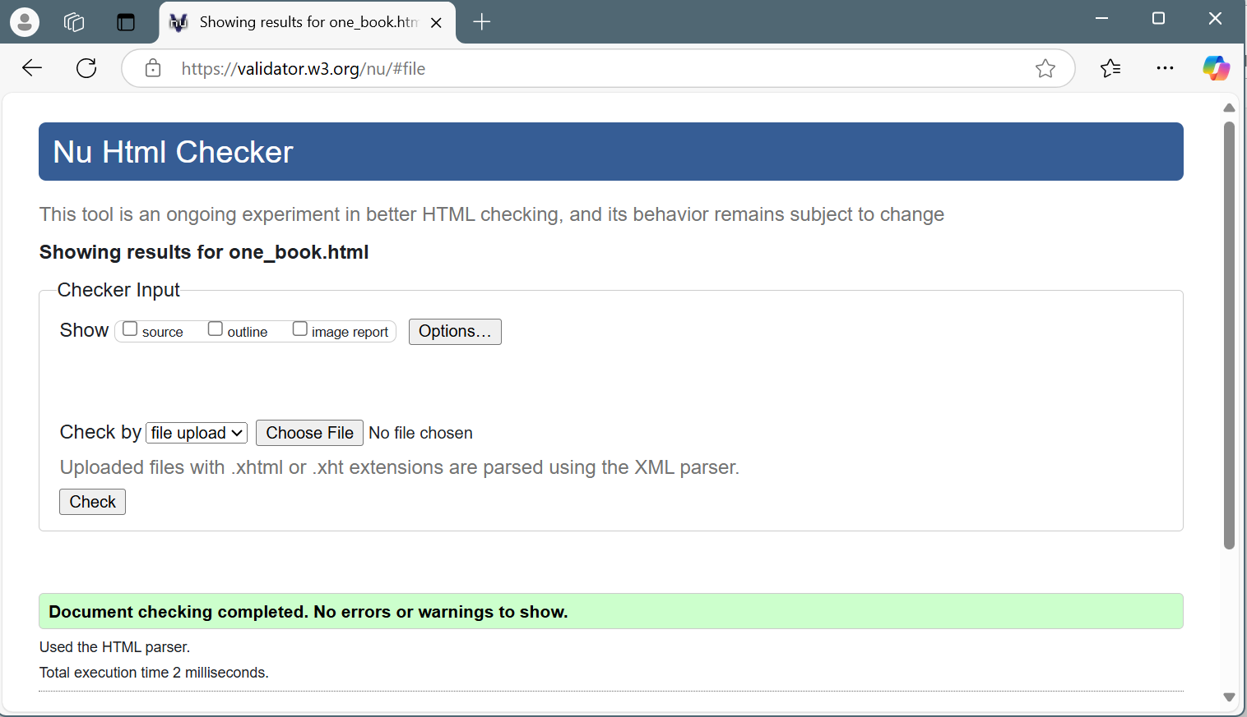

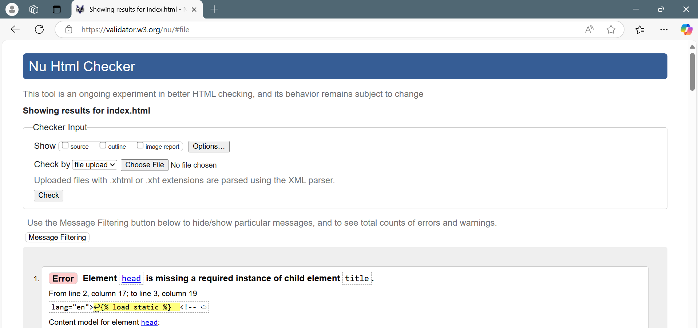

**Task 4: Implementation and management of the previous HTML and static files (e.g. CSS and images) in Django framework.**

**Step 7:** Run the server if you haven’t, open the web browser, and navigate to <http://127.0.0.1:8000/books/>.

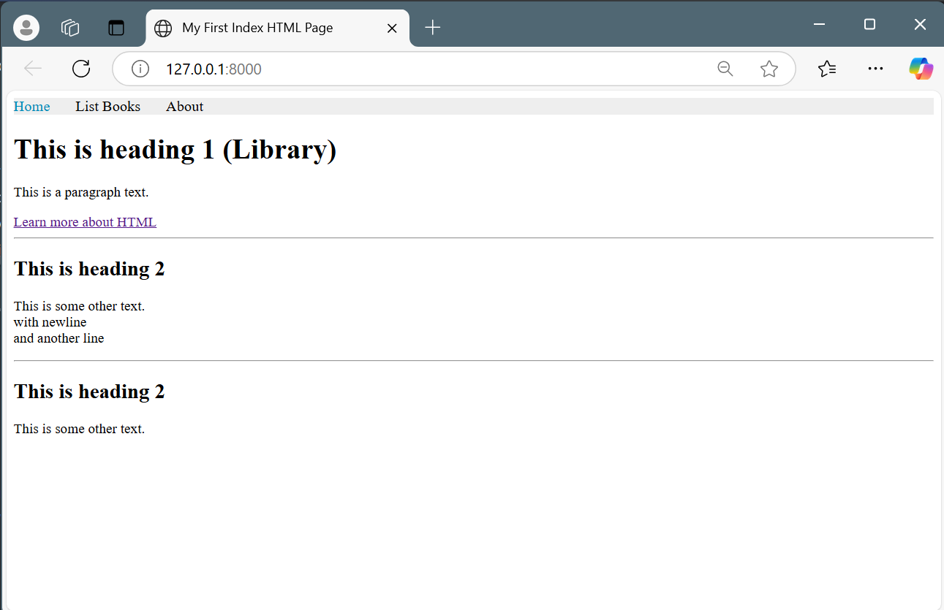

**Task 5: Additional implementation of Django tags to build one layout instead of repeating the layout for every HTML file.**

**Step 6:** Now from the browser navigate to <http://127.0.0.1:8000/books/>

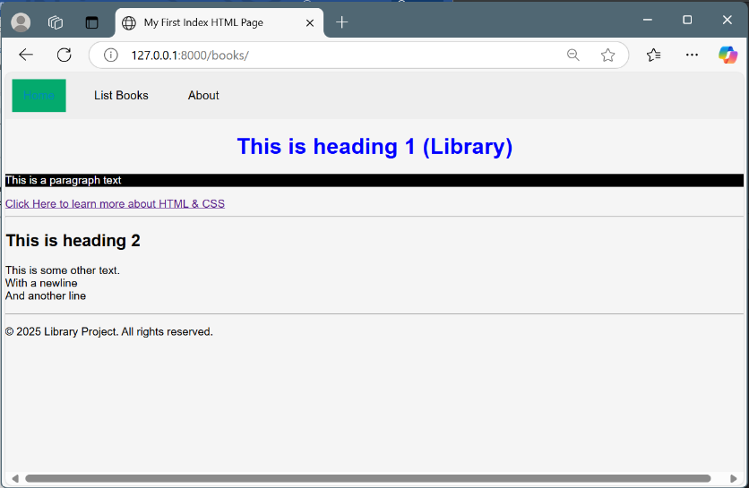

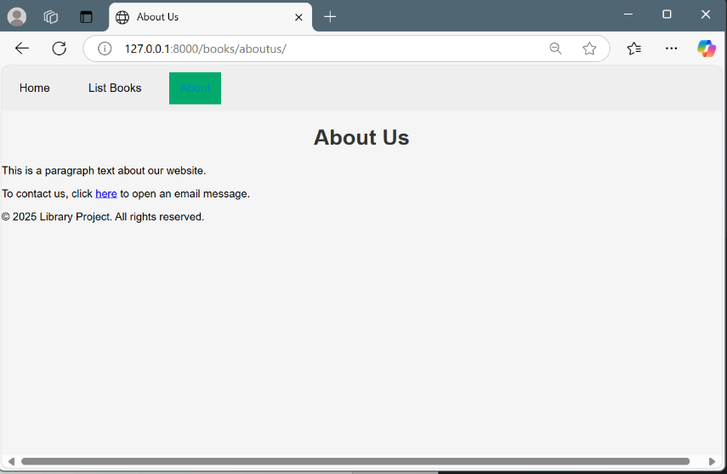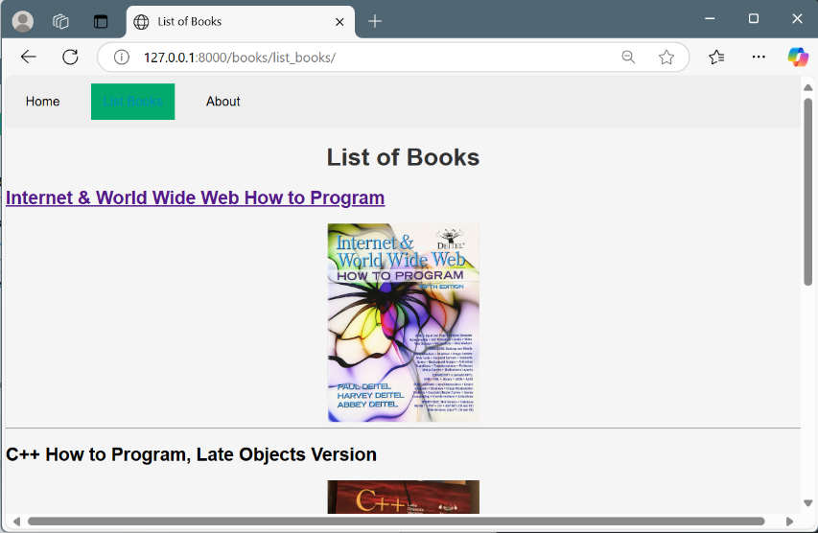

1. The World Wide Web Consortium (W3C) provides a validation service (at validator.w3.org) for checking a document’s syntax