**DAILY ONLINE ACTIVITIES SUMMARY**

|  |  |  |  |  |  |  |  |  |
| --- | --- | --- | --- | --- | --- | --- | --- | --- |
| **Date:** | **23 June 2020** | | | | | **Name:** | **K ISHA HEGDE** | |
| **Sem & Sec** | **4th sem, 2nd year** | | | | | **USN:** | **4al18cs0361** | |
| **Online Test Summary** | | | | | | | | |
| **Subject** | | **-------** | | | | | | |
| **Max. Marks** | | **----** | | **Score** | | | **---** | |
| **Certification Course Summary** | | | | | | | | |
| **Course** | **INTRODUCTION TO DIGITAL MARKETING** | | | | | | | |
| **Certificate Provider** | | | **Google digital garage** | | **Duration** | | | **4 hours** |
| **Coding Challenges** | | | | | | | | |
| **Problem Statement:1 program** | | | | | | | | |
| **Status: Executed** | | | | | | | | |
| **Uploaded the report in Github** | | | | | **Yes** | | | |
| **If yes Repository name** | | | | | <https://github.com/iishaii/locked-down_coding> | | | |
| **Uploaded the report in slack** | | | | | **Yes** | | | |

#### *Certification Course Summary:*

#### Today I continued with INTRODUCTION TO DIGITAL MARKETING from google garage , which is of 40hrs. After the completion of course, certificate will be provided.



***Coding Challenges:***

Today I solved 1 coding challenge,

1. **Python Program to Split the array and add the first part to the end There is a given an array and split it from a specified position, and move the first part of array add to the end.**

Examples:

Input: arr [] = {12, 10, 5, 6, 52, 36}  
k = 2  
Output: arr [] = {5, 6, 52, 36, 12, 10}  
Explanation: Split from index 2 and first  
part {12, 10} add to the end.

Input: arr [] = {3, 1, 2}  
k = 1  
Output: arr [] = {1, 2, 3}  
Explanation: Split from index 1 and first  
part add to the end.

ACTI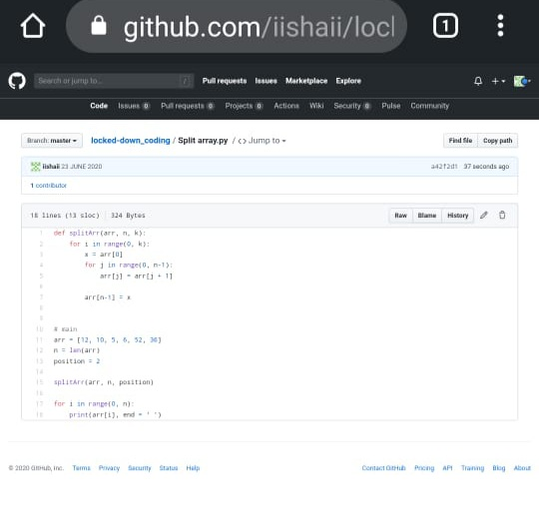

ACTIVITY:

Today I attended IoT webinar conducted by Alva’s Institute of Engineering and Technology for 2 hours.

Which explains deep about IoT, what is IoT and different type of sensors, Application of sensors, about Arduino board and applications, Installation and etc.

*Online exam of IoT:*

After attending IoT webinar I also attended exam conducted on IoT which is of 20 min for 15 marks.

