**DAILY ONLINE ACTIVITIES SUMMARY**

|  |  |  |  |  |  |  |  |  |
| --- | --- | --- | --- | --- | --- | --- | --- | --- |
| **Date:** | **27 June 2020** | | | | | **Name:** | **K ISHA HEGDE** | |
| **Sem & Sec** | **4th sem, 2nd year** | | | | | **USN:** | **4al18cs031** | |
| **Online Test Summary** | | | | | | | | |
| **Subject** | | **Data Communication** | | | | | | |
| **Max. Marks** | | **30** | | **Score** | | | **26** | |
| **Certification Course Summary** | | | | | | | | |
| **Course** | **INTRODUCTION TO HADOOP** | | | | | | | |
| **Certificate Provider** | | | **GreatLearning** | | **Duration** | | | **2 hours** |
| **Coding Challenges** | | | | | | | | |
| **Problem Statement:2 program** | | | | | | | | |
| **Status: Executed** | | | | | | | | |
| **Uploaded the report in Github** | | | | | **Yes** | | | |
| **If yes Repository name** | | | | | <https://github.com/iishaii/locked-down_coding> | | | |
| **Uploaded the report in slack** | | | | | **Yes** | | | |

#### *Online Test Summary:*

#### Today Data Communication test was conducted which is of 30 marks for 30 minutes.

#### 

#### *Certification Course Summary:*

#### Today I started new course INTRODUCTION TO HADOOP in Great Learning which is of 8 hrs. After the completion of course, certificate will be provided.



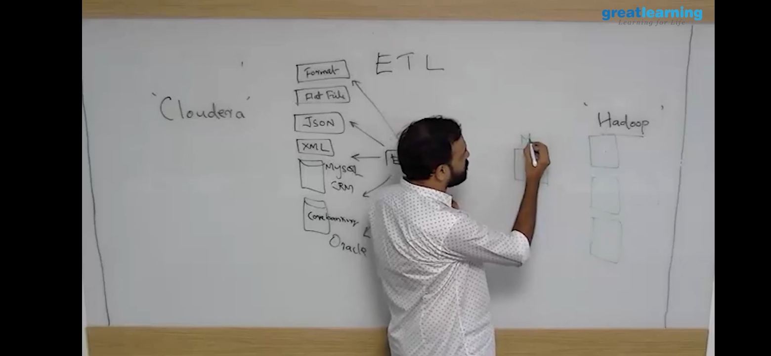

***Coding Challenges:***

Today I solved 2 coding challenge,

1. **Write a C program to print kth digit**

Given two numbers a and b, find kth digit from right of a^b.

**Input:**

The first line of the input contains T denoting the number of test cases. Each of the next T lines contains three space separated positive integers denoting the value of a, b and k respectively.

**Output:**

For each test case, output the kth digit from right of a^b in new line.

Constraints:

1<=T<=100  
1<=a, b <=15  
1<=k<=|total digits in a^b|

**Example:**

**Input:**  
2  
3 3 1  
5 2 2

**Output:**  
7  
2

**Hint:**

**Output: 1**  
Explanation 3^3 = 27 for k = 1. First digit is 7 in 27  
**Output: 2**  
Explanation 5^2 = 25 for k = 2. First digit is 2 in 25

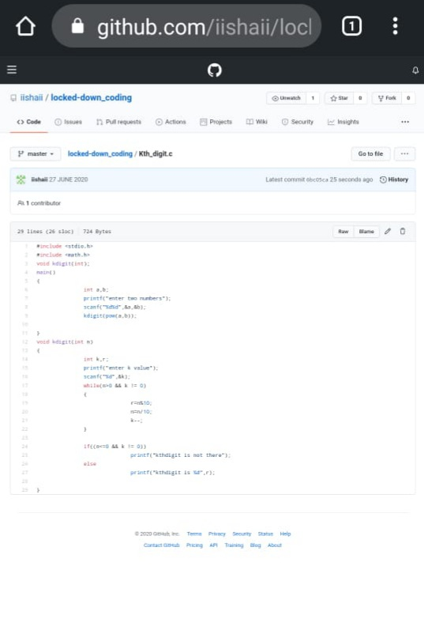

2.Write a C++ program to declare a matrix of size 3*3 matrix of size, initialize the

matrix and display them. Also find the sum of matrix elements, sum of main

diagonal elements and secondary diagonal elements.

