**DAILY ONLINE ACTIVITIES SUMMARY**

|  |  |  |  |  |  |  |  |
| --- | --- | --- | --- | --- | --- | --- | --- |
| **Date:** | **27 may 2020** | | | | **Name:** | **K. Isha hegde** | |
| **Sem & Sec** | **4th sem, 2nd year** | | | | **USN:** | **4al18cs031** | |
| **Online Test Summary** | | | | | | | |
| **Subject** | | **OBJECT ORIENTED CONCEPTS (18cs45)** | | | | | |
| **Max. Marks** | | **30** | | **Score** | | **28** | |
| **Certification Course Summary** | | | | | | | |
| **Course** | **CLOUD FOUNDATION** | | | | | | |
| **Certificate Provider** | | | **great learning** | **Duration** | | | **3 hours** |
| **Coding Challenges** | | | | | | | |
| **Problem Statement :1 problem** | | | | | | | |
| **Status: Executed** | | | | | | | |
| **Uploaded the report in Github** | | | | **Yes** | | | |
| **If yes Repository name** | | | | **[https://github.com/iishaii/locked-down_coding](https://github.com/iishaii/locked-down_coding" \o "https://github.com/iishaii/locked-down_coding)** | | | |
| **Uploaded the report in slack** | | | | **Yes** | | | |

**ONLINE TEST SUMMARY:**

Today **OBJECT ORIENTED CONCEPTS (18cs45)** was conducted of first module. Total marks for the test was 30.

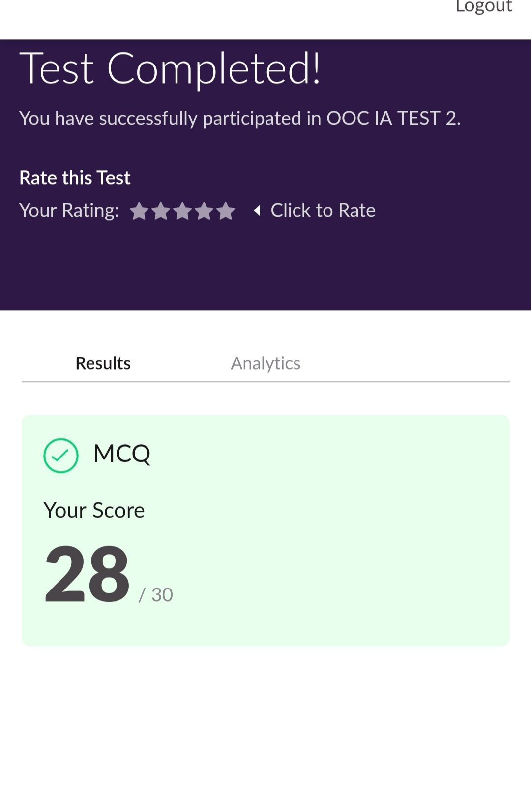

**Certification Course Summary:**

Today I started new certificate course through Great learning. I choose the concept of cloud foundation. I completed 6 modules.It covered topics like why cloud and evolution of cloud ,cloud attributes, introduction to visualization.The below snap says the topic covered in each module.

There are total of 11 modules including assessment.



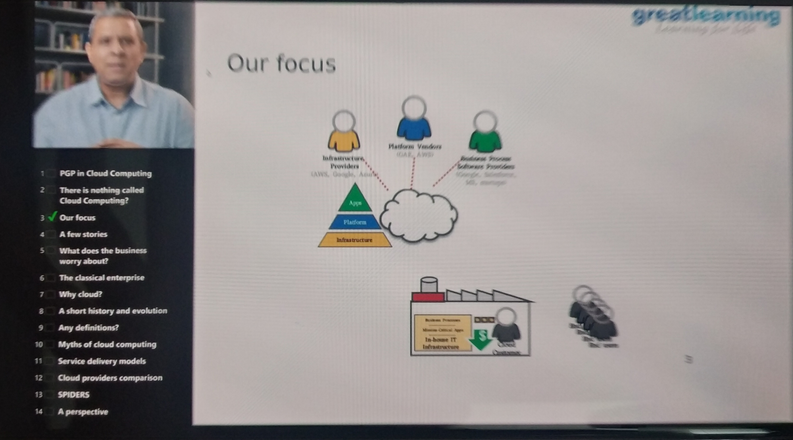

**CODING CHALLENGES:**

Today I solved 1 coding challenge,

**In Bubble sort, each pass consists of comparison each element in the file with its successor (i.e. x[i] with x[i+1]) and interchanging two elements if they are not in the proper order. The array may be sorted in any pass. If the array is sorted, then remaining passes should be skipped off. Write a C Program to sort an array of integers in ascending order and display the sorted array and Number of passes performed for sorting.**

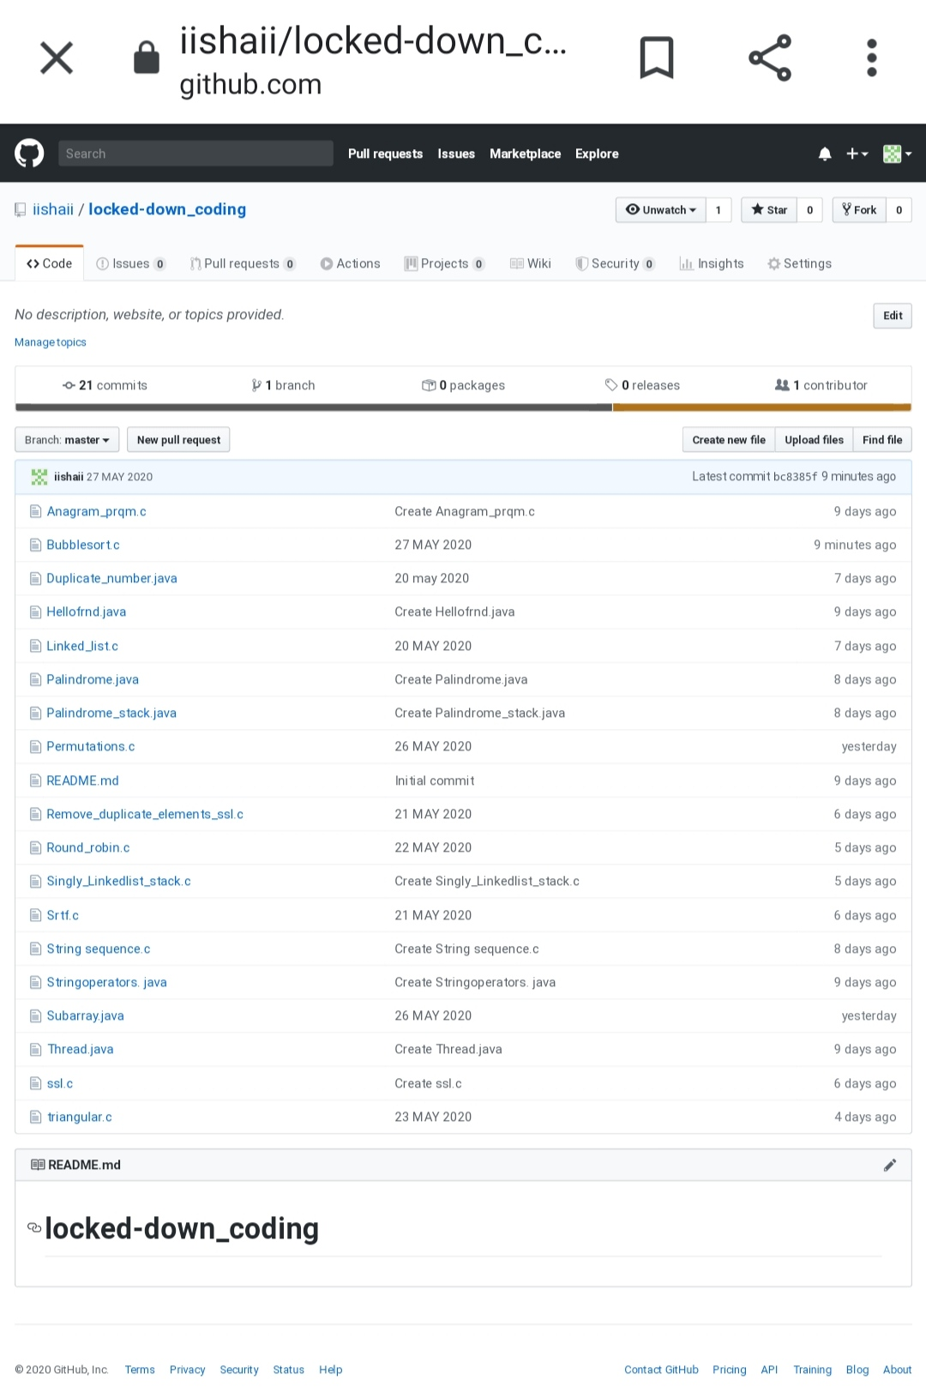

SOLUTION : I have uploaded the solution of the above coding problems in my GitHub repository.

[https://github.com/iishaii/locked-down_coding](https://github.com/iishaii/locked-down_coding" \o "https://github.com/iishaii/locked-down_coding)