**DAILY ONLINE ACTIVITIES SUMMARY**

|  |  |  |  |  |  |  |  |
| --- | --- | --- | --- | --- | --- | --- | --- |
| **Date:** | **04 June 2020** | | | | **Name:** | **K ISHA HEGDE** | |
| **Sem & Sec** | **4th sem, 2nd year** | | | | **USN:** | **4al18cs031** | |
| **Online Test Summary** | | | | | | | |
| **Subject** | | **MICROCONTROLLER AND EMBEDDED SYSTEM (18cs44)** | | | | | |
| **Max. Marks** | | **20** | | **Score** | | **13** | |
| **Certification Course Summary** | | | | | | | |
| **Course** | **GAME DEVELOPMENT BY PYGAME** | | | | | | |
| **Certificate Provider** | | | **GUVI** | **Duration** | | | **3.5 hours** |
| **Coding Challenges** | | | | | | | |
| **Problem Statement:2 program** | | | | | | | |
| **Status: Executed** | | | | | | | |
| **Uploaded the report in Github** | | | | **Yes** | | | |
| **If yes Repository name** | | | | https://github.com/iishaii/Daily_report  https://github.com/iishaii/locked-down_coding  <https://github.com/keertanaganiga/lockdown_reports> | | | |
| **Uploaded the report in slack** | | | | **Yes** | | | |

**Online Test Summary:**

Today **MICROCONTROLLER AND EMBEDDED SYSTEM (18cs44)** was conducted of first module. Total marks for the test was 20.

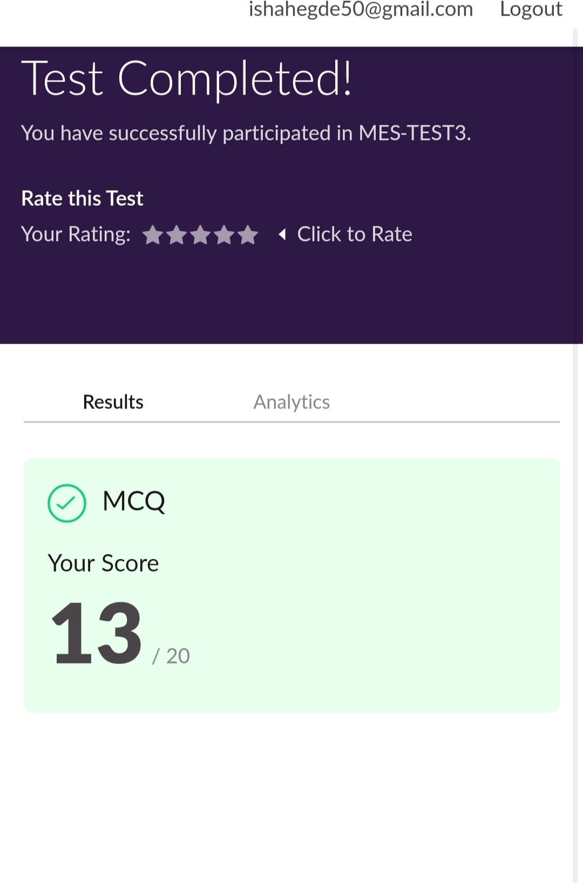

**Certification Course Summary:** **Today I continued with GAME DEVELOPMENT BY PYGAME.Pygame is a python wrapper for SDL– a cross-platform C library for controlling multimedia, written by Pete Shinners.It is a wrapper around the SDL (Simple DirectMedia Layer) library. Using pygame, we can write games or other multimedia applications in Python that will run unaltered on any of SDL's supported platforms (Windows, Unix, Mac, BeOS and others).**

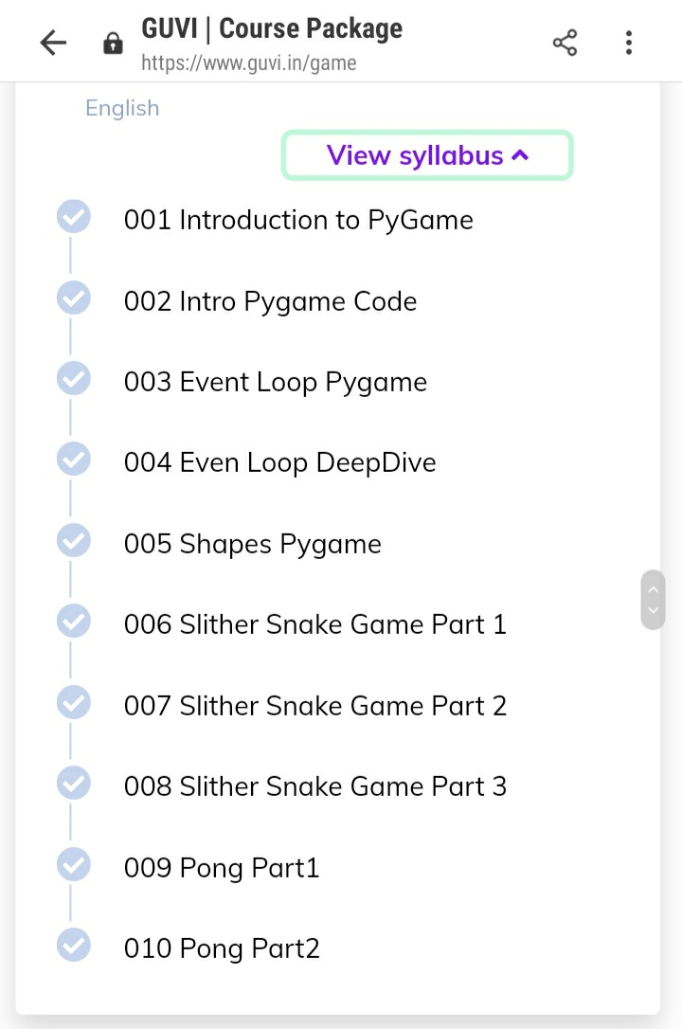

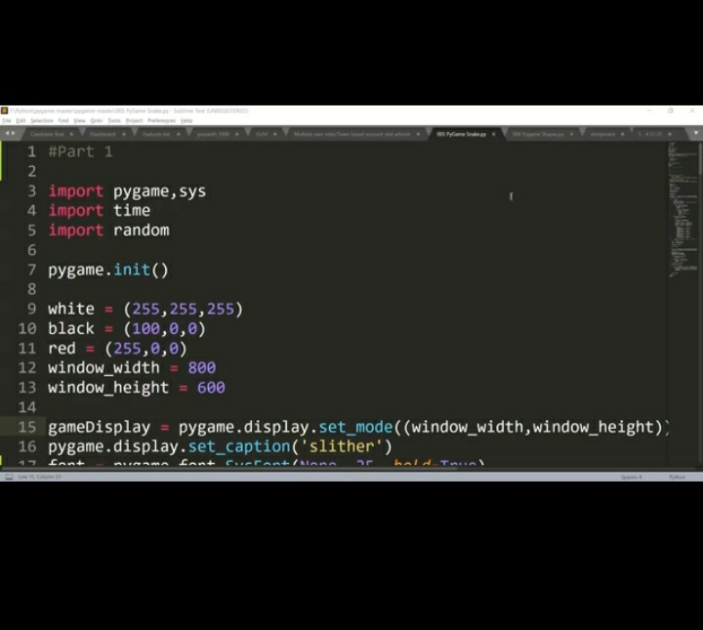

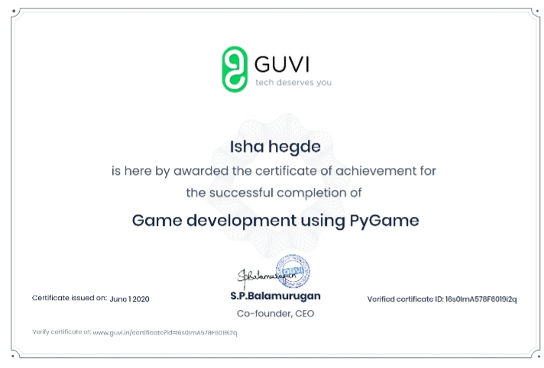

**Coding Challenges:**

Today I solved 2 coding challenge,

**1.** **write a java program to read three integer values from the keyboard and find the sum of the values. Declare a variable "sum" of type int and store the result in it.**

**2. Write a C++ program to find the missing number in array**

