**DAILY ONLINE ACTIVITIES SUMMARY**

|  |  |  |  |  |  |  |  |
| --- | --- | --- | --- | --- | --- | --- | --- |
| **Date:** | **11 June 2020** | | | | **Name:** | **K ISHA HEGDE** | |
| **Sem & Sec** | **4th sem, 2nd year** | | | | **USN:** | **4al18cs031** | |
| **Online Test Summary** | | | | | | | |
| **Subject** | | **--** | | | | | |
| **Max. Marks** | | **--** | | **Score** | | **--** | |
| **Certification Course Summary** | | | | | | | |
| **Course** | **PYTHON** | | | | | | |
| **Certificate Provider** | | | **GUVI** | **Duration** | | | **6 hours** |
| **Coding Challenges** | | | | | | | |
| **Problem Statement:1 program** | | | | | | | |
| **Status: Executed** | | | | | | | |
| **Uploaded the report in Github** | | | | **Yes** | | | |
| **If yes Repository name** | | | | [https://github.com/iishaii/locked-down_coding](https://github.com/iishaii/locked-down_coding" \o "https://github.com/iishaii/locked-down_coding)  <https://github.com/keertanaganiga/lockdown_reports> | | | |
| **Uploaded the report in slack** | | | | **Yes** | | | |

**Certification Course Summary:** **Today I continued with the PYTHON course from GUVI. I completed the intermediate module and attempted quiz after each topic ,which gave me a clear veiw about the topics . The topics I studied are as follows**

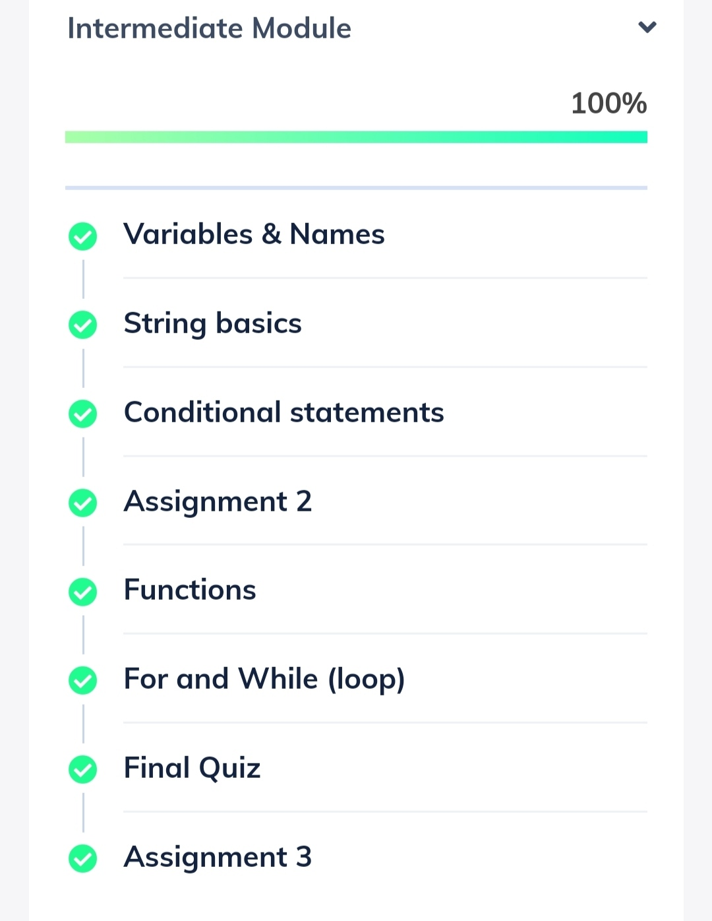

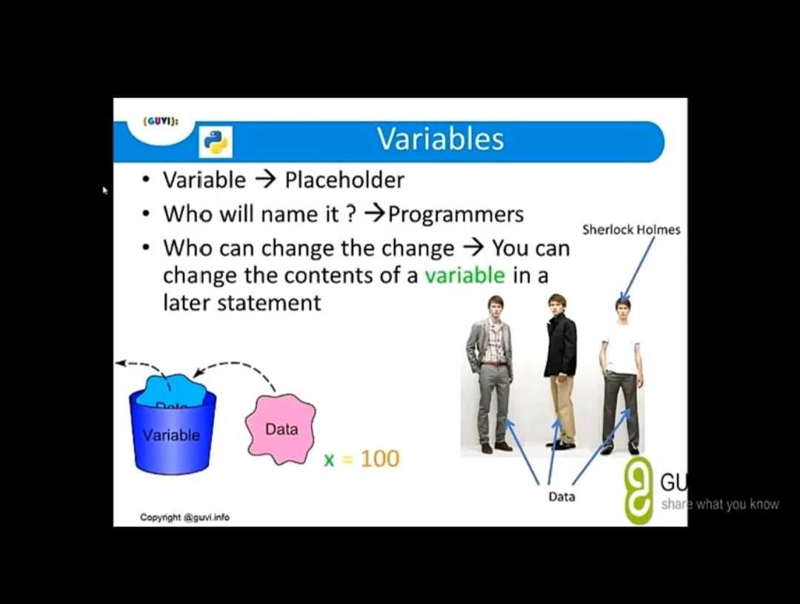

QUIZ:

Today I attempted a technical quiz conducted by NIET, and scored 96% and also secured a certificate

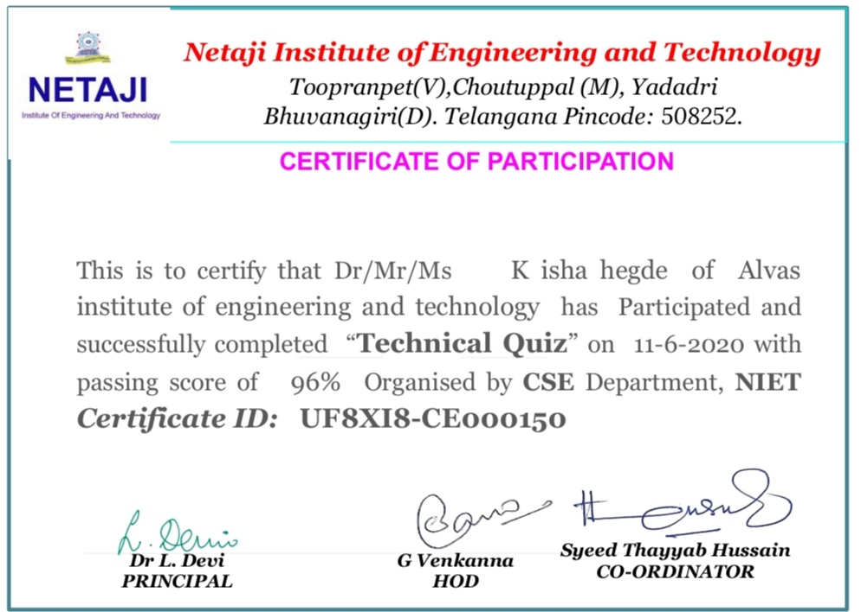

WEBINAR:

I attended a webinar on 5th of June on BRAIN COMPUTER INTERFACE and today I received a certificate. It was hosted by NITK-STEP

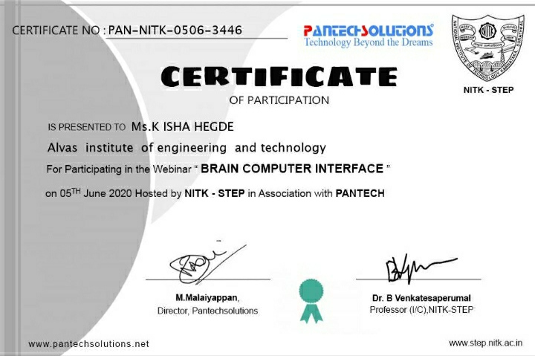

**Coding Challenges:**

Today I solved 1 coding challenge,

**1.Write a Java Program to Segregate Even and Odd numbers**

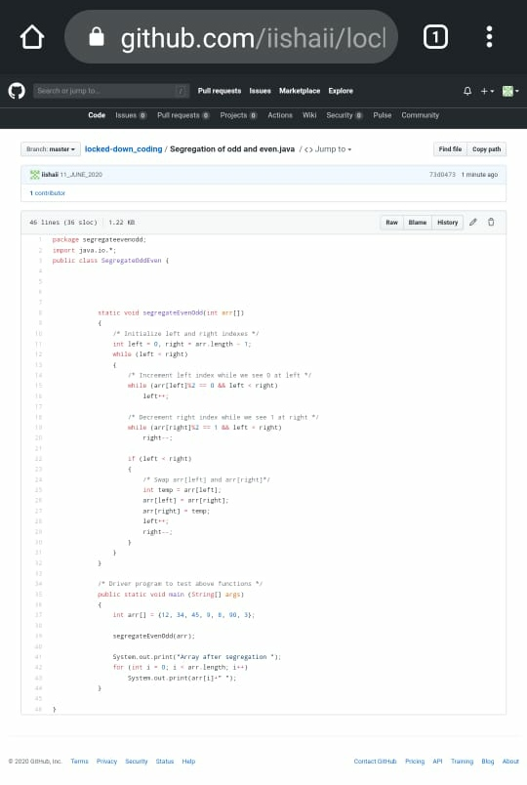

**I have uploaded the code in my GitHub repository and attached a snapchat below:**

**[https://github.com/iishaii/locked-down_coding](https://github.com/iishaii/locked-down_coding" \o "https://github.com/iishaii/locked-down_coding)**

