**DAILY ONLINE ACTIVITIES SUMMARY**

|  |  |  |  |  |  |  |  |  |
| --- | --- | --- | --- | --- | --- | --- | --- | --- |
| **Date:** | **06 June 2020** | | | | | **Name:** | **K ISHA HEGDE** | |
| **Sem & Sec** | **4th sem, 2nd year** | | | | | **USN:** | **4al18cs031** | |
| **Online Test Summary** | | | | | | | | |
| **Subject** | | **DATA COMMUNICATION (18cs46)** | | | | | | |
| **Max. Marks** | | **30** | | **Score** | | | **26** | |
| **Certification Course Summary** | | | | | | | | |
| **Course** | **INTRODUCTION TO FULL STACK DEVELOPMENT** | | | | | | | |
| **Certificate Provider** | | | **Great Learning** | | **Duration** | | | **4hrs** |
| **Coding Challenges** | | | | | | | | |
| **Problem Statement:2 program** | | | | | | | | |
| **Status: Executed** | | | | | | | | |
| **Uploaded the report in Github** | | | | | **Yes** | | | |
| **If yes Repository name** | | | | | <https://github.com/iishaii/locked-down_coding>  https://github.com/iishaii/locked-down_coding | | | |
| **Uploaded the report in slack** | | | | | **Yes** | | | |

**Online Test Summary:**

Today **DATA COMMUNICATION (18cs46)** was conducted for Total 30 marks

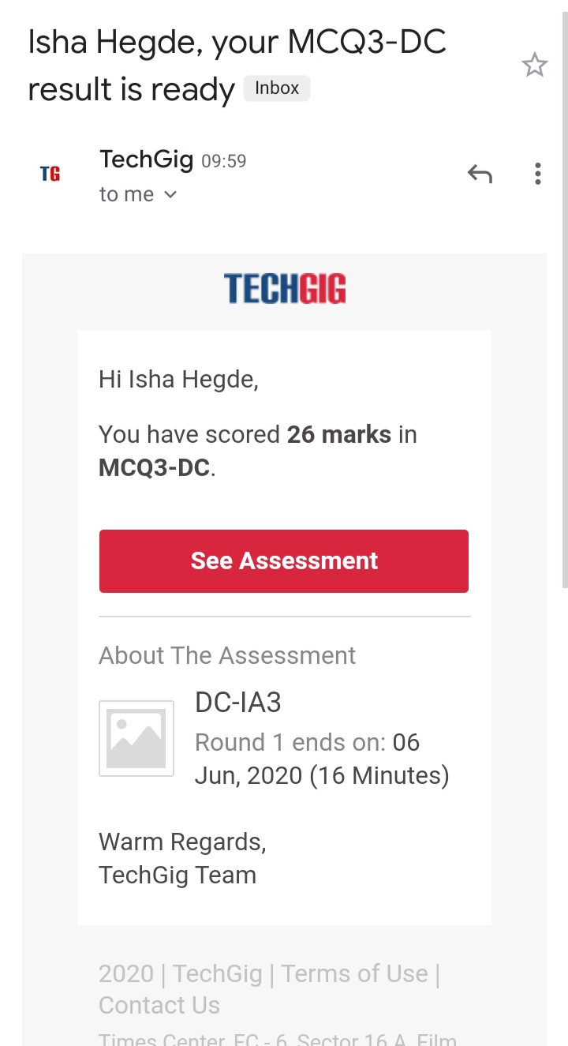

**Certification Course Summary:** **Today I continued the certificate course through Great Learning INTRODUCTION TO FULL STACK DEVELOPMENT. Today I learnt about unordered list, ordered list, tables, introduction to form, labels ,forms ,method attributes, button types, classes, relationship between elements.**

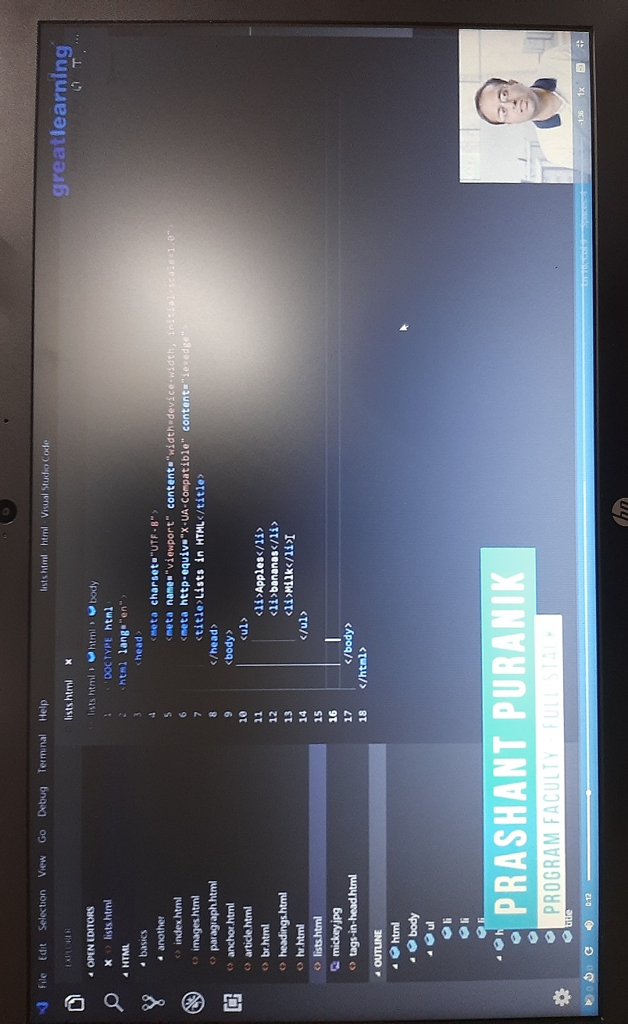

**Coding Challenges:**

Today I solved 2 coding challenge,

1.**Write a Java Program to find the second-highest number in an array**.

2. **Write a program in C to rotate an array by N positions.**

