**DAILY ONLINE ACTIVITIES SUMMARY**

|  |  |  |  |  |  |  |  |
| --- | --- | --- | --- | --- | --- | --- | --- |
| **Date:** | **20 MAY 2020** | | | | **Name:** | **K. ISHA HEGDE** | |
| **Sem & Sec** | **4th sem 'A'** | | | | **USN:** | **4AL18CS031** | |
| **Online Test Summary** | | | | | | | |
| **Subject** | | **OOC** | | | | | |
| **Max. Marks** | | **30** | | **Score** | | **20** | |
| **Certification Course Summary** | | | | | | | |
| **Course** | **Diploma in Amazon Web services** | | | | | | |
| **Certificate Provider** | | | **ALISON** | **Duration** | | | **2:31:10** |
| **Coding Challenges** | | | | | | | |
| **Problem Statement: I have mentioned the 4 problem statements below.** | | | | | | | |
| **Status: completed** | | | | | | | |
| **Uploaded the report in Github** | | | | **Yes** | | | |
| **If yes Repository name** | | | | **https://github.com/iishaii/locked-down_coding** | | | |
| **Uploaded the report in slack** | | | | **Yes** | | | |

Online Test Details: (Attach the snapshot and briefly write the report for the same)

Certification Course Details: (Attach the snapshot and briefly write the report for the same)

Coding Challenges Details: (Attach the snapshot and briefly write the report for the same)

ONLINE TEST DETAILS:

Today OBJECT ORIENTED CONCEPTS was conducted of first module. Total marks for the test was 30.The online test conducted includes MCQ kind questions and also output prediction.

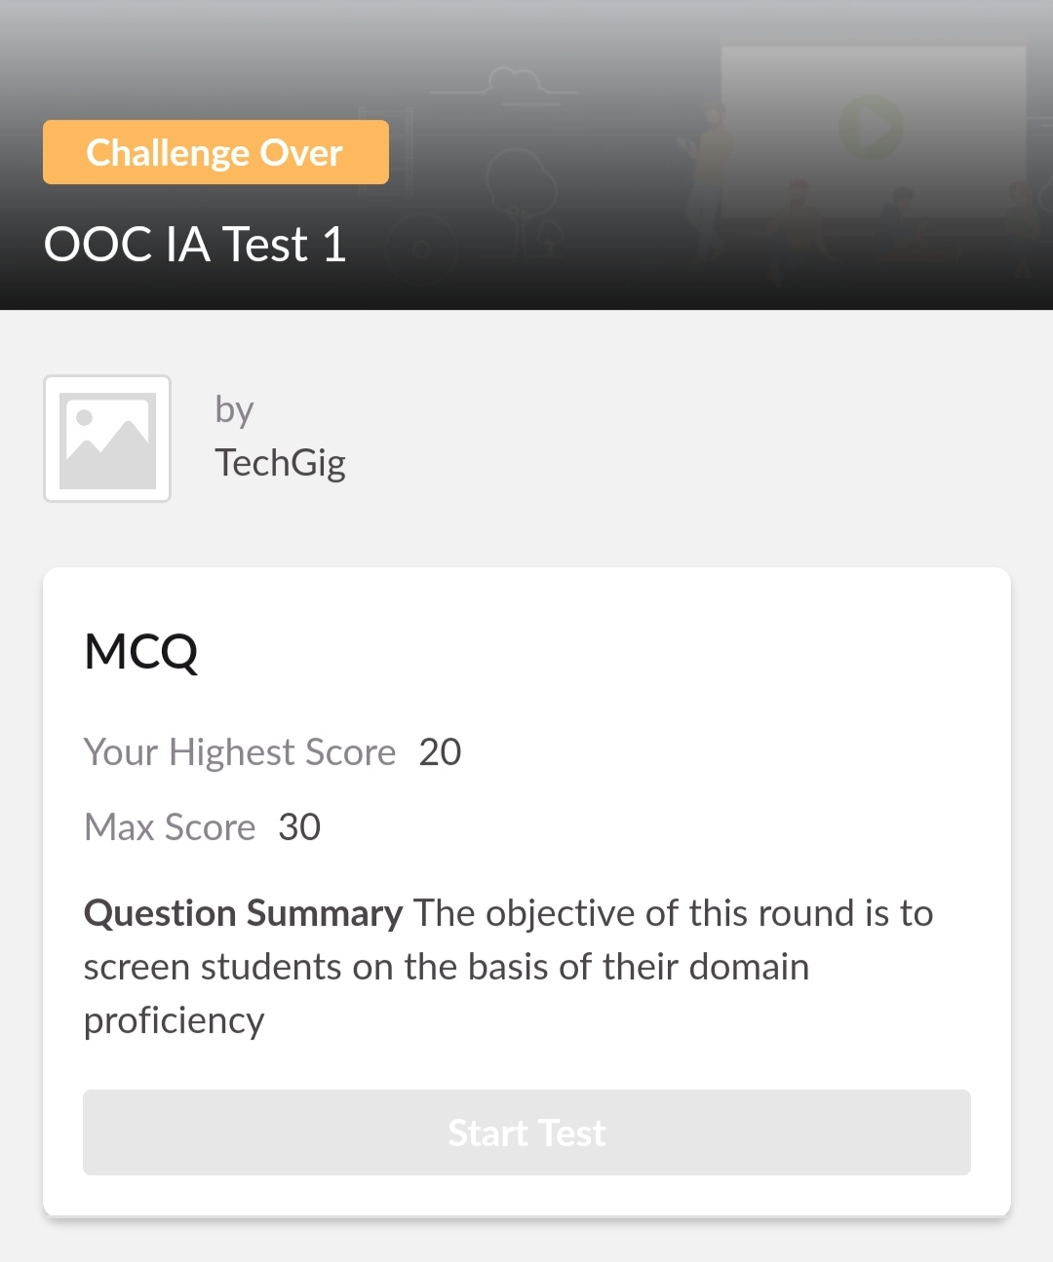

CERTIFICATION COURSE DETAILS:

* As a continuation of the online course, I chose " Diploma in Amazon Web Services".I gained an overall understanding of the AWS cloud platform , including AWS core services with this online course.
* It consists of 11 modules including assessments.

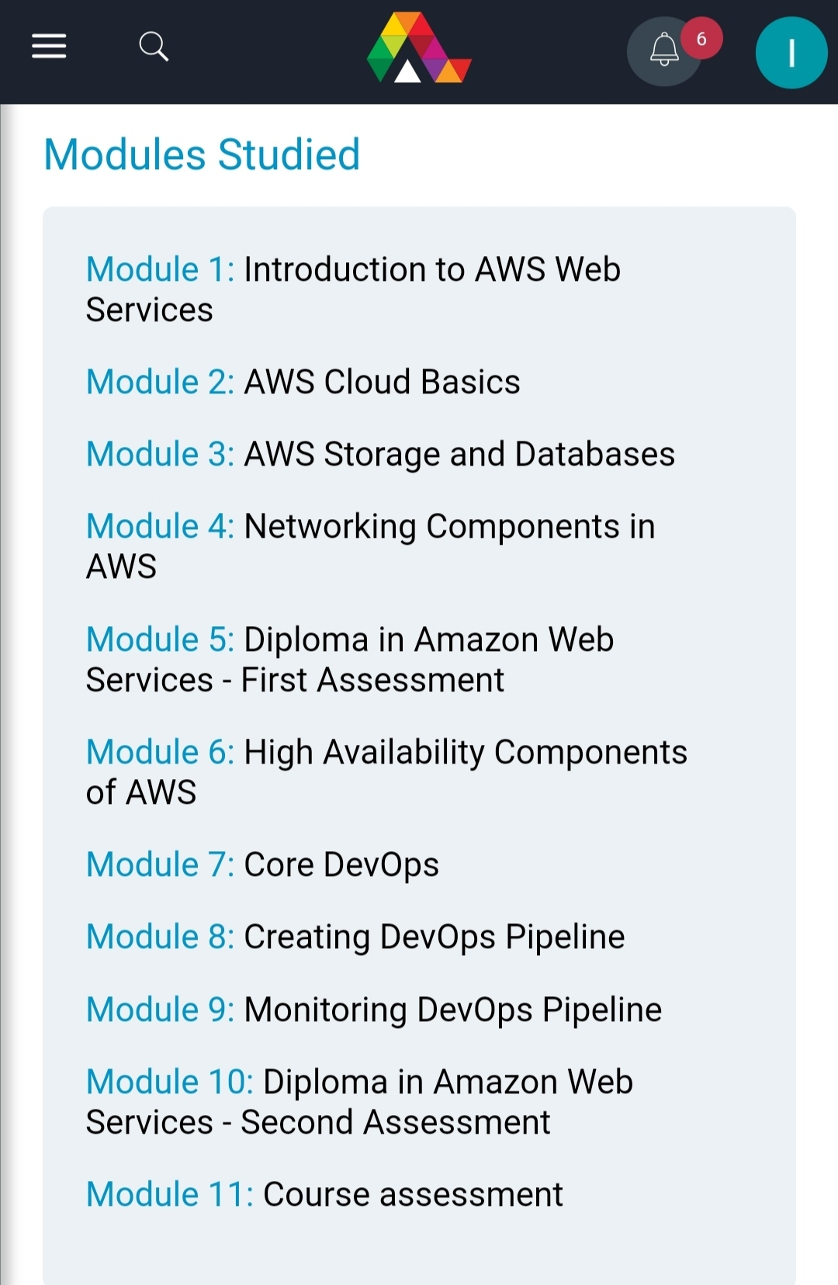

I have successfully completed the course in the given time duration and secured 84%.

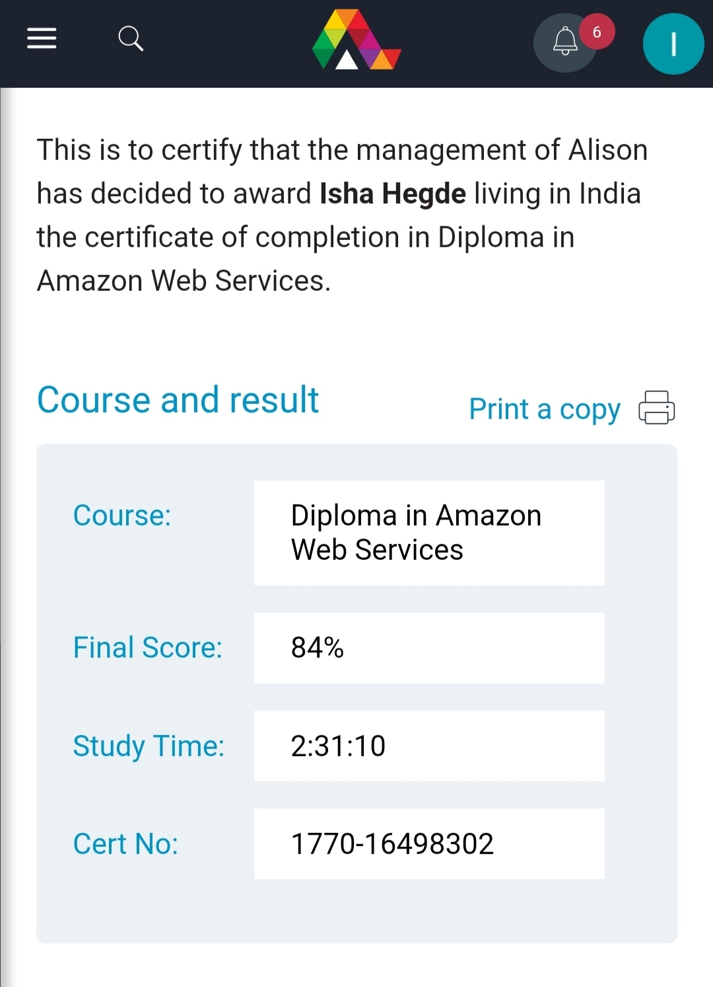

**Coding Challenges:**

Today I solved 4 coding challenge,

1. Related to linked list:

Test Case 1:

If a linked list is: 1 → 2 → 3 → 4 → 5 → 6 → 7 → 8

The value of size k is 2

Then the linked list looks like: 2 → 1 → 4 → 3 → 6 → 5 → 8 → 7

Test Case 2:

If a linked list is: 1 → 2 → 3 → 4 → 5 → 6 → 7 → 8

The value of size k is 3

Then the linked list looks like: 3 → 2 → 1 → 6 → 5 → 4 → 8 → 7

2. program print Duplicates which prints the duplicate elements of the given array:

Given an array a[] of size n which contains elements from 0 to n-1, write a program to print Duplicates which prints the duplicate elements of the given array. If no duplicate element is found print -1.

Input:

The first line of input must contain an integer n which denotes number of elements of Array. Second line contains n space separated integers denoting elements of array a[].

*Output:*

*Print the duplicate elements from the given array.*

3. **First come First Served related and Shortest Job First related:**

**Write a C or Java program to implement FCFS and SJF process scheduling.  
 Input: Processes with burst time  
 Output: Process being scheduled**

SOLUTION : I have uploaded the solution of the above 4 coding problems in my GitHub repository.

https://github.com/iishaii/locked-down_coding

