**DAILY ONLINE ACTIVITIES SUMMARY**

|  |  |  |  |  |  |  |  |  |
| --- | --- | --- | --- | --- | --- | --- | --- | --- |
| **Date:** | **21 may 2020** | | | | | **Name:** | **Keertana Ganesh Ganiga** | |
| **Sem & Sec** | **4th sem, 2nd year** | | | | | **USN:** | **4al18cs036** | |
| **Online Test Summary** | | | | | | | | |
| **Subject** | | **MICROCONTROLLER AND EMBEDDED SYSTEMS (18CS44)** | | | | | | |
| **Max. Marks** | | **30** | | **Score** | | | **16** | |
| **Certification Course Summary** | | | | | | | | |
| **Course** | **Java Programing** | | | | | | | |
| **Certificate Provider** | | | **great learning** | | **Duration** | | | **4 hours** |
| **Coding Challenges** | | | | | | | | |
| **Problem Statement:3 program** | | | | | | | | |
| **Status: Executed** | | | | | | | | |
| **Uploaded the report in Github** | | | | | **Yes** | | | |
| **If yes Repository name** | | | | | <https://github.com/keertanaganiga/Lockdown_coding> | | | |
| **Uploaded the report in slack** | | | | | **Yes** | | | |

**Online Test Summary:**

Today **MICROCONTROLLER AND EMBEDDED SYSTEMS (18CS44)**

was conducted of first module. Total marks for the test was 30.

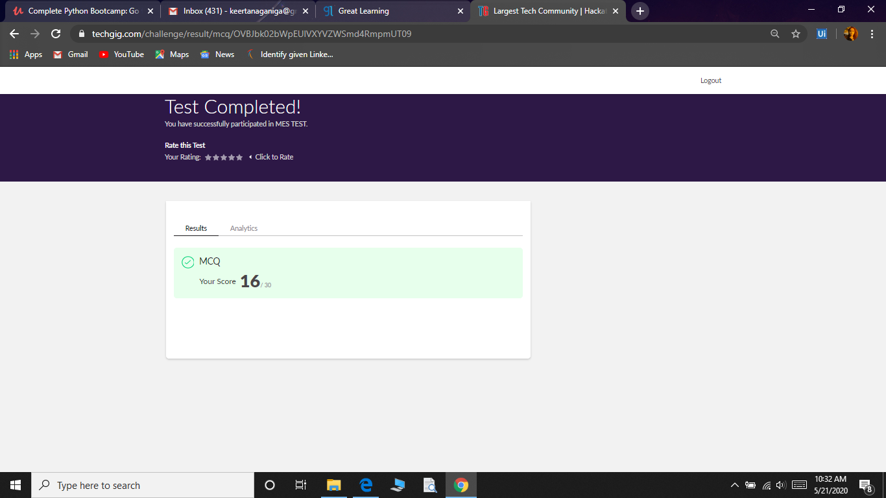

**Certification Course Summary:**

Today I started new certificate course through Great learning. I choose the concept of Java programming. I learnt about Array in java, Functions in java, Object oriented Programming in java, Inheritance, collections in java and I also solved the quiz which is for 10 marks finally I got certificate of completing

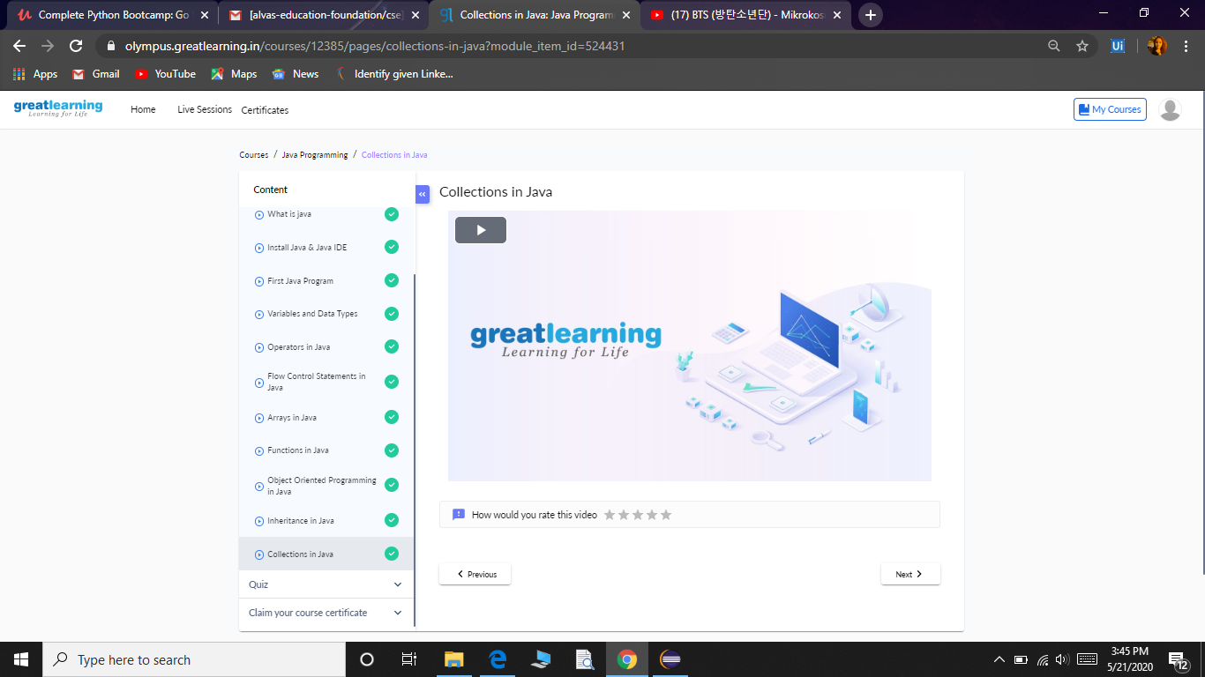

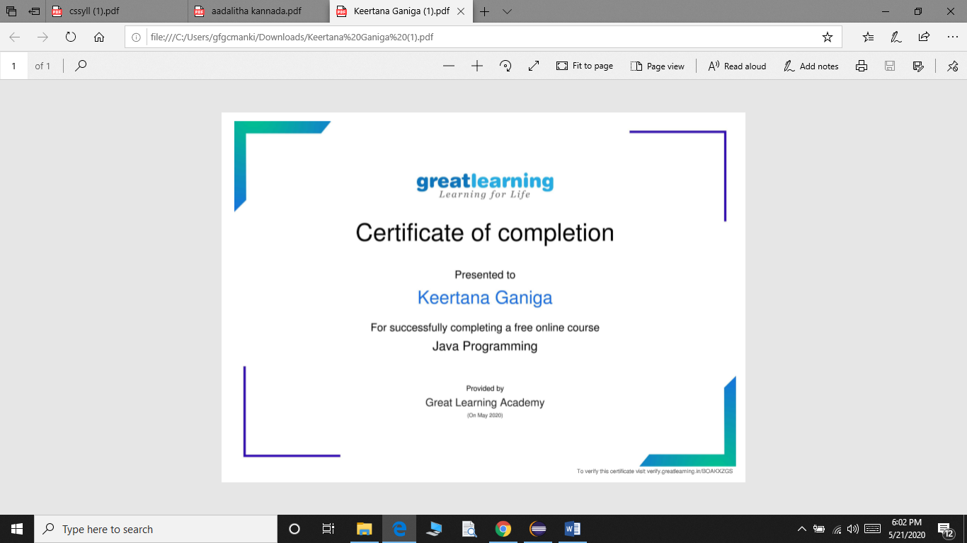

**Coding Challenges:**

Today I solved 3 coding challenge,

1. **Create the SLL, and then Reverse the Link in SLL until Head becomes NULL. Each Time Reversing the Link, Head must be moved to next immediate node.**

2. **Write a C program to implement SRTF process scheduling.  
Input: A set of processes with their burst time and arrival time  
Output: The processes scheduled based on the arrival time and a smaller burst time.**

3. **Write a C program to construct a singly linked list by removing duplicate elements in the sorted linked list  
Description:  
Take a sorted list and traverse the list. Compare the current node element with next adjacent node. If it is same then delete second element, if not retain. Finally print the resulting list.  
Sample output:  
Given list {1,2,2,3,3,3,4}  
Resulting list {1,2,3,4}**

