**DAILY ONLINE ACTIVITIES SUMMARY**

|  |  |  |  |  |  |  |  |  |
| --- | --- | --- | --- | --- | --- | --- | --- | --- |
| **Date:** | **16 June 2020** | | | | | **Name:** | **K. ISHA HEGDE** | |
| **Sem & Sec** | **4th sem, 2nd year** | | | | | **USN:** | **4al18cs031** | |
| **Online Test Summary** | | | | | | | | |
| **Subject** | | **18MAT41** | | | | | | |
| **Max. Marks** | | **30** | | **Score** | | | **24** | |
| **Certification Course Summary** | | | | | | | | |
| **Course** | **Introduction to digital marketing** | | | | | | | |
| **Certificate Provider** | | | **GreatLearning** | | **Duration** | | | **3 hours** |
| **Coding Challenges** | | | | | | | | |
| **Problem Statement:1 program** | | | | | | | | |
| **Status: Executed** | | | | | | | | |
| **Uploaded the report in Github** | | | | | **Yes** | | | |
| **If yes Repository name** | | | | | <https://github.com/iishaii/locked-down_coding> | | | |
| **Uploaded the report in slack** | | | | | **Yes** | | | |

**ONLINE TEST:**

**Today online test was conducted on 18MAT41.Total marks was 30.**

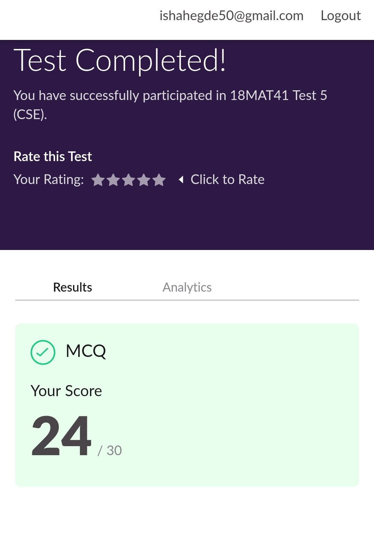

**CERTIFICATION COURSE:**

**Today I started with INTRODUCTION TO DIGITAL MARKETING.I completed the following topics given below and certificate will be provided once the course is done.**

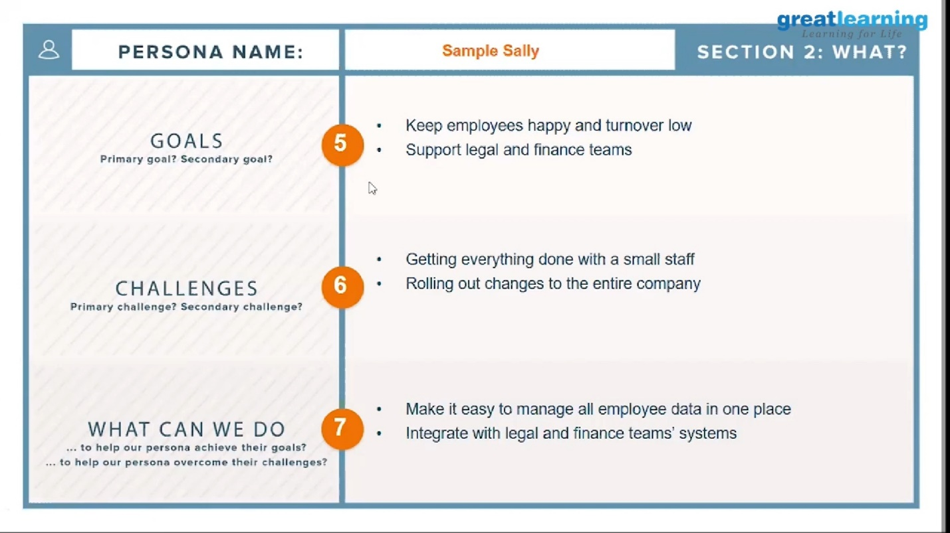

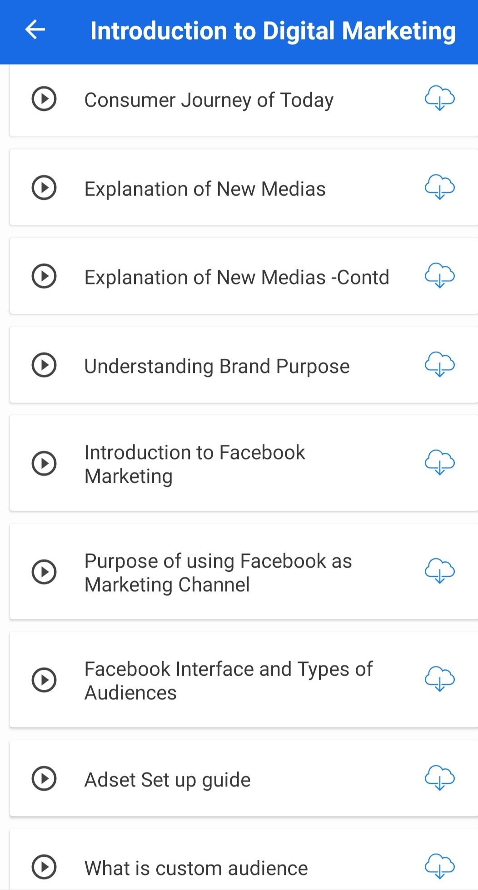

**Coding Challenges:**

Today I solved coding challenge,

1. **Write a Python program to check whether a given a binary tree is a valid binary search tree (BST) or not?**

