Today, I want to talk to you about a neighborhood Canarsie

answering one question: should a real estate brokerage open an office here?

S2

South Brooklyn

Canarsie offers a unique connection to the water that is missing in many central Brooklyn neighborhoods.

- Predominantly 1- and 2-family homes.
- Younger housing stock (1960s builds) with large closets and bedrooms.
- Tidy front yards, driveways, and private parking

S3 - Canarsie is a small but resilient residential neighborhood

Let me start with the big picture.

While wider Brooklyn and NYC sales dropped by nearly 50% after 2021, Canarsie's volume stayed relatively flat through that same period. That is unusual and important.

2. Canarsie's share of Brooklyn's total sales volume. It has grown consistently — from roughly 1% in 2021 to over 1.4% by 2025.

3. And the property mix 92.7% of all transactions are residential.Commercial activity is negligible at around 5%.

S4 - Price is a competitive advantage of Canarsie

Canarsie has consistently traded well below the borough and city averages.

While sales elsewhere were dropping by 50%, Canarsie’s numbers stayed steady.

The mean and median sale prices are nearly identical — $535,838 versus $525,000 — a gap of only 2.1%.

So, to answer the question: Is it growing or shrinking? In terms of market demand, it is growing. It has outperformed the broader market because it is a 'necessity' market, not a 'speculative' one. People aren't buying in Canarsie to flip a condo in six months; they are buying because they want a home.

S5 – Canarsie belongs to the Mid-Market cluster of NYC

cluster analysis across all 256 neighborhoods, using median price, price per square foot, transaction volume, and price variability.

Cluster 1 — Budget Basics

Cluster 2 — Mid-Market: This is where Canarsie lands. It's the most liquid tier of the entire NYC market — the highest average transaction counts by far, at 4,564 deals per neighborhood.
These neighborhoods generate the most brokerage volume.

Cluster 3 — Luxury: A small group of 39 neighborhoods — mostly Manhattan

Canarsie in the Mid-Market cluster means there is a deep, liquid pool of potential listings.

S6 – Around half of all sales in Canarsie are within one segment

Going deeper within Canarsie.

Segment 1 — Standard: These are the typical two-family attached brick homes. They represent 48.3% of all transactions — essentially half the market.

Segment 2 — Premium: Larger multi-unit properties.

Segment 3 — Entry: Single-family starter homes — ideal for first-time buyers.

A new brokerage should lead with Segment 1, the Standard category. It has the largest pool of listings, the broadest buyer base, and high liquidity.

S7 – Building class is the main price driver

what actually drives price per square foot

The most important findings:

- Sale year adds $16 per square foot annually
- Year built has a negative coefficient: -$0.65 per year newer. — likely because brick construction offers more durable materials than newer builds
- Each additional residential unit reduces price per square foot by $14.37. Higher density compresses value on a square-foot basis.
- Building class dominates the model. Three-family homes trade at nearly $99 per square foot less than the baseline, while certain "Other" classifications command a premium.

Now — the residual standard error is $113.99 per square foot. With Canarsie's median around $400 per square foot in recent years, that's still a wide miss range. The model captures the structure of the market well, but it cannot fully price individual properties. The callout here is critical: this is an opaque market where local expertise has real monetary value. A brokerage with agents who know specific blocks and building conditions will systematically outperform any algorithm.

S8 - Future volumes are unpredictable, massive uncertainty range

three distinct historical chapters.

2009 to 2013, the market was flat — a post-financial-crisis hangover.

2014 to 2019, there was a strong sustained uptrend peaking at 124 sales in a single quarter.

Then from 2020 onward: a COVID shock, and then a sustained decline driven by the Fed's rate hike cycle

the recent market data is too volatile to confidently project any historical pattern forward.
The forecast is 43 transactions per quarter for all four quarters of 2026.

But the 95% CI tell the real story – By Q4, the range runs from negative 1 to 87 sales. That is not a forecasting error — that is the market telling us it is uncertain right now.

S9 – We should open the Canarsie office

The optimal configuration under the base case is clear: 4.3% commission, zero employees, 6.6% market penetration, NPV of $215,512. That is a strong positive return.

Why 4.3%? It's the sweet spot that balances margin per deal against market share.

Why zero employees? The penetration gain from hiring — 0.5% per person — does not generate enough additional deal volume to recover a $65,000 annual salary.

Now — the scenario analysis introduces the honest risk. Under the conservative forecast, NPV flips to negative $72,649. The office loses money if the market contracts to the low-end volume scenario.

This means the Go/No-Go decision must include a first-quarter monitoring trigger. If Q1 transaction volume falls toward 12 deals rather than the projected 43, that is the signal to freeze operations before fixed overhead compounds the loss. The optimal configuration stays the same — but the strategic response to early data must be pre-planned.

Under the optimistic scenario, NPV reaches $503,713. The upside is real.

S10 – Target: volume-driven business with superior customer service

Act 2 — What drives price (45 sec) A3 regression. What property characteristics predict sale price in this neighborhood? This matters for the brokerage because it tells agents where to focus — which listings are worth pursuing, what differentiates high-value properties, and whether price is predictable or noisy.

Act 3 — Where the market is going (45 sec) A4 forecast. Is the market growing, declining, or flat? What does the confidence interval look like — wide or narrow? This is the uncertainty context for the As decision. A student whose A4 shows a declining market with wide Cls should be more cautious than one with strong growth and tight Cls

Act 4 — The decision (90 sec) A5. Should we open? What's the optimal configuration? What is the NPV under base and conservative forecasts? This is the answer to the whole project — everything before was evidence, this is the verdict.

Act 5 — The recommendation (30 sec) One clear sentence: open or don't open, at what commission rate and staffing level, and what's the single biggest risk that would change the answer.

Act 1

The NYC market experienced a slight cooling and stabilization between 2023 and 2025 following the post-COVID spike. The borough of Brooklyn largely mirrored this citywide trend. In contrast, the Canarsie neighborhood maintained a relatively stable volume, effectively outperforming the broader market and solidifying its reputation as a consistent middle-market residential hub.
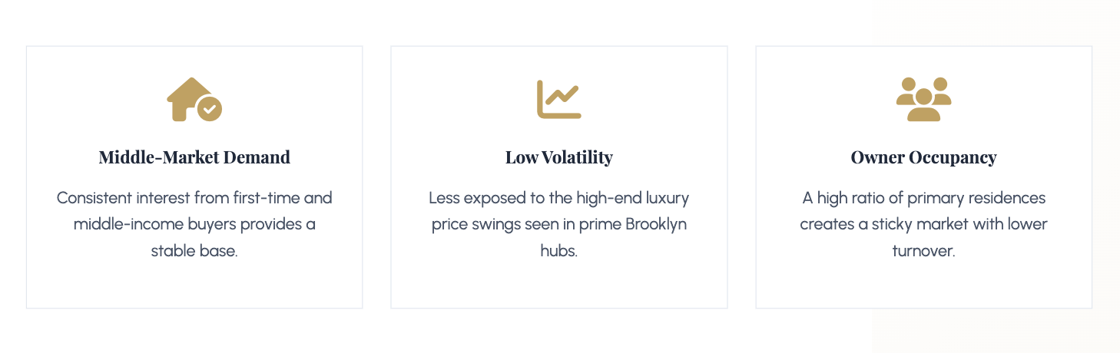
"Canarsie has proven to be much more resilient than the rest of the city... This stability shows that the neighborhood remains a high-demand spot for middle-market buyers."

A new brokerage should strategically focus on Standard (Segment 1 ) to
maximize revenue while minimizing market entry risk. This segment
represents nearly half 48.3% of the local market share, ensuring that agents
will have access to the largest possible pool of potential listings.
Furthermore, with a median price of $478,091, these homes are far more
affordable and liquid than those in the Premium segment ($744k), making
them highly attractive to a broad base of buyers and sellers alike.

Canarsie stands out as a resilient residential naberhood within the broader New York City landscape. Canarsie maintained a stable transaction flow, effectively outperforming the broader market. Especially the last three years years from 2023 to 2025 when the NYC market experienced a slight cooling after the post-COVID spike. The borough of Brooklyn largely mirrored this citywide trend. In contrast, the Canarsie neighborhood maintained a relatively stable volume, effectively outperforming the broader market and solidifying its reputation as a consistent middle-market residential hub. The neighborhood is almost exclusively residential (92.7%), and its footprint within Brooklyn is expanding; its share of the borough’s total sales volume grew from around 1% in 2021 to over 1.4% by 2025. Canarsie offers a highly predictable and stable pricing environment. The price risk is low, evidenced by a Coefficient of Variation of 0.41 and a very narrow gap of only 2.1% between the mean $535,838 and median $525,000 sale prices. This concentration suggests that most properties trade within a well-defined range, minimizing the danger of extreme price volatility. Interestingly, the correlation between building size and price is relatively weak (0.326), indicating that value in this market is less driven by raw square footage alone. For a brokerage, this means that neighborhood-specific knowledge will be more valuable than simple automated valuation models. Canarsie sits in the NYC Mid-Market cluster, the most liquid segment of the city characterized by the highest transaction counts. Within the neighborhood, the clear target for a new brokerage is the Standard (Segment 1) category, which consists of two-family homes. This segment represents nearly half 48.3% of all local activity, providing the largest possible pool of listings and high liquidity. The revenue opportunity is compelling: in 2025 alone, the neighborhood generated over $9.2 million in available commissions. By capturing 12.5% market share, a new firm could secure approximately $1.15 million in annual gross revenue. Given the neighborhood's growth trend, stable risk profile, and high inventory turnover, Canarsie represents a high-conviction opportunity for immediate market entry.

Act 3

The Canarsie residential real estate market is currently in a state of severe contraction after a long, historic
period of growth. While the 2010s saw steady expansion that peaked just before the pandemic, recent
macroeconomic pressures have erased those gains, leaving the market highly volatile and suppressed.
Consequently, the near-term forecast is extremely cautious. Rather than predicting a quick recovery or a
return to peak transaction volumes, the model projects a low, flat baseline of activity with an exceptionally
high degree of downside risk.

Act 5.

We should open the Canarsie office at a 4.3% commission rate with zero salaried employees, provided we immediately reverse course if first-quarter transaction volumes drop toward our conservative forecast.

'Why'
"This specific, lean configuration maximizes our Net Present Value at $215,512. It hits the perfect mathematical sweet spot between margin and market share, and avoids the $65,000 salary hurdle that our model proves is unprofitable to cross."

The Single Biggest Risk (20-30s):
"But here is the single biggest risk that changes my answer: severe market contraction. If early registry data shows transaction velocity sliding down toward our conservative floor of just 12 deals, our fixed overhead will instantly bleed capital, and we must execute a pre-planned exit."

