SatQuery AI - Temporal Analysis Report
Generated automatically by SatQuery Geospatial AI Pipeline.

Professional Temporal Analysis of Provided Geospatial Indices (2023-2026)
---
#### Data Summary:
| Date | NDVI | NDWI | NDBI | NBR |
|-----------|--------|--------|--------|--------|
| 2023-09 | 0.392 | -0.298 | -0.231 | 0.374 |
| 2023-12 | 0.292 | -0.234 | -0.135 | 0.267 |
| 2024-03 | 0.308 | -0.260 | -0.189 | 0.321 |
| 2024-06 | 0.340 | -0.281 | -0.142 | 0.283 |
| 2024-09 | 0.396 | -0.327 | -0.185 | 0.329 |
| 2024-12 | 0.296 | -0.231 | -0.168 | 0.279 |
| 2025-03 | 0.299 | -0.261 | -0.168 | 0.304 |
| 2025-06 | 0.209 | -0.168 | -0.092 | 0.210 |
| 2025-09 | 0.197 | -0.117 | -0.149 | 0.302 |
| 2025-12 | 0.358 | -0.257 | -0.167 | 0.336 |
| 2026-03 | 0.344 | -0.385 | -0.028 | 0.172 |
---

Index Definitions and Implications:
- NDVI (Normalized Difference Vegetation Index): Indicator of live green vegetation.
- NDWI (Normalized Difference Water Index): Indicator of surface water content.
- NDBI (Normalized Difference Built-up Index): Indicator of built-up or urban areas.
- NBR (Normalized Burn Ratio): Indicator related to burnt areas or vegetation stress.
---

1. NDVI Temporal Analysis (Vegetation Health & Density):
- NDVI peaks around 0.392 - 0.396 in Sep 2023 and Sep 2024, indicating high vegetation growth during late summer/early autumn.
- There is a notable decline starting mid-2025, with the lowest values recorded in June and September 2025 (~0.197-0.209), suggesting reduced vegetation vigor or coverage.
- Recovery is observed by December 2025 and March 2026 (~0.344-0.358).
- Seasonality is evident with higher NDVI values in late summer/fall and lower in winter/spring, consistent with temperate vegetation cycles.
---

2. NDWI Temporal Analysis (Water Content & Moisture Conditions):
- NDWI values are consistently negative, indicating limited surface water or dry conditions across the timeline.
- The lowest value (-0.385) occurs in March 2026, implying a potentially dry or stressed moisture state during this time.
- Comparatively, NDWI increases slightly in mid-2025 (-0.168 to -0.117 in June and September), possibly indicating transient moisture increase.
- Overall, the dataset suggests fluctuating but generally low water availability or soil moisture, potentially affecting vegetation.
---

3. NDBI Temporal Analysis (Built-Up / Urban Expansion):
- Negative values throughout the period imply a predominance of non-urban land cover.
- An upward trend in NDBI values occurs from late 2023 (-0.231) to March 2026 (-0.028), indicating slight increase in built-up or urbanized areas.
- March 2026 shows the least negative value, potentially reflecting urban growth or land-use change.
- Some fluctuations are present, but the general trend toward less negative values is notable.
---

4. NBR Temporal Analysis (Burn Severity / Vegetation Stress):
- Highest values (~0.374 in Sep 2023) suggest low burn impact or high vegetation health initially.
- There is a decline over time, with notable low of 0.172 in March 2026, which may indicate increasing stress, degradation, or minor burn effects.
- Intermediate oscillations correlate roughly with seasonal NDVI trends.
- The decreasing NBR trend could warrant monitoring for possible vegetation degradation or fire risk.
---

Integrated Interpretation:
- Vegetation Dynamics: Strong seasonal vegetation growth correlates with typical phenology but shows a mid-term decline in 2025, potentially due to environmental stressors.
-

Raw Geospatial Statistics (GEE)
Date | NDVI (Veg) | NDWI (Water) | NDBI (Urban) | NBR (Burn)
2023-09 | 0.392 | -0.298 | -0.231 | 0.374
2023-12 | 0.292 | -0.234 | -0.135 | 0.267
2024-03 | 0.308 | -0.26 | -0.189 | 0.321
2024-06 | 0.34 | -0.281 | -0.142 | 0.283
2024-09 | 0.396 | -0.327 | -0.185 | 0.329
2024-12 | 0.296 | -0.231 | -0.168 | 0.279
2025-03 | 0.299 | -0.261 | -0.168 | 0.304
2025-06 | 0.209 | -0.168 | -0.092 | 0.21
2025-09 | 0.197 | -0.117 | -0.149 | 0.302
2025-12 | 0.358 | -0.257 | -0.167 | 0.336
2026-03 | 0.344 | -0.385 | -0.028 | 0.172

Latest Geospatial Index Visualizations

Normalized Difference Vegetation Index (NDVI)
- Measures the density and health of vegetation in the area.
- 🔴 Red/Orange: Barren land or built-up areas | 🟢 Green: Dense, healthy vegetation.
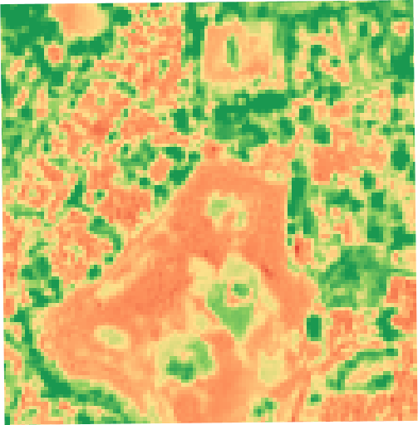

Normalized Difference Water Index (NDWI)
- Highlights water bodies and tracks moisture content in plants and soil.
- ⚪ White/Light Blue: Dry land or shallow water | 🔵 Deep Blue: Deep, clear water bodies.
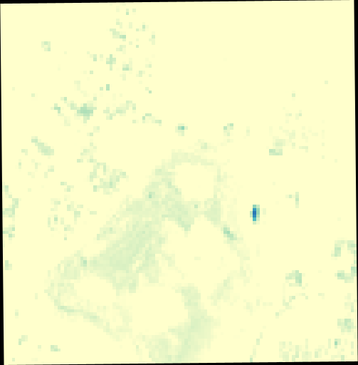

Normalized Difference Built-up Index (NDBI)
- Emphasizes urban areas, buildings, and impervious surfaces.
- ⚪ White/Yellow: Non-urban areas or vegetation | 🔴 Red: Dense urban built-up areas.
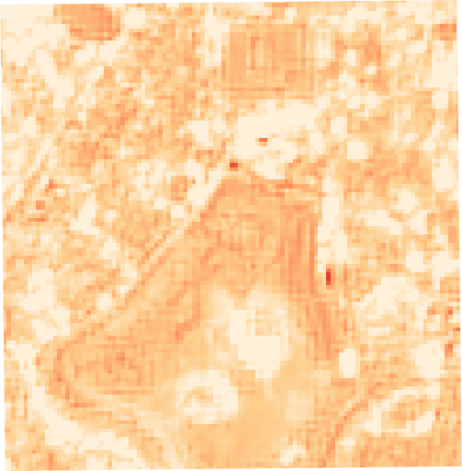

Normalized Burn Ratio (NBR)
- Used to identify burned areas, fire severity, and vegetation survival.
- 🟡 Yellow/Orange: Healthy vegetation or unburned land | ⚫ Dark Red/Black: Severe burn scars.
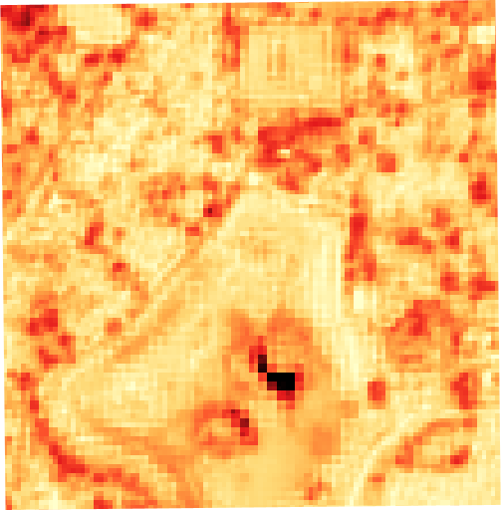

Time-Lapse Video
View the generated time-lapse animation here: https://earthengine.googleapis.com/v1/projects/gen-lang-client-0663284532/videoThumbnails/ddf59c8527c2c73f101a6c81c689e392-b9f95447d2e9bdd7785e4e7f5c979e35:getPixels

