SatQuery AI - Spatial Analysis Report
Generated automatically by SatQuery Geospatial AI Pipeline.

Mapbox Visual Reference (Visualization Only)
This high-resolution satellite imagery is provided by Mapbox strictly for visual context. It is NOT used for any scientific calculations or index measurements.
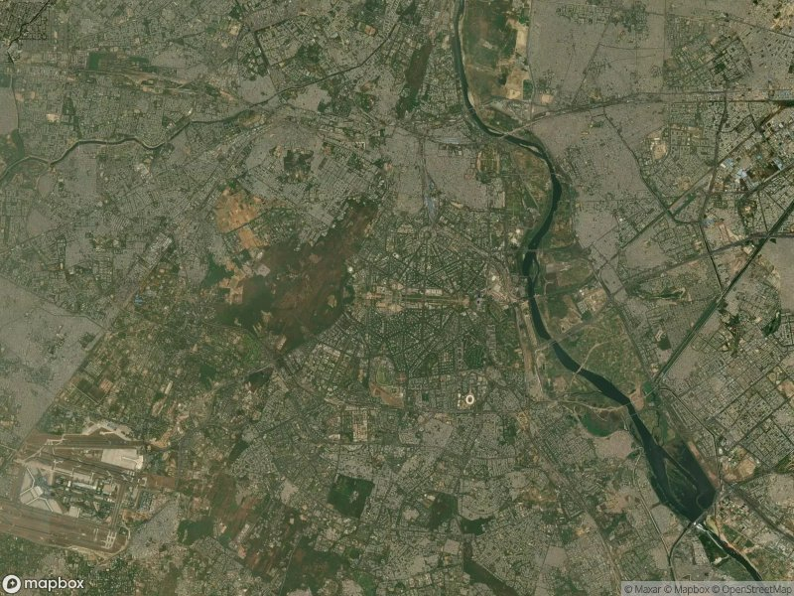

Study Area and Context
The study area for this spatial analysis is Delhi, India, a densely populated metropolitan region and the capital of India. Delhi’s landscape is characterized by a complex mix of urban environments, green spaces such as parks and agricultural land, as well as water bodies including the Yamuna River. Given its rapid urbanization and diverse land use, monitoring key environmental indicators such as vegetation health, water presence, and urban expansion is crucial for sustainable urban planning and environmental management.

Satellite Data Information
The analysis is based on satellite data from Sentinel-2, acquired through the Google Earth Engine platform. The observation date is 23rd September 2026, which corresponds to the post-monsoon season in Delhi, a period where residual vegetation may still be present and water bodies may reflect seasonal variability. Sentinel-2 provides high-resolution multispectral imagery suitable for assessing vegetation, water bodies, urban development, and burn severity through well-established spectral indices.
The indices and their derived values for this study are as follows:
- NDVI (Normalized Difference Vegetation Index): 0.408
- NDWI (Normalized Difference Water Index): -0.404
- NDBI (Normalized Difference Built-up Index): -0.071
- NBR (Normalized Burn Ratio): 0.226

Spatial Findings (Vegetation, Water, Urban)

Vegetation (NDVI = 0.408)
An NDVI value of 0.408 indicates a moderate presence of healthy vegetation across the study area. This suggests that despite the heavily urbanized nature of Delhi, there remain patches of vegetated areas such as urban parks, agricultural zones, or peri-urban greenery that maintain moderate photosynthetic activity. Post-monsoon conditions typically support residual vegetation growth, which aligns with this moderate NDVI level.

Water (NDWI = -0.404)
The NDWI value of -0.404 is strongly negative, indicating sparse or minimal surface water presence in the study area at the time of observation. This is consistent with the late September period after monsoon withdrawal, when many ephemeral water bodies dry up and river flow decreases. The Yamuna River and other water bodies likely have reduced water extent or turbidity affecting detection.

Urban (NDBI = -0.071)
A slightly negative NDBI value close to zero suggests that urban built-up areas are present but not overwhelmingly dominant in the pixel or scene sampled. Generally, positive NDBI values denote dense built-up zones. In this context, the negative but close to zero value may reflect a mixed urban-vegetation landscape where built-up surfaces coexist with green cover, characteristic of Delhi’s heterogeneous fabric.

Burn Severity (NBR = 0.226)
The NBR value of 0.226 is relatively low, indicating negligible to minor burn impacts within the study area. This is expected, as Delhi is an urban environment with limited forest cover and a low likelihood of recent widespread fire events. The value suggests the area is largely unburnt or experiencing low risk for fire disturbance.

Interpretation & Conclusion
The Sentinel-2 derived indices for Delhi on September 23, 2026, present a nuanced picture of the city’s environmental condition during the post-monsoon season. Moderate NDVI values point to the persistence of urban greenery and vegetated patches, which are vital for mitigating urban heat and improving air quality. The strongly negative NDWI indicates limited water availability on the surface, potentially signalling water stress or seasonal dry-down of open water bodies, an important consideration for water resource management in the city.
The near-zero negative NDBI suggests a spatially intermixed landscape where urban built-up areas blend with vegetation rather than dominating it completely. This aligns with Delhi’s mixed land use pattern and underscores the importance of preserving urban green spaces amid ongoing development. Finally, the low NBR confirms an absence of recent burn scars, reflecting the low likelihood of fires within this urban context.
Overall, the spatial metrics highlight the interplay between urbanization, vegetation health, and water availability in Delhi. Continuous monitoring using Sentinel-2 indices will allow city planners and environmental managers to track changes in vegetation cover, urban expansion, and water resources, supporting sustainable urban development and ecological resilience in one of the world’s fastest-growing megacities.

Raw Geospatial Statistics (GEE-Derived)
All scientific metrics, indices, and findings are derived directly from Google Earth Engine satellite observations.
NDVI (Vegetation) | NDWI (Water) | NDBI (Urban) | NBR (Burn)
0.408 | -0.404 | -0.071 | 0.226

GEE-Derived Scientific Results (Visualizations)

Normalized Difference Vegetation Index (NDVI)
- Measures the density and health of vegetation in the area.
- 🔴 Red/Orange: Barren land or built-up areas | 🟢 Green: Dense, healthy vegetation.
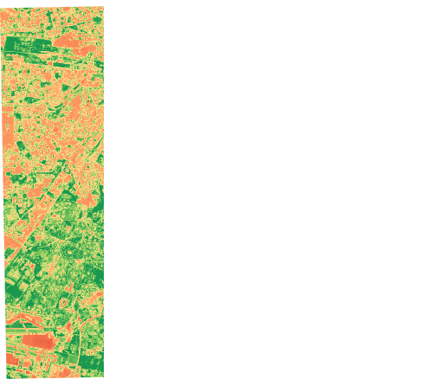

Normalized Difference Water Index (NDWI)
- Highlights water bodies and tracks moisture content in plants and soil.
- ⚪ White/Light Blue: Dry land or shallow water | 🔵 Deep Blue: Deep, clear water bodies.
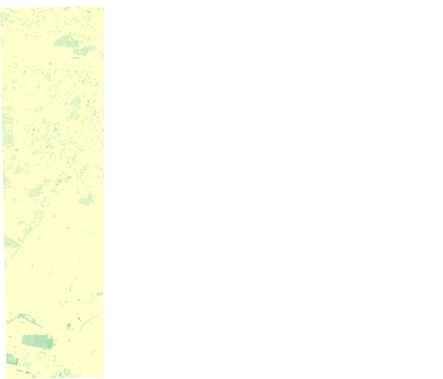

Normalized Difference Built-up Index (NDBI)
- Emphasizes urban areas, buildings, and impervious surfaces.
- ⚪ White/Yellow: Non-urban areas or vegetation | 🔴 Red: Dense urban built-up areas.
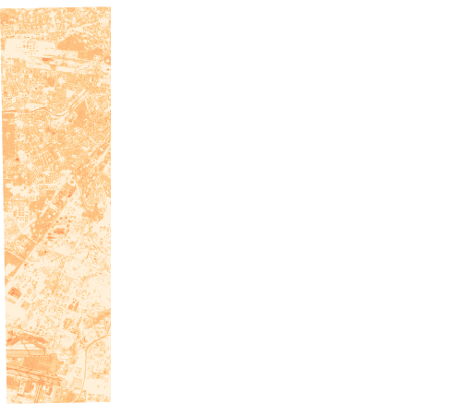

Normalized Burn Ratio (NBR)
- Used to identify burned areas, fire severity, and vegetation survival.
- 🟡 Yellow/Orange: Healthy vegetation or unburned land | ⚫ Dark Red/Black: Severe burn scars.
