**[Note: Later parts of this document try to capture aspects relevant to the hardware setup of the array configuration considered for the multi-channel recording.]**

### 18 Jan 2017

#### Linear array

In addition to the quad-array / circular array suggested earlier. A possible linear array configuration is shown in Fig.1. This includes non-uniformly placed microphones and similar to a Kinect array. The non-uniform placement gives us flexibility in using various combination of microphone pair distances (d). We are limiting it to have eight microphones because of the 8-channel data acquisition setup.

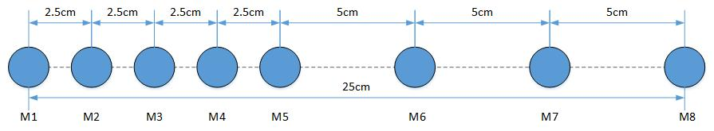

**Fig. 1 Recommended linear array configuration.**

### 13 Jan 2017

#### Recommended setup and array configuration for multi-channel speech recording

We are interested in recording two streams of speech data.

* First stream is the baseline data to record the speaker data, using close talking microphones (collar mic). We will have three or four persons speaking (wearing this microphone) as if in a meeting and will be seated around a table.
* Second stream is the array data. Here the array consists of four or more microphones depending on those needed for the participants.
  + One recommended array configuration is a quad array (M2, M4, M6, and M8 microphones shown in ‘black’) as shown in Fig.1, assuming four microphones are available for the array. The radius of the underlying circle is R=10cm. We are using alternate microphones in a potential circular array. It is recommended that the fabrication be flexible to accommodate the complete 8-microphone circular array with an additional one at the center. If there are five microphones available then the center microphone M9 can be included with M2, M4, M6, and M8.
  + It is recommended that the approximate distance (D) between the source and microphone center be more than 70cm and less than or equal to 120cm (1.2m). i.e., 70cm < D ≤ 120cm.
  + It is assumed that the participants be seated around the table, with the array at the center of the table, having a minimum separation of about 45- to 60-degree in azimuth.

Together, we will be recording a maximum of 8 channels of speech data using the hardware setup provided in the laptop.

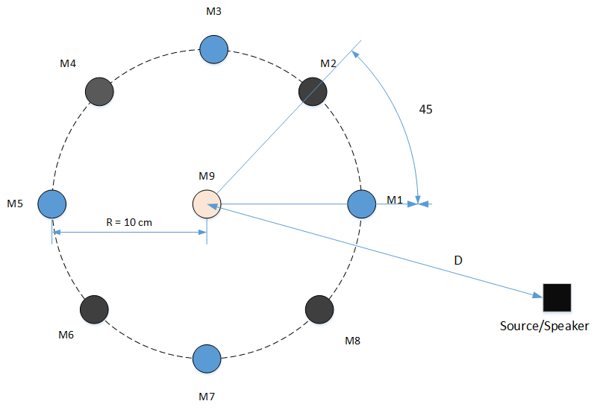

**Figure 2 Recommended array configuration is the quad array formed by M2, M4, M6, and M8 (microphones shown in black).**

### 5 Jan 2017

#### Images of the setup at IIT Bombay

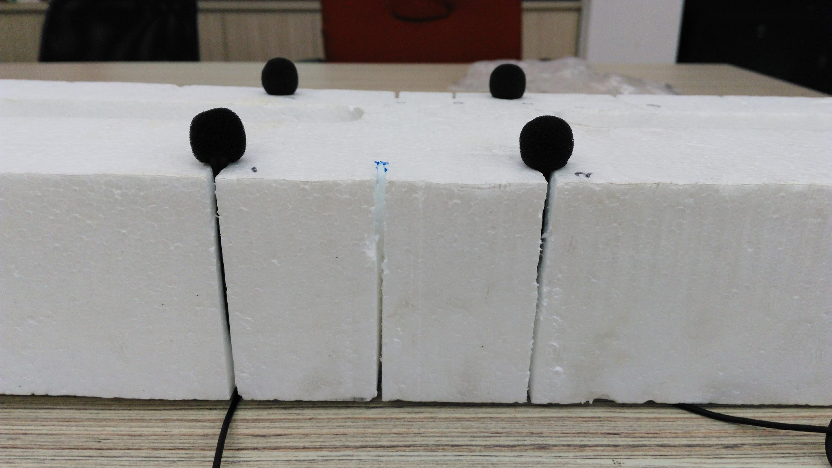

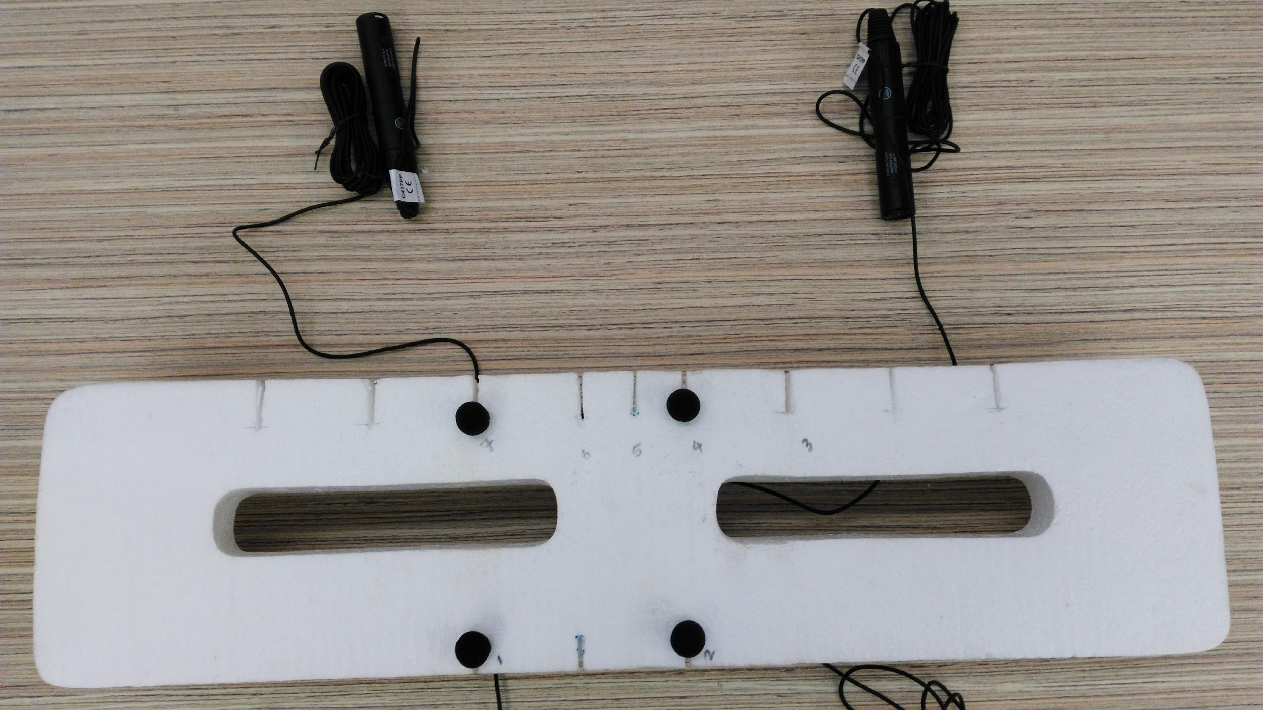

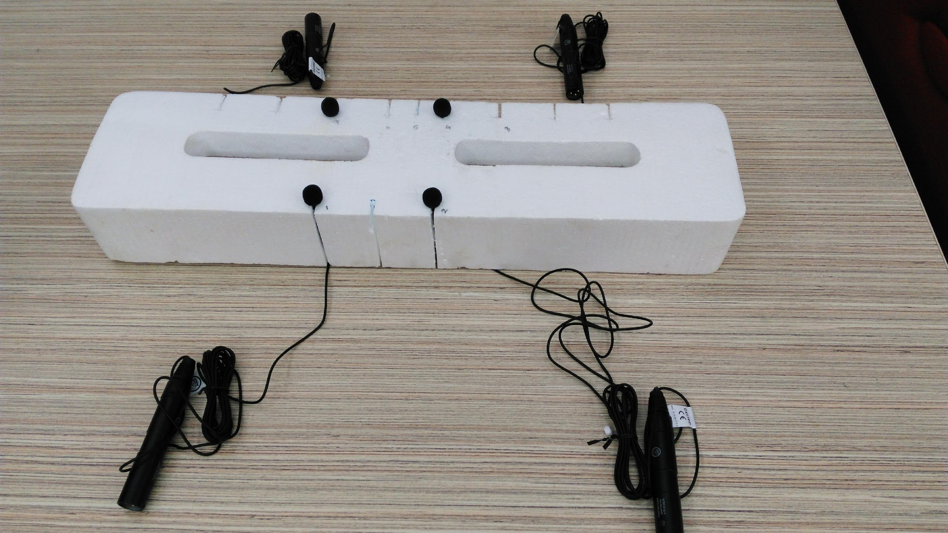

**Figure 3 Three images showing microphones mounted on a thermocol setup at IIT Bombay.**

### 3 Jan 2017

#### Microphone used

The microphone to be used in the array is AKG C 417 PP condenser microphone shown in Fig.4, Fig.5, and Fig. 6. The specification of the microphone is available in the following link:

<http://www.akg.com/pro/p/c417group>

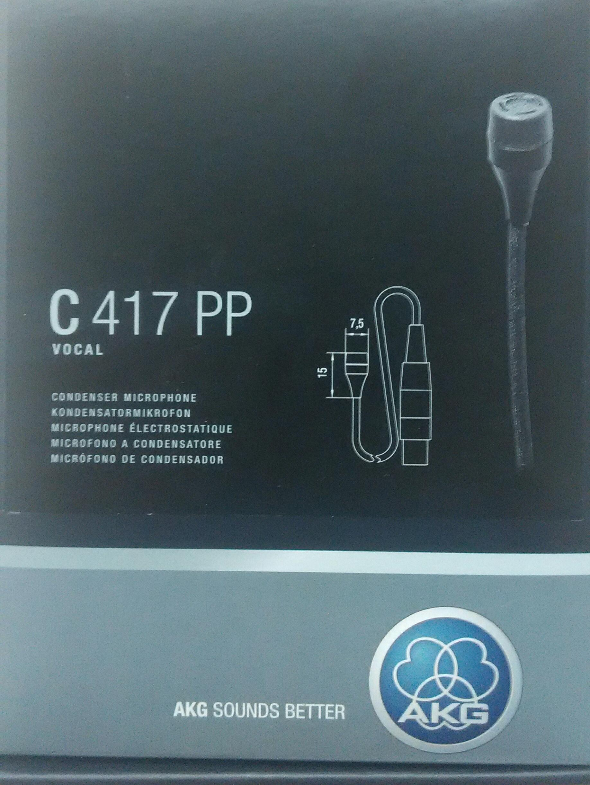

**Figure 4 Image of the microphone package.**

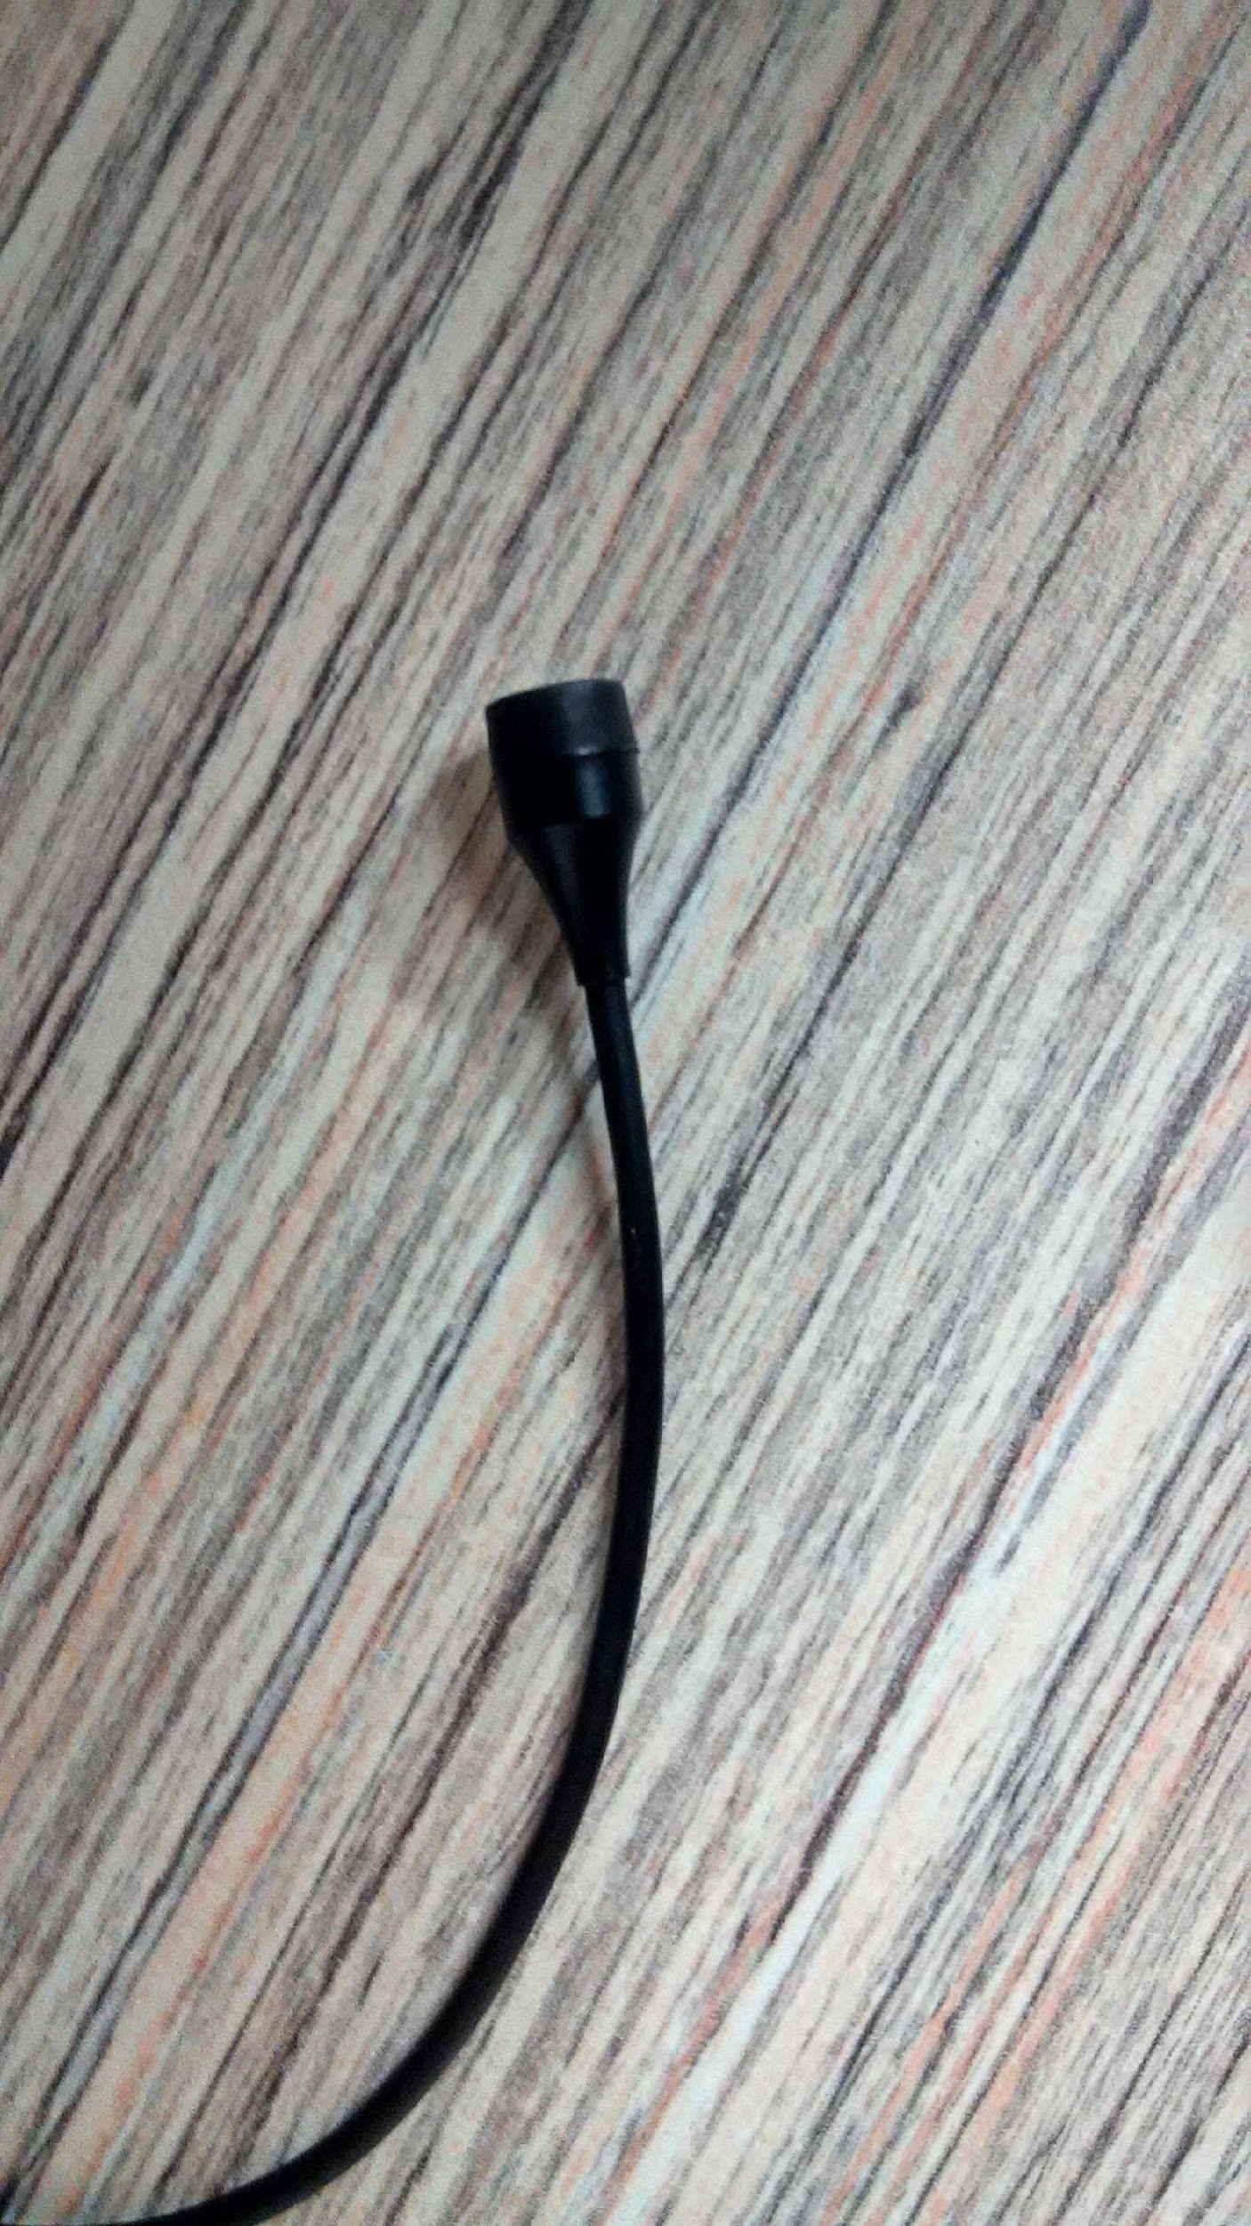

**Figure 5 Image of the AKG C 417 PP condenser microphone.**

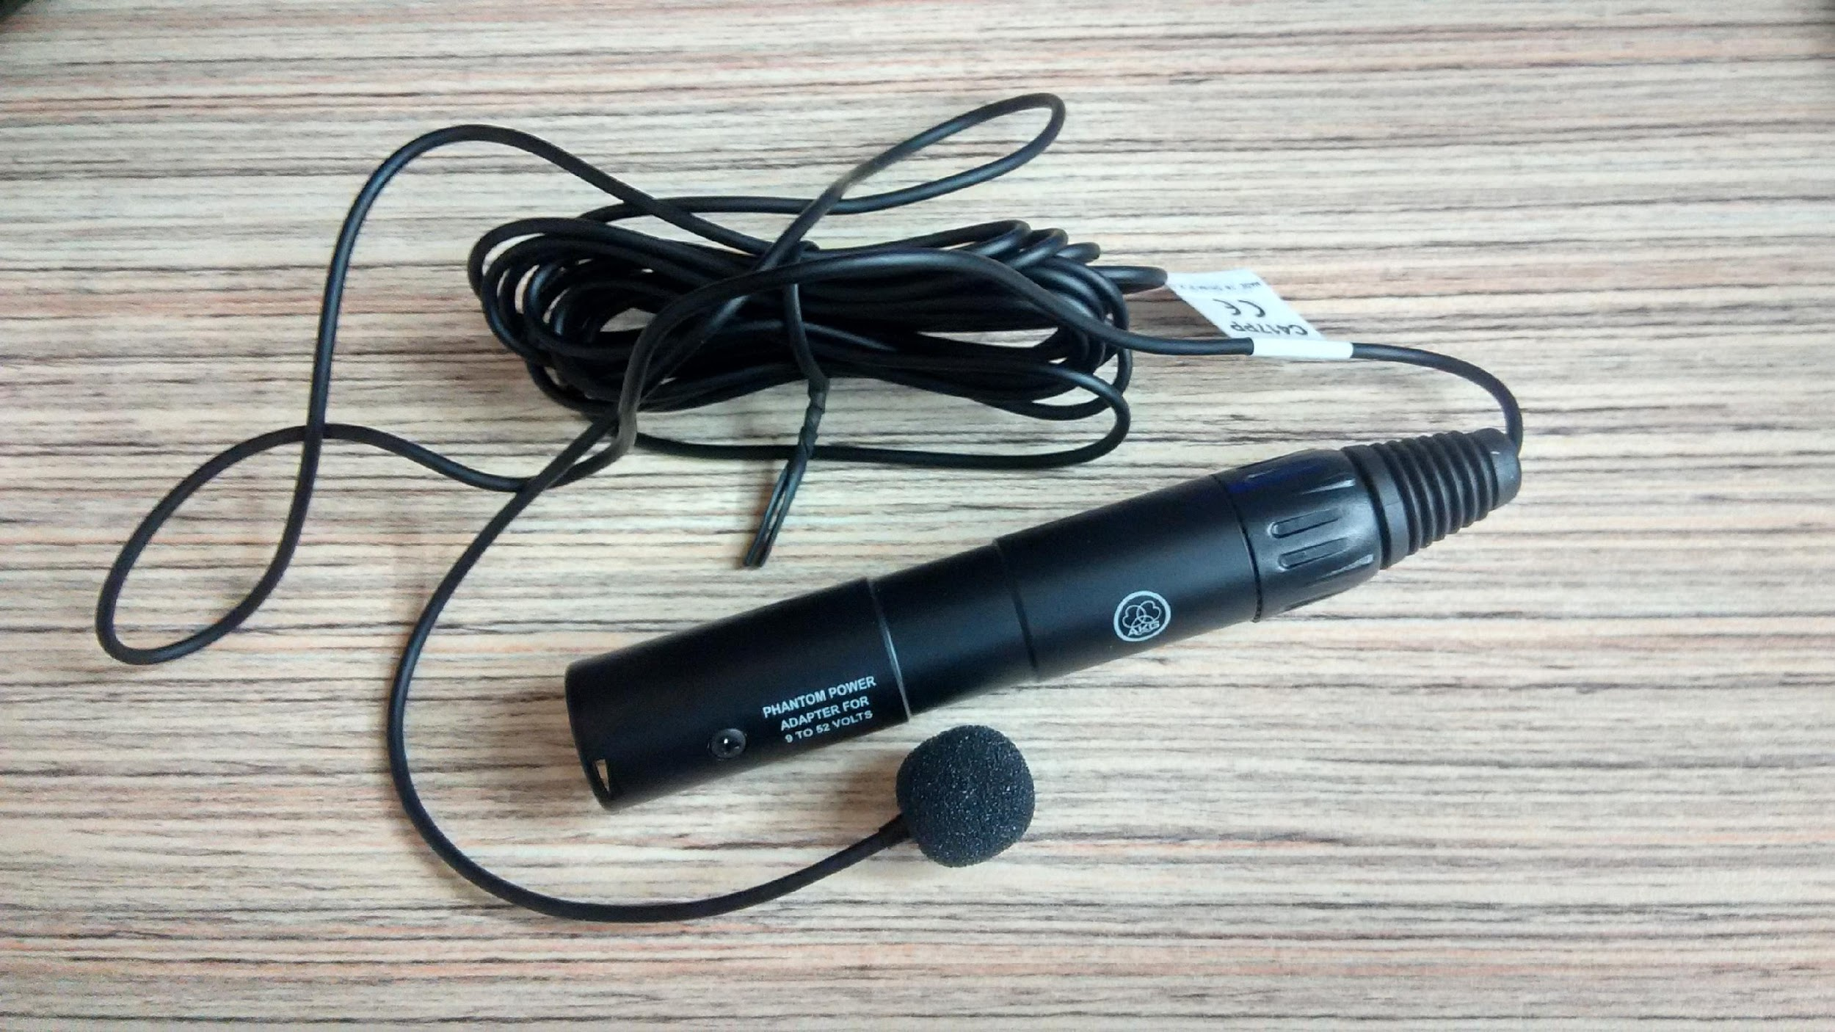

**Figure 6 Image of the microphone along with its phantom power adapter.**

### 24 Jul 2016

#### Plan for multi-channel recording setup

Objective:

We are interested in recording two streams of speech data.

* First stream is the baseline data to record the speaker data using close talking microphones (collar or lavalier mic). We will have 3 or 4 persons speaking (wearing this microphone) as if in a meeting and will be seated around a table.
* Second steam is the array data. Here the array consists of 3 or 4 microphones placed linearly and equispaced. One possible set up is where they are equispaced by 20cm from each other, .i.e., the array is about 60cm longer. This linear array is to be placed on a table possibly at about 30cm from the edge of the table.

Together, we will be recording a maximum of 8 channels of speech data. We need to have these speech data synchronized in time and be recorded in a laptop or PC. The whole setup needs to be portable.

Proposed setup:

* Having omnidirectional, mics with similar characteristics will be useful. Hence, we will plan to have the array also use the mic used by the speaker (collar mics).
* AKG C417 PP (corded) microphones to be used as collar mics – 4 nos.
* AKG C417 PP (corded) microphones to be used as array element – 4 nos.
* M-Audio M-Track Eight is a 8 channel USB 2.0 audio interface – 1no.

(this can take as inputs the above 8 channels. It also provides phantom power, which the above microphones can use.)

* 8 - XLR cables to connect the microphones to the M-Audio M-Track
* Array mount to hold 4 AKG C417 PP microphones – 1 no.

(this is something we are not able to find the appropriate one. Some references are given below)

Microphone choice - additional notes:

* The AKG C417 PP seems to be equivalent to the Sennheiser MKE 2 PC that was used in the AMI Corpus recording. The MKE 2 PC and an equivalent wireless version (MKE 2 EW) were used as the circular array elements and collar microphones, respectively.

Array mount: (some initial ideas)

* A uniform circular array (UCA) mount for a different microphone configuration was configured in IISc and built using 3D printing. This is shown in Fig. 7. (expecting to get more specific information from them). Their microphones are Sennheiser ME62/K6 meant for outdoor or noisy recording.
* Another one I saw was this (in Fig. 8) This is from Sabra-Som, but I am not sure about its availability in India or if there are equivalents. Its probably designed to be placed on ground, but might be of use.

http://www.bhphotovideo.com/c/product/272483-REG/Sabra_Som_ST4_ST_4_Quad_Microphone.html

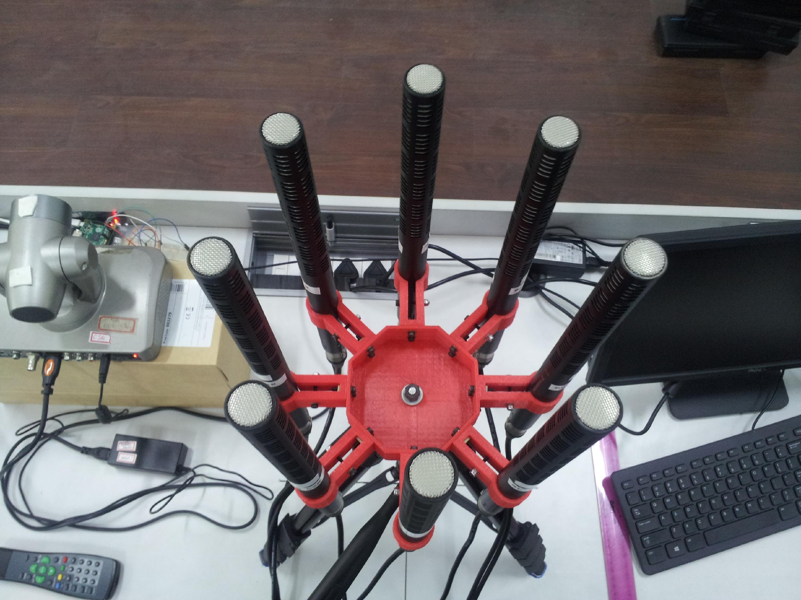

**Figure 7 Uniform circular array (UCA) fabricated at IISc to hold ME 62/K6 microphones. This was done using 3D printing.**

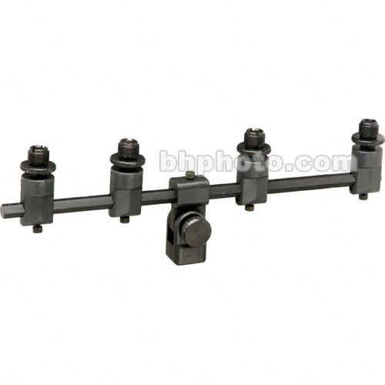

**Figure 8 Sabra-Som ST-4 Universal quad microphone T support with 3/8" and 5/8" threading.**