SMART LABORATORY ON CLEAN RIVERS
User Manual
How to use the Holistic River Management system
For: Everyday users, field staff and the data administrator
System: Holistic River Management – Decision Support System (Holistic module, Ideum / Split view, data upload)
Version: 1.0 · Date: 28 October 2026

Contents
1. About the system
2. Getting started
2.1 Home page
2.2 Signing in and out
3. Uploading data (administrator only)
4. Holistic module
5. Ideum – Split view
6. Saving and reopening your work
7. Map tools at a glance
8. Questions and problems

1. About the system
The Holistic River Management system shows river data on a map so you can study an area and compare information side by side. Data is grouped under six pillars, called Ganga categories:
Category | What it covers
Aviral Ganga | River flow, rainfall, groundwater recharge, terrain (DEM, slope), flow direction
Nirmal Ganga | River and groundwater quality, STPs, drains, industrial discharge
Jan Ganga | Population, gram panchayats, community participation
Arth Ganga | Agriculture, irrigation, tourism, heritage, economic activity
Gyan Ganga | Baseline datasets, remote sensing, SWAT models, monitoring stations
Jeevant Ganga | Wetlands, riparian vegetation, biodiversity, floodplains

Who can do what
Person | Needs to sign in? | Can do
Visitor / user | No (only to save work) | Open the Holistic module and Ideum, pick zones, draw areas, view and clip data
Signed-in user | Yes | Everything above, plus save sessions and reopen them from History
Data administrator (superuser) | Yes | Everything above, plus upload, retry and delete data
Tip: There is no sign-up page. Accounts are created by the administrator (see section 3.6).

2. Getting started

2.1 Home page
Open the website. The home page has two main buttons:
- Open Holistic module – step-by-step analysis of the six categories.
- Split view (also called Ideum) – a big map with a control panel and extra screens for comparing.
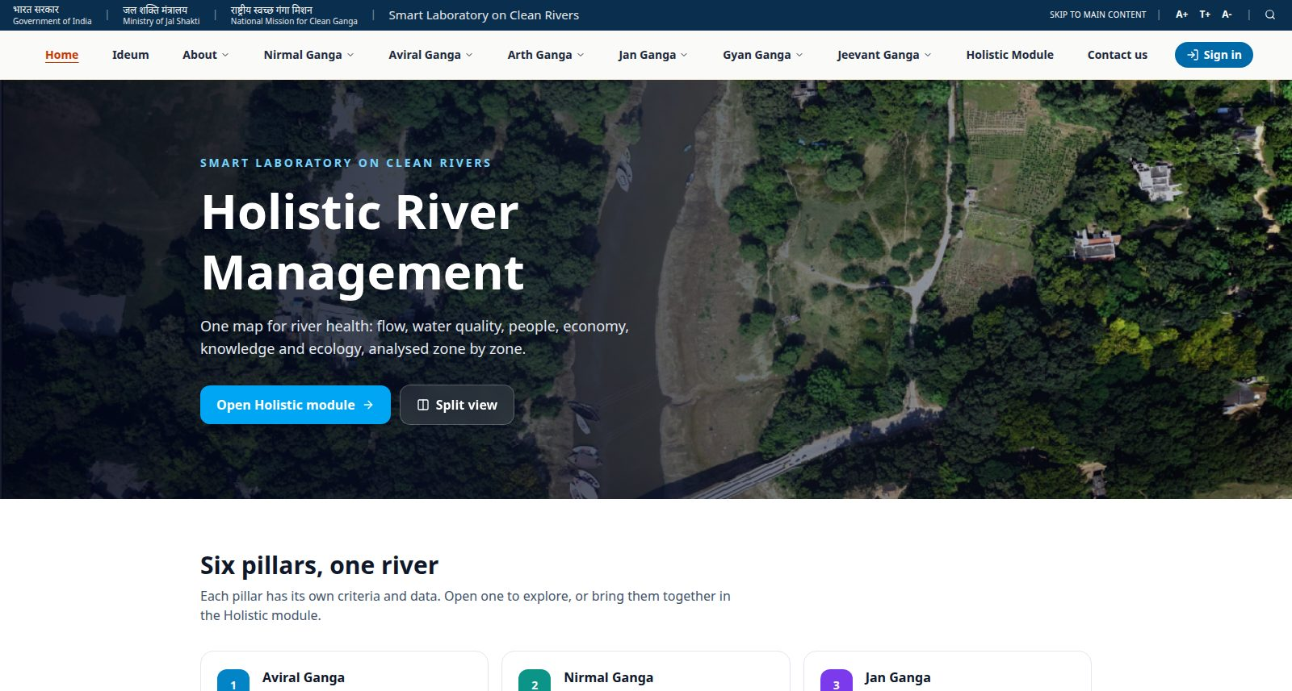
Figure 1: Home page
Scroll down to see the six pillars. Click a pillar card to open that category's information pages.
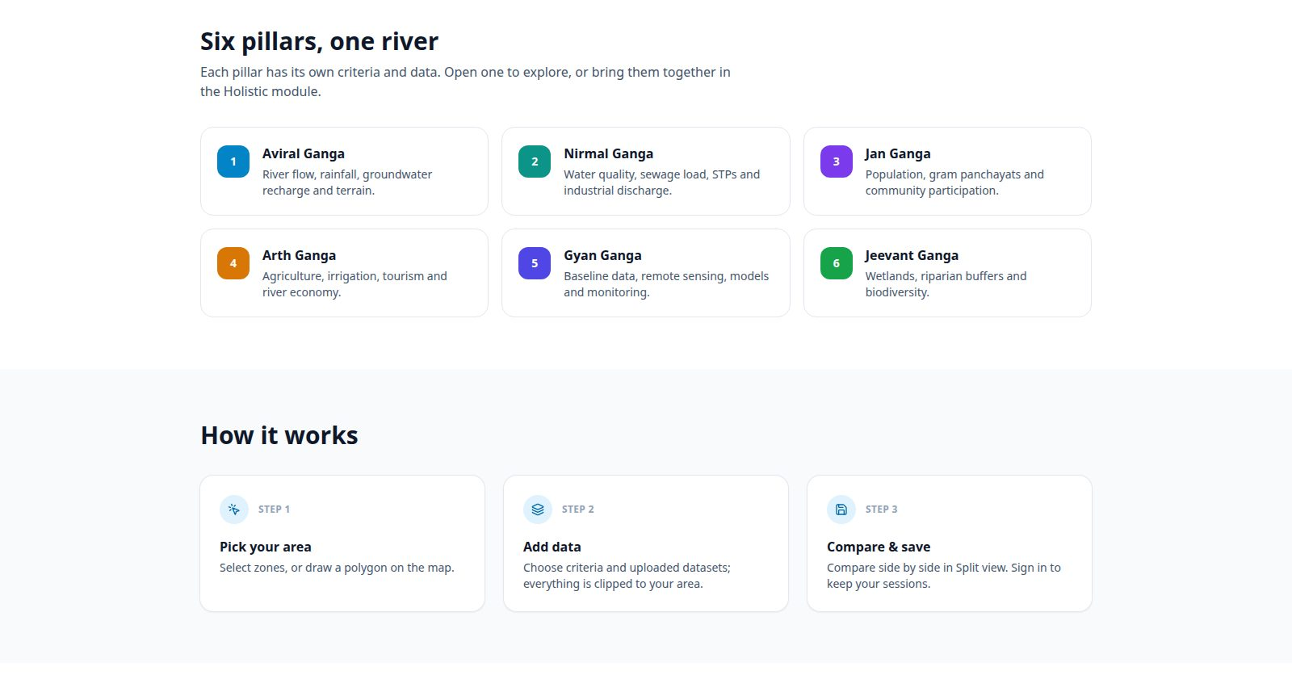
Figure 2: The six pillars and how it works

2.2 Signing in and out
- Click Sign in at the top right of the menu bar.
- Type your email and password given by the administrator.
- Click Sign in. You are taken to the Holistic module.
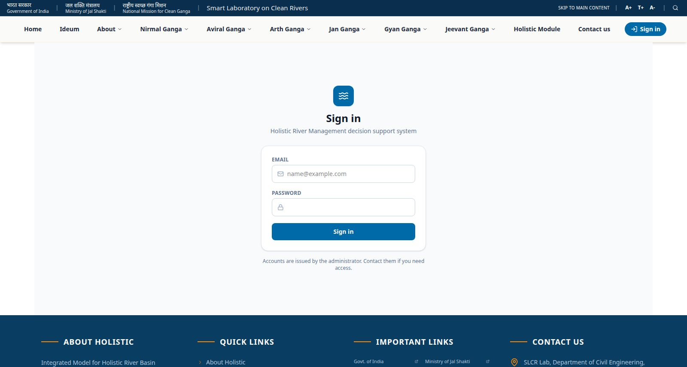
Figure 3: Sign-in page
Tip: This Sign in is for users. Administrator accounts cannot sign in here – they use Admin (data upload) in the footer (section 3).
After signing in, your name appears at the top right. Click it to see your role, open Data upload (administrators only) or Sign out.
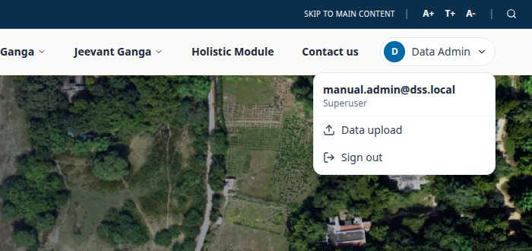
Figure 4: User menu after signing in
Tip: You do not need to sign in to look at maps and data. You are only asked to sign in when you save a Split session.

3. Uploading data (administrator only)
Administrators have their own sign-in page:
- Scroll to the bottom of any page and click Admin (data upload) under Quick Links.
- The Administrator sign in page opens. Enter the administrator email and password. (User accounts are refused here.)
- The Data upload page opens. Without an administrator sign-in this page never opens.
The left side is the upload form; the right side lists everything already uploaded. While signed in, Data upload is also in your name menu at the top right.
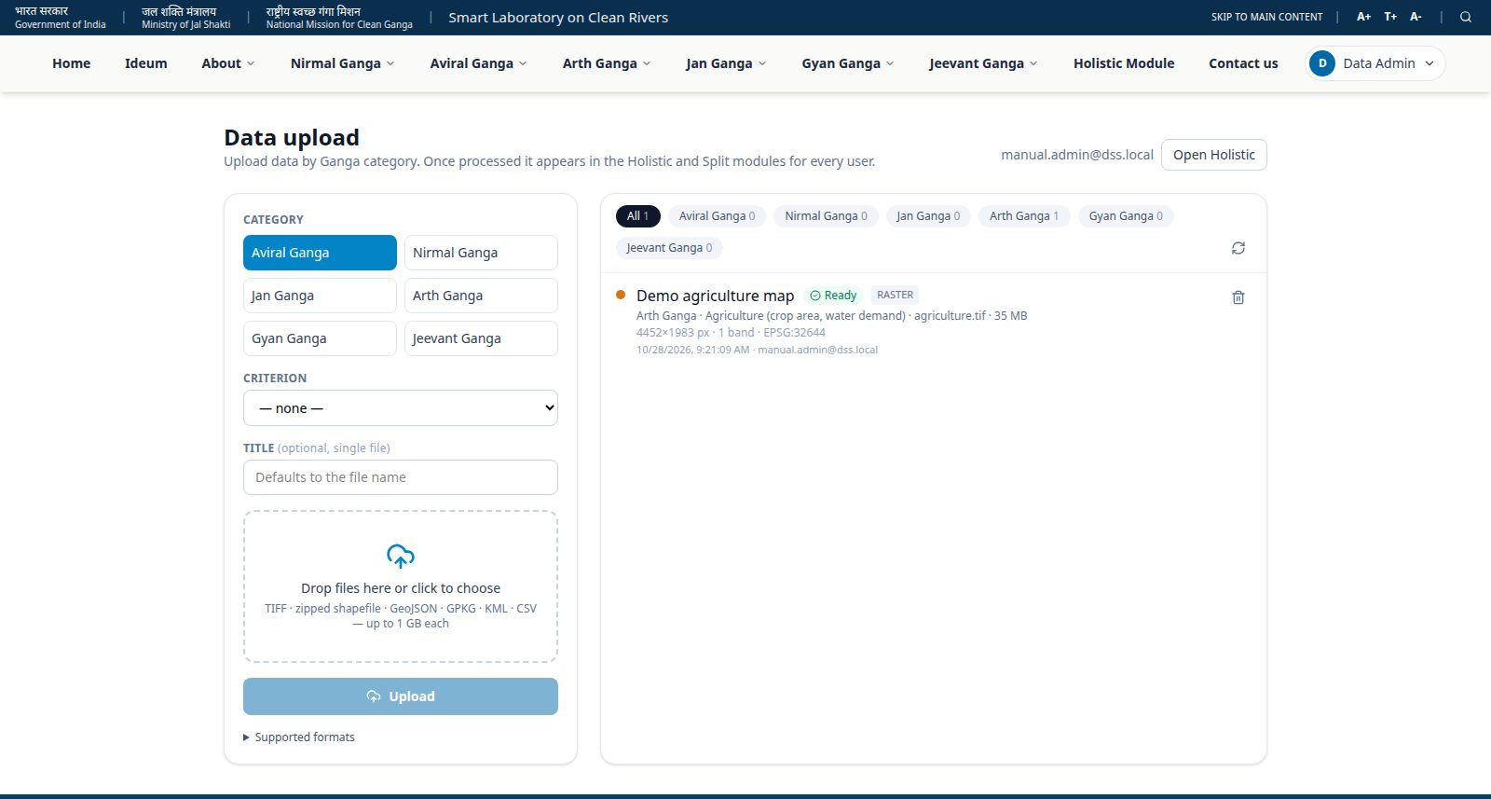
Figure 5: Data upload page

3.1 Upload a file
- Click the Category the data belongs to, e.g. Aviral Ganga.
- Choose a Criterion from the list, e.g. Rainfall & runoff. Choose Other… to type your own.
- Optional: type a Title. If left empty, the file name is used.
- Drag files into the dashed box, or click it to choose files. You can choose several files at once.
- For a CSV without coordinates you may type the zone column name. If left empty the system finds it.
- Click Upload. A progress bar shows each file.
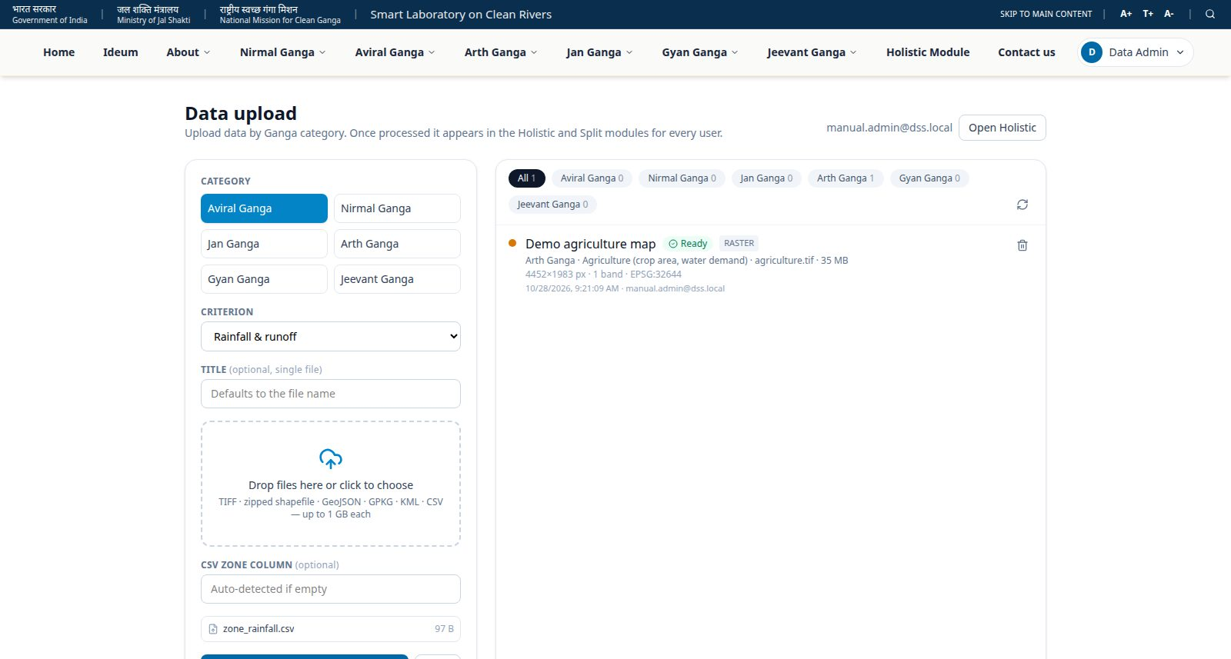
Figure 6: Category, criterion and file chosen
After upload the file is processed on the server. Its status changes from Processing to Ready (the list refreshes by itself). Ready data appears immediately for every user in the Holistic module and in Ideum.
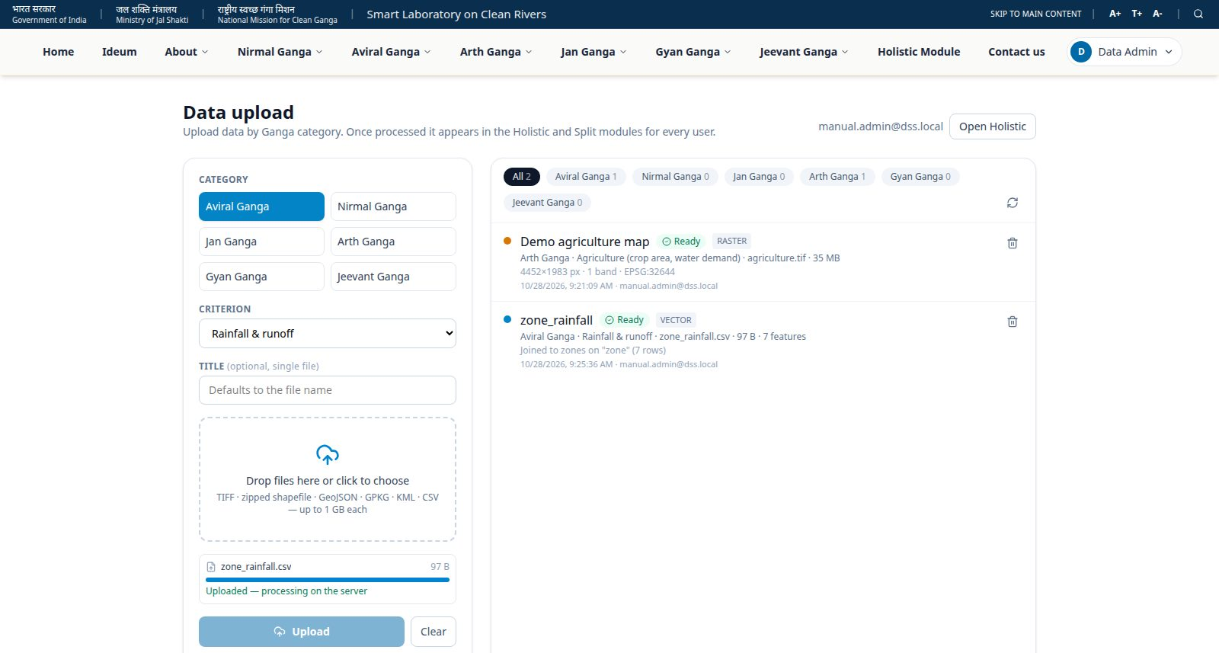
Figure 7: Upload finished – the new dataset is Ready

3.2 Supported files
Type | File | What happens
Raster | .tif / .tiff (GeoTIFF with a coordinate system) | Converted for fast map tiles; shown as a coloured layer
Shapefile | .zip containing .shp, .shx, .dbf and .prj | Shown as map features
Vector | .geojson, .gpkg, .kml | Shown as map features
CSV with coordinates | .csv with lat/lon (or latitude/longitude) columns | Each row becomes a point
CSV with zone names | .csv with a column of zone names (A, B, C …) | Values are joined to the zone shapes
Other CSV | .csv without coordinates or zones | Kept as a table you can view
Tip: Maximum file size is 1 GB per file.

3.3 Duplicate files
If the same file was uploaded before, the system refuses it and tells you where it already is, who uploaded it and when.
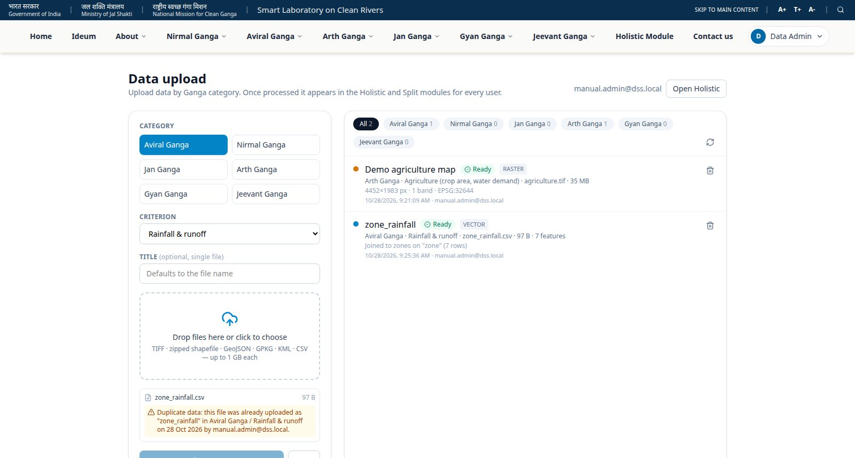
Figure 8: Duplicate file message

3.4 Statuses, retry and delete
- Ready – usable on the maps.
- Processing – still being prepared; wait a moment.
- Failed – the reason is shown in red. Fix the file and upload again, or click the retry arrow.
- Click the bin icon to delete a dataset. It disappears for all users.
- Use the category chips above the list to filter it.

3.5 Where uploaded data appears
- Holistic module – in the Uploaded data tab of the left panel, for the current stage's category.
- Ideum – in the master panel's Criteria list, under Uploaded data, for the active module.

3.6 Adding user accounts
Accounts are listed in the file backend/media/user/users.csv with the columns: email, password, role (superuser or user), full_name, active (yes/no).
- Add or change a row in users.csv.
- Restart the backend, or ask the technical team to run the sync command (see the Technical Document).
- To block someone, set active to no – their account is disabled.
Important: Keep users.csv private. It contains passwords in plain text; the database itself stores them encrypted.

4. Holistic module
The Holistic module has three parts: the left panel (choices), the map in the middle and the Outputs panel on the right. The coloured tabs at the top are the six stages; the current stage is highlighted.
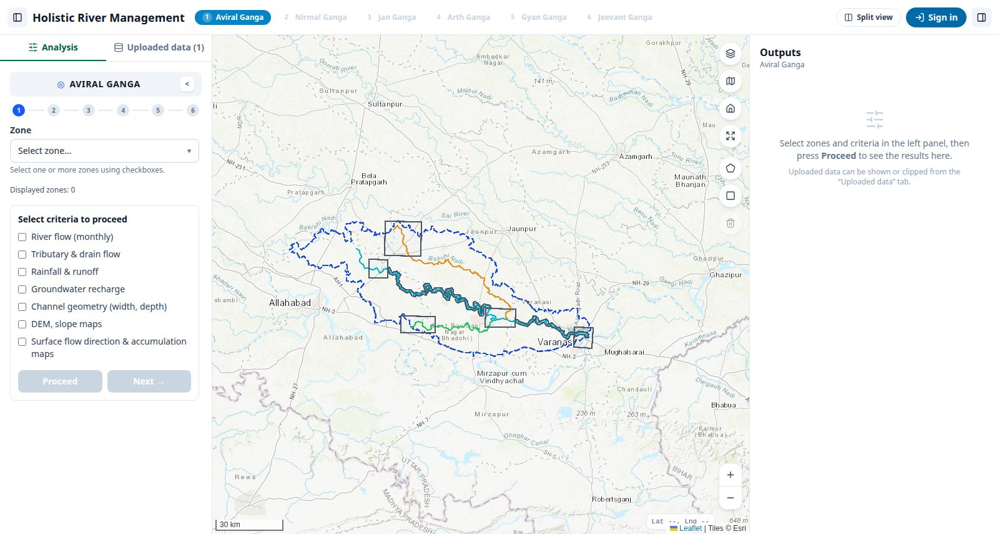
Figure 9: Holistic module layout
- The icons at the far left and far right of the top bar hide or show the side panels.
- History (when signed in) lists your saved Split sessions. Split view opens Ideum.

4.1 Choose zones
- In the Analysis tab, click Select zone….
- Tick one or more zones (A to G), or Select all.
- Click outside the list to close it. Selected zones are outlined in green on the map.
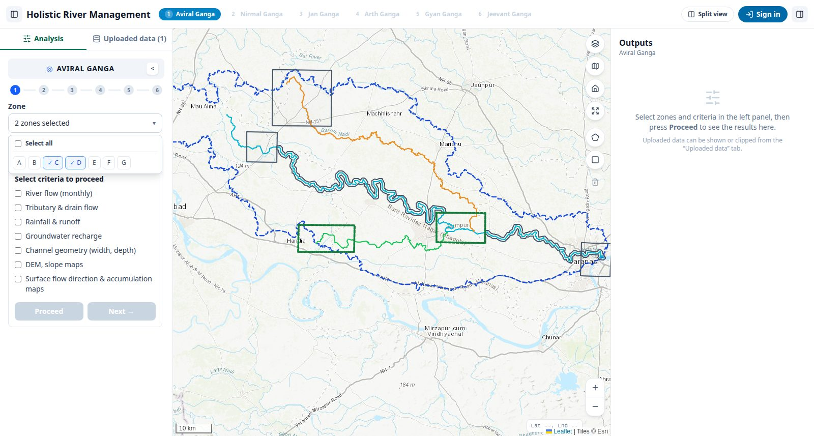
Figure 10: Selecting zones C and D

4.2 Choose criteria and see results
- Tick the criteria you want, e.g. Rainfall & runoff and DEM, slope maps.
- Click Proceed. The layers appear on the map, cut to your zones.
- The Outputs panel shows tables (mean, minimum, maximum per zone) and legends.
- Click Next → to move to the next stage (Nirmal Ganga, and so on). Use ← Prev to go back.
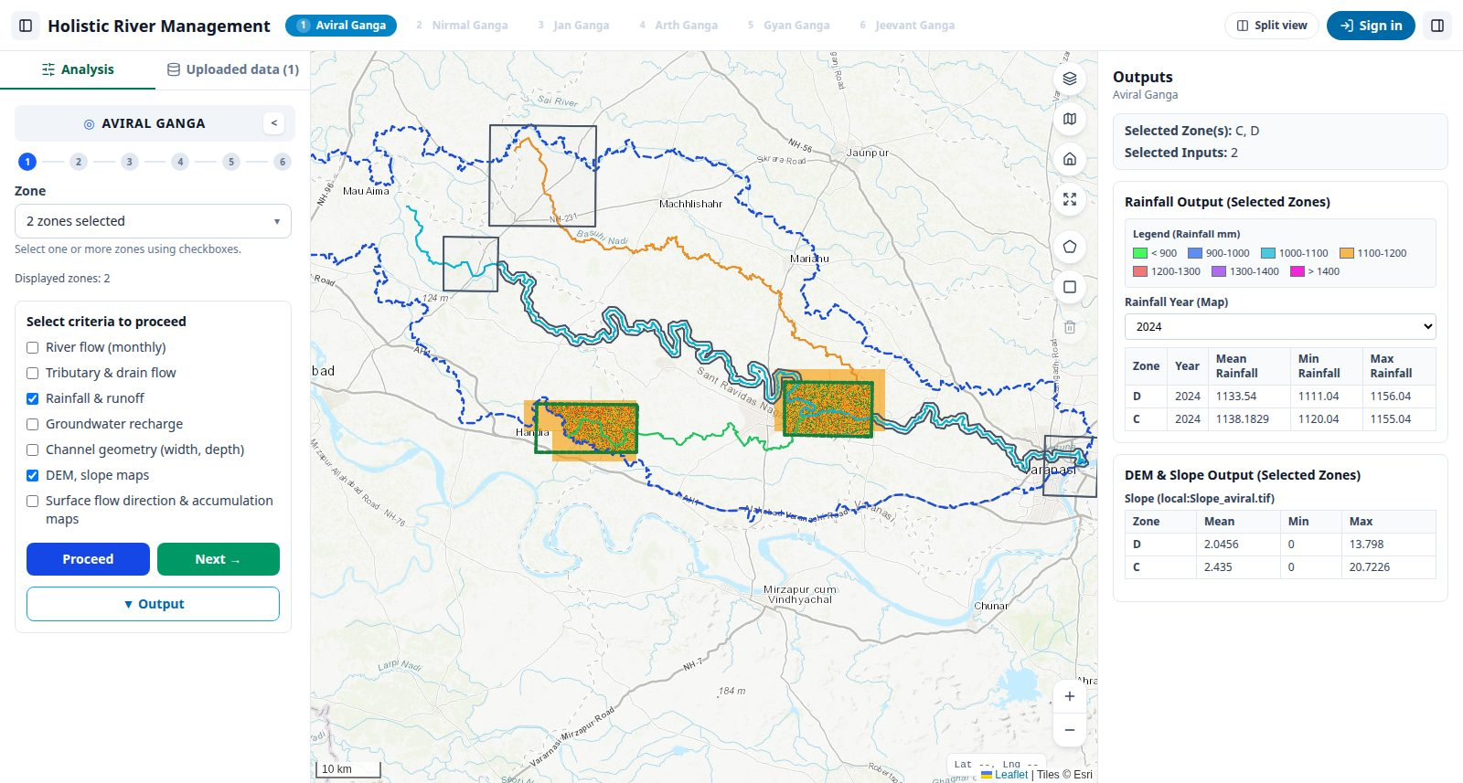
Figure 11: Results for the selected zones

4.3 Weighted output (combined map)
- Click Output under the criteria.
- Move the sliders to give each criterion more or less importance. The lock keeps a value fixed.
- Click Generate, then Show on Map. The combined map is also kept for Ideum's “Combined Output”.
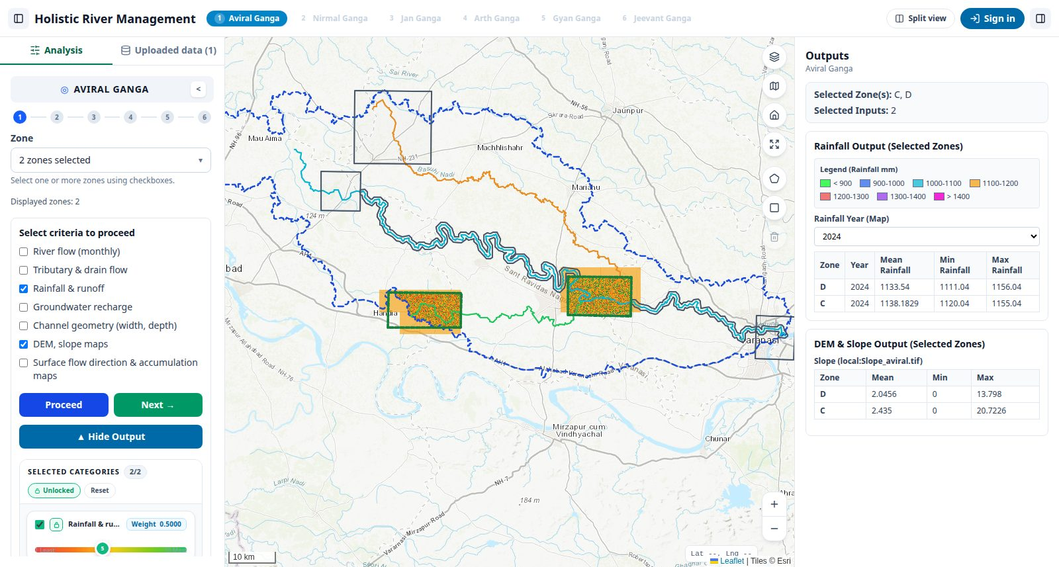
Figure 12: Weight sliders for the combined output

4.4 Draw your own area and use uploaded data
You are not limited to zones. You can draw any area on the map; everything is then cut to that area. If zones are also selected, only the part of the zones inside your drawing is used.
- Click the pentagon icon on the right of the map (Draw polygon).
- Click on the map to add corners. Double-click (or press Enter) to finish. Press Esc to cancel.
- Or click the square icon and drag to draw a rectangle.
- Open the Uploaded data tab on the left. Click the eye to show a dataset on the map, or the scissors to clip it and see its statistics. Use the download icon to save the clipped file.
- Click the bin icon on the map to remove the drawing.
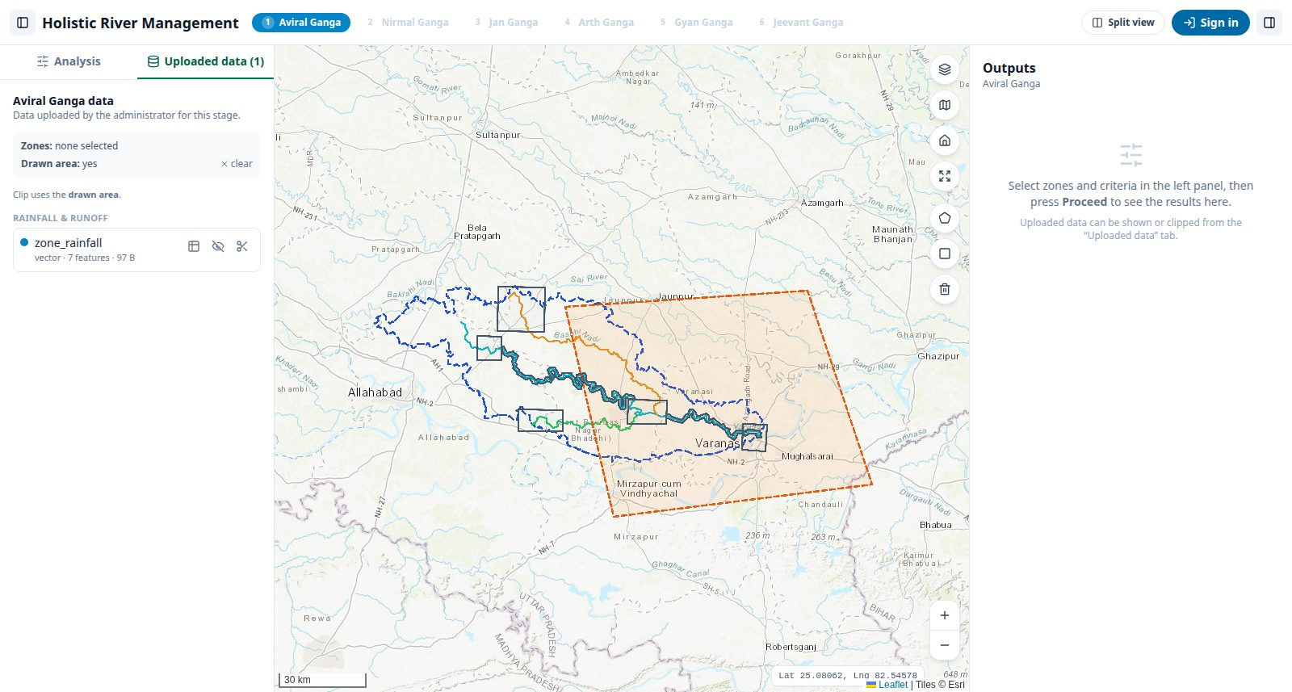
Figure 13: A drawn area with the Uploaded data tab open

5. Ideum – Split view
Ideum shows one large map and a dark master panel at the bottom. All controls are in the master panel, so nothing covers the map.
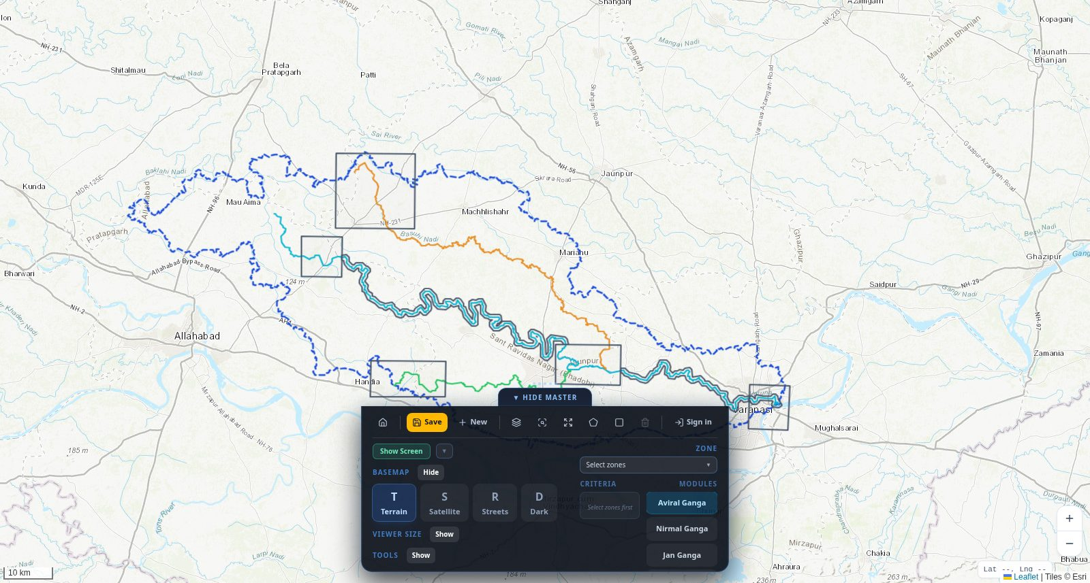
Figure 14: Ideum with the master panel

5.1 The master panel
Part | What it does
Top row (toolbar) | Home · Save · History · New · Layers · Fit · Full screen · Draw polygon · Draw rectangle · Clear drawing · Sign out (when signed in). There is no Sign in button – Save asks you to sign in.
Show Screen | Opens extra viewer screens (1–4) for side-by-side comparison
Basemap | Terrain, Satellite, Streets or Dark background
Viewer size | Makes the extra screens bigger or smaller
Tools | Sticky notes and shapes you can place on the map
Zone | Pick zones; shows “Drawn area” when you have drawn one
Criteria | Layers of the active module, plus Uploaded data
Modules | Aviral, Nirmal, Jan, Arth, Gyan, Jeevant Ganga and STP Suitability
Tip: Drag the panel left or right by its empty area. Click ▼ HIDE MASTER to fold it away.

5.2 Show criteria for zones
- Click the Zone box and pick one or more zones.
- Choose a Module on the right, e.g. Aviral Ganga.
- Tick a criterion in the Criteria list. The layer appears, cut to the zones.
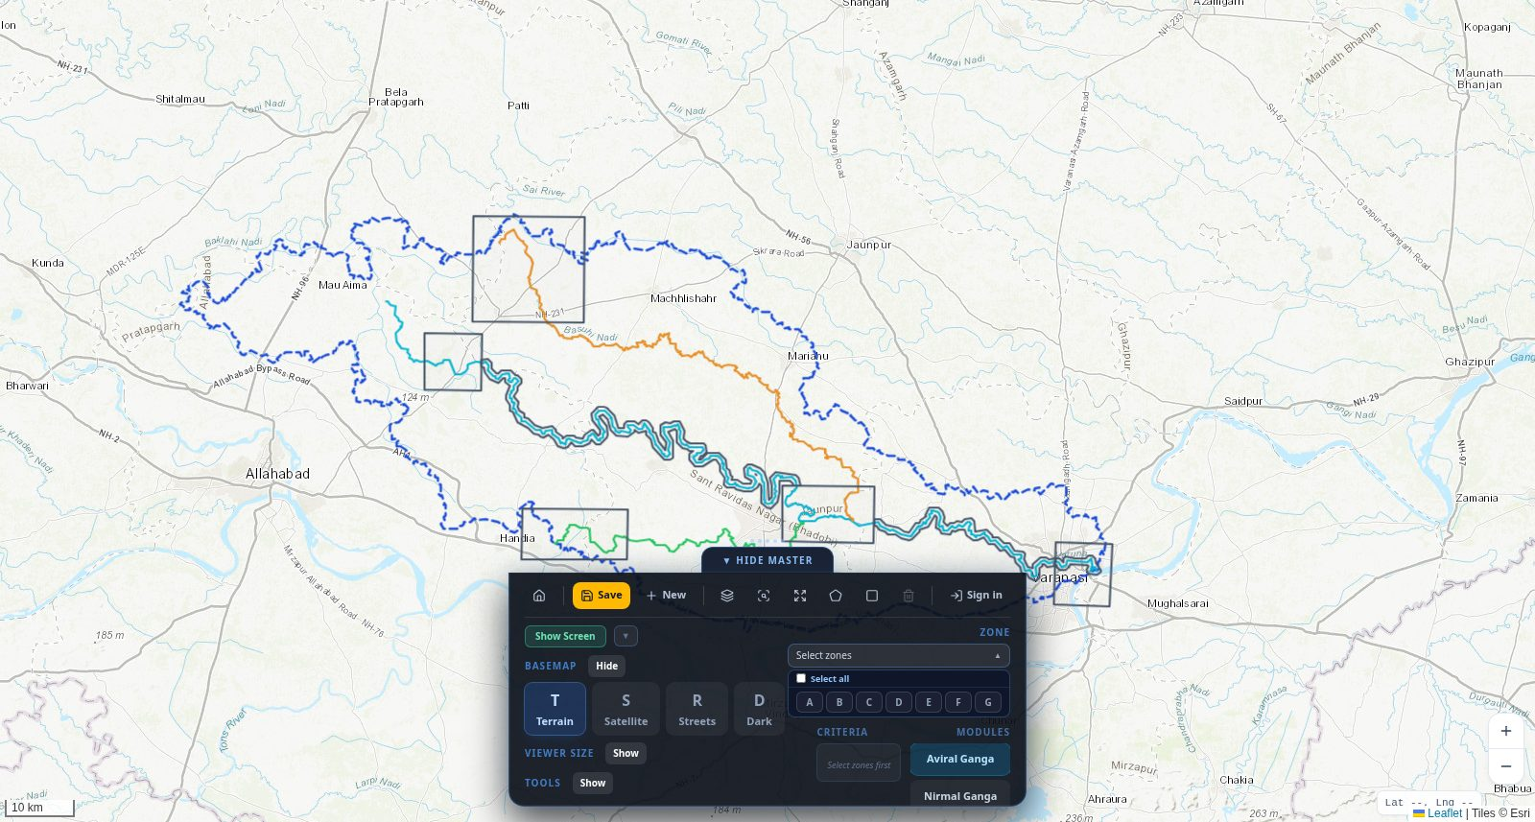
Figure 15: Picking zones in the master panel
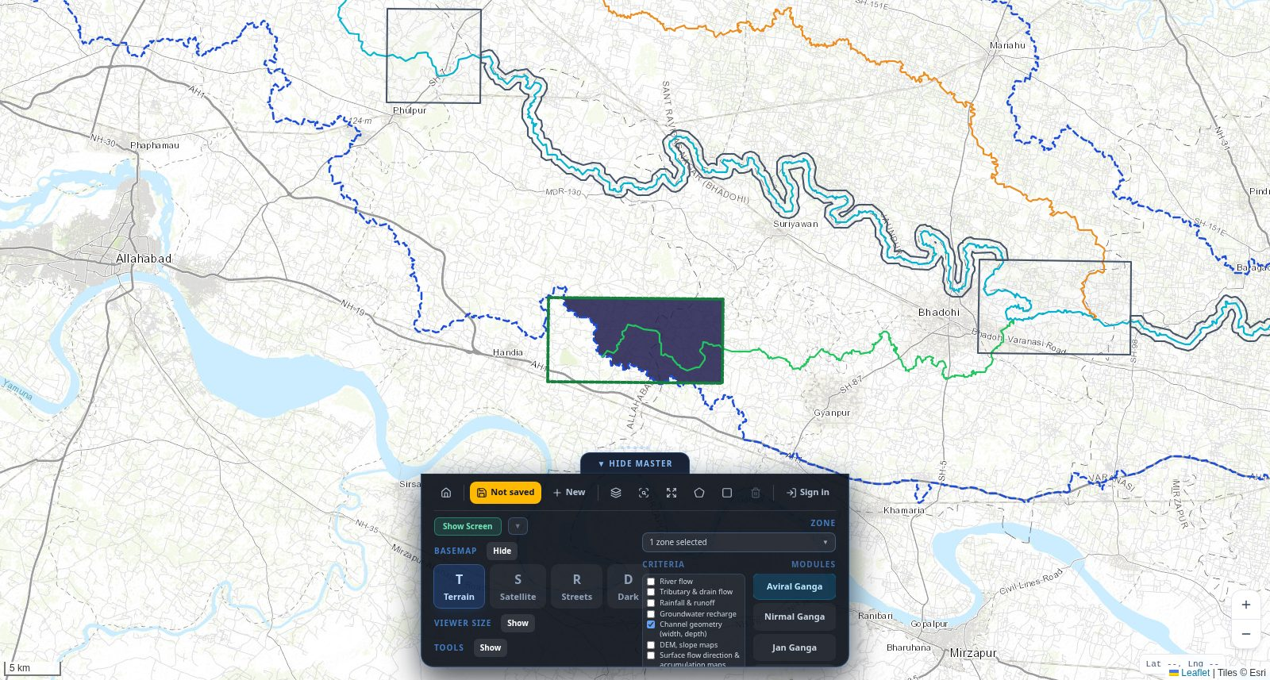
Figure 16: Channel geometry shown for zone C

5.3 Draw an area instead of (or with) zones
- Click the square (rectangle) or pentagon (polygon) icon in the toolbar and draw on the map.
- The Zone box now says Drawn area, and the criteria become available even without zones.
- Tick criteria – they are cut to your drawing. With zones selected too, only the overlap is used.
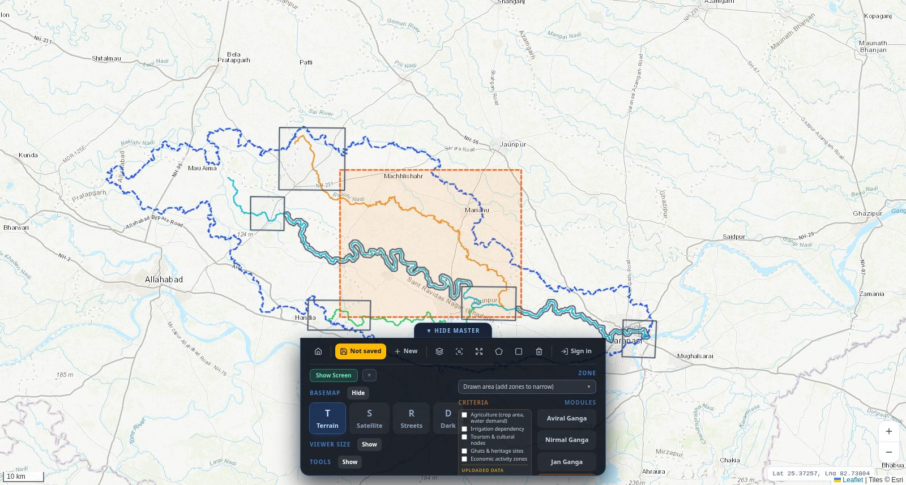
Figure 17: A drawn rectangle; the criteria are unlocked

5.4 Uploaded data in Ideum
Data uploaded for the active module appears at the bottom of the Criteria list under UPLOADED DATA. Tick it to show it on the map, already cut to your zones or drawn area. If you change the area, it updates by itself.
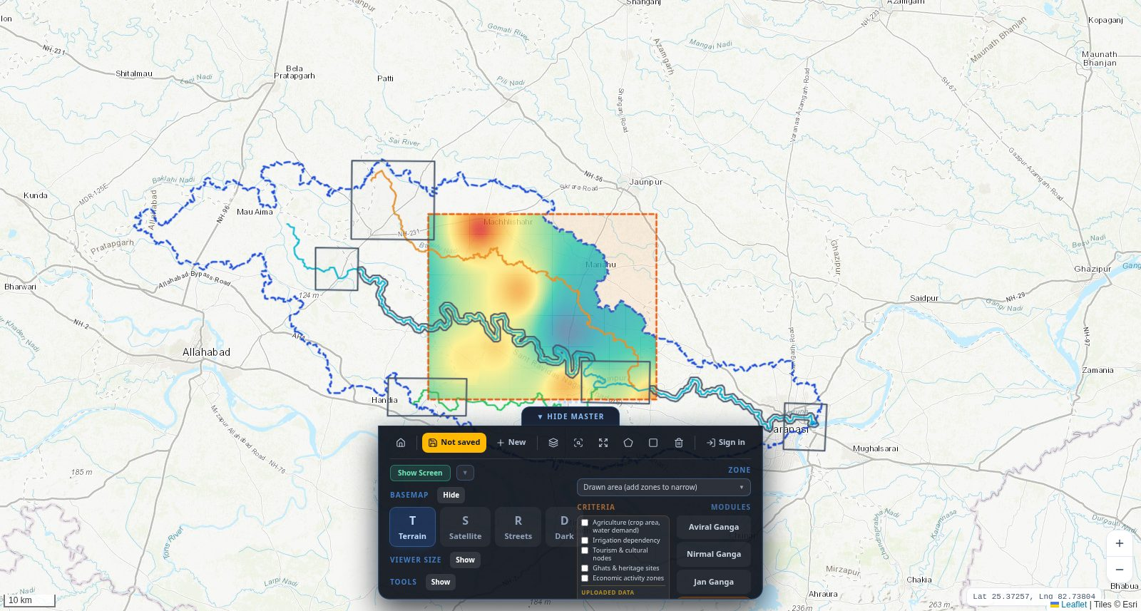
Figure 18: An uploaded Arth Ganga dataset clipped to the drawn area

5.5 Extra screens
Click Show Screen to open up to four extra screens around the map. Each one can show different criteria and has its own message box for comparing and discussing.
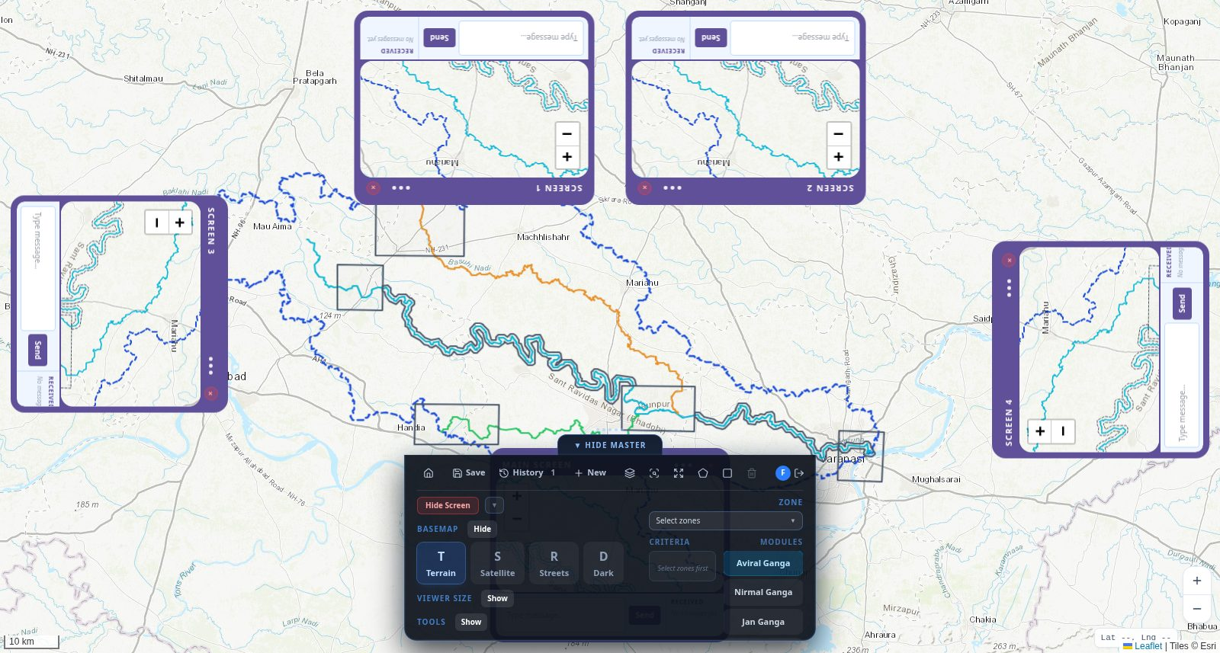
Figure 19: Extra viewer screens

5.6 STP Suitability
- Pick zones or draw an area.
- Choose the STP Suitability module and open the screens with Show Screen.
- In a screen's STP panel, tick the conditions and constraints, then run the analysis.
- Enter the capacity (MLD) and technology, then find a suitable site area.
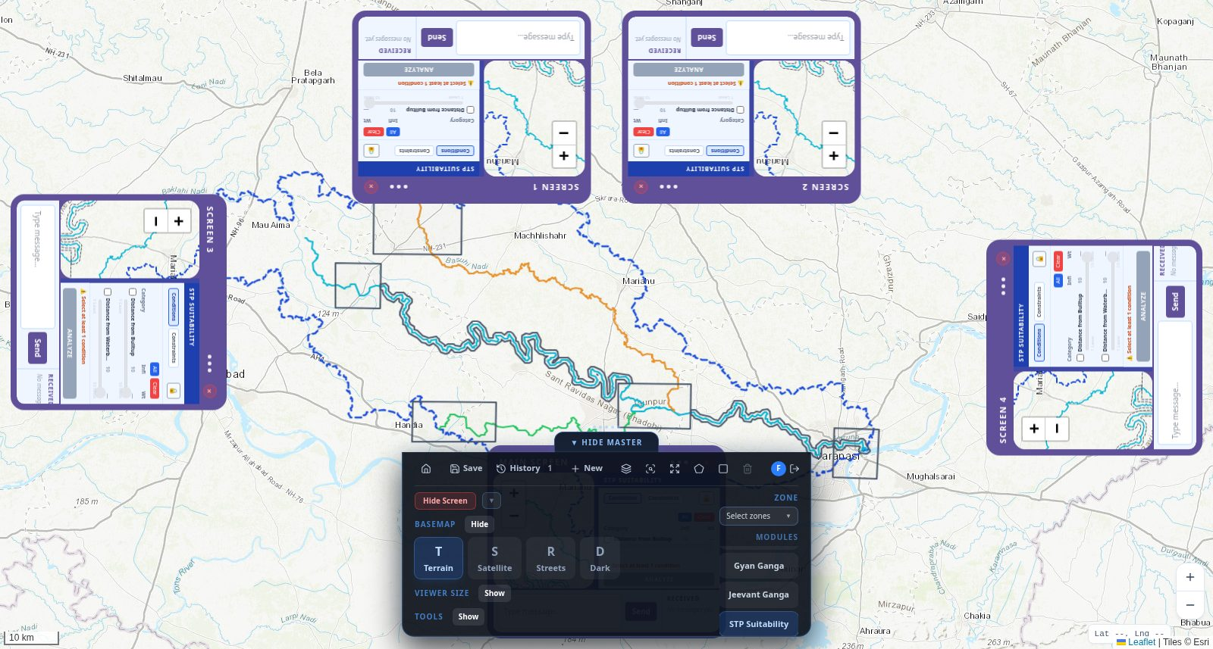
Figure 20: STP Suitability panels in the viewer screens

6. Saving and reopening your work
Ideum remembers everything you did – zones, drawn area, criteria, uploaded data shown, notes and the map position.

6.1 Save
- Click Save (yellow when not signed in, it shows “Not saved”).
- If you are not signed in, a small sign-in box opens. Sign in there – your work stays on screen.
- After signing in, saving is automatic. The toolbar shows Saved and the time.
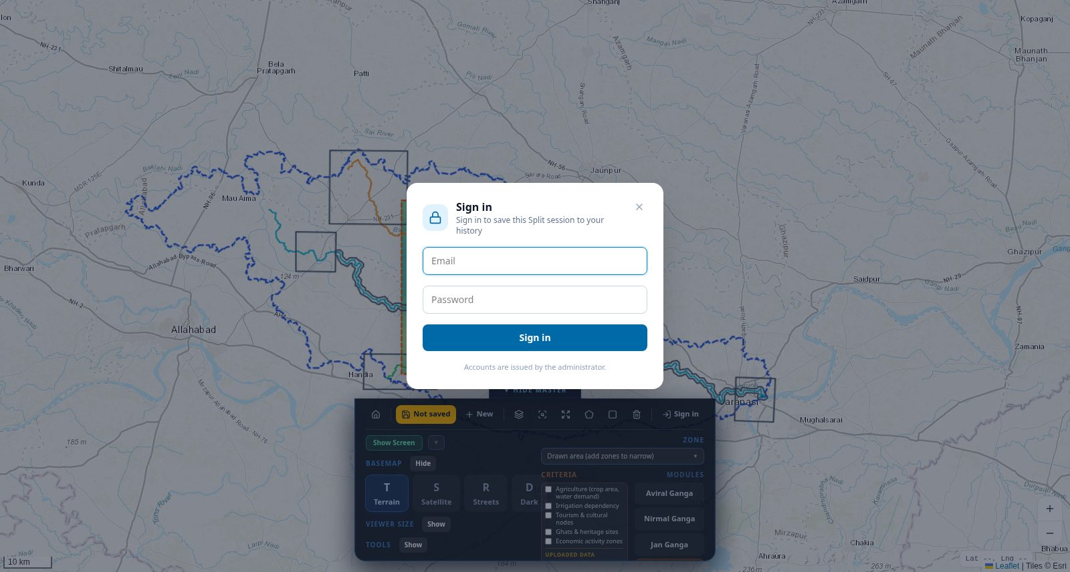
Figure 21: Sign-in box when saving
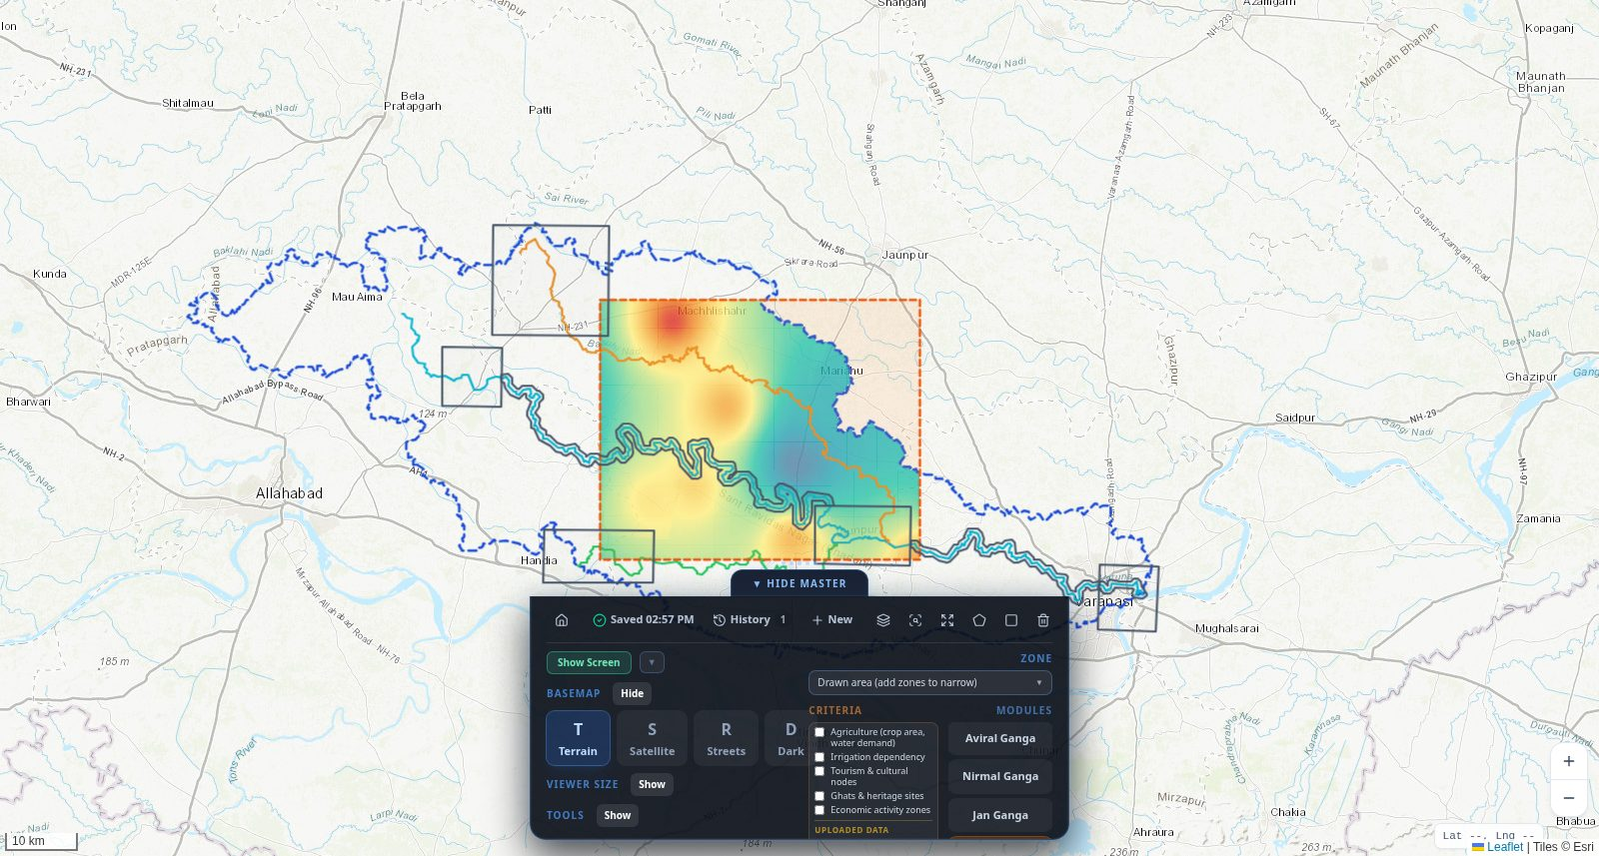
Figure 22: Session saved

6.2 History and resume
- Click History in the toolbar (or in the Holistic top bar).
- Click a session to see its details.
- Click Resume Session to reopen it exactly as you left it. PDF Report prints a summary; Delete removes it.
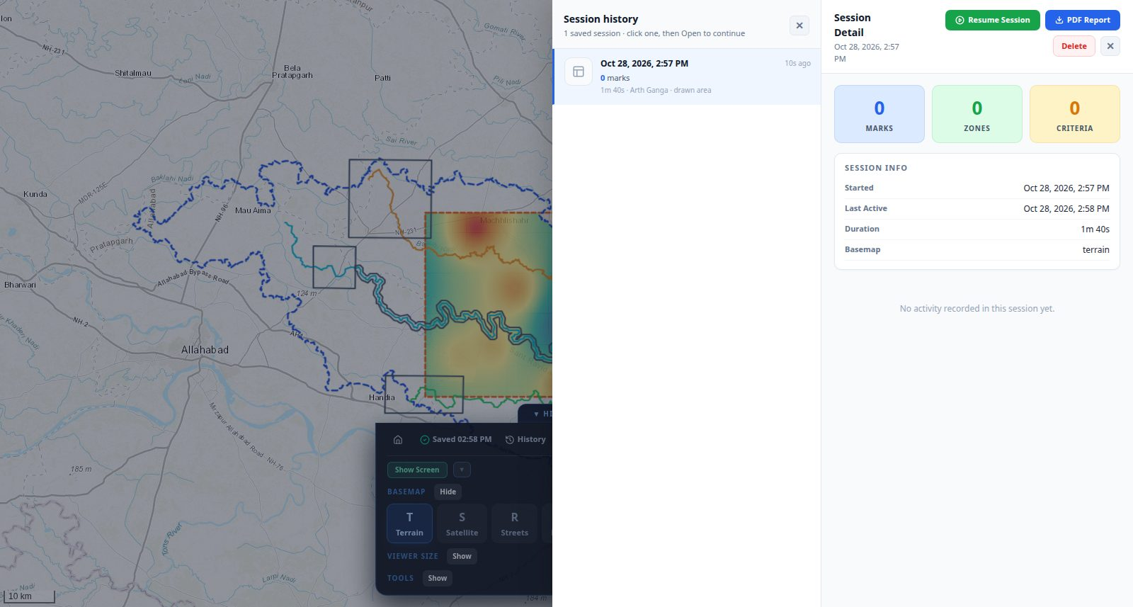
Figure 23: Session history and detail
Tip: When you open Ideum while signed in, your most recent session opens automatically. Click New in the toolbar to start an empty one.

7. Map tools at a glance
In the Holistic module these buttons are on the right edge of the map. In Ideum the same tools are in the master panel toolbar.
Tool | What it does
Layers | Turn basin boundary, rivers and zones on or off; see uploaded data and clipped results on the map
Basemap | Change the background map
Fit to area | Zoom to your selected zones (or the whole basin)
Full screen | Use the whole screen for the map; press again or Esc to exit
Draw polygon | Click corners, double-click to finish
Draw rectangle | Press and drag
Clear drawing | Remove the drawn area
+ / − | Zoom in and out (the mouse wheel also works)
Lat / Lng box | Shows the position under the mouse pointer
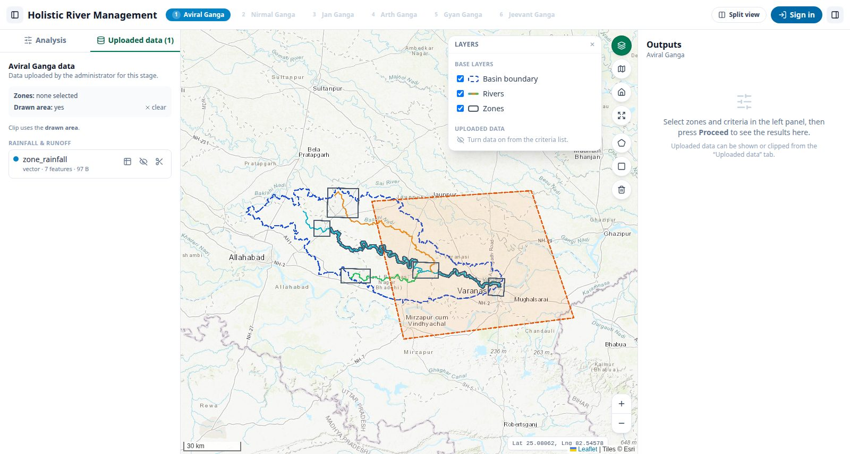
Figure 24: Layers pop-up
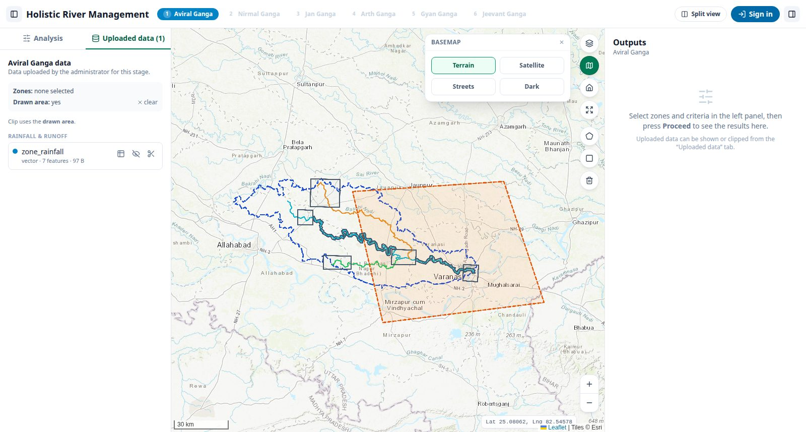
Figure 25: Basemap pop-up

8. Questions and problems
Problem | What to do
Criteria say “Select zones first” | Pick at least one zone or draw an area.
“The drawn area does not overlap the selected zones” | Draw inside the zones, or clear the zones and use only the drawing.
Save shows “Not saved” | You are not signed in. Click Save and sign in in the box that opens.
An uploaded file says Failed | Read the red message (often a missing coordinate system or .prj file), fix the file and upload again.
“Duplicate data” when uploading | That exact file is already in the system – nothing to do.
A layer takes long to appear | Large areas take longer to cut. Zoom in or use a smaller area.
I forgot my password | Ask the administrator to change it in users.csv.

