Multimodal Emotion Recognition Experiment Report
Qwen2.5 VL 3B Instruct on MELD

Purpose and main conclusion
This report consolidates the shared baseline, modality ablations, post-hoc alpha fusion, conflict testing, DivPrune token pruning, and DINOv2-based frame pruning. It emphasizes class-level behavior to determine whether aggregate scores are driven by neutral-class prediction collapse.
Main conclusion: The strongest classifiers do not simply predict neutral. The full baseline, DivPrune at 0.30 retention, and diverse-frame pruning all retain meaningful diagonal predictions across anger, joy, sadness, surprise, and the rare classes, although neutral remains the dominant class and the easiest class. Directly removing either modality causes substantial collapse toward frequent classes.

Experimental setup
Component | Configuration
Model | Qwen2.5-VL-3B-Instruct
Dataset | MELD train, development, and test splits
Classes | anger, disgust, fear, joy, neutral, sadness, surprise
Video sampling | 6 fps, up to 64 frames
Representation | Final 2048-dimensional pooled LM hidden state
Classifier | Linear 2048 to 512, ReLU, dropout 0.3, Linear 512 to 7
Checkpoint rule | Best development macro F1

Experiment families
Experiment | What changes
Shared baseline | Joint video and utterance representation with the saved MLP.
Direct modality ablation | Zero visual or utterance contribution while reusing the saved baseline MLP.
Alpha fusion | Linearly combine separately extracted video-only and text-only embeddings, then reuse the baseline MLP.
Conflict evaluation | Pair utterance and video sources with different inherited labels to measure model preference.
DivPrune | Retain diverse projected visual tokens using max-min cosine selection at ratios 0.30 and 0.70.
Frame pruning | Use DINOv2-Base embeddings to retain 20% diverse frames before Qwen visual processing.

Sample coverage
Representation | Train | Dev | Test | Comparison
Full baseline cleaned | 9,966 | 1,102 | 2,599 | Classifier reference
DivPrune retain 0.30 | 9,966 | 1,102 | 2,599 | Exactly matched
DivPrune retain 0.70 | 9,966 | 1,102 | 2,599 | Exactly matched
DINOv2 frames retain 0.20 | 9,984 | 1,107 | 2,609 | Different valid set
Baseline vs frame intersection | Not evaluated | Not evaluated | 2,598 | Used for matched test analysis

The frame-pruned extractor failed on fewer samples than the original full-frame pipeline. Consequently, its native headline metrics use a slightly different test population. The matched analysis below uses the 2,598 IDs available in both prediction files.

Why the valid sets differ
The original baseline produced 9,988 train, 1,108 development, and 2,610 test rows before cleaning. One training video could not be read, and cleaning removed a further 22 train, 6 development, and 11 test rows containing non-finite values. The newer frame-pruning extractor validates finiteness during extraction and rejected only four additional train rows, one development row, and one test row, alongside the same unreadable training video. Fewer frames changed the Qwen input and appears to have avoided most of the earlier numerical failures.
Comparability rule: DivPrune may be compared directly with the cleaned baseline. Frame pruning should be reported on both its native valid set and the exact baseline intersection.

Overall performance
Test representation | Accuracy | Macro F1 | Weighted F1 | n
Full video and utterance | 0.5883 | 0.4336 | 0.5948 | 2599
Zero visual contribution | 0.3859 | 0.1394 | 0.3269 | 2599
Zero utterance contribution | 0.3582 | 0.1768 | 0.3437 | 2599
DivPrune 0.30 + previous MLP | 0.5952 | 0.4105 | 0.5913 | 2599
DivPrune 0.30 + new MLP | 0.6087 | 0.4541 | 0.6127 | 2599
DivPrune 0.70 + previous MLP | 0.5837 | 0.4119 | 0.5883 | 2599
DivPrune 0.70 + new MLP | 0.5795 | 0.4217 | 0.5858 | 2599
DINOv2-base diverse 0.20 + previous MLP | 0.5914 | 0.4275 | 0.5954 | 2609
DINOv2-base diverse 0.20 + new MLP | 0.5998 | 0.4417 | 0.6024 | 2609

DivPrune retaining 30% of projected visual tokens produces the strongest recorded test metrics. Retaining 70% does not reproduce that gain, so performance is not monotonic in token count. DINOv2 frame pruning also exceeds the unmatched baseline while processing only 20% of candidate frames through Qwen.

Matched frame-pruning comparison
Representation | n | Accuracy | Macro F1 | Weighted F1
Full baseline on intersection | 2,598 | 0.5881 | 0.4336 | 0.5946
DINOv2 frames 0.20 new MLP | 2,598 | 0.6001 | 0.4394 | 0.6026
Frame minus baseline |  | +0.0119 | +0.0058 | +0.0080

On identical test IDs, frame pruning retains a positive accuracy and weighted-F1 improvement, while the macro-F1 gain narrows to approximately 0.0058. This is the defensible comparison for the frame-selection result.

Development performance
Development representation | Accuracy | Macro F1 | Weighted F1 | n
Full video and utterance | 0.6107 | 0.4872 | 0.6132 | 1102
Zero visual contribution | 0.3230 | 0.1230 | 0.2608 | 1102
Zero utterance contribution | 0.3203 | 0.1810 | 0.2981 | 1102
DivPrune 0.30 + previous MLP | 0.5853 | 0.4398 | 0.5767 | 1102
DivPrune 0.30 + new MLP | 0.5907 | 0.4648 | 0.5915 | 1102
DivPrune 0.70 + previous MLP | 0.6034 | 0.4678 | 0.6027 | 1102
DivPrune 0.70 + new MLP | 0.6034 | 0.4839 | 0.6065 | 1102
DINOv2-base diverse 0.20 + previous MLP | 0.5971 | 0.4609 | 0.5957 | 1107
DINOv2-base diverse 0.20 + new MLP | 0.6089 | 0.4657 | 0.6082 | 1107

Modality ablation
Removed | Split | n | Ablated acc. | Ablated macro F1 | Macro F1 drop | Benefit rate
Visual | Dev | 1102 | 0.3230 | 0.1230 | 0.3641 | 69.7%
Visual | Test | 2599 | 0.3859 | 0.1394 | 0.2942 | 65.6%
Utterance | Dev | 1102 | 0.3203 | 0.1810 | 0.3062 | 73.6%
Utterance | Test | 2599 | 0.3582 | 0.1768 | 0.2568 | 71.0%

Both interventions cause severe degradation. On test, removing visual contribution lowers macro F1 by 0.2942 and removing utterance contribution lowers it by 0.2568. These direct ablations show that neither modality is dispensable in the joint representation.

Conflict preference
Conflict statistic | Value
Evaluated conflict pairs | 6,574
Utterance-label follow rate | 54.3%
Video-label follow rate | 9.9%
Other-class prediction rate | 35.8%
Utterance pairwise preference | 80.8%
Mean utterance minus video log probability | 3.8432

Conflict testing reveals a strong conditional preference for utterance evidence, but this does not contradict the direct ablations. The conflict labels are inherited multimodal MELD labels rather than independently verified unimodal ground truth, so the experiment measures preference under disagreement, not which modality is objectively correct.

Neutral prediction diagnostic
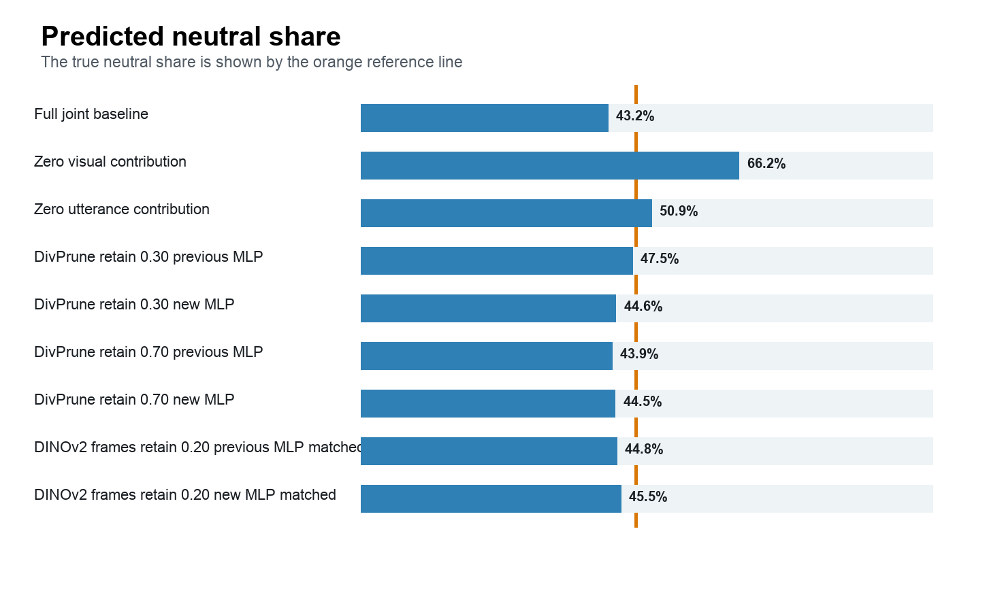
Predicted neutral share for the principal test conditions. Orange indicates the true neutral prevalence in the baseline test set.

Neutral class statistics
Condition | Neutral predictions | Prediction share | Precision | Recall | F1
Full joint baseline | 1,124 | 43.2% | 0.780 | 0.700 | 0.738
Zero visual contribution | 1,720 | 66.2% | 0.484 | 0.665 | 0.560
Zero utterance contribution | 1,322 | 50.9% | 0.523 | 0.552 | 0.537
DivPrune retain 0.30 previous MLP | 1,235 | 47.5% | 0.761 | 0.751 | 0.756
DivPrune retain 0.30 new MLP | 1,159 | 44.6% | 0.788 | 0.729 | 0.757
DivPrune retain 0.70 previous MLP | 1,142 | 43.9% | 0.780 | 0.712 | 0.744
DivPrune retain 0.70 new MLP | 1,156 | 44.5% | 0.772 | 0.713 | 0.742
DINOv2 frames retain 0.20 previous MLP matched | 1,163 | 44.8% | 0.774 | 0.719 | 0.746
DINOv2 frames retain 0.20 new MLP matched | 1,182 | 45.5% | 0.769 | 0.727 | 0.747

A model predicting neutral for every test example would have approximately 48.2% accuracy but very low macro F1. The competitive models instead predict all seven classes and attain nonzero F1 for every class. The direct ablations move substantially closer to frequent-class behavior and are the clearest signs of partial class collapse.

Per-class performance
Class | Base P | Base R | Base F1 | Div03 P | Div03 R | Div03 F1 | Frame P | Frame R | Frame F1
Anger | 0.462 | 0.422 | 0.441 | 0.451 | 0.456 | 0.454 | 0.483 | 0.419 | 0.449
Disgust | 0.176 | 0.231 | 0.200 | 0.315 | 0.262 | 0.286 | 0.157 | 0.215 | 0.182
Fear | 0.206 | 0.280 | 0.237 | 0.169 | 0.220 | 0.191 | 0.222 | 0.280 | 0.248
Joy | 0.539 | 0.643 | 0.586 | 0.549 | 0.611 | 0.579 | 0.541 | 0.641 | 0.587
Neutral | 0.780 | 0.700 | 0.738 | 0.788 | 0.729 | 0.757 | 0.769 | 0.727 | 0.747
Sadness | 0.310 | 0.322 | 0.316 | 0.377 | 0.370 | 0.374 | 0.367 | 0.312 | 0.338
Surprise | 0.489 | 0.548 | 0.517 | 0.502 | 0.581 | 0.538 | 0.497 | 0.559 | 0.526

Neutral is the strongest class, but it is not the only functioning class. Joy, surprise, anger, and sadness retain substantial F1. Fear and disgust remain difficult because they are rare, yet their nonzero recall confirms that the strongest models are not reducing the task to neutral versus non-neutral.

Complete alpha sweep
Video alpha | Text beta | Dev acc. | Dev macro F1 | Dev wtd. F1 | Test acc. | Test macro F1 | Test wtd. F1
0.00 | 1.00 | 0.5381 | 0.3363 | 0.4788 | 0.5891 | 0.3450 | 0.5314
0.10 | 0.90 | 0.5318 | 0.3251 | 0.4638 | 0.5891 | 0.3350 | 0.5229
0.20 | 0.80 | 0.5200 | 0.2904 | 0.4368 | 0.5887 | 0.3274 | 0.5153
0.30 | 0.70 | 0.5254 | 0.2713 | 0.4381 | 0.5864 | 0.3055 | 0.5037
0.40 | 0.60 | 0.5191 | 0.2605 | 0.4258 | 0.5718 | 0.2687 | 0.4797
0.50 | 0.50 | 0.5118 | 0.2449 | 0.4086 | 0.5629 | 0.2440 | 0.4635
0.60 | 0.40 | 0.4973 | 0.2174 | 0.3815 | 0.5421 | 0.2088 | 0.4308
0.70 | 0.30 | 0.4791 | 0.1920 | 0.3557 | 0.5233 | 0.1852 | 0.4056
0.80 | 0.20 | 0.4501 | 0.1523 | 0.3194 | 0.5029 | 0.1648 | 0.3779
0.90 | 0.10 | 0.4347 | 0.1391 | 0.3016 | 0.4817 | 0.1297 | 0.3451
1.00 | 0.00 | 0.4093 | 0.1234 | 0.2816 | 0.4613 | 0.1157 | 0.3269

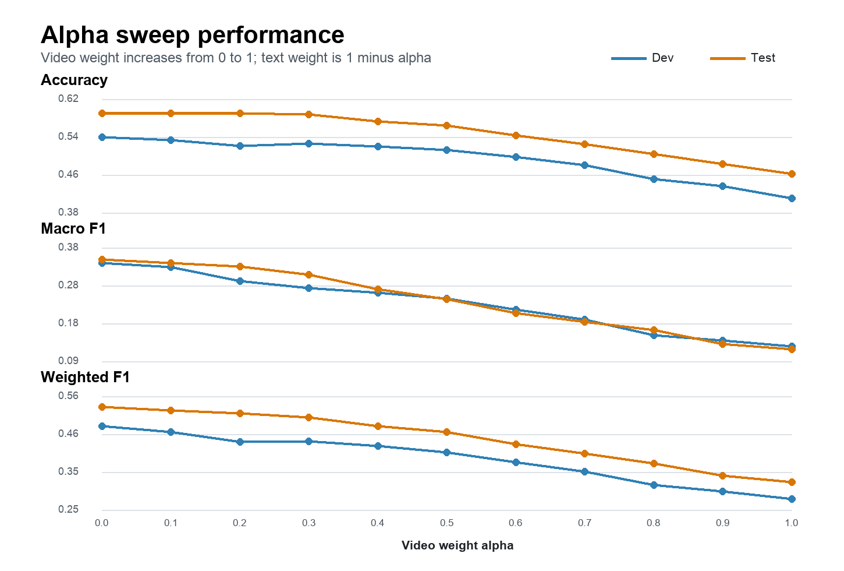
Performance of the fixed shared MLP on post-hoc video and text embedding mixtures.
Performance broadly declines as video-only embedding weight increases. This is evidence of classifier sensitivity and representation mismatch, not a clean causal ranking of modality usefulness. The MLP was trained on joint embeddings, not on arbitrary linear mixtures of separately prompted unimodal embeddings.

Test confusion matrices
Each cell reports the number of predictions and the percentage within its true-class row. A model predicting mostly neutral would show dark cells concentrated in the neutral prediction column. The principal models instead preserve visible diagonal structure across multiple emotion classes.
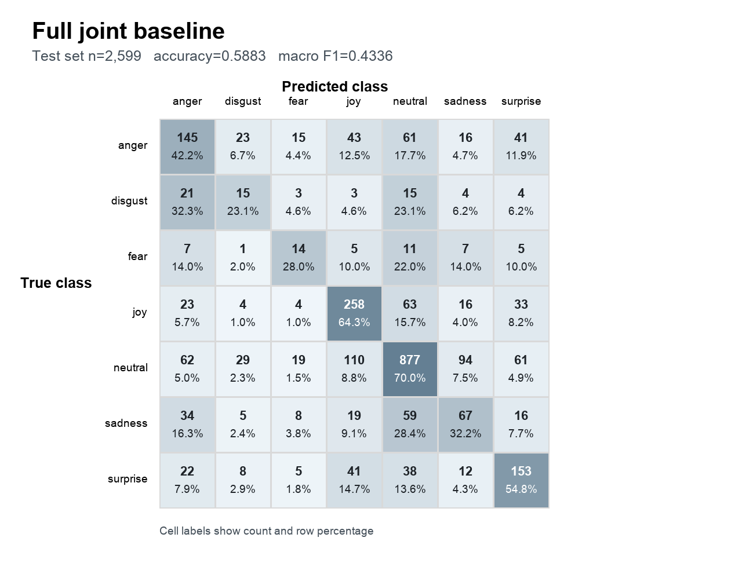 | 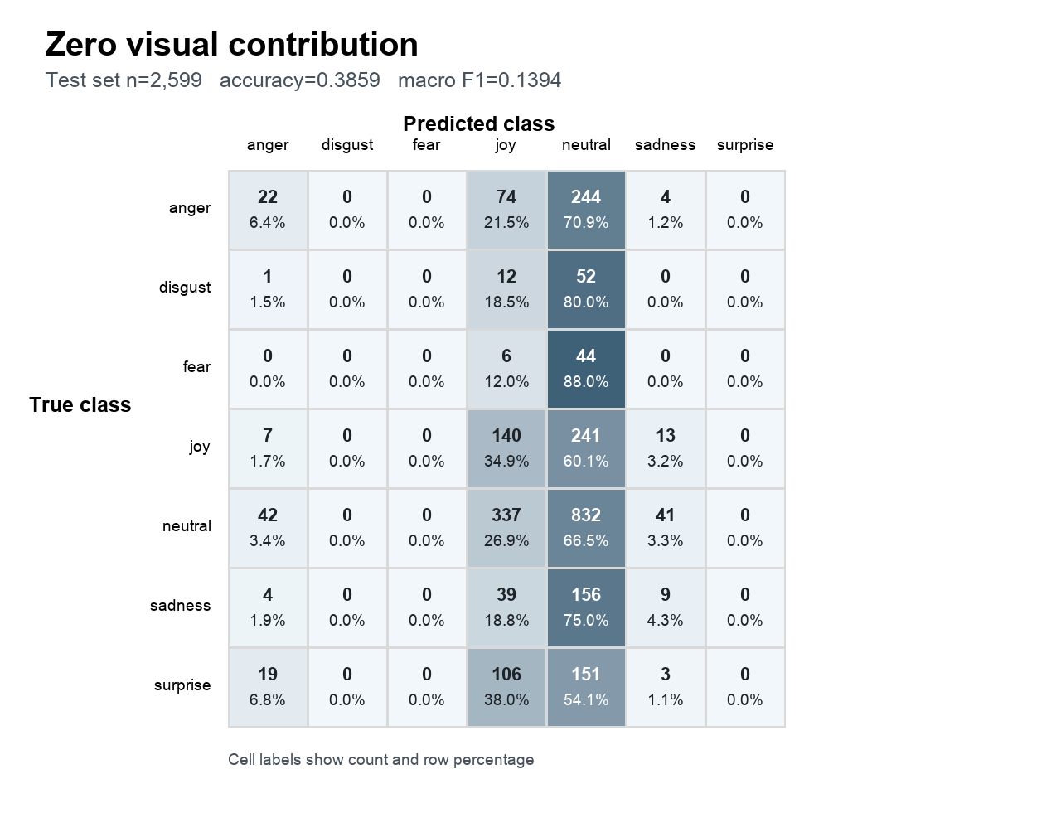
Figure 1 Full joint baseline | Figure 2 Zero visual contribution

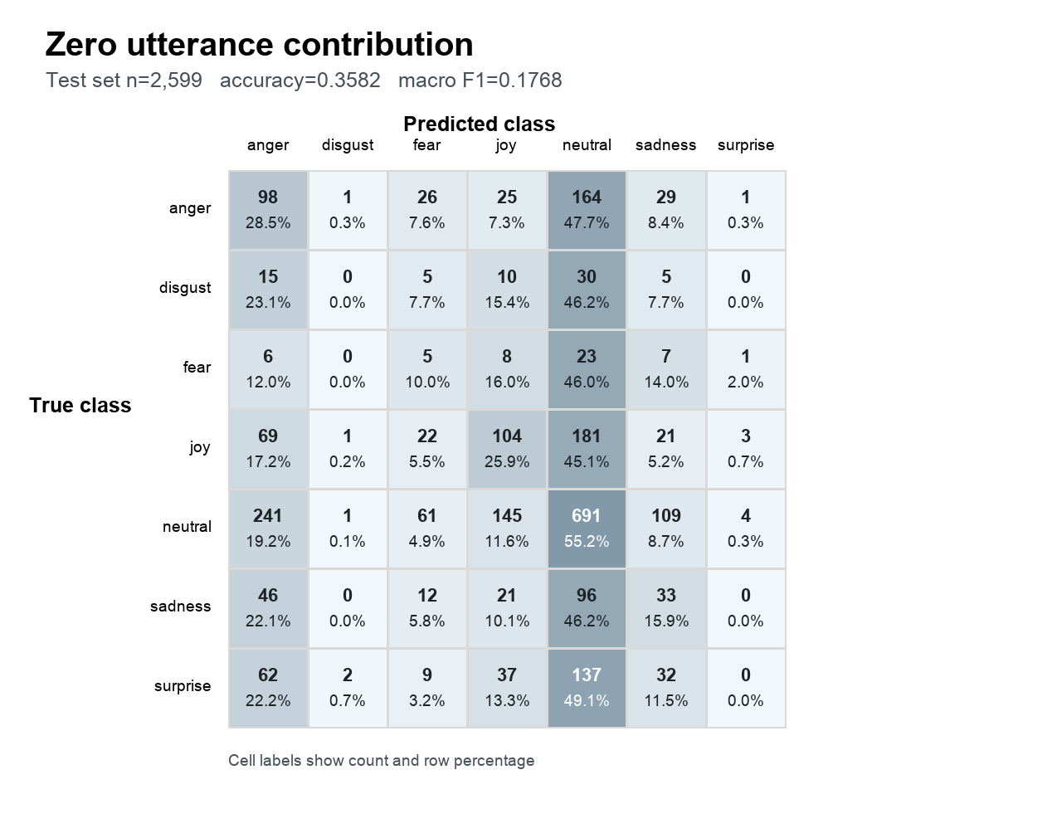 | 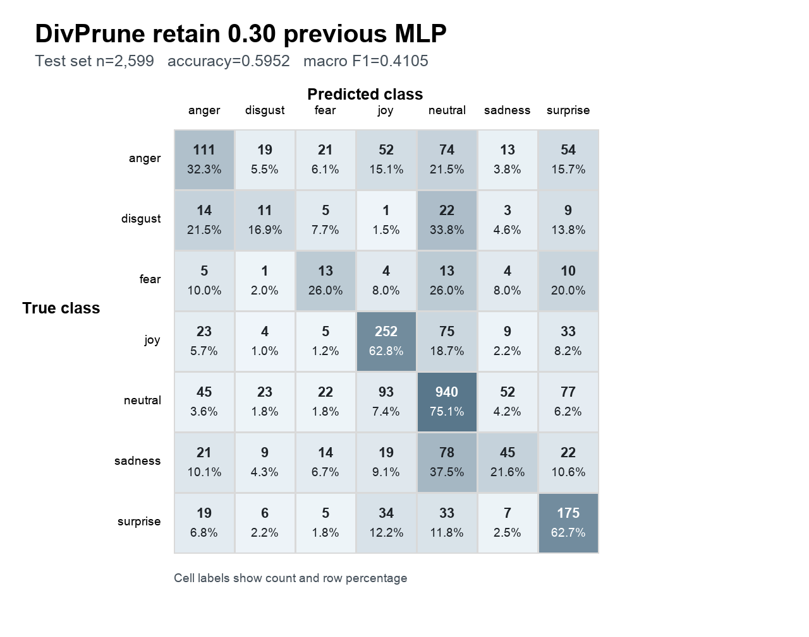
Figure 3 Zero utterance contribution | Figure 4 DivPrune retain 0.30 previous MLP

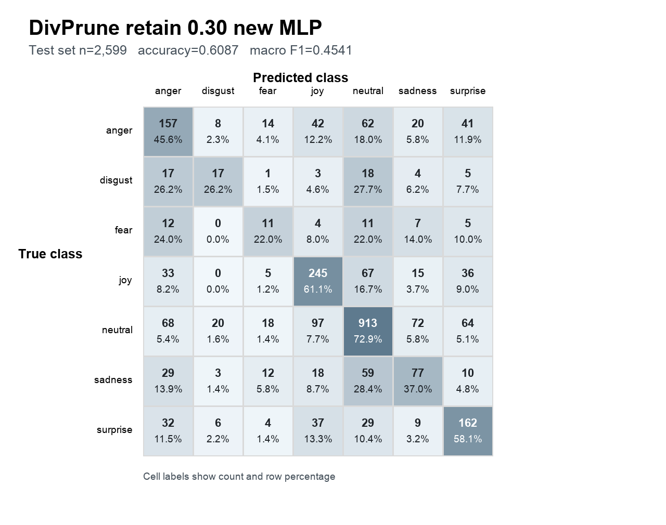 | 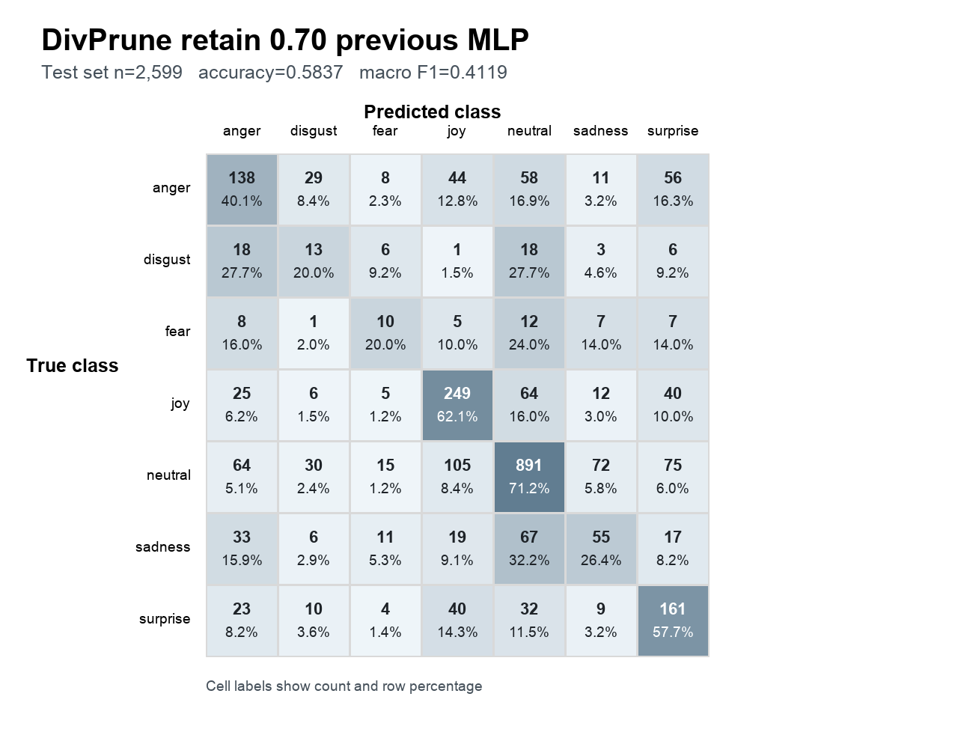
Figure 5 DivPrune retain 0.30 new MLP | Figure 6 DivPrune retain 0.70 previous MLP

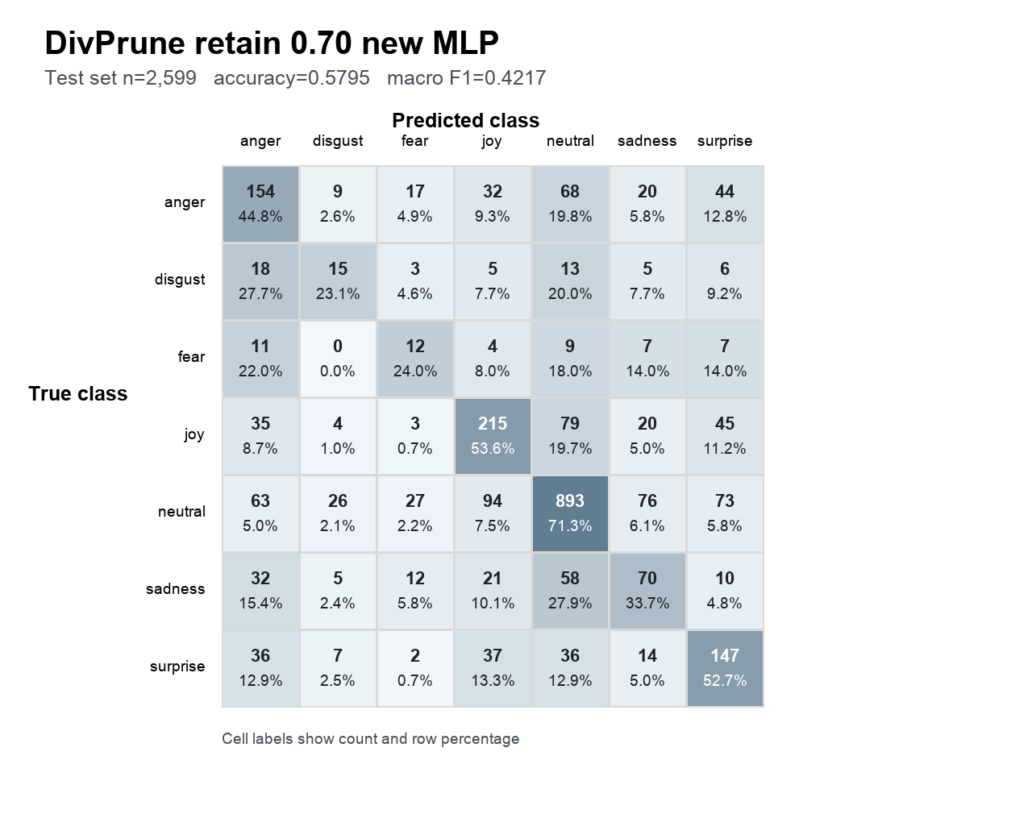 | 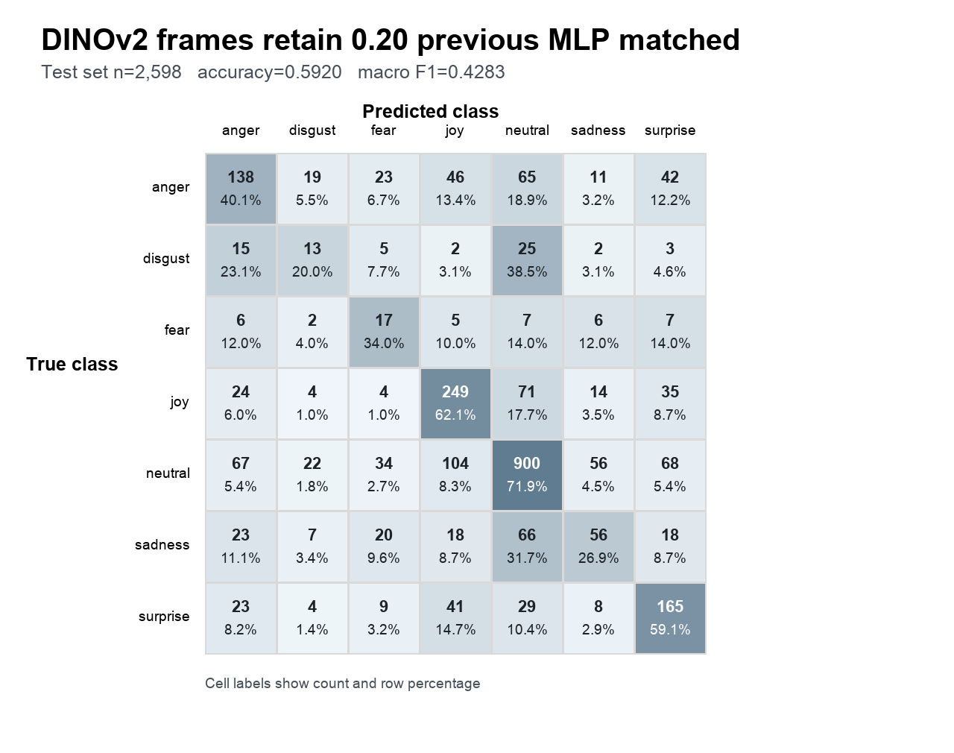
Figure 7 DivPrune retain 0.70 new MLP | Figure 8 DINOv2 frames retain 0.20 previous MLP matched

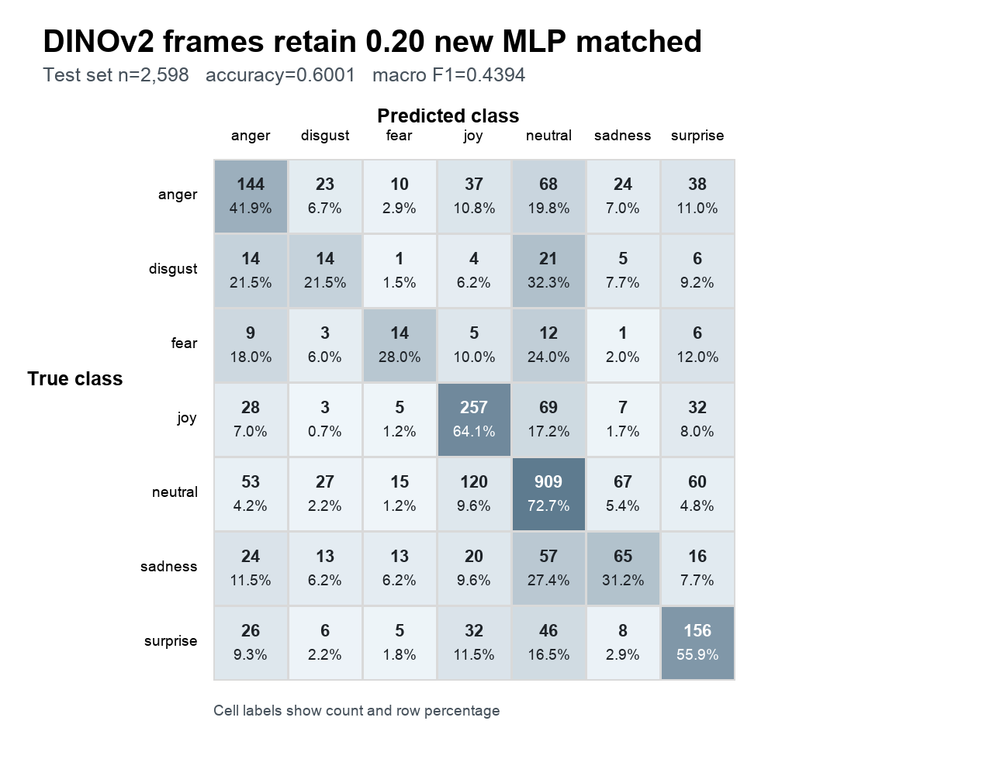
Figure 9 DINOv2 frames retain 0.20 with retrained MLP on the matched test intersection

Alpha endpoint confusion matrices
These matrices show representative points from the eleven-setting sweep. Neutral concentration grows as the representation moves toward the video-only endpoint, matching the decline in macro F1.
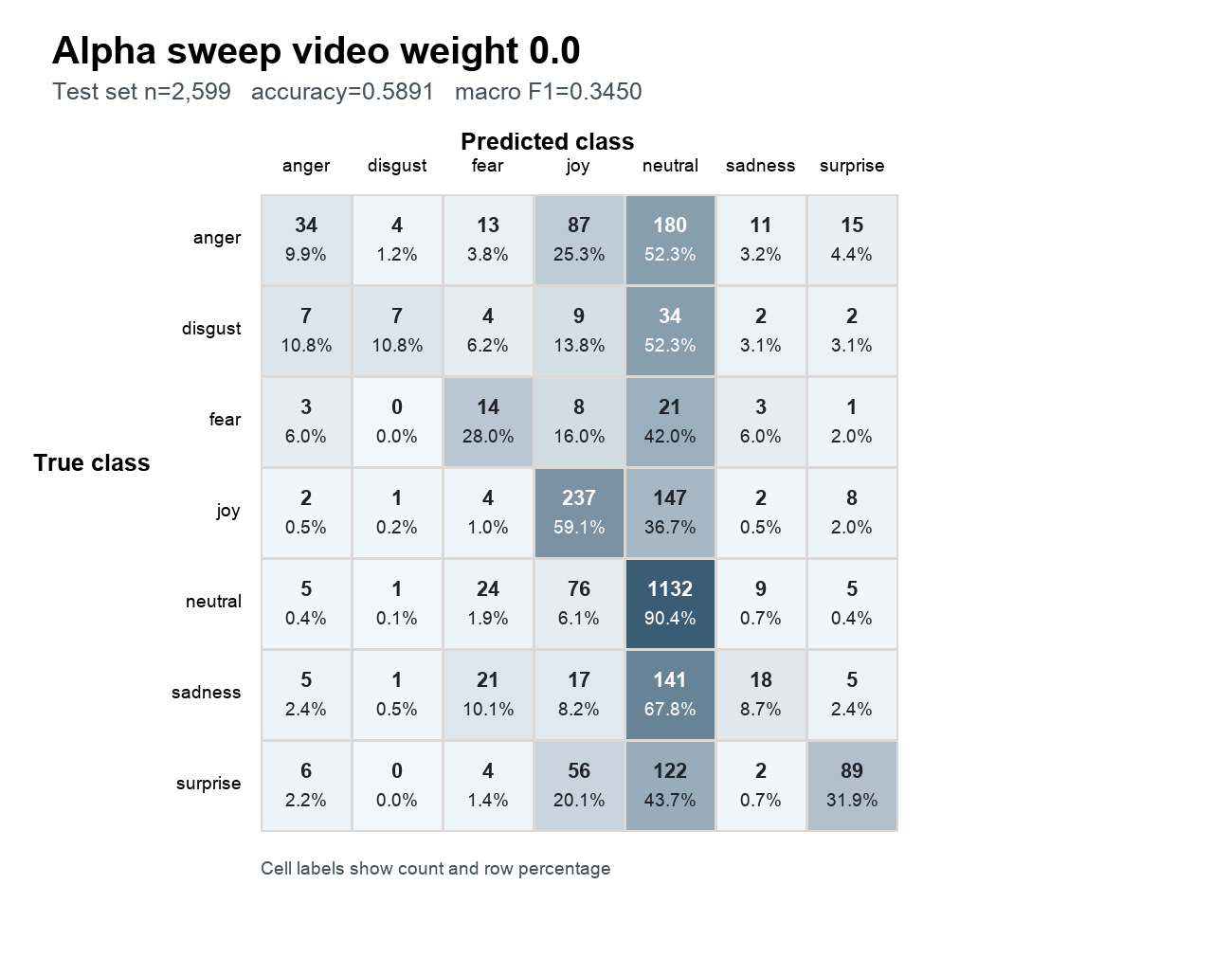 | 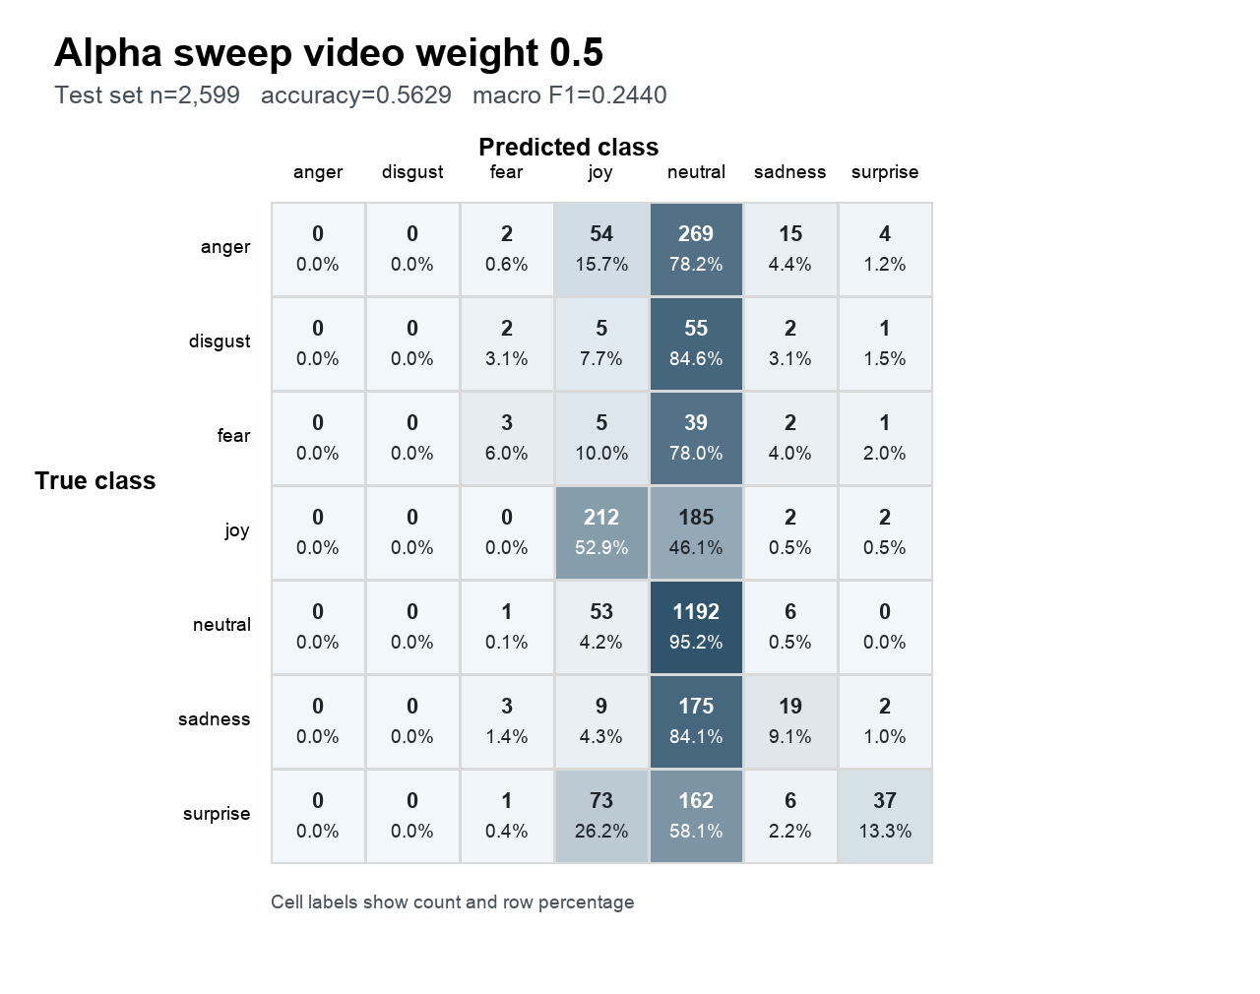
Figure 10 Alpha 0.0 text-only endpoint | Figure 11 Alpha 0.5 balanced mixture

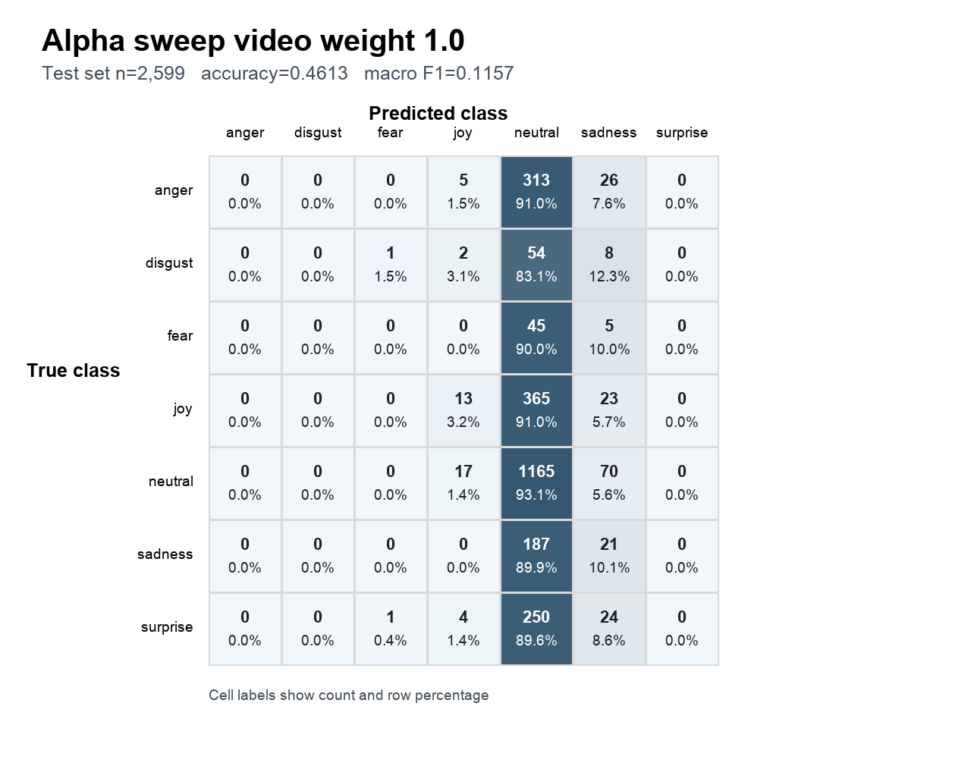
Figure 12 Alpha 1.0 video-only endpoint

Conflict confusion matrices
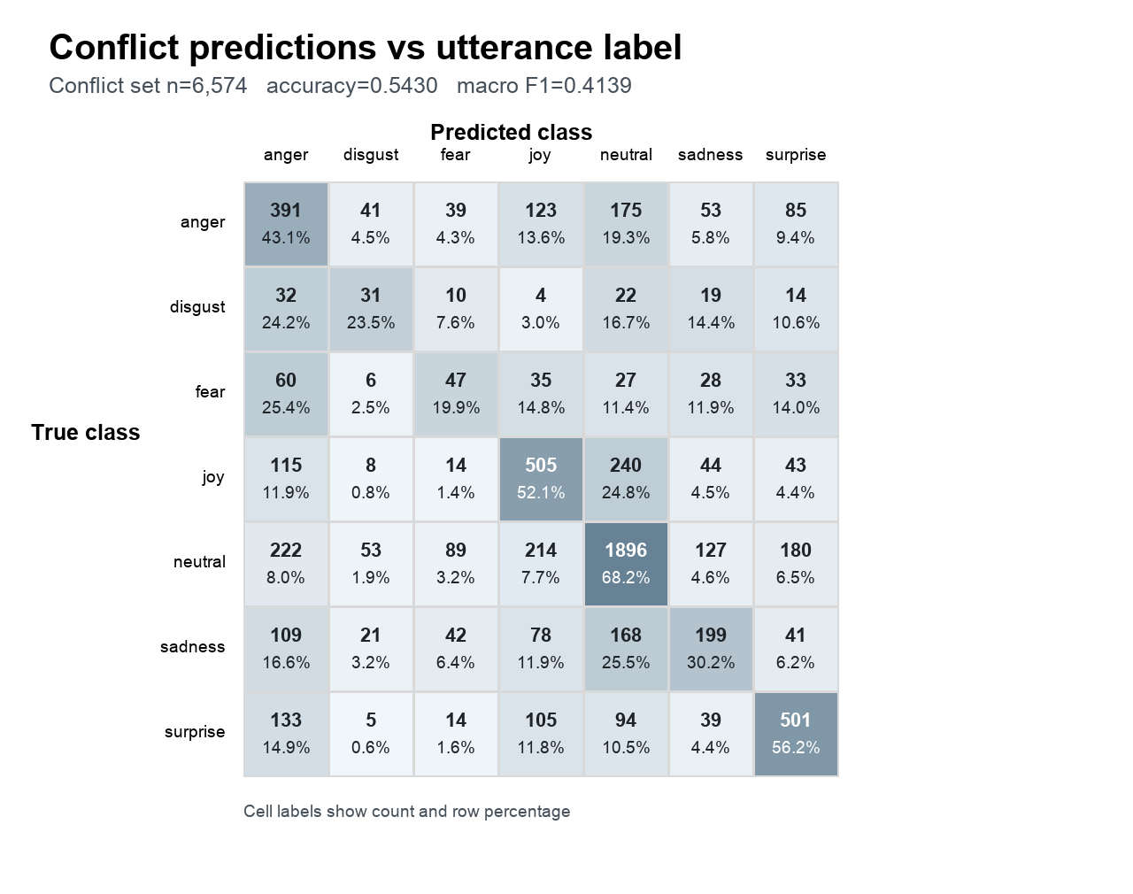 | 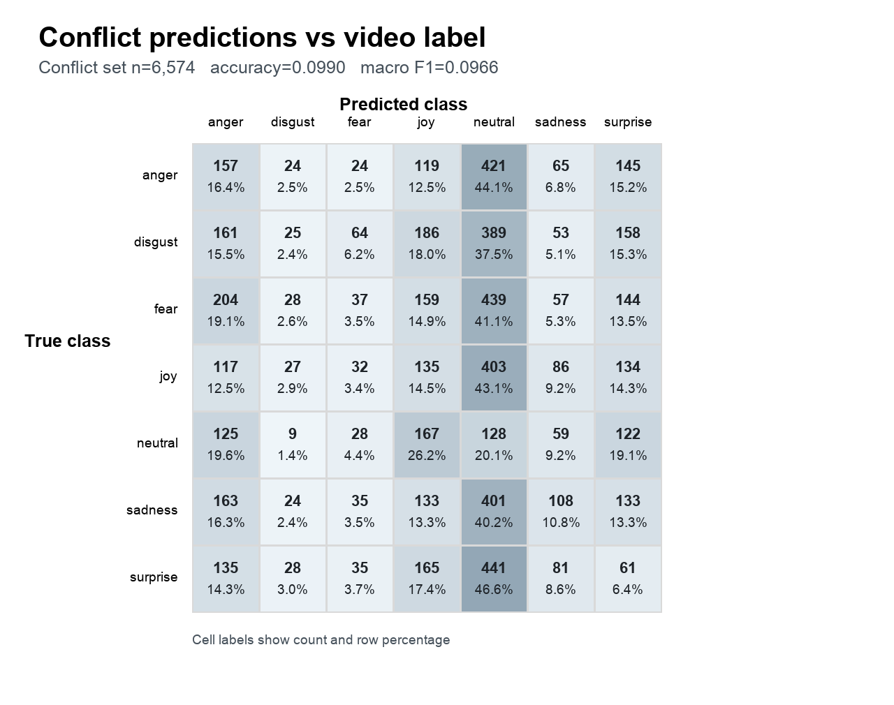
Figure 13 Agreement with utterance-source labels | Figure 14 Agreement with video-source labels

Interpretation
No neutral-only collapse. The strongest models predict all seven labels and preserve class-specific diagonal structure. Neutral dominance largely reflects MELD imbalance and higher neutral recall, not exclusive neutral prediction.
Both modalities matter. Directly removing either visual or utterance contribution sharply reduces macro F1. Visual removal causes the larger test macro-F1 loss in this intervention.
Preference and necessity are different. Conflict testing favors utterance evidence, while direct ablation shows strong visual necessity. The findings describe different interventions and should not be collapsed into one overshadowing claim.
Aggressive pruning is promising. DivPrune at 0.30 token retention gives the best recorded test result, and DINOv2 selection retains comparable performance with only 20% of frames entering Qwen.
Retraining matters. The retrained classifier generally adapts better to changed representations, especially for the 0.30 DivPrune and frame-pruned conditions.

Limitations and next checks
• Results currently cover one VLM family and one emotion dataset.
• Classifier results are single runs; multiple seeds and confidence intervals are needed.
• The frame-pruning extraction has a different native valid-sample set, although the matched 2,598-sample test analysis remains positive.
• The alpha sweep uses a classifier outside its training representation distribution.
• Conflict source labels are inherited multimodal labels rather than independent unimodal annotations.
• Frame-count reduction is not yet accompanied by end-to-end latency, memory, FLOP, or selector-overhead measurements.

Recommended reporting statement
On MELD with Qwen2.5-VL-3B-Instruct representations, both visual and utterance information materially affect emotion classification. The model shows an utterance preference under constructed cross-modal conflict, but direct modality ablations do not support a claim that visual evidence is unused. Diversity-based compression is effective: retaining 30% of projected visual tokens yields the strongest recorded test result, while retaining 20% of DINOv2-selected frames preserves and slightly improves performance on the matched test intersection. Confusion matrices confirm that these gains are not explained by predicting only the neutral class.

