# Roles and Responsibilities

STUDENT RELATIONS

A long, thin rectangle to divide sections of the document

The Student Relations Department stands as a cornerstone in the foundation of Paradox, representing the heartbeat that connects all the diverse events and elements of this vibrant Fest while acting as the brain & mouthpiece of Paradox. The Student Relations Department works as a silent force behind the scenes, dedicated to fostering a sense of unity and efficient coordination among the different departments of Paradox. The department also plays a multifaceted role in ensuring that every participant, organizer, and visitor experiences the richness of the offline manifestation of the Online BS Degree at IIT Madras.

### Department's Aim and Responsibility:

The primary objective of the Student Relations Department is to foster effective communication, streamline data management, and provide constant support to all participants, organizers and Paradox Departments. From handling event registrations to managing queries and feedback, the department plays a pivotal role in shaping the overall success of Paradox Fest without necessarily being in the spotlight. While our department might not be visible to the students, it is our tireless efforts in the background that make every aspect of Paradox seamless for every student.

### The Roles of the Department Includes:

1. Data Management and Analysis:
   * Oversees the management of student, winner, and organizing team data.
   * Responsible for compiling and interpreting data from various departments.
   * Conducts thorough analysis from the data to derive insights for continuous improvement.
2. Event Documentation:
   * Documents the entire event, capturing the essence and highlights, records data related to every aspect of the events.
   * Prepares comprehensive event reports for future reference and enhancement.
3. Communication, Announcements and Query Resolution:
   * Manages communication channels, sending announcements, updates and communication mails to all the students of the BS Degree (Data Science/ Electronic Systems).
   * Handles emails sent to [support@iitmparadox.org](mailto:support@iitmparadox.org) and resolves queries promptly.
4. Coordination with Other Departments:
   * Collaborates and Coordinates with Sports, Culturals, Technicals, Multimedia, WebOps and other Paradox departments, acting as liaison between different Departments of Paradox.
   * Ensures seamless integration of efforts across diverse event segments.
5. Certificate Generation:
   * Manages the end-to-end process of certificate generation for participants and winners.
   * Ensures accurate and timely distribution of certificates.
6. On-Campus Assistance and Help Desk:
   * Manages Paradox registrations and provides assistance at the help desk on Campus.
   * Guides new students through the check-in process, addressing queries, and aiding navigation.
7. Attendance Monitoring:
   * Keeps track of participant attendance during events.
   * Records and manages participation data for future references.
8. Mediation and Liaison:
   * Acts as a mediator between students, resolving conflicts when necessary.
   * Serves as a liaison connecting different facets of Paradox.
9. Multilingual Proficiency:
   * Demonstrates proficiency in major languages - English, Hindi, Tamil, Telugu, Malayalam, Kannada, Odia, Marathi, Bengali.
   * Ensures effective communication with a diverse participant base for quick and effective resolution of queries.
10. Technical Expertise:
    * Possesses skills in HTML, CSS, JavaScript, Python, UI/UX design.
    * Manages HTML mail creation, mail automation, etc..



Department Hierarchy

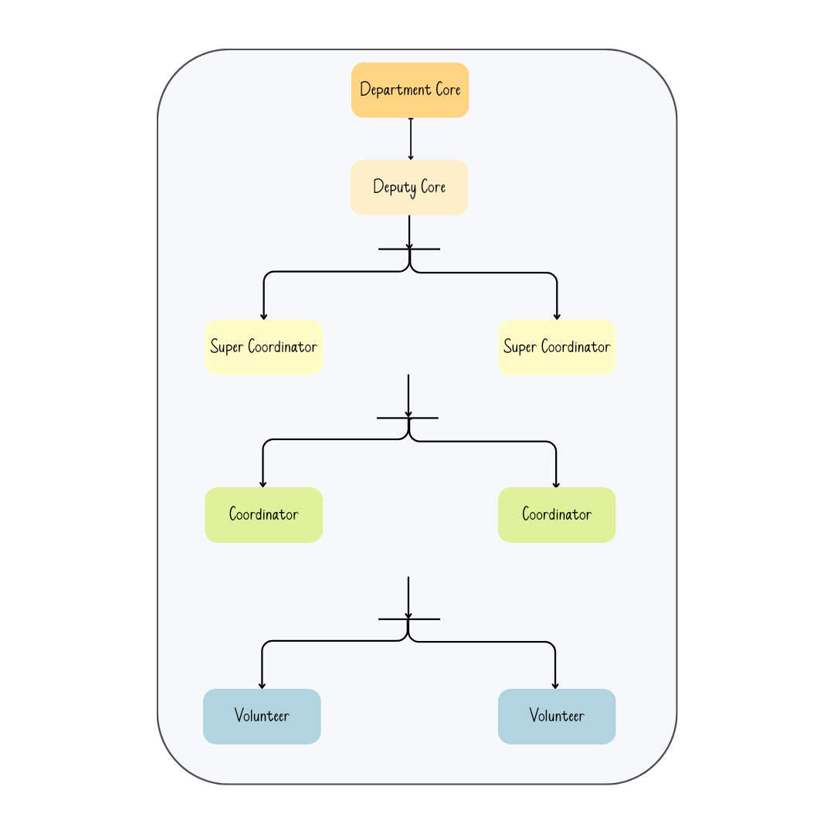

### Roles:

1. Department Head:

As the leader of the Student Relations Department, the Department Head assumes the critical role of primary decision-maker and visionary guide. The Department Core sets the course for the entire department, defining strategic goals and objectives, and ensuring the seamless execution of plans. The Department Head plays a pivotal role in aligning events with the overarching vision of Paradox, making crucial organizational decisions, and fostering collaboration with other departments.

Responsibilities:

* + Formulating and overseeing the implementation of long-term strategies.
  + Managing and overseeing all departmental functions.
  + Serving as the primary Point of Contact for the Steering Committee and Secretaries.
  + Coordinating with other departments to ensure the efficient conduct of all events.
  + Making critical organizational decisions in alignment with the vision of Paradox.

1. Deputy Head:

The Deputy Head serves as a vital support to the Department Head, contributing significantly to the planning, decision-making, and oversight of specific departments within the Student Relations Department. Acting as a liaison between the Core, the department team, and other departments, the Deputy Head plays a crucial role in ensuring the day-to-day functioning of the department, especially in the absence of the Department Head.

Responsibilities:

* Assisting the Department Head in planning and decision-making.
* Coordinating with other departments, Overseeing events, and Resolving any issues.
* Acting as a liaison between the Core, the department team, and other departments.
* Ensuring the day-to-day functioning of the department.
* Providing leadership in the absence of the Department Head.

1. Super Coordinator:

Super Coordinators are the linchpin of communication between various departments and teams. They play a pivotal role in managing data, handling the help desk, overseeing attendance during events, responding to query emails, and generating HTML mails and certificates. Super Coordinators also guide and mentor Coordinators, ensuring the successful completion of assigned tasks.

Responsibilities:

* Coordinating within the department and among other departments.
* Managing timelines, project plans, and resolving issues.
* Handling data of students, participants, organizers, and other departments.
* Managing the help desk, attendance during events, and query emails.
* Email writing, HTML mail generation, and certificate generation.
* Guiding and mentoring Coordinators for improved performance.

1. Coordinator:

Coordinators play a vital role in the collection, organization, and management of data and information related to their assigned tasks. They assist Super Coordinators in tasks such as managing volunteers, reporting progress, and handling day-to-day operations within their assigned domain. Coordinators contribute to maintaining consistency and efficiency within the team.

Responsibilities:

* Planning and executing tasks in specific areas.
* Managing volunteers and ensuring their seamless integration into tasks.
* Reporting progress to Super Coordinators or Deputy Head.
* Handling day-to-day operations within their assigned domain.
* Addressing emails, responding to student community concerns, data entry, and other tasks pertaining to data management.

1. Volunteer:

Volunteers, as the lifeblood of the organization, actively contribute hands-on efforts to execute plans and bring events to life. They play a crucial role in the successful implementation of tasks, supporting Coordinators and Super Coordinators in their assigned responsibilities.

Responsibilities:

* Executing assigned tasks and responsibilities diligently.
* Assisting Coordinators and Super Coordinators in their tasks for expedited execution.
* Contributing to the collection of data, conducting surveys, and various event-related tasks like taking attendance during the events, assisting students on campus, helping students in on-campus navigation.



### 

### 

### Skill sets required:

* Basic knowledge of various web-based applications
* Knowledge of G Suite Applications
* Data Management, Data Analysis and Interpretation
* Email-writing Skills
* Experience in Content writing
* Ability to patiently deal with students’ queries
* Any prior knowledge of Email Automation, Canva, BeeFree HTML Mail creation etc.
* Good knowledge of Python, Html, CSS, Javascript, Backend.
* Proficiency in Major languages like English, Hindi, Tamil, Telugu, Malayalam, Bengali, Marathi, Kannada, Odia etc.
* Teamwork and communication
* Quick decision-making and critical-thinking skills
* Curiosity to learn new things and adapt quickly to the changing environment
* Event management

### Standard Operating Procedure:

1. All the mail, including customized mail, that is to be sent to the students should be sent at least 24 hours in advance to the SR Team .  
   The request to the SR Team Should be sent in the following format.
   * 1. Scheduled Send Time and Date
     2. Recipients
     3. Subject of the Mail
     4. Body
2. Emergency emails, which after the 24 hours window, must be routed through the secretaries and sent at least six hours before the scheduled send time to the SR Team.
3. All paradox payments should be collected through student dashboard or paradox website only.
4. Emails pertaining to Paradox should not include any society email IDs or social media promotion or indirectly promote the society.
5. Any Email pertaining to paradox should be sent through SR Team only. Personal Email IDs, Social Media Accounts, Society Email IDs Should strictly not be used for such purposes. If, in case, anyone wants to use personal email IDs they should get the approval of secretaries and the SR Team should be notified.
6. Only the web-ops team and SR Team can collect students' data, and share it with the respective team. Any other team should not collect students’ data through any format such as google forms, etc. There may be some exceptions but with the approval of secretaries and SR Core only.
7. Any data shared by the web-ops or SR Team is strictly confidential and must not be shared outside of the organization and should strictly be used only for the purpose of paradox.
8. All organizers will be issued certificates based on the data that is provided in the Organizers Directory. This sheet will be locked for editing after the recruitment process, and any new entries will be added only after the approval of secretaries.
9. All Participation/Merit Certificates of Students will be handled by Student Relations and also the attendance tracking of students will also be handled by student relation. So the SR Team will generate certificates based on the data that the team gets from webops by cross referencing it with the attendance data collected by SR Team.
10. All event organizers must wear their Organizer's tag at all times during the event. The Organizer's tag must be clearly visible and must not be shared with anyone else.
11. All event organizers must provide accurate and up-to-date information during the registration process. Any changes to the registration details must be communicated to the registrations team as soon as possible.
12. Cores must ensure that their team members, including super coordinators, Coordinators and Volunteers are also registered and have their Organizer's tags with them at all times during the event. Failure to do so may result in restricted access to certain areas of the event.
13. Event organizers must ensure that their team members follow the registration process correctly and do not engage in any fraudulent activities.
14. The organizers are advised that their tags are non-transferable. Any offenders caught sharing their tags will have them confiscated and reported to the secretaries. Appropriate action will then be taken.

Note: Any matter pertaining to students or the organizers will be handled by the SR Team, So the SR Team has the discretion to make changes in the document pertaining to these matters after consultation with the Secretaries.

### Team Members' Availability Requirements:

* Available Online Year-Round
* Offline Availability Required Two Weeks Before Paradox Event Commencement