

**ID6108-Process and Design for Additive Manufacturing**

**Assignment-2**

**Department of Metallurgical and Materials Engineering**

**IIT Madras**

**Submitted by – Amit Pathak (MM21S024)**

Question 2. Write a code for the surface roughness prediction in FDM parts and display the same  
as a colour map on the surface.

**Solution-**

The ASCII STL file for the UMS5_airplane can be accessed at - <https://drive.google.com/file/d/1UbannaAR_mEfgg35q4Suw27tdYcrloud/view?usp=sharing>

The code used for plotting and predicting the surface roughness is written in MATLAB. It reads the ASCII STL file and calculates the normal to each face. It then calculates the angle made by normal with the vertical (Z- axis). The values of the different angles made by the normal of each face with horizontal are stored. Then each loop is iterated through each angle, and based on the value of the angle, a formula is applied to calculate the mean value of surface roughness (Ra). The formula is as follows-

If angle == 0

Ra = 118.07*t

If angle > 0 && angle <= 30

Ra = ((-2.2442e-4)*angle^4 + (0.134e-1)*angle^3 - (1.777e-1)*angle^2 + 2.1*angle - 1.681e-1)*t/sin(angle*0.017444)

If angle > 30 && angle <= 90

Ra = 71.472*(t/sin(angle*0.017444)); [1]

The MATLAB code is as follows

% Read mesh and compute normal vector

% Read mesh and compute normal vector

TR = stlread('UMS5_airplane.stl'); % contains "Mesh" structure

[X,~,J] = unique(TR.Points,'rows');

F = J(TR.ConnectivityList).';

P = TR ;

X = X.';

XF = reshape(X(:,F),3,3,[]);

N = cross(XF(:,2,:)-XF(:,1,:),XF(:,3,:)-XF(:,2,:),1);

% Compute angles made by normals with vertical line

angles = zeros(1, size(N, 3));

for i = 1:size(N, 3)

normal = N(:,:,i);

vertical = [0;0;1]; % assuming vertical line is z-axis

angles(i) = acosd(dot(normal, vertical)/(norm(normal)*norm(vertical)));

end

% for thickness t=0.3 mm

t = 0.3; % Example value of t

Ra=0;

% Loop over each angle

for i = 1:length(angles)

angle = angles(i);

if angle == 0

Ra = 118.07*t;

elseif angle > 0 && angle <= 30

Ra = ((-2.2442e-4)*angle^4 + (0.134e-1)*angle^3 - (1.777e-1)*angle^2 + 2.1*angle - 1.681e-1)*t/sin(angle*0.017444);

elseif angle > 30 && angle <= 90

Ra = 71.472*(t/sin(angle*0.017444));

end

Ra_values(i)= Ra;

% Display the result for the current angle

fprintf('For angle %d degrees, Ra = %f\n', angle, Ra);

end

[F, V, N, C] = stlread('UMS5_airplane.stl');

trisurf(F, Ra_values);

colorbar; % add a colorbar to show the range of Ra values

xlabel('X');

ylabel('Y');

zlabel('Z');

title('Ra Values for UMS5 Airplane');

% value of Ra for some standard angle

angles = [0, 10, 20, 30, 40, 50, 60, 70, 80, 90]; % Example array of angles

t = 0.3; % Example value of t

% Loop over each angle

for i = 1:length(angles)

angle = angles(i);

if angle == 0

Ra = 118.07*t;

elseif angle > 0 && angle <= 30

Ra = ((-2.2442e-4)*angle^4 + (0.134e-1)*angle^3 - (1.777e-1)*angle^2 + 2.1*angle - 1.681e-1)*t/sin(angle*0.017444);

elseif angle > 30 && angle <= 90

Ra = 71.472*(t/sin(angle*0.017444));

else

error('Invalid angle');

end

% Display the result for the current angle

fprintf('For angle %d degrees, Ra = %f\n', angle, Ra);

end

The code can be found at the following link-

<https://drive.google.com/file/d/1R3rHV1AQQ-NplEL9GnRiWf9yexupP9Jp/view?usp=sharing>

The output of the code is a row matrix containing the values of angles made by the normal to each face with the vertical. The code also loads the values of other variables like X, N, Ra_values etc. The 3D plot of the Ra_values with the respective face is plotted using a trisurf command. It plots the surface roughness values with the corresponding faces, which are stored in F as Fx, Fy, and Fz. The output tells the value of surface roughness corresponding to each face.

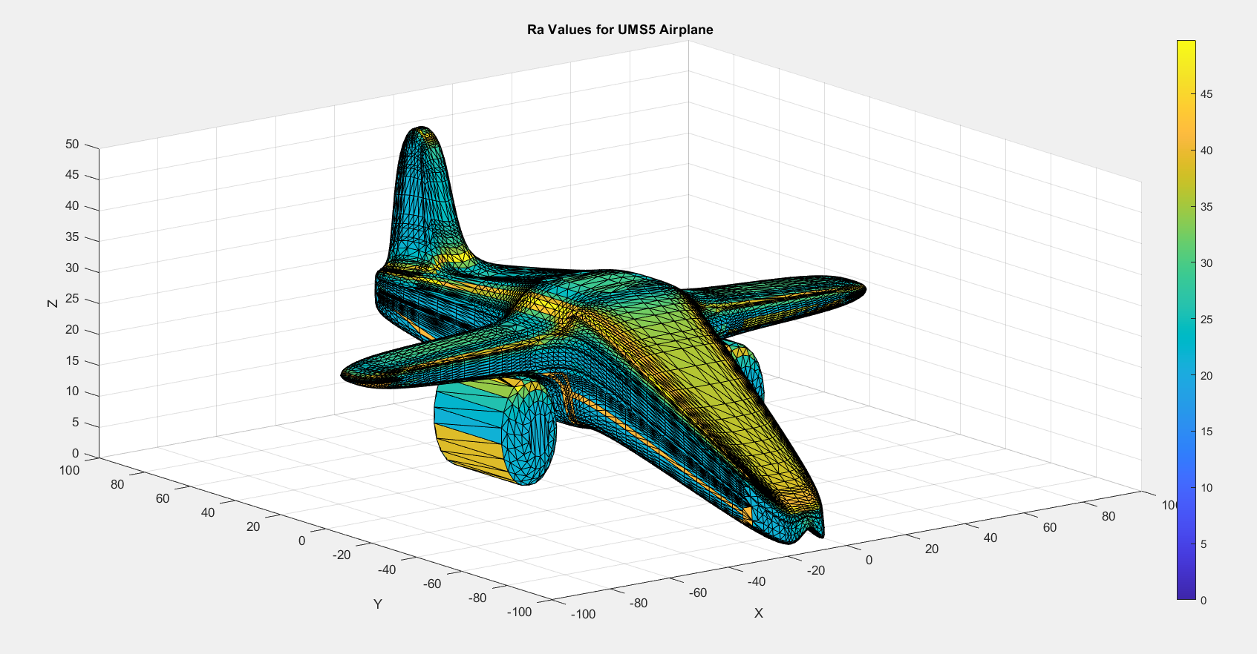 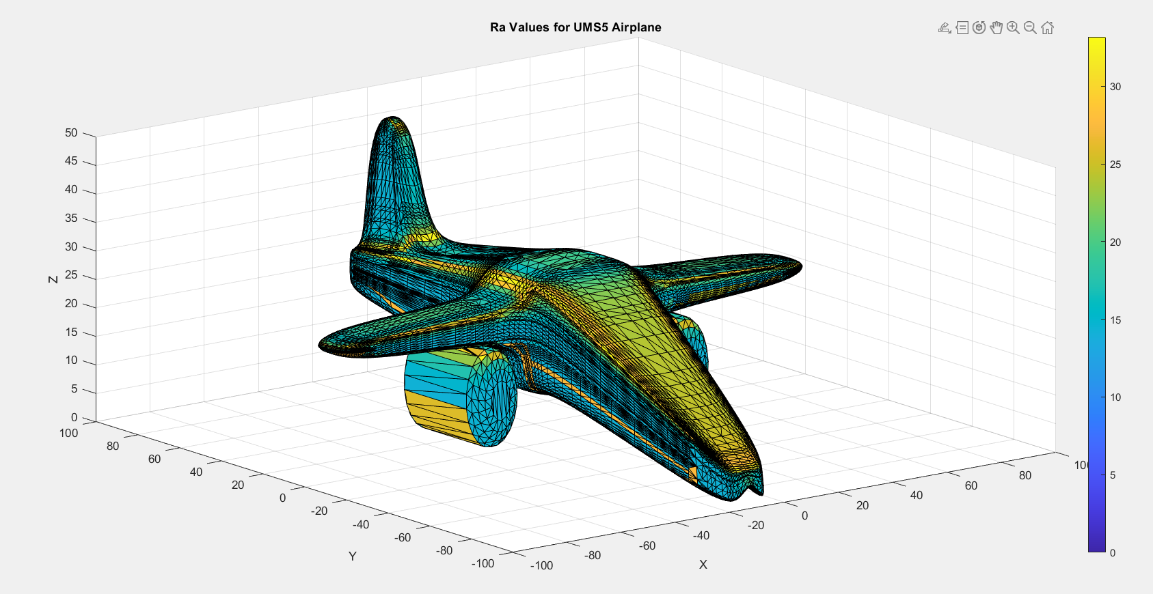 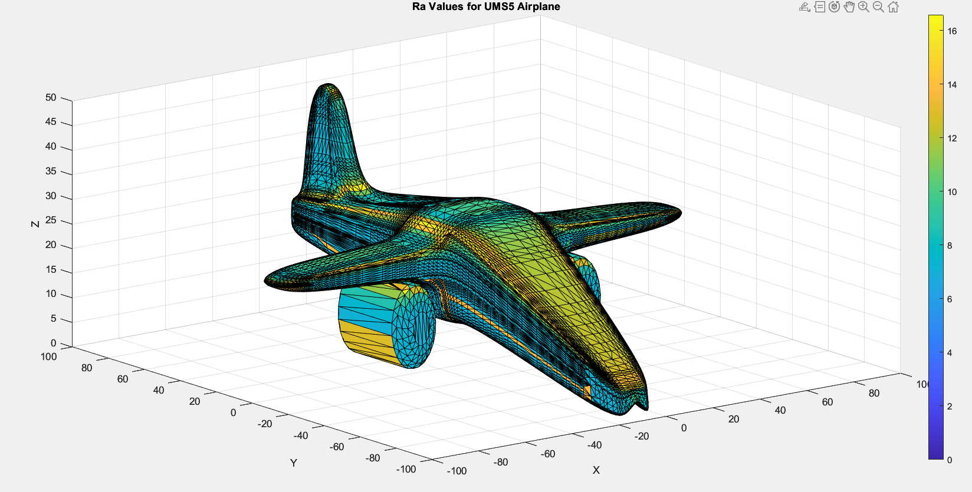

Fig.1 Ra Values(µm) for t= 0.3mm Fig.2 Ra Values(µm) for t= 0.2mm Fig.3 Ra Values(µm) for t= 0.1mm

The output plot can be accessed at the following link- (for t = 0.3 mm)

<https://drive.google.com/file/d/1nQTAsnK2W4mTEpSg51-RHMnkzzEYbRZS/view?usp=sharing>

This shows the plot corresponding to each face.

References

[1] M. Taufik, P.K. Jain, A study of build edge profile for prediction of surface roughness in fused deposition modeling,

J. Manuf. Sci. Eng. Trans. ASME. 138 (2016) 1–11. https://doi.org/10.1115/1.4032193.