**“Mobile Applications Development”**

**course**

**a.y. 2011-2012**

**YOUR_APP_NAME**

**Design[1],[2]**

|  |  |  |
| --- | --- | --- |
| **Team Members[3]** | | |
| **Name** | **Student Number** | **E-mail address** |
|  |  |  |
|  |  |  |
|  |  |  |
|  |  |  |
|  |  |  |

Strategy

# Product Overview

Very brief overview of the app

## Competitors

Identify possible competitors (up to 5-6) and evaluate your app against theirs (a couple of lines for each competitor, no more)

# User Research

Describe the Needs that you want to fill with your app

Describe the main Goals your app allows users to achieve

Segmentation: identify the class of your target users by age, job, life style, etc.(usually an app targets 1-2, 3 classes of users at most)

## Personas

Define a “persona” for each kind of target user identified in the previous section

Scope

# Features

Provide a list of the main features of your app

**Requirements**

Describe the various requirements (prioritizing them), constraints, rules, etc.

**Content**

Describe how your app manages text, video, audio

Data provenance (use of external API, web service, DB …)

Scenarios

Propose a set of scenarios that describe how each “persona” can interact with your app (here it is mandatory to use personas).

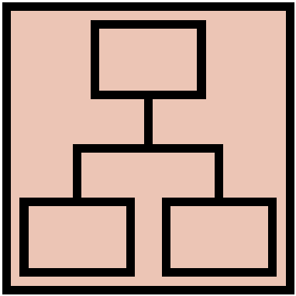Structure

# Sitemap

Provide a sitemap of your app, together with a brief description of its main parts (and the relevant choices you made).

# Vocabulary

Provide a well-defined terminology for all the content and tasks you manage in your app.

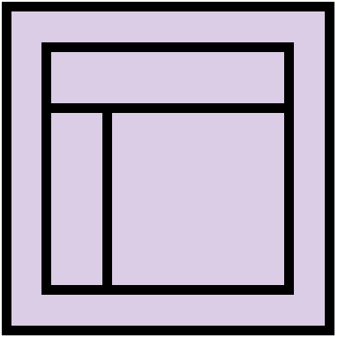Skeleton

Provide Lo-Fi Wireframes of your app, together with a brief description of the relevant choices you made about the user interaction and how information flows among views. Here you may use any digital means to define the wireframes, but you can also provide the various sketches you made during the evolution of the design of your app.

Surface

Provide Hi-Fi Wireframes of your app, together with a brief description of the relevant choices you made about the layour, colors, UI design, user interaction, etc. Here you can use also mockups, prototypes, photos, etc.

1. The max length of this document is 20 pages
2. The structure of this document is fixed, it cannot be changed in any way
3. The team leader is listed as first member in this list