

Al Imam Muhammad ibn Saud Islamic University College of Computer and Information System

Computer Science Department

1st semester 1442 H – 2020 G

**CS 438 – Internet Technologies**

**Project**

**[ Riyadh Trail ]**

**By**

|  |  |
| --- | --- |
| Student Name | ID |
| Waleed aldukhail | 439014124 |
| meshal alsaleh |  |
| abdulaziz alsubaie |  |
| faisal alqahtani |  |

15/8/2022

In this project, we managed to develop a website to help tourists and residents of Riyadh city to know about the city and its facilities such as : Restaurants , Café’s , Events and Hotels .

This project will be beneficial in many aspects , it’ll help businesses to get more exposure and reach their targeted audience , it will also help tourists flowing to the city to get familiar with it even before arriving here .

## 1. Site Map

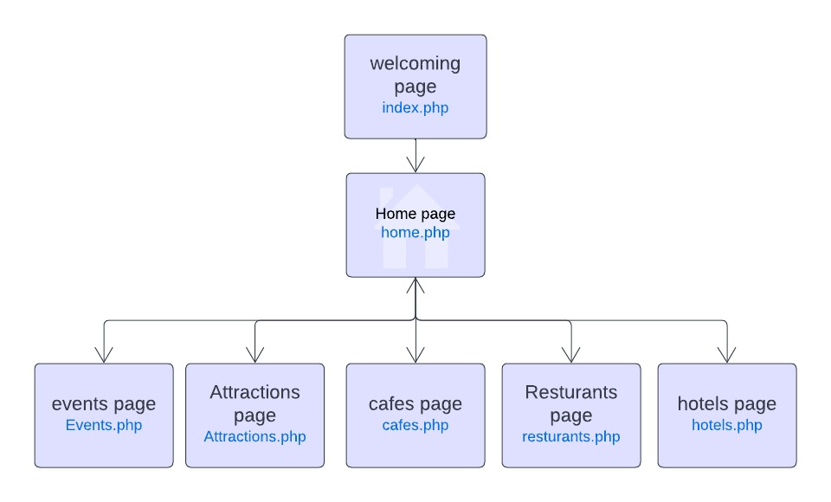

## 2. Look & Feel

To make things clear and rich in content we will describe each aspect alone , starting with :

### 2.1 Look

2.1.1. The colorsIn 2022 the trending colors an color pallets are categorized to a specific area or “aesthetic” which is the Minimalist approach, we have carefully chosen the following colors :-

* Shape

  Description automatically generatedrgb(88, 75, 75)
* Shape

  Description automatically generatedrgb(128, 128, 128)
* Black
* White
* Baige

2.1.2. Images and media  
We have included many pictures and videos of Riyadh’s Events , restaurants , cafes and attractions .

2.1.3. Fonts  
After researching many available fonts we choose the following font family :

font-family: "Trebuchet MS", "Lucida Sans Unicode", "Lucida Grande",

"Lucida Sans", Arial, sans-serif;

### 2.2 Feel

We Asked ourselves what is our first impression of our website?

Is it Serious?, we accomplished that.

Approachable and Sophisticated? , The website was easy to use by many user groups and was up to date in the HCI perspective .

Playful? , Video backgrounds and multimedia presence made huge efforts in that aspect

consideration of the type of motion and pacing makes all the difference. For example, using a smooth slide-in for an image would result in a very different feel than using a quick popup and bounce effect for that same image.

## 3. Dynamic Components

[List the web pages that include javaScripts to create dynamic components]

## 4. Business Logic

## 5. Diagrams

### 5.1 Use Case Diagram

### 5.2. Flowchart

### 5.3 Test Case Scenarios

|  |  |  |  |  |  |
| --- | --- | --- | --- | --- | --- |
| **Test case#** | **Test Case Description** | **Test Data** | **Expected Result** | **Actual Result** | **Pass/Fail** |
| **1** | Check response when user press”proceed to HomePage”Button | User presses the button | The user should be redirected to HomePage | user is redirected to HomePage | Pass |
| **2** | Check response when user press”Resturants”Button in home page | User presses the button | The user should be redirected to Restaurants page | The user is redirected to resturants page | pass |
| **3** | Check response when user press”Café’s”Button in home page | User presses the button | The user should be redirected to Cafe’s page | The user is redirected to cafe’s page | pass |
| **4** | Check response when user press”Events”Button in home page | User presses the button | The user should be redirected to Events page | The user is redirected to Events page | pass |
| **5** | Check response when user press”Hotels”Button in home page | User presses the button | The user should be redirected to Hotels page | The user is redirected to Hotels page | pass |
| **6** | Check response when user press”Attractions”Button in home page | User presses the button | The user should be redirected to Attractions page | The user is redirected to Attractions page | pass |
| **7** | Check response when user press”Home”Button in home page | User presses the button | The user should be redirected to Home page | The user is redirected to Home page | pass |
| **8** | Check response when user search for”Resturants” in the search bar | User types “Resturants” in the “search for pages” search bar | The user should be redirected to the Resturants page | The user is redirected to the Resturants page | pass |
| **9** | Check response when user search for”Café’s” in the search bar | User types “Cafe’s” in the “search for pages” search bar | The user should be redirected to the Cafe’s page | The user is redirected to the Cafe’s page | pass |
| **10** | Check response when user search for”Events” in the search bar | User types “Events” in the “search for pages” search bar | The user should be redirected to the Events page | The user is redirected to the Events page | pass |
| **11** | Check response when user search for”Hotels” in the search bar | User types “Hotels” in the “search for pages” search bar | The user should be redirected to the Hotels page | The user is redirected to the Hotels page | pass |
| **12** | Check response when user search for”Attractions” in the search bar | User types “Attractions” in the “search for pages” search bar | The user should be redirected to the Attractions page | The user is redirected to the Attractions page | pass |

# References