|  |  |  |
| --- | --- | --- |
| **المملكة العربية السعودية**  **وزارة التعليم العالي**  **جامعة الإمام محمد بن سعود الإسلامية**  **كلية علوم الحاسب والمعلومات** | A description...  **Second term 1441/2020** | **KINGDOM OF SAUDI ARABIA**  **Ministry of Higher Education**  **Al-Imam Mohammad University**  **College of Computer & Information Sciences** |
| **Software Engineering (CS- 310)**  **BSCS- Section: 171**  **Project-Phase No: 2**  **Ecrops**  **(System Design document)** Submitted By  |  | | --- | | Waleed Al-Dukhail (439014124) – Coordinator **(437013846)** **Abdallah Sultan Alenzi**  **(439016631) Mohammed Algrain**  **Turki Alhoshan (439023714)**  **(439013290)** **Abdulrahman Suleiman Alorf** SupervisorDr. Sultan AL QahtaniDate: 20/10/2020 | | | |



Table of Contents

1. Introduction ………….…………………………………………………………………………………………………….………4

1.1 Team Members ….......................................................................................................................4

1.2 Purpose ………………………………….………………………………………………………………………..………………..…4

1.3 Definitions, Acronyms, And Abbreviations. ………………………………………………………...................…5

1.4 Project timeline ….….……….…………………………………………………………………………………………………….5

* 1. Challenges …….…….……………………………………………………………………………………………………………….5

1. General description ..........................................................................................................................................................7

2.1. Product Perspective .................................................................................................................7

2.2. Product Functions ....................................................................................................................7

2.3. User Characteristics .................................................................................................................8

3.0 Functional Requirements Specification....................................................................................................................8

3.1 Stakeholders……………….…….......................................................................................................8

3.2 Actors and Goals………….………….................................................................................................9

3.3 Use Cases description ….………….……………………………………………………………………………………………9

3.4 Use Case diagram ....…….………….…………………………………………………………………………………………13

3.4 Use Case Scenarios ...……………….…………………………………………………………………………………………14

4.0 Non-Functional Requirements Specification.......................................................................................................19

5.0 System Design document…………….……………........................................................................................................19

5.1 The user interface scenario ……….............................................................................................20

5.2 System Level Diagram ………….…...............................................................................................23

6.0 Conclusion ………………………………………………........................................................................................................19

|  |
| --- |
| **1.0 Introduction** |

Ecorps is an application made for farmers and farm owners to sell their goods directly to the consumers without the hassle of selling it in the street in dirty cars or giving it to specific stores with high commissions , in Ecorps everyone can buy their favorite vegetables or fruits or even dairy products from their favorite farms registered in the app with many choices available , which can truly transform regular farms to smart and efficient farms.

* 1. **Team members**

|  |  |
| --- | --- |
| Team Member | The tasks |
| Waleed Al-Dukhail (The Coordinator) | task Distributor, Helped with the user cases and SRS in general, Interface |
| Mohammed Algrain | identifying the challenges, User cases, and functional requirements,Interface |
| Abdulrahman Suleiman Alorf | identifying the main user goals, product Functions and user cases,Class diagram |
| Abdallah Sultan Alenzi | identifying the User characteristics, stakeholders and user cases, Class diagram |
| Turki Alhoshan | identifying the Stakeholders, key goals and user cases |

**1.2 Purpose**

The main purpose of this application is to make farmers life easy and more efficient to contribute directly to the society, so consumers can easily access and view the farms crops and goods and also dairy products with a lot of options including organic options.

**1.3 Definitions, Acronyms, and Abbreviations**

|  |  |
| --- | --- |
| Term | Definition |
| Stake Holder | a person with an interest or concern in the application. |
| Requirement | the description of what the system should do. |
| Functional Requirement | specific services or functions the system must provide. |
| Non- Functional Requirement | constraints on the services or functions offered by the system |

**1.4 Project timeline**

**1.5 Challenges**

Here are some challenges that we might face during the make of our application: -

**• Long time to purchase a product**

Consumers find it difficult sometimes to search for a specific product in the market, after finding this product usually it takes time to purchase this specific product because having the client waiting in a queue for the procedure would take time, and it will be a waste of time and effort for them. In Ecrops application customers will find product information and searching methods that will help them to find what they are looking for faster and ordering will be much easier.

• **Poor quality and lack of productivity**

Ecrops supplier’s supervisors have difficulty knowing the best-selling products specially if it is farm far away from the city, the Ecrops application will provide suppliers supervisors with more detailed, accurate and up-to-date best seller products. They will be informed of potential customers more quickly and they will have faster access to the sold products, and they interact with suppliers to inform them about sales and profits.

**• Poor customer service**

Customer Service Department in the markets are defective, and the new system should reduce the workload of Customer Service as customers are able to find the information they need from the application, so we provided a live chat between suppliers and customers to interact with each other directly for faster response.

**•Delivery delay**

The delivery staff delays in delivering orders because of the delay in receiving orders and the lack of delivery representative, In the application purchase information will be sent directly to delivery staff for inventory control and order processing faster.

• **Lack of experience in the IT department** The Information Technology Department faces a lack of staff, experiences and advanced devices, But in the new system this department will be responsible for implementing the new database, hosting the application and maintaining the system professionally because its supported by the latest devices and with IT staff having certifications and experience

**• Delayed receipt of information on the latest new products**

Suppliers have a problem delay in receiving the latest news about their sold products from markets. In Ecrops application the suppliers will be allowed to maintain the data about their products directly. This will eliminate delays in getting new products or change product specifications into the system, this makes suppliers to gain more complete understanding of the businesses they serve, and this allows them to meet their needs more effectively.

|  |
| --- |
| **2.0 General description** |

**2.1 Product Perspective**

In Ecrops we believe in local farmers to enhance and benefit their own society and economy,

Because farmers do not have to worry about a two-week delivery route, they are able to focus on flavor rather than durability. In turn, this provides a more delicious product for their customers. As a result, we are more likely to eat fresh vegetables. In addition to fresh delivery for customers, farmers who deliver locally have a positive impact on environment by decreasing the distance trucks must travel on the road ,so we can take off a heavy load out of them and making their farms more smarter and efficient .

‏When someone buys fresh produce or other local farm products at an area farmer’s market, the money stays in the state longer than buying imported products into the state. One riyal spent with a local farmer is re-spent three to seven times in the local community. As local farmers are successful.

**2.2 Product Functions**

The Ecrops acts as a mediator as shown in Figure 1, the system Gives each farmer a separate page to allows the farmer to present his products and the details for each product , The buyer can view the products and chose from the products, the system then adds the choose products to the cart, when the user is done from shopping in the Ecrops system. To conform the payment the user must enter his registration details (name - address – phone number – email) and then chose the payment method (Electronic card – cash on delivery) then submit the order. The farmer will receive the order, prepare it and then ship it to the buyer.

Figure 1 : The Relations between the farmers , buyers and Ecrops

**2.3 User characteristics**

This application is targeting people who has an interest in agricultural products and looking for tools with perfect quality and low prices And we need to know user's personal information such as ( country , city , sex , age and educational level ) , to know who is interested in these products, This will help us to improve the application and specify the targeted people.

|  |
| --- |
| 3.0 FUNCTIONAL REQUIREMENTS |

**3.1 Stakeholders**

•Clients: view and purchase products.

•Suppliers: sell products.

•Delivery staff: deliver products to clients.

•Ecrops Database: keeping records of user’s data.

•Administrator: who is responsible for ensuring that system information can be maintained and preserved and that record keeping procedures have been properly implemented.

•Managers: ensuring free flow of communication and efficient use of resources.

•IT staff: who are responsible for installing and maintaining the system.

•Health organization: who obtain management information from the system.

•Supplier supervisors: keep in contact with the suppliers to ensure quality and continuity of supply.

•Client supervisors: keep in contact with clients.

•Accounting staff: recording financial transactions and keeping track with any transaction issues.

**3.2 Actors and Goals**

Actors are the people or things (other applications, hardware, etc.) that will interact with our system to get something done. Each actor has a set of goals – tasks they need to get done using the system we are specifying. These goals are the starting point of our requirements.

|  |  |  |
| --- | --- | --- |
| Actor | Type | Goal |
| Client | Initiating | View and purchase products |
| Supplier | Initiating | Sell products |
| Mada system | Participating | Confirming payments through its bank system |
| Administrator | Initiating | Ensuring that system information can be maintained and preserved |
| GPS system | Participating | Provides user’s geolocation and time information to a GPS receiver |
| Ecrops Database | Participating | Keeping records of user’s data |

**3.3 Use Cases description**

|  |  |  |
| --- | --- | --- |
| Use Case ID | Name | Short Description |
| UC1 | Login | User can login in the application if they have an account |
| UC2 | Alert | System alert the user for wrong number entry |
| UC3 | Register | The user (Client/Supplier) can make a new account in the application |
| UC4 | Reset Password | The user should be able to make a new password in case they forgot the old one |
| UC5 | Approve registration | The system sends an email to confirm appointment |
| UC6 | Confirm SMS | When the user forgets his password and choose to reset the password and add their number when the number is confirmed as a registered number a confirmation page will be view |
| UC7 | Confirm mobile number | When a user registers a code with 4 numbers will be send to the user phone number and let the user enter the code |
| UC8 | Set up an appointment | The supplier can set an appointment with the company to add his/her farm to the application |
| UC9 | View terms and conditions | View to the user terms and conditions |
| UC10 | Select section | The client can select one of 3 sections of products |
| UC11 | Search | The client can search for products |
| U12 | Filter | The client can filter for products by cost and farm name |
| U13 | Add to cart | The client can add products and quantity to their cart |
| UC14 | Rate | The client can rate items from suppliers |
| UC15 | Chat | Clients and suppliers can live chat with each other |
| UC16 | Notify | System notify if the user has notification |
| UC17 | View profile | Users can view their profile from their homepage |
| UC18 | View settings | Users can view settings, button from their homepage |
| UC19 | View notification | Clients can view notifications from their homepage and if the order status is accepted, shipped or delivered |
| UC20 | View Homepage | Users can return to homepage |
| UC21 | Edit information | The client can edit their name, location, phone number, and change password |
| UC22 | View order history | The client can view their order history and track them by checking on the order status. |
| UC23 | View packages | The client can view the subscription packages and their purchased subscription |
| UC24 | Subscribe | The client can subscribe to a subscription package |
| UC25 | Cancel package | The client can cancel their purchased subscription package |
| UC26 | Confirm cancelation | Takes the client to a confirmation page of the canceled subscription. |
| UC27 | Enter subscription information | The client can enter the time of delivery for the subscription (time\day) |
| UC28 | Make a payment | The client can select the payment method (Cash on delivery, Visa or Mada) |
| UC29 | Enter card information | The client can enter their card information if visa or mada was chosen |
| UC30 | Confirm payment | System takes the client to a confirmation page |
| UC31 | Choose language | The client can choose one of two languages (Arabic \ English) |
| UC32 | View shopping cart | The client can view the added products and their total |
| UC33 | Remove from cart | The client can remove the products from cart |
| UC34 | Order | The client can order by proceeding to checkout |
| UC35 | Confirm order | Takes the client to a confirmation page and view the order number and date |
| UC36 | Edit information | The supplier can edit their information (location, phone number and change password) |
| UC37 | View balance | The supplier can view their current balance |
| UC38 | Add product | The supplier can add products (name, price and quantity) |
| UC39 | Remove product | The supplier can remove products from item menu |
| UC40 | View bought items | View to the suppliers the bought items |
| UC41 | Find us | View to the user Ecrops location |
| UC42 | Contact us | The user can contact the Ecrops number |
| UC43 | Log out | Users can log out from the account |

**3.4 Use Case diagram**

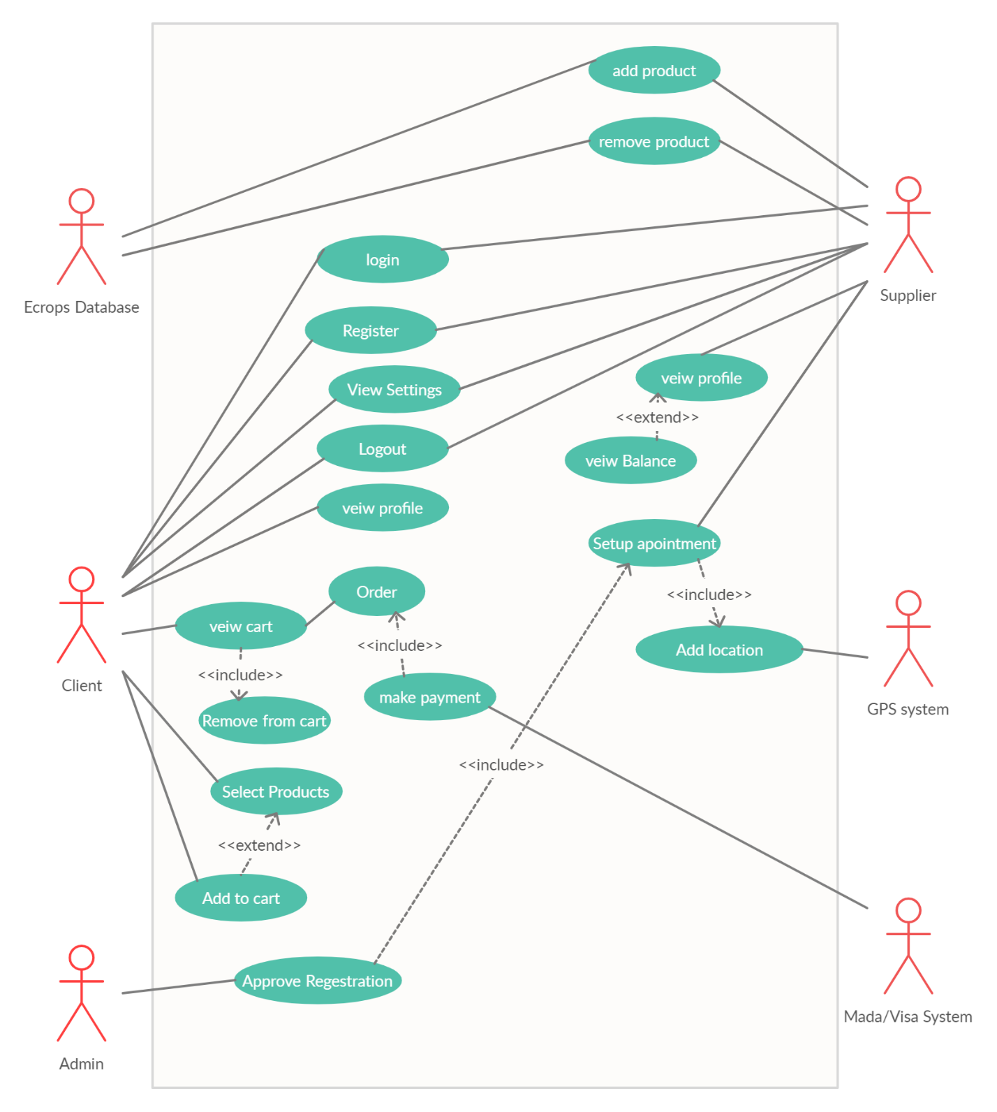

**3.5 Use Case Scenarios**

|  |  |  |  |
| --- | --- | --- | --- |
| **UC1 < Chat >** | | | |
| **Participating actor(s):** *Ecrops Database* | | | **Initiating actor*:*** *Supplier /Client* |
| **Actor’s Goal:** *users communicating with each other.* | | | |
| **Pre-conditions:**  *1. the user must be logged in successfully.*  *2. the product must be added by the supplier.* | | | |
|  | | | |
| **Flow of Events for Extension:**  *1.1 the supplier deletes the product.*  *1.2 system displays an error message for the client and end use case* | | **Flow of Events for Success Scenario:**  *1. the client selects the supplier’s product.*  *2. System displays the supplier’s product window*  *3. client requests to chat with supplier.*  *4. the system notifies the supplier if they received a message.*  *5. The message is stored in Ecrops database. 6. supplier enters the chat page.* | |
| **Post-conditions:**  **Successful condition:** *Client and Supplier communicating with each other successfully.*  **Failure Condition:** *None.* | | | |

|  |  |  |
| --- | --- | --- |
| **UC2 < Subscribe >** | | |
| **Participating actor(s):** *Ecrops Database.* | **Initiating actor:** *Client* |
| **Actor’s Goal:** *the client chooses one of three packages provided by Ecrops.* | | |
| **Pre-conditions:***the client must be logged in.* | | |
|  | | |
| **Flow of Events for Extension:**  *2.1 client already subscribed to a package. 2.2 the system displays an alert message and end use case.*  *3.1 The client misses a required field.*  *3.2 the system displays an alert message. 4.1 the client forgets to choose payment method. 4.2 the system displays an alert message.* | **Flow of Events for Success Scenario:**  *1. the client requests for subscription*  *2. the client selects one of the three*  *3. The system checks in Ecrops*  *4. the client enters time and date*  *5. the client chooses the payment*  *6. the client proceeds to payment*  *7. Ecrops Database is updated* |
| **Post conditions:**    **Successful condition*:*** *client purchases subscription package successfully.*  **Failure Condition*:*** *no new package purchased* | | |

|  |  |
| --- | --- |
| **UC3 < Rate product >** | |
| **Participating actor(s):** *Ecrops Database* | *Initiating actor: Client* |
| **Actor’s Goal:** *show admiration and the rate of their evaluation of the product* | |
| **Pre-conditions*:*** *Client must be logged in.* | |
|  | |
| **Flow of Events for Extension:**  *2.1 the supplier deletes the product.*  *2.2 system displays an error message for the client and end use case.* | **Flow of Events for Success Scenario:**  *1. The client selects the product*  *2. System displays the product*  *3. The client rates the supplier from*  *4. Ecrops Database is updated*  *5. The system displays a message that*  *6. The system displays the rate in the* |
| **Post-conditions:**  **Successful condition:** *The client will rate the product successfully.*  **failure condition:** *None.* | |

|  |  |
| --- | --- |
| **UC4 < Add product >** | |
| **Participating actor(s):** *Ecrops Database* | **Initiating actor:** *Supplier* |
| **Actor’s Goal:** *Supplier adds a product to the application.* | |
| **Pre-conditions:** *Supplier must be logged in.* | |
|  | |
| **Flow of Events for Extension:**  *2.1 supplier tries to add a product like an existing one from the same farm.*  *2.2 system displays an alert.*  *2.3 the supplier misses a required field of the product information.*  *2.4 system displays an alert.* | **Flow of Events for Success Scenario:**  *1. the supplier requests to add a product*  *2. the system requests the supplier to enter product information*  *3. the supplier enters*  *- name*  *- price*  *- quantity*  *- upload a picture of the product*  *4. the supplier approves the product.*  *5. Ecrops Database is updated* |
| **Post-conditions:**  **Successful condition:** *the new product will be added successfully.*  **failure condition:** *no product will be added.* | |

|  |  |
| --- | --- |
| **UC5 < Set up an Appointment >** | |
| **Participating actor(s):** *GPS system, Ecrops Database* | **Initiating actor:** *Suppliers.* |
| **Actor’s Goal:** *Suppliers join Ecrops to be able to sell their products online* | |
| **Pre-conditions:** *none* | |
|  | |
| Flow of Events for Extension:  *3.1 insufficient date (if the year passed)*  *3.2 system displays an alert.*  *4.1 missing required fields*  *4.2 system displays an alert.* | **Flow of Events for Success Scenario:**    *1. Select set-up appointment*  *2. The supplier selects an appointment date.*  *3. The supplier adds their email.*  *4. The supplier adds Farm location through a location locator (map).*  *5. The system request map from GPS system 6. the supplier submits the appointment arrangement.*  *7. the system confirms the arrangement.*  *8. Ecrops Database is updated* |
| **Post-conditions:**  **Successful condition:** *the supplier will set up an appointment successfully.*  **failure condition:** *no appointment will be booked.* | |

|  |
| --- |
| **4.0 Non-Functional Requirements** |

* the system holds extremely sensitive information, so by that protecting that information is the highest priority
* The common language used in the incoming mail department will be English to increase communication effectiveness and reduce processing errors
* the app will have updated products daily
* the system will store the information for a long time which will be benefit the user
* Each page of app loads within short seconds
* Each request will be processed within short seconds
* The app has user friendly interface and will be easy to use for everyone especially the elderly
* Any update will be fixed on the backend and a notice will be sent to the user
* The app is capable for any future upgrade, code and document can be modified easily for any new function needed

|  |
| --- |
| **5.0** Software Design Document |

## 5.1 The user interface scenario

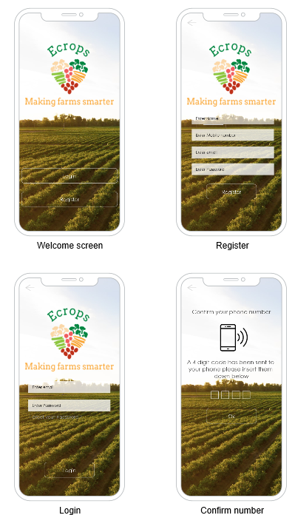

Figure 2 : The login and register pages

Figure 3 : the Ecrops main pages and Categories

**Figure 4 : the Payment and Confirmation pages**

## 5.2 System Level Diagram

Figure : Ecrops System Architecture

Descriptions of subsystems are as follows:

**GUI**

The GUI Subsystem is responsible for managing user input, such as mouse movements and keyclicks

**Client**

The Client Subsystem interacts with all requests that the Client may request while using the application

**Administrator**

The Administrator Subsystem is dedicated to the developers of the program to manage the whole Application.

**Supplier**

The Supplier Subsystem interacts with all requests that the Supplier may request while using the application.

**Mada System**

The Credit Card Subsystem is used to distinguish between different payment methods provided by the Mada\Visa System

**Requests**

The Requests Subsystem manages all the user requests, orders and subscriptions

**Ecrops DB**

The Ecrops data base subsystem which stores the application data

**Product**

The Product Subsystem is responsible for the appearance of all products in the Ecrops application.

**GPS System**

GPS Subsystem provides user’s geolocation and time information to a GPS receiver.

**5.3 The Sequence Diagram**

**5.4 The Detailed Class Diagram “Software Artifact”**

Figure : The class Diagram

## 5.5 The Attributes and Methods description for each Class

|  |  |
| --- | --- |
| Class | Supplier |
| Method | Login |
| Visibility | Public |
| Return Type | void |
| Parameters, types | Usrname:string ,pass:string |
| Description | Login to app with correct username and password |

|  |  |
| --- | --- |
| Class | Supplier |
| Method | viewRequests |
| Visibility | Public |
| Return Type | Array of Requests |
| Parameters, types | None |
| Description | Return list of requests belong to specific supplier |

|  |  |
| --- | --- |
| Class | Supplier |
| Method | addProduct |
| Visibility | Public |
| Return Type | Void |
| Parameters, types | name:string,description:string, price:money,img:image |
| Description | Add new product to the list of his products |

|  |  |
| --- | --- |
| Class | Supplier |
| Method | comunicateWithAdmin |
| Visibility | Public |
| Return Type | Void |
| Parameters, types | none |
| Description | Chat with online app administrator to complain something |

|  |  |
| --- | --- |
| Class | Supplier |
| Method | comuniateWithClient |
| Visibility | Public |
| Return Type | Void |
| Parameters, types | clientname:string |
| Description | Chat with client to check client's request/s |

|  |  |
| --- | --- |
| Class | Client |
| Method | Login |
| Visibility | Public |
| Return Type | void |
| Parameters, types | Usrname:string ,pass:string |
| Description | Login to app with correct username and password |

|  |  |
| --- | --- |
| Class | Client |
| Method | Register |
| Visibility | public |
| Return Type | void |
| Parameters, types | none |
| Description | Create client's profile in app |

|  |  |
| --- | --- |
| Class | Client |
| Method | viewProducts |
| Visibility | public |
| Return Type | Array list of products |
| Parameters, types | none |
| Description | Display contents of app , products |
|  |  |

|  |  |
| --- | --- |
| Class | Client |
| Method | ComunicateWithSupplier |
| Visibility | public |
| Return Type | none |
| Parameters, types | name:string |
| Description | Chat with supplier name |

|  |  |
| --- | --- |
| Class | Client |
| Method | PurchaseProducts |
| Visibility | puclic |
| Return Type | void |
| Parameters, types | Array of products |
| Description | Purchase list of Products |

|  |  |
| --- | --- |
| Class | Product |
| Method | viewProducts |
| Visibility | public |
| Return Type | Void |
| Parameters, types | None |
| Description | Return list of products of app |

|  |  |
| --- | --- |
| Class | Product |
| Method | postProducts |
| Visibility | public |
| Return Type | Boolean |
| Parameters, types | ProdName:string |
| Description | Accept publish of product in app |

|  |  |
| --- | --- |
| Class | Product |
| Method | editProducts |
| Visibility | public |
| Return Type | Boolean |
| Parameters, types | name:string,dec:string,  prc:money,pic:image |
| Description | Edit product data |

|  |  |
| --- | --- |
| Class | Product |
| Method | addAD |
| Visibility | public |
| Return Type | void |
| Parameters, types | ProdName:string |
| Description | Make price offer to product |

|  |  |
| --- | --- |
| Class | Product |
| Method | removeAd |
| Visibility | public |
| Return Type | void |
| Parameters, types | ProdName:string |
| Description | Remove price offer |

|  |  |
| --- | --- |
| Class | Administrator |
| Method | Login |
| Visibility | Public |
| Return Type | void |
| Parameters, types | Usrname:string ,pass:string |
| Description | Login to app with correct username and password |

|  |  |
| --- | --- |
| Class | Administrator |
| Method | ConfrimSupplier |
| Visibility | Public |
| Return Type | void |
| Parameters, types | name:string |
| Description | Accept Supplier user into app |

|  |  |
| --- | --- |
| Class | Administrator |
| Method | ConfrimProducts |
| Visibility | Public |
| Return Type | void |
| Parameters, types | name:string |
| Description | Accept product into app |

|  |  |
| --- | --- |
| Class | Administrator |
| Method | ConfrimClients |
| Visibility | Public |
| Return Type | void |
| Parameters, types | name:string |
| Description | Accept client user into app |

|  |
| --- |
| 6.0 CONCLUSION |

In the end , this app is recommended for those interested in the agricultural industry , which can truly transform regular farms to smart and efficient farms that’s powered by the latest technologies , and we will see real competition between farmers and farms