Alternative Route Suggestion based on Crime Hotspots

Sandip Shaw
Symbiosis Institute of Geoinformatics
Symbiosis International University, Pune
Maharashtra, India
sandip8017shaw@gmail.com

Abstract— The increasing demand for public safety in urban transportation highlights the value of blending crime data into route planning, thus providing alternate, safer options for commuters. This work addresses the problem of extracting and leveraging crime information from noisy, unstructured textual reports for enabling crime-aware routing in New Delhi. We developed a hybrid pipeline that combines the use of web scraping, Doccano-annotation, and a SpaCy-trained Named Entity Recognition model with a Large Language Model fallback for accurately extracting crime events and their respective locations. These are then geocoded via OpenStreetMap and retained in MongoDB for spatial analysis. Using OSMnx, crime events were projected over a road network and used in routing algorithms through dynamic penalization, while interactive visualization of routes was enabled by a Streamlit frontend and FastAPI backend. Experiments done on approximately 4,000 articles scraped, of which approximately 1,800 were crime-related and several origins–destination case studies demonstrated that the hybrid extraction method enriched entity coverage and penalized routing computationally produced alternate paths avoiding high-risk zones. These experiments show that the proposed modular pipeline effectively converts unstructured reports of crimes into actionable routing insights, and sets the stage for a safer urban navigation and future eventualities, including multilingual data ingestion, real-time feeds, and fairness-sensitive risk modeling.
Keywords—natural language processing, neural networks, geospatial intelligence, artificial intelligence, large language models, Information extraction

Introduction
Safety in cities through transportation is an increasingly large issue, especially in rapidly growing metropolitan cities such as New Delhi, wherein high levels of crime severely affect commuter trust and influence day-to-day travel patterns. Traditional routing solutions favor optimality in terms of distance and time, however, and lack the safety awareness of commuters, thus putting commuters in danger of potentially unsafe hotspots. Since crime data commonly exists in unstructured venues such as internet news reports or reports from users, the dilemma is finding a method of converting this disjointed and disorderly data into usable information, which can optimize routing and promote safety in cities.

Existing solution and its Gap

Current navigation services, including Google Maps and OpenStreetMap-based tools, prioritize shortest path or fastest travel time without integrating crime data. Some existing studies have attempted crime mapping and hotspot detection, but they often rely on structured police datasets, which are limited, difficult to access, or not updated in real time. Moreover, very few efforts combine unstructured text processing with geospatial analysis to inform routing. This creates a critical gap in building practical systems that can extract crime events from widely available textual sources and use them to generate safer navigation routes.

The Research Question
How effectively can Named Entity Recognition (NER) models, supported by Large Language Models (LLMs) as a fallback, extract crime-related entities such as locations, times, and crime types from noisy and multilingual unstructured data? 2. Which extracted features (e.g., location, time, type of crime) have the greatest influence on determining safe and reliable route recommendations?
3. What methods enable efficient geo-tagging, storage, and visualization of crime incident data to support spatial decision-making for crime-aware routing?
4. What is the optimal combination of NER models and routing algorithms to balance accuracy, safety, and usability in crime-aware navigation systems?

Objectives Of The Study
This study is aimed at giving a citizen an interface which safeguards their commute from origin to destination by making them aware of the crimes that has happened in past near their route.
- Develop a model pipeline that extracts vital information from extremely unstructured texts, sourced from news articles and other means.
- Explore the efficiency of Named Entity Recognition (NER) and Large Language Model (LLM) architecture used to process the texts. (Zhang et al)
- Create a Routing system that avoids the crime locations, providing a safe commute, mainly within Delhi.

Literature Review

NER Architectures
NER research has evolved from sequential labelling to transformer-based architectures which understands contextual information. Traditional NER such as BiLSTM-CRF became the foundation [13] and pretrained transformers like BERT mastered downstream performance [5]. LUKE further showcases gains when entities were properly identified [6]. Latest findings

Methodology

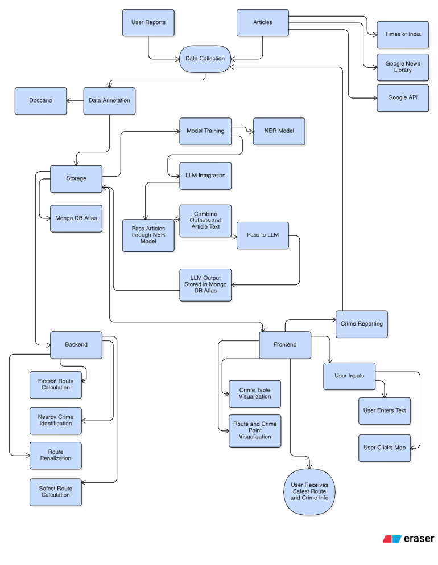
Figure 1: Methodology Diagram

Data Collection
This was the first step, which involved web-scraping crime-related article links from the internet. Major news outlets publish dedicated articles for each incident, such as The Times of India and The Hindustan Times [1][2]. Approximately 4000 articles were scraped from multiple sources. The metadata was extracted from these links using the Newspaper3k library that includes title, text, published date, author, etc. Based on the article information, they were filtered for crimes, and 1800 were shortlisted. Duplicates were removed and stored in the local MongoDB database for further processing. The data has been collected for the city of New Delhi to create a demonstrator that can later be scaled up to include other metropolitan cities.

Annotation and Dataset Preparation
Doccano was utilized to perform the annotation where crime and other entities like Crime Type, Location, Date, Suspect, Victim, Date, and Weapon were categorized upon and annotated manually. This step was lengthy and time-consuming, as the task was manual and every article needed to be read before categorizing them and therefore 550 articles were annotated which was then transformed into spacy file, that is suitable for model building.
[Article Text
“Entities”: [[43, 53, “Location”], [54, 70, “Crime Type”], [115, 123, “Weapon”]]
]

Named Entity Recognition (NER) and Large Language Model pipeline
The Spacy file created was then used to train a custom NER model. Multiple hyperparameters like Batch Size, Learning Rate, etc., were tuned in an attempt to improve the model's performance; however, due to the nature of unstructuredness found in the article text and the small size of the dataset, the model's Precision came out to be 51%.
A need for a Large Language Model (LLM) was felt, as an Underfit model would not be able to extract all entities from the crime reports or articles, which is the cornerstone of this project. The Spacy NER outputs were used as a reference, providing context to the LLM alongside the actual text, which eventually improved its outputs [10].
A detailed prompt was given to extract the outputs strictly in a JSON format of a fixed schema, maintaining consistency.
This Hybrid approach turned out to be extremely successful, giving near-perfect results every time with minimal hallucination.
The only time this hybrid approach fails is when there are multiple crimes mentioned (history or some other cases) alongside the actual crime, and it gets confused.
The data was then standardized and stored in document format. Any ambiguity was removed (few outputs were not in the desired format) and a spatial component, POINT was added to address the coordinates of the crime location stored.

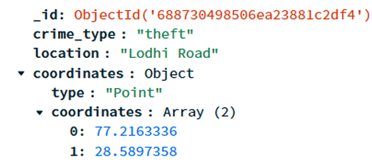
Figure 2: Final data stored in MongoDB

Geospatial Intelligence System(GIS) Integration
This step acts as a bridge between the Raw data and the practicality of the project, as it enables the visualization and interaction of the data fetched from the NER and LLM pipeline.
Location coordinates were extracted during two instances:
- From the crime location entity (text), which was extracted from the NER and LLM pipeline.
- User inputs of origin and destination when they interact with the User Interface to get a safe commute within the city of New Delhi.
Nominatim library was used to extract the coordinates from the location names.
The base map of New Delhi was fetched from the folium which is based on the Open Street Maps with road networks.
The location coordinates fetched were used initially to find the shortest and the fastest route using the OSMnx [3] algorithm based on the Dijkstra’s shortest path algorithm alongside all the crime points from the database.
The route and the crime points were then spatially joined and a buffer is created (200 meters). The aim was to avoid the crimes which has occurred and maintain a distance of at least 200 meters to create a safer alternative route.

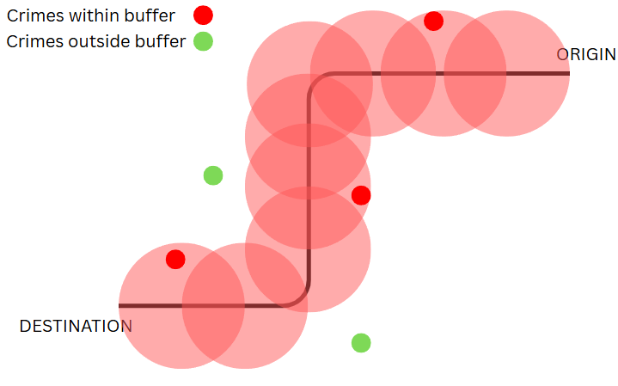
Figure 3: Simple Representation
Next important and the cornerstone of this project was to find a safe alternative route other than the fastest one which ensures a distance of at least 200 meters.
The Open Street Maps contains road networks consisting of Nodes and Edges where edges represent the road networks, consisting of a weight value which represents the length of it.
The edges near the route (<200 meters) were penalized by assigning a very high value. The routing algorithm then automatically avoids these edges while calculating the shortest route, providing a safer alternative route

All crimes within the city of New Delhi were extracted and were visualized to identify the hotspots based on the frequency of the crimes happening.
Darker circles represent higher frequency of crimes.

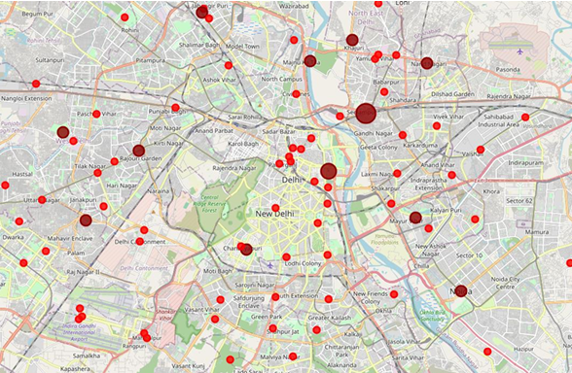
Figure 4: Crime Hotspots

Experiments and results
A total of 25 Routes were tested to check for ambiguity. A sample of the tested routes are as follows.

Origin | Destination | Crime Zone Count | Remarks
AIIMS | AIIMS Metro | 3 | None
Jafrabad | Deer Park | 0 | Jafrabad Name not identified
Ashrm Metro | Hauz Khas | 2 | None
Aerocity | Chandni Chowk | 2 | None
Naraina | Paschim Vihar | 3 | None

Users can input origin and destination via 2 methods:
- By clicking on map
- By manually typing location names
There are some locations present which has same names and it may happen that coordinates fetched are of outside New Delhi which may give incomplete route as our map is restricted to New Delhi.

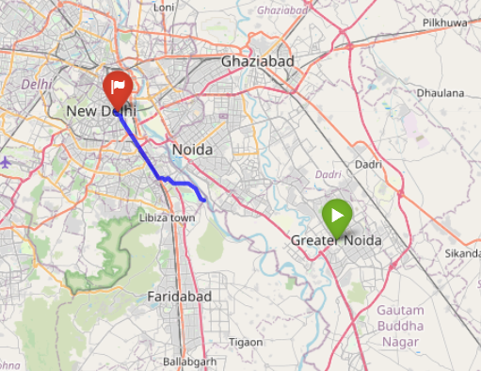
Figure 5: Incomplete Route
This problem was partially tackled by concatenating the word “Delhi” with the location name and then fetching the coordinates.

When user fetches route from origin to destination, the fastest possible route is given along with the crime points which are within the threshold (<200 meters), are highlighted with red circle based on the frequency of crimes and when we hover over the icon, crime type gets displayed.

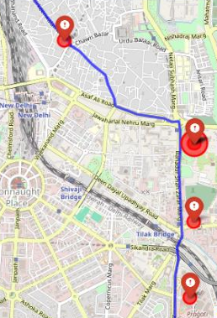
Figure 6: Fastest Route and Nearest Crimes
Subsequently, to fetch the safe route, the edges near the crime points (<200 meters) are given a very high weight value, that is, the edges get penalized.
Now during the fastest route computation, these edges are automatically avoided as selecting the edges near the crime zones are no longer feasible and shortest.

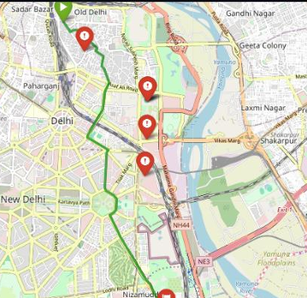
Figure 7: Safe Route Computation

Acknowledgment

I take this opportunity to convey my deepest appreciation to everyone who has helped, advised, and motivated me during the completion of this project. Without their precious input, the successful completion of this work could not have been achieved.

I would like to express my utmost gratitude to my internal guide, Mr. Sahil Shah, for his constant guidance, support, and mentorship during each stage of this project. His critiques helped me to overcome multiple hurdles, improve my approach and properly structure my project. His regular interactions kept my project on track, enhanced the scholarly worth and helped me with discipline and perseverance which is essential in researches.

I would also like to thank my external guide, Mr. Devawrat Bhave, for his industry-oriented approach, constructive criticism and professional vision. The suggestions he provided helped me focus more on the usability and practical applications of the project making it more impactful.

I am also grateful to the teaching staff of the Symbiosis Institute of Geoinformatics for providing me with the opportunity and academic foundation to pursue this project. Their constant support and encouragement throughout my academic career were the pillars of this research.

In addition, I would also like to show gratitude to the research and authors whose work was the origin of data and inspiration. In particular, the LinkNER research paper provided significant guidance in developing the Named Entity Recognition (NER) part of my system. The concepts and approaches brought forth in that paper helped me to define my approach and establish a firm foundation for my own research contribution.

I would further like to thank the open-source community for providing strong yet accessible tools and frameworks such as Python, FastAPI, React, MongoDB and Leaflet. Availability of these tools assisted me in planning and executing my project effectively within the given time limit. Online forums, documentation, and communities further assisted me with timely solutions and guidance each time I encountered technical problems.

References

- https://timesofindia.com/
- https://hindustantimes.com/
- https://osmnx.readthedocs.io/
- Mengliev, D., Barakhnin, V., Abdurakhmonova, N., & Eshkulov, M. (2024). Developing named entity recognition algorithms for Uzbek: Dataset insights and implementation. Data in Brief, 54, 110413.
- Keraghel, I., Morbieu, S., & Nadif, M. (2024). Recent Advances in Named Entity Recognition: A Comprehensive Survey and Comparative Study.
- Devlin, J., Chang, M. W., Lee, K., & Toutanova, K. (2019, June). Bert: Pre-training of deep bidirectional transformers for language understanding. In Proceedings of the 2019 conference of the North American chapter of the association for computational linguistics: human language technologies, volume 1 (long and short papers) (pp. 4171-4186).
- Yamada, I., Asai, A., Shindo, H., Takeda, H., & Matsumoto, Y. (2020). LUKE: Deep contextualized entity representations with entity-aware self-attention. arXiv preprint arXiv:2010.01057.
- Tsai, C. M. (2023). Stylometric fake news detection based on natural language processing using named entity recognition: In-domain and cross-domain analysis. Electronics, 12(17), 3676.
- Deturck, K., Magistry, P., Ahmad, B. D. P., Wang, I., Nouvel, D., & Lafayette, H. (2023, July). Ertim at SemEval-2023 Task 2: Fine-tuning of Transformer Language Models and External Knowledge Leveraging for NER in Farsi, English, French and Chinese. In Proceedings of the 17th International Workshop on Semantic Evaluation (SemEval-2023) (pp. 2211-2215).
- Sang, E. F., & De Meulder, F. (2003). Introduction to the CoNLL-2003 shared task: Language-independent named entity recognition. arXiv preprint cs/0306050.
- Zhang, Z., Zhao, Y., Gao, H., & Hu, M. (2024, May). LinkNER: linking local named entity recognition models to large language models using uncertainty. In Proceedings of the ACM Web Conference 2024 (pp. 4047-4058).
- Surana, S., Chekkala, J., & Bihani, P. (2021). Chatbot based crime registration and crime awareness system using a custom named entity recognition model for extracting information from complaints. International research journal of engineering and technology, 8(04).
- Skórzewski, P., Pieniowski, M., & Demenko, G. (2022, June). Named Entity Recognition to Detect Criminal Texts on the Web. In Proceedings of the Thirteenth Language Resources and Evaluation Conference (pp. 6223-6231).
- Lample, G., Ballesteros, M., Subramanian, S., Kawakami, K., & Dyer, C. (2016). Neural architectures for named entity recognition. arXiv preprint arXiv:1603.01360.
- Yang, J., Zhang, T., Tsai, C. Y., Lu, Y., & Yao, L. (2024). Evolution and emerging trends of named entity recognition: Bibliometric analysis from 2000 to 2023. Heliyon.
- Hata, T., & Aono, R. (2024). Dynamic attention seeking to address the challenge of named entity recognition of large language models.
- Dash, A., Darshana, S., Yadav, D. K., & Gupta, V. (2024). A clinical named entity recognition model using pretrained word embedding and deep neural networks. Decision Analytics Journal, 10, 100426.
- Li, J., Li, H., Sun, D., Wang, J., Zhang, W., Wang, Z., & Pan, G. (2024). LLMs as bridges: Reformulating grounded multimodal named entity recognition. arXiv preprint arXiv:2402.09989.

