Project - High Level Design
on
IaC Provisioning for Telecom System
  - Course Name: DevOps
Institution Name: Medicaps University – Datagami Skill Based Course

Student Name(s) & Enrolment Number(s):
Sr no | Student Name | Enrolment Number
1. | Isha Joshi | EN22CS301438
2. | Harsh Chouhan | EN22CS301387
3. | Goutam Choudhary | EN22CS301370
4. | Goutam Sharma | EN22CS301374
5. | Harshita Chouhan | EN22CS301406

Group Name: Group 03D4
Project Number: DO-39
Industry Mentor Name:
University Mentor Name:
Academic Year: 2025–2026

Table of Contents
Sr No. | Contacts | Page No.
1. | Introduction | 3-4
 | 1.1 Scope of the document
 | 1.2 Intended Audience
 | 1.3 System Overview
2. | System Design | 4-9
 | 2.1 Application Design
 | 2.2 Process Flow
 | 2.3 Information Flow
 | 2.4 Components Design
 | 2.5 Key Design Considerations
 | 2.6 API Catalogue
3. | Data Design | 9-10
 | 3.1 Data Model
 | 3.2 Data Access Mechanism
 | 3.3 Data Retention Policies
 | 3.4 Data Migration
4. | Interfaces | 10
5. | State and Session Management | 10
6. | Caching | 10
7. | Non-Functional Requirements | 11
 | 7.1 Security Aspects
 | 7.2 Performance Aspects
8. | References | 11

High Level Design (HLD)
1. Introduction
1.1 Scope of the Document
This document provides a High-Level Design (HLD) for the Infrastructure as Code (IaC) Provisioning for Telecom System. It describes the overall architecture, system components, data flow, and deployment pipeline required to automate infrastructure provisioning and application deployment on AWS.
The document focuses on designing a scalable and automated DevOps system using CI/CD pipelines, containerization, and infrastructure automation tools.
1.2 Intended Audience
This document is intended for:
- DevOps Engineers
- Backend Developers
- System Architects
- Cloud Engineers
- Stakeholders involved in system design and implementation
1.3 System Overview
The system is designed to automate the provisioning and deployment of a telecom application using DevOps practices and Infrastructure as Code (IaC).
The system integrates multiple tools and technologies including Jenkins, Docker, Terraform, Ansible, and AWS EC2 to enable a fully automated deployment pipeline.
Key functionalities include:
- Automated infrastructure provisioning on AWS EC2
- Containerized application deployment using Docker
- Continuous Integration and Continuous Deployment using Jenkins
- Configuration management using Ansible
- Centralized image storage using Docker Hub

- Remote state management using AWS S3
The primary objective is to eliminate manual setup, ensure consistency across environments, and enable faster and reliable deployments.

2. System Design
2.1 Application Design
The system follows a layered architecture with clear separation of responsibilities:
- Developer Layer: Developers write and push code to the repository
- Version Control Layer: GitHub stores application and infrastructure code
- CI/CD Layer: Jenkins automates build, provisioning, and deployment
- Containerization Layer: Docker builds application images and pushes them to Docker Hub
- Infrastructure Layer: Terraform provisions AWS EC2 instances
- Configuration Layer: Ansible configures EC2 instances and prepares runtime environment
- Runtime Layer: Telecom application runs inside Docker container on EC2
The architecture is modular to ensure scalability and maintainability.

2.2 Process Flow
- Developer pushes code to GitHub repository
- Jenkins detects the change and triggers the pipeline
- Docker image is built from the application code
- Docker image is pushed to Docker Hub
- Terraform provisions infrastructure on AWS EC2
- Terraform state is stored in AWS S3

- Ansible connects to EC2 via SSH
- Required dependencies are installed and configured
- Docker container is pulled from Docker Hub and deployed
- Application starts and becomes accessible to users

2.3 Information Flow
The system consists of multiple flows:
- Code Flow: Developer → GitHub → Jenkins
- Build & Image Flow: Jenkins → Docker → Docker Hub
- Infrastructure Flow: Jenkins → Terraform → AWS EC2 → State stored in S3
- Configuration Flow: Jenkins → Ansible → EC2 (via SSH)
- Execution Flow: Docker container runs application on EC2
- Monitoring Flow: Logs generated during pipeline execution are stored in Jenkins and server

2.4 Components Design
1. GitHub Repository
- Stores code
- Enables version control
2. Jenkins Server
- Runs CI/CD pipeline
- Automates deployment
3. Docker Engine
- Builds images
- Ensures consistency
4. Docker Hub
- Stores images

- Acts as registry
5. Terraform Engine
- Provisions infrastructure
- Manages resources
6. AWS EC2 Instance
- Runs application
- Provides compute
7. Ansible Engine
- Configures server
- Installs dependencies
8. Telecom Application
- Provides APIs and Handles requests

2.5 Key Design Considerations
- Scalability: System can be extended to multiple EC2 instances or container orchestration platforms like Kubernetes.
- Idempotency: Terraform ensures consistent infrastructure provisioning across multiple runs.
- Reliability: Jenkins pipelines automate deployments, reducing human error.
- Security: Secure handling of AWS credentials, Docker Hub credentials, and SSH keys.
- Portability: Docker ensures application can run consistently across different environments.
- Cost Optimization: Efficient use of AWS resources to avoid unnecessary infrastructure costs.
- Extensibility: Modular design allows easy addition of new services or tools.

2.6 API Catalogue
1. Health Check API
- Endpoint: /
- Method: GET
- Description: Checks if application is running
2. Status API
- Endpoint: /status
- Method: GET
- Description: Returns system status

UML Diagrams :-

Sequence Diagram
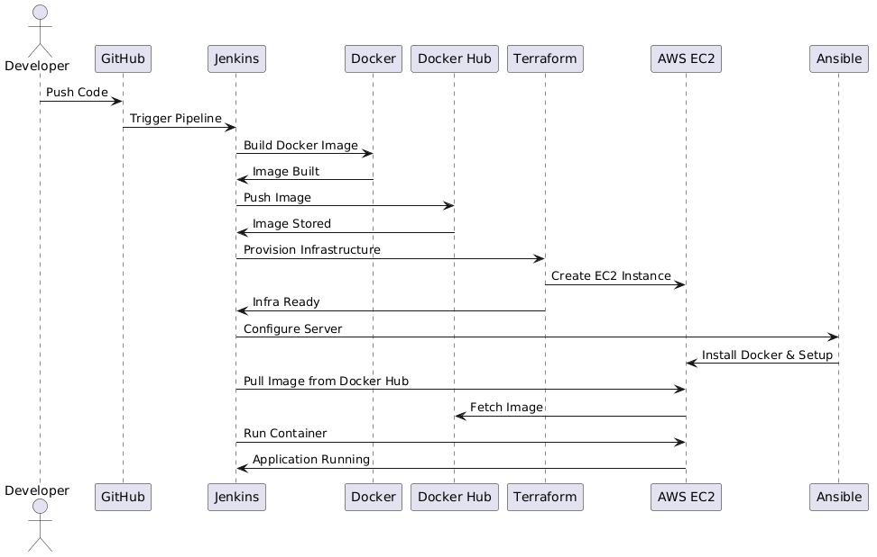

Activity Diagram

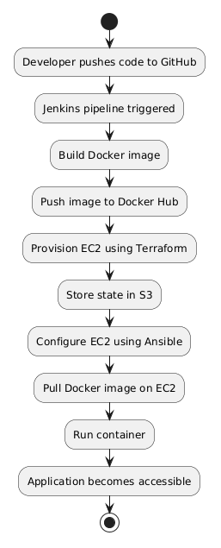

Component Diagram

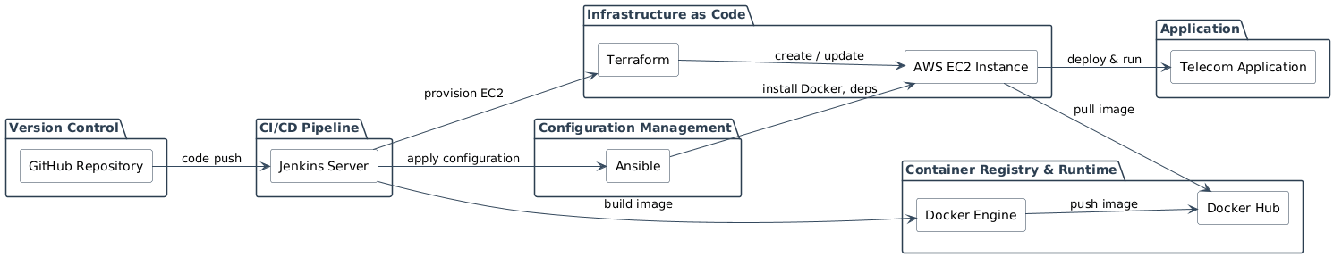

3. Data Design
3.1 Data Model
The system primarily handles operational and configuration data:
- Terraform state data
- Deployment logs
- Application logs
- Environment variables

3.2 Data Access Mechanism
- Jenkins accesses logs through pipeline execution
- Terraform interacts with AWS services via APIs
- Ansible communicates with EC2 using SSH
- Application exposes REST APIs for user interaction

3.3 Data Retention Policies
- Jenkins logs retained for debugging and auditing
- Application logs stored temporarily on EC2
- Terraform state stored in S3 for persistence
3.4 Data Storage
- Terraform state → AWS S3
- Docker images → Docker Hub
- Logs → Jenkins and EC2 instance
4. Interfaces
- GitHub ↔ Jenkins
- Jenkins ↔ Docker Hub
- Jenkins ↔ Terraform
- Terraform ↔ AWS
- Jenkins ↔ Ansible
- Ansible ↔ EC2 (SSH)
- User ↔ Application
5. State and Session Management
- Jenkins pipelines are stateless for each execution
- Terraform maintains infrastructure state in AWS S3
- Application follows stateless REST architecture
6. Caching
- Docker layer caching improves build performance
- Jenkins caches dependencies for faster execution
- Docker images reused from Docker Hub to reduce rebuild time

7. Non-Functional Requirements
7.1 Security Aspects
- Secure management of AWS credentials and IAM roles
- SSH-based authentication for EC2 access
- Secure storage of environment variables
- HTTPS-based communication

7.2 Performance Aspects
- Fast CI/CD pipeline execution
- Reduced deployment time through automation
- Efficient container-based deployment
- Minimal downtime during updates

8. References
- Docker Documentation
- Terraform Documentation
- Ansible Documentation
- Jenkins Documentation
- AWS EC2 Documentation

