Texture Quality Extensions to Image Quilting

By
Nick Vavra

For
CS766: Computer Vision
Dept of Computer Science
University of Wisconsin

Abstract: This paper reviews Image Quilting, a texture synthesis algorithm proposed by Efros and Freeman in SIGGRAPH 2001. Image Quilting is an effective algorithm in that it produces very high quality output images in reasonable time. This paper provides implementation notes that confirm claims made in the Image Quilting paper about quality and simplicity. Finally, several extensions to the algorithm are discussed that are designed to improve the quality of output on highly structured textures. Image Quilting performs better than other algorithms on such textures, yet there is still room for improvement. One of the proposed extensions proves to be effective by altering the matching criterion to partially focus on the transition boundary instead of on pure sum of squared differences.

1) Introduction

As the importance of texture to graphics grows, so does the importance of texture synthesis. Given a small sample of a texture, texture synthesis lets us grow what appears to be more of that texture until we have enough to fit our needs.

At a very high level, texture synthesis is about approximating the process that created the sample texture and creating more random samples of that model. The field originated with complex texture modeling techniques that took a lot of computation. See [3] for a good discussion of the theoretical process and [5] for a good overview of the texture synthesis field.

In 1999, Efros and Leung [2] proposed a much simpler model that sampled pixels directly from similar neighborhoods in the input image. This was an important advancement in the field and a number of extensions/improvements have been developed since.

One such algorithm is Image Quilting [1] as proposed by Efros and Freeman. Image Quilting provides very high quality results in very manageable time, mainly by sampling patches of texture instead of individual pixels. By using patches, speed is increased by doing matching once per block instead of once per pixel and quality is increased by increasing the amount of structure captured. The first part of this paper gives an overview of the Image Quilting algorithm and my implementation thereof. That section confirms that Image Quilting is as good as [1] claims.

Other texture synthesis algorithms have achieved real time speed, but Image Quilting currently provides the highest quality output. As [1] shows, and as my results confirm, Image Quilting still does have trouble with some very structured textures. To fix that, I discuss several extensions in the second half of this paper that aim to improve output quality. Two of the extensions did not pan out, but the third provides some nice results.

2) Related Work

There have been many texture synthesis algorithms proposed over the years, and a survey of them is not important to this work. Image Quilting is based directly on [2], so reviewing other algorithms based on that work might provide some insight into possible extensions. Most of these papers, such as [5] use various data structures and search methods to increase the efficiency of the algorithm while maintaining the output quality. Some of these, [6,7], even claim real time speeds.

One extension to [2] is "Real-time texture synthesis by patch-based sampling" [4]. This algorithm was developed at the same time Image Quilting, and as the name implies it is also patch based instead of pixel based. It shows most of the same patch based quality and efficiency improvements over [2] as Image Quilting. [4] concentrates on speed instead of quality, and shows real time results by applying by techniques such as multi-resolution sampling that could also be applied to Image Quilting.

The main algorithmic distinction between [4] and Image Quilting lies in how they handle the overlap region. Their algorithm uses blending as a quick fix whereas Image Quilting takes extra time to find a good boundary. This shows the fundamental difference in approach, which is why I chose to improve Image Quilting's quality rather than its efficiency, to take it further down that path.

3) Image Quilting

This section will provide background on the Image Quilting algorithm and discuss my experience implementing it. This should give the reader sufficient insight into the algorithm to understand the latter section on extensions to the algorithm. For the best information about Image Quilting, see [1]

3.1) Modeling and Sampling

Like its pixel based predecessor [2], Image Quilting assumes that the target texture is a Marchov Random Field. This assumption means that a point in the texture is completely determined by the neighborhood of points around it. This is a common assumption for texture synthesis algorithms, and has been shown to be valid for many textures.

Older algorithms generate a complex probabilistic model of the texture's real PDF and sampling from that based on the MRF assumption. Like its predecessor, Image Quilting instead searches the input texture for matches to a given neighborhood using sum of squared differences (SSD). A degree of randomness (as is necessary to grow new results) is kept by randomly choosing a match from the list of all close matches instead of just choosing the best match, where close is defined as a threshold.

3.2) Output as a Sequence of Patches

The output image is created and a rectangular patch is placed in the upper left corner. That patch is taken from a random position from the input image and is the seed. Patches are then sampled and placed in the output image in raster scan order with each new patch overlapping the existing output by some amount. Since the patches are placed in raster scan order, that overlap region is on the new patch's left and top sides. The values in this overlap region from the existing output are the neighborhood used to sample from the input image. This proceeds until the output image is filled.

3.3) Merging Values in the Overlap Region

When placing a chosen patch into the output image, the patch's pixel values in the overlap region must be merged with those already in the output image. Image Quilting finds a good boundary and transitions on that boundary.

The boundary is the minimum cost path from one end of the overlap region to the other, where the cost of being at a pixel is defined as the squared difference between the patch's value for that pixel and the output image's value for that pixel. Image Quilting recommends using a simple dynamic programming algorithm to find that path. A path for the left region is calculated by setting the path's source at the top row of the region and the destination at the bottom row, with each dynamic programming stage being one row. The path is allowed to move from a pixel in a row to any of the three eight-neighbors in the previous row. A path is similarly found for the top region, and the shared corner is searched for the best joining point of the two paths.

3.4) Implementation Experience

I chose to implement Image Quilting as a set of Java classes. A non-academic version would be implemented in Matlab to improve efficiency. I wanted the flexibility that Java provides to help me try out different extensions.

One of the benefits of Image Quilting is supposed to be the relative simplicity of the algorithm as compared to alternative texture synthesis algorithms. I would have to back them up on that claim. Their paper does gloss over important details like how they did their sampling, but reading through other current and background papers fills in those details. There were no major tricky details hidden from the reader.

There are three main parameters in Image Quilting, and they are patch size, overlap size, and the matching threshold. Once I had the algorithm working, I tried tuning the parameters. For Image Quilting, like [2], the parameters should be intuitive and fairly easy to set. My experience supports that. I wanted a set of parameters that worked well for most textures, and I settled on a patch width and height of 36 pixels, an overlap size of 6 pixels, and a matching threshold of 1.1 times the best match found. Unsurprisingly, those values match up with those chosen in the Image Quilting paper. All results shown in this paper were generated using those parameters. See figure 1 for some results.

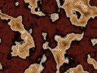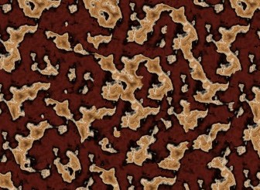

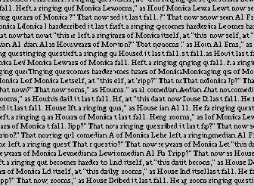

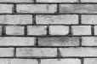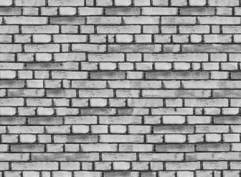

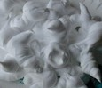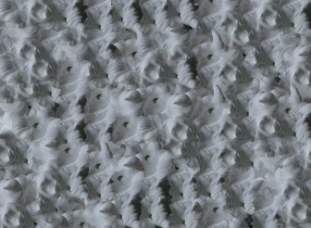

Figure 1: Image Quilting Results. The small images on the left are the input images. The large images on the right were grown using my implementation of Image Quilting.

4) Improving the Output Quality

The results shown in the previous section are subjectively very good. Image Quilting does an excellent job on many textures, but has difficulty with some structured textures. Take a look at these results:

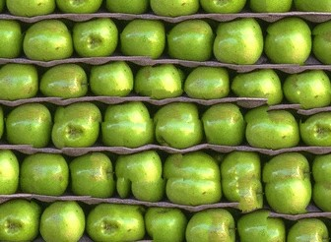
Figure 2: Boundary artifacts in a grown texture.

There are obvious places where the algorithm failed. Some of these are boundary artifacts, where a patch is slightly out of place and a better edge might have fixed the problem. Other failures are more severe. This section will discuss several ways of reducing these errors.

4.1) Methods External to the Algorithm

Even without modifying the algorithm, there are several ways to get a higher quality output image. One way would be to simply run the algorithm multiple times, manually select the best output, and discard the rest. A similar method would be to grow a larger image than is needed and then manually select the best sub-image of the appropriate size. Since the Image Quilting is fairly fast, these are viable options if the errors are infrequent.

A second external approach would be to provide more of the sample texture. This would give the algorithm a better approximation of the true texture and more possible patches to choose from. Unfortunately, a larger sample is not always available.

Though those are practical approaches, a more ambitious user may be able to do better. There are three main parameters to Image Quilting that could be tuned: patch size, overlap size, and the matching threshold. These parameters are rather intuitive and easy to tune. Increasing the sizes, or decreasing the threshold, forces the algorithm to make the output image more similar to the input image. Tuning these parameters can help reduce the occurrences of errors in the output, but it does so at a loss of output randomness. See [4] for more information.

Rather than go into a detailed analysis of how to set these parameters, the rest of this section will focus on changing the algorithm to increase the output quality at the cost of some efficiency.

4.2) Better Transitions Between Patches

Image Quilting has a very unique way of merging the overlap regions when placing a patch. A simple comparison between blending the overlap like [4] does and Image Quilting's min path boundary shows that the stitching provides subjectively better results. See Figure 3 for a comparison. The presence of boundary artifacts in some output images, however, suggests that the algorithm could be improved in this area.

Since using the minimum error path as the boundary usually works quite well, I did not want to discard it. There is one simple improvement that can be made, though. In the Image Quilting paper, [1], they define the path as a dynamic programming problem where each stage is a vertical (horizontal) step for the left (top) overlap region, and each state for a stage is a pixel along that row (column). Taken this way, the minimum path might not be found. Take this top overlap region as an example:

8 8 8 8 8 8 8 8 8 8 8 8 8 8 8
1 1 1 8 8 8 8 8 8 8 8 1 1 1 1
8 8 8 1 8 8 8 8 8 8 1 8 8 8 8
8 8 8 1 8 8 8 8 8 8 1 8 8 8 8
8 8 8 8 1 1 1 1 1 1 8 8 8 8 8

In this contrived example, the best path would be to follow the ones. That path will not be found by dynamic programming, though, since the path travels along some of the stages. The path found (shown in green) instead cuts corners through the eights in an attempt to follow the ones. Though this example is contrived, there are plenty of chances for this sort of pathing error to occur in reality.

An extension to the dynamic programming technique can allow paths to travel along a stage. After calculating the cost and transition for each state for a given stage, allow each state to chose to transition to a neighbor state in that same stage if it would reduce the cost. Redo that step until there are no changes.

I added this as an optional extension in my Image Quilting implementation. Trials showed that it had a negligible impact on efficiency. Trials also showed that it had little impact on output quality, though over many runs I did notice a slight improvement. The results were inconclusive and unpromising, so I moved on to more aggressive extensions.

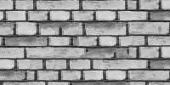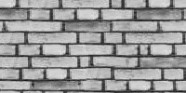
Figure 3: Blending vs Min Cost Path. The image on the left was grown using blending in the overlap region. The image on the right used the minimum cost path as the boundary.

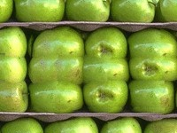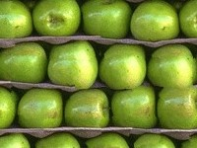
Figure 4: Effect of the path cost as a matching criterion. The image on the left used 100% path cost and 0% SSD. The image on the right used 50% of each. As more SSD is added, the structure of the image is restored while maintaining good boundaries.

4.3) Backtracking

Abandoning small tweaks, I next tried to tackle the problem directly. Garbled output may be due to the algorithm failing to find a good match for a particular overlap region. Earlier patch choices could create a left and top overlap region pair that is unlike anything in the input image. One approach would be this:

1) detect a matchless overlap region
2) undo the last several patch choices
3) choose a different match for the last removed patch
4) resume from that point

Steps two through four are fairly straightforward and add a small amount of time complexity and memory footprint. Step one needs criteria to classify overlap regions as matchable and unmatchable. I chose two such criteria, which are discussed briefly below.

The first criterion is a simple threshold on the sum of squared differences between the overlap region and the closest 'match' in the input image. A relatively large SSD should indicate that the match was poor and not worth using.

The second criterion works like this. The closest match in the input image is found. The contributions from the left and top overlap regions to the SSD score of that closest match are calculated. A large difference between the two contributions would indicate that the closest match only matched one of the two regions. The criterion is then a threshold on the difference.

I tried both of these criteria, but neither proved adequate at picking out bad matches. Both suffer from the same basic problem: choosing an appropriate threshold is not practical. Different images have different composition, and thus have much different average SSDs. The threshold would need to be chosen individually for each image, and the algorithm does not encounter enough best match SSD values to probabilistically model the threshold. Since Image Quilting follows in [2]'s spirit of being non-parameterized, I chose to abandon this method to future work rather than require tedious manual parameter tuning.

4.4) Include Path Cost in Matching

Third time is the charm. This extension notes that with many of the boundary artifacts, the neighboring patches do have a lot in common but do not have a nice boundary to transition between them. This would occur if the overlap SSDs were small, but there was no good minimum cost path to use as the boundary. This extension attempts to fix that problem by considering not only the SSDs when matching, but also the cost of the min path.

The extension works like this. After determining the SSD between the current overlap region and an input patch being considered, calculate the minimum cost path for that patch. Divide the SSD by the number of pixels in the overlap region, and divide the path cost by the number of pixels along the path. That puts both values in the same range without altering comparisons between patches. The distance used for comparing this patch to other potential matches is then the weighted sum of these two values.

This adds a parameter to the algorithm: the relative weight given to the path cost. Though less intuitive to tune than patch size or overlap size, a few runs showed that the relative weight of the path cost should be low. See Figure 4 to see the effects of the weight. The value I settled on was .1, meaning that the match value was ninety percent of the SSD plus ten percent of the path cost. This weight works well for many input textures.

Trials showed that this extension, using that weight on ‘hard’ input textures, noticeably decreased errors in the output image. It did so at the cost of running for half again as long. See Figures 5, 6, and 7 to see a comparison of the results to those of normal Image Quilting.

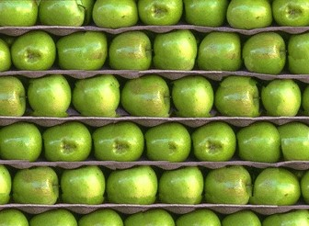

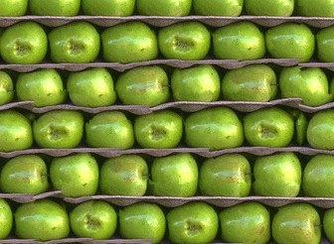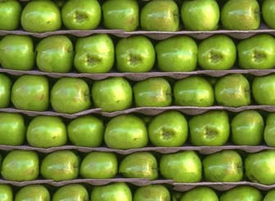

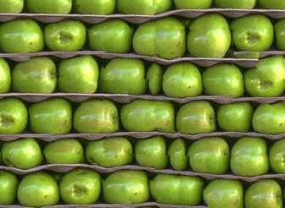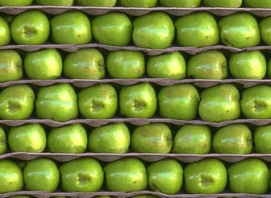

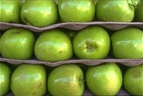

Figure 5: Normal Image Quilting vs. Extended Matching Criterion. The input image is the image shown last. The left images were grown using normal Image Quilting. The images on the right were grown using the revised matching criterion proposed in section 4.4. In both cases, the best 3 images of 5 runs are shown. The extension visibly reduced the number of boundary artifacts.

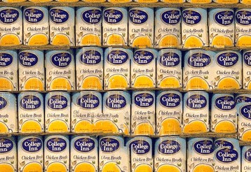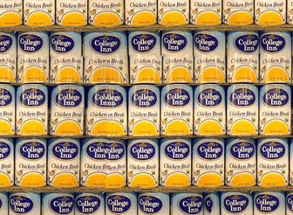

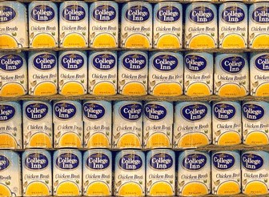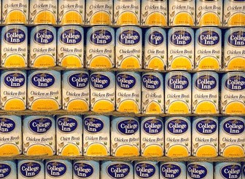

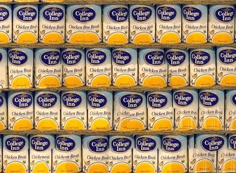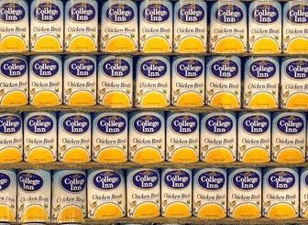

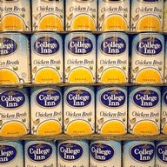

Figure 6: Normal Image Quilting vs. Extended Matching Criterion. The input image is the small image shown last. The images to the left were grown using normal Image Quilting. The images on the right were grown using the revised matching criterion proposed in section 4.4. In both cases, the best 3 images of 5 runs are shown. The extension visibly reduced the number of boundary artifacts. Though it was more successful with the apples texture, the extension did subjectively improve the quality of the output image.

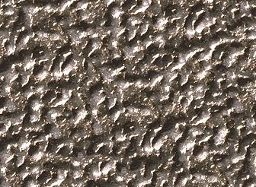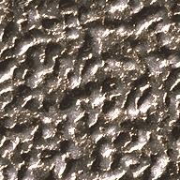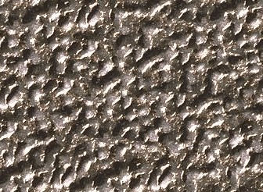

Figure 7: This figure shows that section 4.4’s updated match criterion does not degrade the quality of more stochastic textures. The input image is in the center, the normal Image Quilting result is on the left, and the extended Image Quilting result is on the right.

5) Conclusions

Image Quilting is an excellent texture synthesis algorithm. My firsthand experience verifies their claims that the algorithm is straightforward to implement and use, and that the result textures are of very high quality. Efficiency is not as good as some current algorithms, but Image Quilting is not optimized and more concerned with quality.

Image Quilting does have difficulty with some structured textures, and I introduced some extensions to help deal with that difficulty. One of those extensions helps ensure that chosen patches mesh with their neighbors by using a matching criterion that includes the cost of the boundary used. That extension shows some promising results. Image quality is visibly improved on highly structured textures with no degradation for less structured textures.

6) References

[1] A.A. Efros and W. T. Freeman. "Image Quilting for Texture Synthesis and Transfer", Proceedings of SIGGRAPH el, Los Angeles, California, August, 2001.

[2] A.A. Efros and T.K Leung. "Texture Synthesis by Nonparametric Sampling". In Proc. IEEE International Conference on Computer Vision, 1999.

[3] J.S. de Bonet. "Multi-resolution sampling procedure for analysis and synthesis of texture images". SIGGRAPH'97. pp. 361-368, 1997.

[4] L. Liang, C. Liu, Y. Xu, B. Guo, and H.-Y. Shum. "Real-time texture synthesis by patch-based sampling". Technical Report MSR-TR-2001-40, Microsoft Research, March 2001.

[5] L.-Y. Wei and M. Levoy. "Fast texture synthesis using tree-structured vector quantization". In SIGGRAPH 2000.

[6] S. Zelinka and M. Garland. "Towards Real-Time Texture Synthesis with the Jump Map". In Eurographics Workshop on Rendering 2002.

[7] XU,Y.,GUO, B., AND SHUM, H.-Y. "Chaos mosaic: Fast and memory efficient texture synthesis". Tech. Rep. MSR-TR2000 -32, Microsoft Research, 2000.

