Intro to SQL Server Assignment – Answer Sheet

Problem Statement:
Consider yourself to be Sam, who is a student at a prestigious university. You have enrolled for the SQL course and it is your first semester.

Tasks to be done:

- Install MS SQL Server
  - To install MS SQL server in my Ubuntu 20.04 system I have ran the following commands in my terminal:
    - Import public repository GPG keys:
$ wget -qO- https://packages.microsoft.com/keys/microsoft.asc | sudo tee /etc/apt/trusted.gpg.d/microsoft.asc
    - Register the SQL Server Ubuntu repository:
$ sudo add-apt-repository "$(wget -qO- https://packages.microsoft.com/config/ubuntu/20.04/mssql-server-2022.list)"
    - Install SQL Server
$ sudo apt-get update
$ sudo apt-get install -y mssql-server
    - To setup SA account password and edition
$ sudo /opt/mssql/bin/mssql-conf setup
    - Verify if service is running
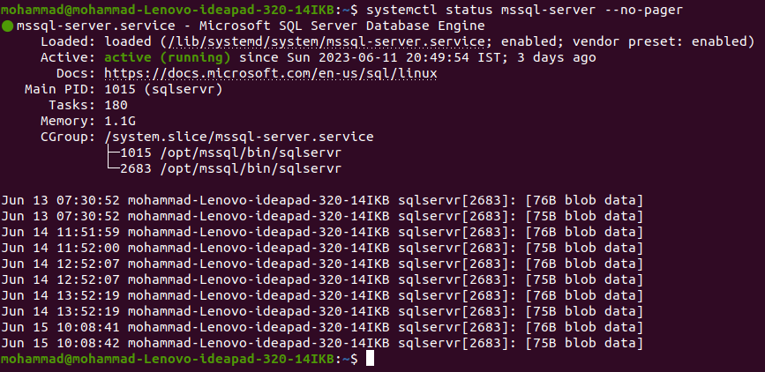
$ systemctl status mssql-server –no-pager

    - To install the command-line tools
$ sudo apt-get update
$ sudo apt install curl
$ curl https://packages.microsoft.com/keys/microsoft.asc | sudo tee /etc/apt/trusted.gpg.d/microsoft.asc
$ curl https://packages.microsoft.com/config/ubuntu/20.04/prod.list | sudo tee /etc/apt/sources.list.d/msprod.list
$ curl https://packages.microsoft.com/config/ubuntu/20.04/prod.list | sudo tee /etc/apt/sources.list.d/msprod.list
$ sudo apt-get update
$ sudo apt-get install mssql-tools unixodbc-dev
$ sudo apt-get update
$ sudo apt-get install mssql-tools
$ echo 'export PATH="$PATH:/opt/mssql-tools/bin"' >> ~/.bash_profile
    - To connect locally
$ sqlcmd -S localhost -U sa -P '<RegisteredPassword>'
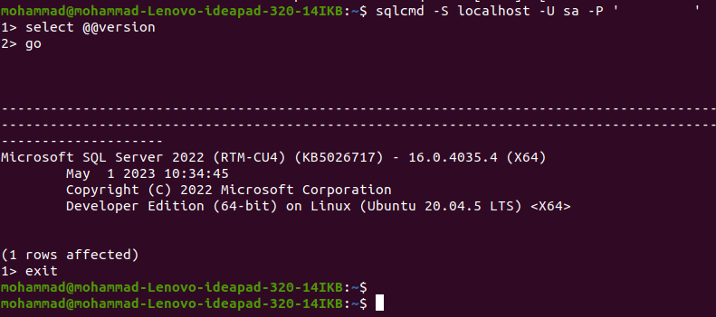
By following the steps listed above we have successfully installed mssql in our system. Unfortunately we cannot install SSMS as it is not available for linux systems. So here we shall be using MSSQL in the CLI.
Note: The steps listed above were followed from Quickstart: Install SQL Server and create a database on Ubuntu

- Learn the basics of Structured Query Language

