WEEK 2 REPORT
Model Design and Algorithm Selection
Crop Yield Prediction for Agriculture and Agribusiness
Prepared by: Jai Prakash Gupta
Internship Program: Machine Learning Internship in Nagpur, YuvaIntern
Internship Duration: 12 October 2026 to 16 November 2026 (5 weeks, Remote)

Contents
1. Executive Summary and Value Proposition
2. Problem Definition
3. Challenges in Agricultural Data and Modelling Implications
4. Algorithm Research
5. Comparative Analysis of Selected Algorithms
6. Proposed Model Architecture
7. Preprocessing and Data Transformation Design
8. Model Configuration and Validation Strategy
9. Evaluation Metrics and Success Criteria
10. Uncertainty, Explainability and Risk Management
11. Extension: Crop Recommendation Module
12. Implementation Plan for Weeks 3 to 5
13. Conclusion
14. References

1. Executive Summary and Value Proposition
This document presents the model design for the machine learning solution planned in Week 1. It builds on the datasets and exploratory plan chosen there (FAOSTAT crop yield data joined with NASA POWER climate data, and the Kaggle Crop Recommendation Dataset). The main goal is to predict crop yield for a crop, country and year, so that agribusiness stakeholders can plan production, procurement, pricing and risk management.
The design recommends a staged approach: simple baselines first (naive, linear trend and Ridge Regression), then tree-based ensembles (Random Forest and LightGBM) as the main models, combined through a weighted ensemble. A recurrent neural network (LSTM) is kept as an optional future experiment, because annual agricultural data are usually too small for deep learning to be reliable.

1.1 Value Proposition
Stakeholder | Value Delivered
Farmers and cooperatives | Early estimates of expected yield and the main weather drivers help in planning inputs, storage and sales.
Agribusiness firms (seed, fertilizer, processors, traders) | Better demand and supply forecasting, procurement planning and inventory decisions.
Banks and insurers | Yield forecasts with uncertainty ranges support credit decisions and crop insurance risk assessment.
Policy makers and NGOs | Explainable drivers of yield variation support food security planning and climate adaptation programmes.

2. Problem Definition
Element | Definition
Task type | Supervised regression (primary). Market trend forecasting is treated as a time series extension.
Target variable | Crop yield (tonnes per hectare) for a given crop, country and year.
Unit of prediction | Country-crop-year records (FAOSTAT); can be extended to district level using Indian open data.
Forecast horizon | Next growing season (one year ahead), with an option for in-season forecasts using partial-season weather.
Input features | Growing-season temperature, rainfall, solar radiation and humidity; lagged weather; previous yields and rolling averages; crop and country identifiers; a time trend; where available, soil nutrients and pH.
Business question | What yield can be expected next season, how uncertain is it, and which factors drive it?

3. Challenges in Agricultural Data and Modelling Implications
Agricultural data differ from typical business data in ways that directly shape model design. The table below links each challenge to the design decision taken in this document.
Challenge | Why It Matters | Design Response
Seasonality | Crops follow sowing, growth and harvest cycles; weather matters differently at each growth stage. Annual yield data hide within-year patterns. | Aggregate weather into growing-season windows (e.g., sowing, vegetative, flowering and grain filling where data allow). Use seasonal models (SARIMA / Prophet) for monthly price data in the market-trend extension.
Weather variability and extreme events | Droughts, heat waves and floods cause sudden yield drops that are rare but important. | Add anomaly features (deviation from long-term mean), use robust loss functions (Huber), keep valid extremes, and report prediction intervals.
Long-term technology trend | Yields rise over decades because of better seeds, irrigation and practices, so raw year is a strong but misleading signal. | Include an explicit trend term or detrend yields before modelling; use a Ridge model to extrapolate the trend and tree models for residual effects.
External factors | Policy, fertilizer prices, pests, irrigation access and market prices influence yield and are rarely in the dataset. | Document as limitations; add proxy features (e.g., irrigated area share, fertilizer use) if available; use country effects to absorb stable differences.
Spatial heterogeneity | Soil, climate and practices vary by region; national averages hide local variation. | Include country and crop encodings; test leave-one-country-out validation; extend to district data later.
Small and uneven datasets | Annual data give only tens of observations per country-crop series. | Pool countries and crops into one model, prefer regularised and tree-based models, avoid deep networks at first.
Missing values and noise | Reporting gaps, unit changes and measurement error are common. | Use imputation with missing flags and algorithms that handle missing values (LightGBM).
Autocorrelation and non-stationarity | Neighbouring years are correlated, and relationships change over time. | Use time-based splits, rolling-origin validation and recent-year weighting; never shuffle randomly.

4. Algorithm Research
Several algorithm families were reviewed for suitability on agricultural yield data. The assessment considers data size, ability to model non-linear weather effects, handling of seasonality and trend, interpretability and effort required.
Algorithm | How It Works | Suitability for Agricultural Data
Linear / Ridge / Lasso Regression | Fits a weighted sum of features; regularisation shrinks coefficients to reduce overfitting. | Good baseline and good at extrapolating trends; easy to explain; cannot capture non-linear effects such as heat thresholds without manual feature design.
Random Forest | Averages many decision trees trained on random samples and feature subsets. | Handles non-linear effects and interactions, resistant to overfitting and outliers, little tuning; cannot extrapolate beyond training range.
Gradient Boosting (XGBoost, LightGBM) | Builds trees sequentially, each correcting errors of the previous ones. | Usually among the strongest methods for tabular data; handles missing values and mixed features; needs careful tuning to avoid overfitting on small data.
Support Vector Regression | Fits a margin-based function using kernels. | Can model non-linear patterns on small data; scales poorly and is harder to interpret and tune.
SARIMA / Prophet | Time series models using trend, seasonality and past values. | Well suited to monthly market prices and single series with clear seasonality; limited for multi-country panel data with many predictors.
LSTM / Temporal CNN | Neural networks that learn from sequences. | Can learn growth-stage dynamics from daily weather and satellite series; needs large data, careful tuning and is less interpretable.
Hybrid / ensemble models | Combine predictions from several models. | Reduce variance and combine strengths, such as trend extrapolation from linear models with non-linear effects from trees.

5. Comparative Analysis of Selected Algorithms
Three algorithms are compared in depth: Random Forest, LightGBM (gradient boosting) and LSTM. Ridge Regression is used as the interpretable baseline, and the naive last-year and linear-trend predictors act as minimum benchmarks.

5.1 Random Forest
Advantages: captures non-linear and interaction effects between rainfall, temperature and crop type; robust to outliers and noisy records; works well on small to medium data; needs little preprocessing; provides feature importance and out-of-bag error estimates.
Constraints: predictions cannot go beyond the range of training yields, so rising technology trends are underestimated unless handled by detrending; larger models are slower and less compact; feature importance can be biased toward high-cardinality variables.

5.2 LightGBM (Gradient Boosting)
Advantages: usually gives higher accuracy than Random Forest on tabular data; native handling of missing values and categorical features; fast training; supports early stopping, custom losses (Huber, quantile) for robustness and prediction intervals; works well with SHAP explanations.
Constraints: more sensitive to hyperparameters and may overfit small datasets; like all tree models, it cannot extrapolate trends; requires strict time-based validation to avoid optimistic scores.

5.3 LSTM
Advantages: learns temporal patterns directly from daily or weekly weather and satellite sequences; captures growth-stage effects and long-range dependencies without manual lag features.
Constraints: needs far more data than annual country-level records provide; higher computational cost; harder to tune and explain; risk of overfitting. For this reason it is only an optional experiment if finer-resolution data become available.

5.4 Decision Matrix
The ratings below are the author's qualitative assessment for this project (High / Medium / Low), based on the literature and the data characteristics described above. They will be tested empirically in Weeks 3 and 4.
Criterion | Ridge | Random Forest | LightGBM | LSTM
Non-linear effects | Low | High | High | High
Performance on small data | High | High | Medium to High | Low
Trend extrapolation | High | Low | Low | Medium
Handles missing values | Low | Medium | High | Low
Interpretability | High | Medium | Medium (with SHAP) | Low
Tuning effort | Low | Low | Medium | High
Training cost | Low | Medium | Low to Medium | High

5.5 Selection Decision
- Baselines: Ridge Regression, plus naive last-year and linear-trend predictors.
- Primary model: LightGBM, chosen for expected accuracy, missing-value handling and flexibility.
- Secondary model: Random Forest, chosen as a stable and robust comparison model.
- Final ensemble: Weighted average of the best models (weights set on validation error), which combines the strengths of both tree models and can include the Ridge trend component.
- Future experiment: LSTM, tested only if daily weather or satellite sequences are added.

6. Proposed Model Architecture
The architecture is a modular pipeline. Each stage has a single responsibility and can be tested separately, which keeps the design transparent and reproducible.
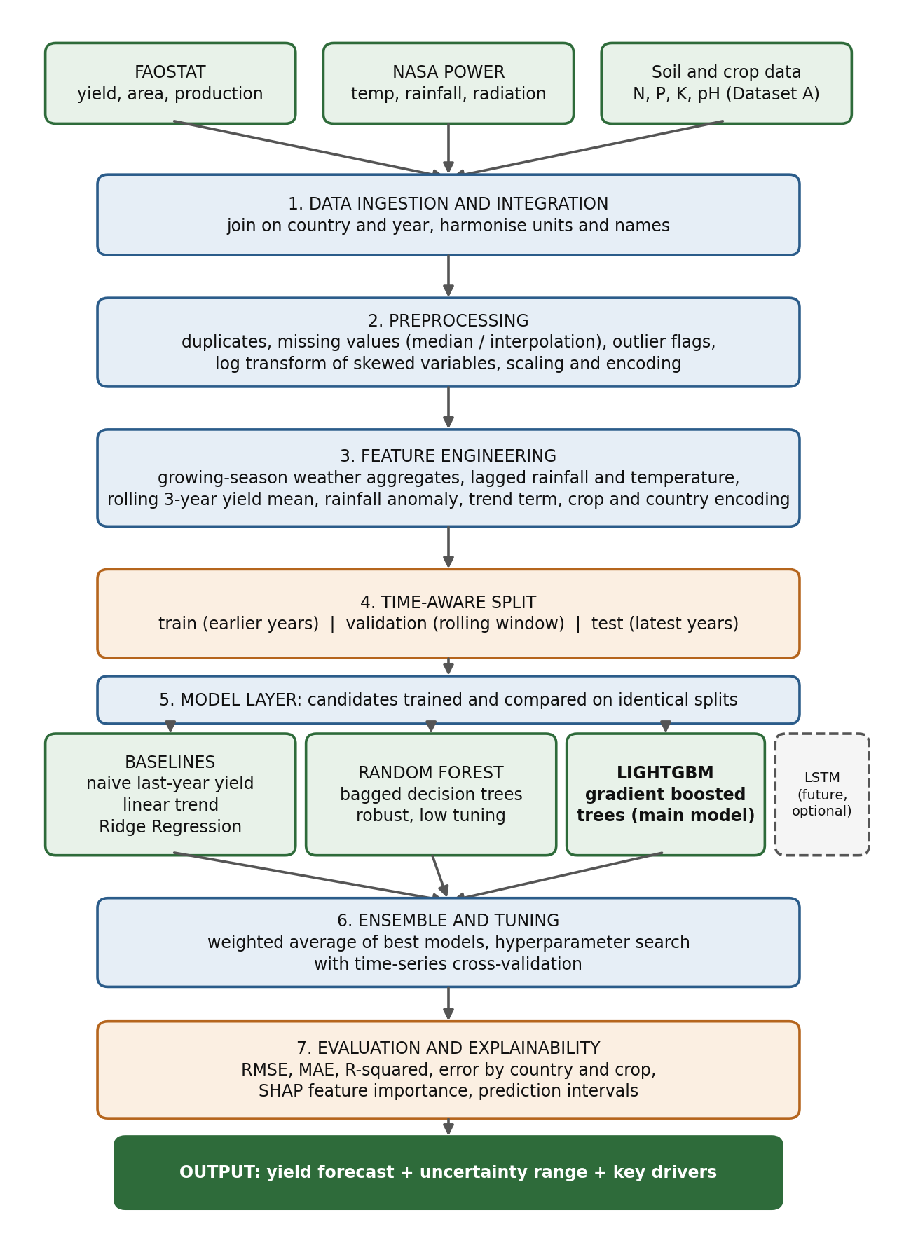
Figure 1: Proposed model architecture for crop yield prediction

6.1 Role of Each Component
Component | Role
Data sources | FAOSTAT supplies yield, area and production; NASA POWER supplies weather; Dataset A supplies soil nutrient and pH information for the recommendation extension.
1. Ingestion and integration | Downloads data, harmonises country and crop names and units, and joins sources on country and year while logging the match rate.
2. Preprocessing | Removes duplicates, imputes missing values, flags outliers, transforms skewed variables and encodes categorical features, all inside a pipeline fitted on training data only.
3. Feature engineering | Creates growing-season aggregates, lags, rolling means, anomalies and trend terms that give models information about seasonality and weather variability.
4. Time-aware split | Separates earlier years for training from later years for validation and testing, preventing leakage from the future.
5. Model layer | Trains baselines, Random Forest and LightGBM on the same splits so that comparison is fair.
6. Ensemble and tuning | Searches hyperparameters with time-series cross-validation and blends the best models with weights from validation error.
7. Evaluation and explainability | Computes error metrics overall and by country and crop, shows feature importance with SHAP, and produces prediction intervals.
Output | A yield forecast, an uncertainty range and a list of the main drivers, ready for reporting or a simple dashboard.

7. Preprocessing and Data Transformation Design
All steps are implemented in a scikit-learn Pipeline and ColumnTransformer, so that any statistic (median, mean, scaling factor) is learned from the training period only and then applied to validation and test data.
# | Step | Design Detail
1 | Unit and schema standardisation | Convert yield to tonnes per hectare, unify country and crop names, parse years, and set consistent column names.
2 | Data integration | Aggregate NASA POWER daily or monthly values to growing-season windows per crop and country, then join to yield records.
3 | Missing values | Median imputation for skewed numeric features, linear interpolation for short gaps in time series, missing-indicator flags; LightGBM also receives raw missing values.
4 | Outliers | Apply domain rules (non-negative yield and rainfall, humidity within 0 to 100%), then flag extreme values with IQR; keep real extremes such as drought years.
5 | Transformations | Log transform for skewed targets or features, standardisation for Ridge, no scaling needed for tree models.
6 | Trend handling | Add a year trend feature and test detrended yield (yield minus fitted country-crop trend) as an alternative target.
7 | Lag and rolling features | Previous-year yield, 3-year rolling mean yield, lagged rainfall and temperature (one season back).
8 | Seasonal features | Growing-season mean temperature, total rainfall, heat-stress days above a crop threshold, dry-spell length where daily data are used.
9 | Anomaly features | Rainfall and temperature deviation from the long-term mean of each country, computed using training years only.
10 | Categorical encoding | One-hot encoding for crop (few levels); target or ordinal encoding for country, with leakage-safe fitting inside cross-validation.
11 | Feature selection | Remove highly collinear features using VIF and correlation, then check importance with mutual information and SHAP.

8. Model Configuration and Validation Strategy

8.1 Initial Hyperparameter Search Space
Model | Parameters and Ranges to Tune
Ridge Regression | alpha from 0.01 to 100 on a log scale.
Random Forest | n_estimators 300 to 1000; max_depth 6 to None; min_samples_leaf 1 to 10; max_features sqrt or 0.5.
LightGBM | n_estimators 300 to 1500 with early stopping; learning_rate 0.01 to 0.1; num_leaves 15 to 63; min_child_samples 10 to 50; subsample and colsample_bytree 0.7 to 1.0; reg_lambda 0 to 10; objective regression or Huber.
Ensemble | Non-negative weights summing to 1, fitted on validation predictions (or a simple stacking with Ridge as meta-learner).

Tuning will use randomised search or Optuna, with a limited number of trials to keep effort manageable. All random seeds will be fixed for reproducibility.

8.2 Validation Strategy
- Time-based cross-validation: Train on earlier years, validate on a following block, and move the window forward (rolling-origin / expanding window). The latest years are kept as a final untouched test set.
- Leave-one-country-out check: Train on all countries except one and test on the held-out country, to measure how well the model generalises to regions without history.
- Leakage control: Any imputation, scaling or encoding is fitted inside each training fold only.
- Baseline comparison: Every model is compared with naive last-year yield and linear trend benchmarks.

9. Evaluation Metrics and Success Criteria
Metric | Purpose
RMSE | Main accuracy measure; penalises large errors, which matter for drought years.
MAE | Average absolute error in tonnes per hectare; easy for stakeholders to interpret.
R-squared | Share of yield variation explained by the model.
MAPE or sMAPE | Percentage error that allows comparison across crops with different yield levels.
Error by country, crop and year | Reveals where the model fails, including bias in extreme years.
Prediction interval coverage | Checks whether the stated uncertainty range contains the actual yield at the expected rate (e.g., about 80%).

9.1 Success Criteria
- The final model beats the best simple baseline on the test set. A working target is a reduction of at least 10% in RMSE, which will be reviewed once real baseline results are known.
- Performance is stable across validation windows rather than good in a single split.
- Errors in extreme weather years are analysed and explained.
- Feature importance results agree with agronomic knowledge (e.g., rainfall and temperature during the growing season are influential).

10. Uncertainty, Explainability and Risk Management

10.1 Uncertainty and Explainability
- Uncertainty: LightGBM quantile regression (for example the 10th and 90th percentiles) or conformal prediction will give prediction intervals, which are more useful than a single number when weather is uncertain.
- Explainability: SHAP values and partial dependence plots show how rainfall, temperature and other variables move predictions, helping non-technical users trust the results.

10.2 Design Risks and Mitigation
Risk | Impact | Mitigation
Overfitting on small data | Good training score but poor future performance. | Regularisation, early stopping, simple baselines, time-based validation, limited tuning trials.
Data leakage | Inflated results. | Pipelines fitted on training folds only, no random shuffling, remove duplicates before splitting.
Trend extrapolation failure | Tree models underpredict in later years. | Trend feature, detrended target and Ridge or hybrid component.
Spatial mismatch of weather data | Weak link between climate and yield. | Aggregate weather over crop areas where possible; state limits clearly; consider district data.
Unmodelled external factors | Unexplained errors from policy, pests or prices. | Document limitations, add proxy variables if available, communicate uncertainty ranges.
Model complexity vs. time | Delays in the five-week internship. | Keep LSTM and satellite features optional; focus on baselines, Random Forest and LightGBM.

11. Extension: Crop Recommendation Module
The Kaggle Crop Recommendation Dataset supports a second, simpler model that recommends a crop from soil nutrients (N, P, K), pH, temperature, humidity and rainfall. This is a multi-class classification problem with 22 crops.
- Models: Logistic Regression and Decision Tree as baselines, Random Forest and LightGBM as main models.
- Metrics: accuracy, macro F1, per-class precision and recall, confusion matrix.
- Validation: stratified k-fold cross-validation; because the dataset is small and may be cleaner than real field data, results will be treated as a pipeline check, not as proof of real-world accuracy.
- Link to yield model: the recommended crop can be combined with the yield forecast to suggest which crop gives the best expected return.

12. Implementation Plan for Weeks 3 to 5
Week | Activities | Output
Week 3 (26 Oct to 1 Nov) | Build the data pipeline and feature set; train baselines, Random Forest and LightGBM with time-based validation. | Feature set, baseline and first model results
Week 4 (2 to 8 Nov) | Hyperparameter tuning, ensemble, error analysis, SHAP explanations, prediction intervals. | Model comparison and evaluation report
Week 5 (9 to 16 Nov) | Finalise code and documentation, optional dashboard demo, prepare the final report and presentation. | Final report, GitHub repository, presentation

The weekly plan may be adjusted when the mentor provides the actual tasks for Weeks 3 to 5.

13. Conclusion
This design turns the Week 1 plan into a concrete, defensible modelling approach. It recognises the particular difficulties of agricultural data (seasonality, weather variability, long-term trend, small samples and external factors) and responds to each with a specific design choice. By starting with simple baselines, then using Random Forest and LightGBM with a weighted ensemble, and by validating strictly through time, the model aims to be accurate, robust and explainable. Prediction intervals and SHAP explanations make the output practical for farmers, agribusiness firms, insurers and policy makers. The design also leaves room for future growth, such as satellite data and sequence models, once the core pipeline is proven.

14. References
- Breiman, L. (2001). Random Forests. Machine Learning, 45, 5 to 32.
- Chen, T. and Guestrin, C. (2016). XGBoost: A Scalable Tree Boosting System. Proceedings of KDD 2016.
- Ke, G. et al. (2017). LightGBM: A Highly Efficient Gradient Boosting Decision Tree. Advances in Neural Information Processing Systems 30.
- Hochreiter, S. and Schmidhuber, J. (1997). Long Short-Term Memory. Neural Computation, 9(8), 1735 to 1780.
- Lundberg, S. and Lee, S. (2017). A Unified Approach to Interpreting Model Predictions. Advances in Neural Information Processing Systems 30.
- FAOSTAT, Crops and livestock products, Food and Agriculture Organization of the United Nations (fao.org/faostat).
- NASA POWER Data Access Viewer (power.larc.nasa.gov).
- Pedregosa, F. et al. (2011). Scikit-learn: Machine Learning in Python. Journal of Machine Learning Research, 12, 2825 to 2830.

