WEEK 4 REPORT
Model Evaluation and Optimization Strategy
Evaluation Framework for Crop Yield and Crop Health Models
Prepared by: Jai Prakash Gupta
Internship Program: Machine Learning Internship in Nagpur, YuvaIntern
Internship Duration: 12 October 2026 to 16 November 2026 (5 weeks, Remote)

Contents
1. Executive Summary
2. Evaluation Context and Goals
3. Evaluation Design and Validation Scheme
4. Performance Metrics
5. Thresholds for Success
6. Diagnostic Strategy
7. Optimization Framework
8. Model Limitations and Realistic Solutions
9. Turning Evaluation into Actionable Insights
10. Risks in the Evaluation Process
11. Implementation Plan for Weeks 4 and 5
12. Conclusion
13. References

1. Executive Summary
Building a model is only half of the work; knowing whether it can be trusted for real farming and business decisions is the other half. This report presents the evaluation and optimization framework for the models designed in Week 2 (Ridge, Random Forest and LightGBM) and fed by the features planned in Week 3. It covers the two prediction targets of this project: crop yield (regression) and crop health (classification).
The framework answers five questions:
- Which metrics reflect what agribusiness stakeholders actually care about, such as error margin in tonnes per hectare, bias, behaviour in bad seasons and reliability of uncertainty ranges?
- What results count as success, and how are they compared against simple baselines?
- How are overfitting, underfitting, bias and data leakage detected?
- How is the model tuned in a disciplined, step-by-step way without wasting the test data?
- What are the model's limits in a real agricultural setting, and which realistic steps can improve it?
Important note: this document is a plan. Threshold values are working targets set from agronomic reasoning and published practice; they will be reviewed once real baseline results are available in the model-building phase.

2. Evaluation Context and Goals

2.1 Decisions the Model Supports
Stakeholder Decision | What the Model Must Provide | Evaluation Focus
Procurement and storage planning (agribusiness firms) | Expected yield for the coming season by region | Low bias, small relative error, directional accuracy
Crop insurance and lending (banks, insurers) | Forecast with uncertainty range and early warning of bad seasons | Interval coverage, error in extreme years
Input advice (fertilizer, irrigation, cooperatives) | Reliable drivers of yield and early crop-health alerts | Recall for stressed fields, stable feature importance
Policy and food security | Regional trend and risk signals | Seasonal stability, performance across regions

2.2 What 'Good' Means in Agriculture
- Average accuracy is not enough. A single score can hide the fact that the model fails in drought years or on small farms, which are exactly the cases that matter most.
- Errors have business costs. Over-forecasting yield can leave a buyer short of supply; under-forecasting can lead to wasted storage or unsold stock. Costs are often asymmetric.
- Time order matters. A model that looks good on shuffled data may fail on the next season. Evaluation must mimic real forecasting, using only the past to predict the future.
- Uncertainty is part of the answer. A forecast of 3.2 tonnes per hectare is far more useful when stated as 'between 2.8 and 3.6 with 80% confidence'.

3. Evaluation Design and Validation Scheme

3.1 Data Splitting
- Final test set: The most recent seasons (for example the last two to three years) form a final test set that is locked and used only once at the end.
- Development data: The earlier seasons are used for training and validation with rolling-origin (expanding window) cross-validation.
- Group integrity: Fields, farms or countries are never split between training and validation in a way that leaks local information; group-aware splits are used where the same unit appears in several seasons.

3.2 Validation Techniques and Their Purpose
Technique | How It Works | Question It Answers
Rolling-origin (expanding window) CV | Train on seasons 1 to k, validate on season k+1, then move forward. | How well does the model forecast the next season using only the past?
Blocked time-series split | Contiguous blocks of seasons per fold with a gap between train and validation. | Is performance stable and free from near-neighbour leakage?
Leave-one-group-out (country, district or farm) | Hold out one group completely. | Does the model work in regions or fields it has never seen?
Nested cross-validation | Inner loop tunes hyperparameters; outer loop estimates performance. | What is the unbiased performance when tuning is part of the method? (used for small data)
Final locked test | One evaluation on untouched recent seasons. | What performance should stakeholders expect in practice?

Random shuffled k-fold is not used for yield data, because it mixes seasons and lets the model learn from the future.

3.3 Baselines
Every model is judged against simple benchmarks, because an impressive R-squared can still be worse than a trivial forecast in a series with a strong trend.
- Naive: next yield equals last season's yield.
- Linear trend: yield extrapolated from a fitted trend for each crop and region.
- Historical mean of the last three to five seasons (district or country).
- Ridge Regression on the Week 3 features, as the simple learned model.

4. Performance Metrics
Metrics are chosen to describe size of error, systematic bias, relative accuracy, usefulness against baselines, behaviour across seasons, and reliability of uncertainty. No single metric is used alone.

4.1 Core Regression Metrics for Crop Yield
Metric | Formula | Why It Matters in Agribusiness | Caution
RMSE | sqrt(mean((predicted - actual)^2)) | Penalises large misses, which hurt most in bad seasons; in tonnes per hectare, so easy to explain. | Sensitive to outliers; compare only on the same data.
MAE | mean(|predicted - actual|) | Typical error size; robust and easy for farmers to understand. | Hides how bad the worst misses are; read together with RMSE.
Relative RMSE (NRMSE) | RMSE / mean actual yield | Compares accuracy across crops with different yield levels. | Use mean yield of the same crop and region.
MAPE or sMAPE | mean(|error| / actual) x 100 | Percentage error is natural for business reporting. | Unstable when actual yield is near zero; sMAPE is safer.
R-squared | 1 - SS_residual / SS_total | Share of yield variation explained. | Inflated by trends; always report next to baseline skill.
Mean Bias Error (MBE) | mean(predicted - actual) | Shows systematic over- or under-forecasting, which directly affects procurement and credit. | Positive and negative errors cancel; use by subgroup.
Skill score vs baseline | 1 - RMSE_model / RMSE_baseline | Shows how much the model improves on a naive forecast; the most honest summary. | Depends on chosen baseline; report several.

4.2 Seasonal and Variability Metrics
Metric | Purpose and Method
Error by season or year | Report RMSE and MBE for each validation season to see whether the model fails in specific years such as drought or flood seasons.
Seasonal stability | Standard deviation of RMSE across validation windows divided by its mean (coefficient of variation); a low value means consistent performance.
Worst-season error | Maximum seasonal RMSE or the error in the worst 10% of seasons; important for insurance and risk planning.
Extreme-year performance | Error in years where rainfall or temperature anomaly is beyond a set limit (for example outside 1.5 standard deviations).
Directional accuracy | Share of cases where the model correctly predicts whether yield will rise or fall compared with the previous season; useful for planning decisions.
In-season lead-time error | Error when forecasts are made at different points of the season (e.g., at sowing, flowering, 60 days before harvest) to show how accuracy grows with more information.
Error by segment | RMSE and bias by crop, country or district, farm size and irrigation type to find weak segments.

4.3 Uncertainty Metrics
- Prediction interval coverage: Share of actual values falling inside the stated interval (an 80% interval should contain about 80% of outcomes).
- Interval width: Average interval width; narrower is better only if coverage stays correct.
- Pinball (quantile) loss: A proper scoring rule for quantile forecasts that rewards both accuracy and honest uncertainty.

4.4 Metrics for Crop Health Classification
Metric | Why It Is Used
Recall for stressed and diseased classes | Missing a stressed field is costlier than a false alarm, so recall on at-risk classes is the priority metric.
Precision for at-risk classes | Too many false alarms make advisors ignore the system; used with recall.
Macro F1 | Balances all classes even when healthy fields dominate.
PR-AUC | Better than ROC-AUC when at-risk fields are rare.
Confusion matrix | Shows which classes are confused (e.g., stressed predicted as healthy).
Brier score and calibration curve | Check whether predicted probabilities can be trusted as risk levels.

4.5 Business-Cost Metric
Where cost information is available, an asymmetric loss is added: cost = a x (over-forecast tonnes) + b x (under-forecast tonnes), with a and b set from the stakeholder's situation (for example storage cost versus shortage penalty). This helps choose between models that have similar RMSE but different bias direction.

4.6 Worked Example of Metric Calculation
Five hypothetical field predictions (yield in tonnes per hectare; error = predicted - actual). Numbers are for illustration only.
Field | Actual | Predicted | Error | Squared error | % error
A | 3.2 | 3.0 | -0.2 | 0.04 | 6.3%
B | 2.8 | 3.1 | +0.3 | 0.09 | 10.7%
C | 4.1 | 3.7 | -0.4 | 0.16 | 9.8%
D | 3.5 | 3.6 | +0.1 | 0.01 | 2.9%
E (dry field) | 2.0 | 2.9 | +0.9 | 0.81 | 45.0%

Results: MAE = 0.38, RMSE = 0.47, MBE = +0.14 (slight over-forecasting), NRMSE = 0.47 / 3.12 = 15.1%, MAPE = 14.9%, R-squared = 0.55. If a hypothetical baseline had RMSE 0.60, the skill score would be 1 - 0.47 / 0.60 = 0.22. Note that the single dry field E causes most of the squared error: RMSE is much higher than MAE, which signals that the model struggles in poor conditions. This is exactly the insight a single accuracy figure would hide.

5. Thresholds for Success
Thresholds are proposed in two levels: a minimum acceptable level (model can be used for guidance) and a target level (model is suitable for planning decisions). They are working values based on agronomic reasoning and typical forecasting practice, and will be recalibrated once baseline results are known. Field-level forecasts are naturally less precise than country-level ones, so separate limits are given.
Metric | Minimum Acceptable | Target | Notes
Skill score vs best baseline (RMSE) | At least 0.05 | At least 0.10 | Must hold on test seasons, not only on validation.
Relative RMSE, country-crop level | 15% or lower | 10% or lower | Based on locked test seasons.
Relative RMSE, field level | 30% or lower | 20% or lower | More noise expected from local factors.
R-squared (time-based test) | 0.50 or higher | 0.65 or higher | Always reported with baseline R-squared.
Mean bias (MBE as % of mean yield) | Within 5% | Within 3% | Checked per crop and region.
Directional accuracy | 70% or higher | 80% or higher | Rise or fall versus previous season.
Seasonal stability (CV of RMSE) | 35% or lower | 25% or lower | Across rolling validation windows.
Worst-season RMSE | No more than 2.5x typical | No more than 2x typical | Typical means median seasonal RMSE.
80% interval coverage | 70% to 90% | 75% to 85% | Intervals must be informative, not just wide.
Crop health: recall of at-risk classes | 0.70 or higher | 0.80 or higher | Priority over precision.
Crop health: precision of at-risk classes | 0.50 or higher | 0.60 or higher | Avoid alert fatigue.
Crop health: macro F1 | 0.65 or higher | 0.75 or higher | Stratified, group-aware CV.

5.1 Decision Rules
- A model is accepted only if it meets the minimum level on every row marked as a primary requirement (skill score, bias, interval coverage and worst-season error) and does so consistently across validation windows.
- If two models are close, the simpler and more interpretable one is preferred (within one standard error of the best score).
- If targets are not met, the diagnostic strategy (Section 6) identifies whether data, features or model settings are the cause before any further tuning.

6. Diagnostic Strategy

6.1 Detecting Overfitting and Underfitting
Learning curves plot training and validation error against the amount of training data. Their shape shows whether the model is too simple, too complex or well balanced. Figure 1 shows the three typical patterns (conceptual illustration, not project results).
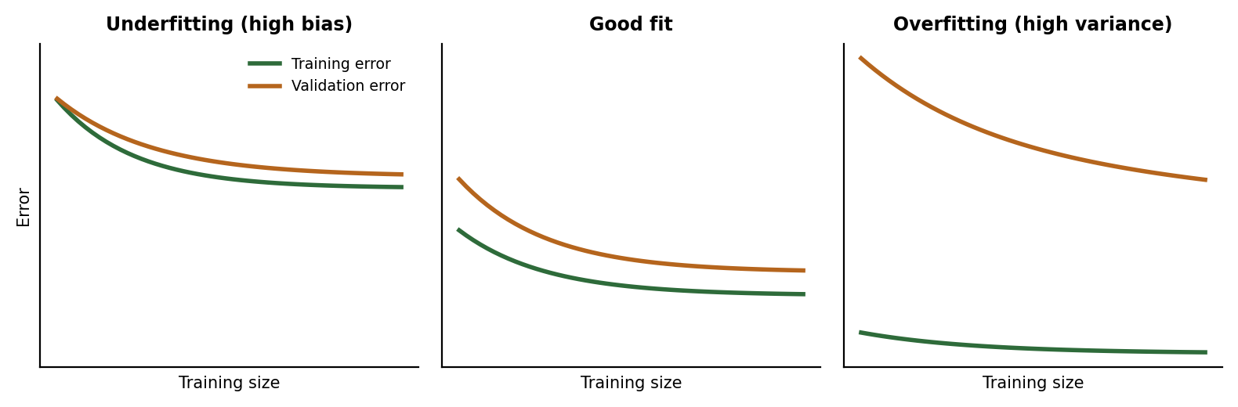
Figure 1: Conceptual learning curves for underfitting, good fit and overfitting
Pattern | Symptoms | Likely Cause | Typical Remedy
Underfitting (high bias) | Training and validation error both high and close together; adding data does not help. | Model too simple, missing key features, too much regularisation. | More expressive model, better features (GDD, stress days, NDVI), lower regularisation, more trees or leaves.
Overfitting (high variance) | Training error very low, validation error much higher; large spread between folds. | Too many features or too complex model for small data; leakage. | Stronger regularisation, shallower trees, larger min leaf size, early stopping, fewer features, more data, ensembles.
Good fit | Small gap, both errors low and stable across windows. | Balanced complexity. | Keep; check bias and robustness.
Optimistic validation | Validation far better than locked test. | Data leakage or repeated tuning on the same folds. | Repair splits, nested CV, keep test locked.

Additional checks: validation curves for one key hyperparameter at a time (for example tree depth or number of leaves), and the spread of scores across folds (a large spread is itself a warning sign).

6.2 Detecting Bias and Systematic Error
- Residual analysis: Plot residuals against predicted yield, year, crop, country, farm size and rainfall; patterns show where the model errs systematically.
- Subgroup bias: Compute MBE and RMSE for each subgroup; flag groups that differ by more than a set margin from the overall result.
- Calibration plot: Predicted versus actual plot, in bins of predicted yield, to see over-prediction for low-yield fields (a common problem where models regress to the mean).
- Drift over time: Plot error against year; a rising trend suggests technology drift or changing conditions the model does not follow.
- Heteroscedasticity: Check whether the error spread grows with yield level or in extreme weather; if so, use weighted or Huber loss and report intervals by segment.

6.3 Seasonal and Temporal Diagnostics
- Table and chart of errors by season, with weather anomaly shown next to each, to see whether weather extremes explain the large errors.
- Compare early validation windows with the latest; a worsening trend signals concept drift and the need for retraining or recency weighting.
- Population Stability Index (PSI) or simple distribution comparison for key features (rainfall, temperature, NDVI) between training and new seasons.

6.4 Detecting Data Leakage
- Shuffled-target test: Train on randomly shuffled targets; scores should collapse to baseline level. A good score means leakage.
- Feature ablation: Remove suspicious features (for example harvest-time variables or neighbour yields) and see whether performance drops sharply.
- Time and group audit: Confirm that all features use only data available at the forecast date and that the same field never appears in both training and validation sets of a group split.

6.5 Explainability and Agronomic Sanity Checks
- SHAP values and partial dependence plots show whether the model uses features in agronomically sensible ways (for example yield falling with more heat-stress days).
- Feature importance is compared across folds and seasons; unstable rankings suggest overfitting.
- An agronomist reviews the main drivers; implausible effects trigger a check for data errors or spurious correlation.

6.6 Robustness Tests
- Noise injection: Add realistic noise to weather and soil inputs and measure the change in predictions.
- Missing-input stress test: Drop one feature group (e.g., NDVI or weather station data) to see how gracefully performance degrades, simulating sensor or satellite outages.
- Out-of-distribution test: Test on a new country, district or crop variety not used in training.

7. Optimization Framework
Optimization follows a fixed loop (Figure 2) so that improvements come from the right source and the test data stays unbiased.
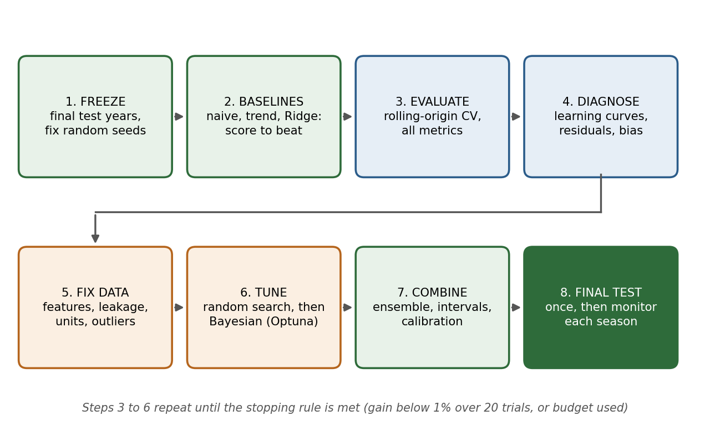
Figure 2: Evaluation and optimization workflow

7.1 Step-by-Step Approach
# | Step | Details
1 | Freeze test set and seeds | Lock the latest seasons as test data, fix random seeds, version datasets and code.
2 | Measure baselines | Score naive, trend and Ridge models with all metrics; these are the scores to beat.
3 | Evaluate with rolling-origin CV | Run Random Forest and LightGBM with default settings; record all metrics and fold spread.
4 | Diagnose | Use learning curves, residual and subgroup analysis, leakage tests (Section 6) to decide whether the problem is data, features or model complexity.
5 | Fix data and features first | Correct leakage, units and outliers, improve weather alignment and add missing agronomic features. Data improvements usually beat hyperparameter tuning in agriculture.
6 | Tune hyperparameters | Coarse random search, then focused Bayesian search (Section 7.3), always inside time-based CV.
7 | Regularise, ensemble and calibrate | Early stopping, weighted average of the best models, quantile models for prediction intervals, probability calibration for the health classifier.
8 | Final test and monitoring | Refit on all development data, evaluate once on the locked test set, then monitor errors each season and retrain when drift appears.

7.2 Cross-Validation Choices
- Rolling-origin CV: Primary method for yield; expanding window with a one-season gap where autocorrelation is strong.
- Stratified group k-fold: For the crop recommendation and crop health models, where rows are not ordered in time but belong to fields or farms.
- Leave-one-country-out: To measure generalisation to new regions.
- Nested CV: When the dataset is small, so that reported performance is not inflated by tuning.

7.3 Hyperparameter Search Strategies
Strategy | Description | Use in This Project
Grid search | Tries all combinations on a fixed grid. | Only for very small spaces such as the Ridge alpha.
Random search | Samples settings at random from defined ranges. | First stage for Random Forest and LightGBM; efficient when only a few parameters matter (Bergstra and Bengio, 2012).
Bayesian optimization (Optuna, TPE) | Uses past trials to choose promising settings. | Second stage for LightGBM: 50 to 100 trials around the best region, with pruning of weak trials.
Successive halving / Hyperband | Stops poor trials early to save compute. | Optional if the dataset or number of trials grows.

7.4 Model-Specific Tuning Guide
Model | Parameters to Tune | Adjustment Rules
Ridge | alpha (0.01 to 100, log scale) | Overfitting: increase alpha. Underfitting: decrease alpha or add interaction features.
Random Forest | n_estimators (300 to 1000); max_depth (6 to None); min_samples_leaf (1 to 10); max_features (sqrt to 0.5) | Overfitting: raise min_samples_leaf, limit depth, lower max_features. Underfitting: deeper trees, more features per split.
LightGBM | learning_rate (0.01 to 0.1); num_leaves (15 to 63); min_child_samples (10 to 50); subsample and colsample (0.7 to 1.0); reg_lambda (0 to 10); n_estimators with early stopping | Overfitting: fewer leaves, higher min_child_samples, higher reg_lambda, lower learning rate with early stopping. Underfitting: more leaves, more trees, more informative features.
Loss and weights | Squared, Huber or quantile objective; recency weights | Use Huber when extreme years distort fitting; use recent-year weights if drift is detected.

7.5 Stopping Rules and Model Selection
- Stop tuning when the improvement in cross-validated RMSE is below 1% over 20 consecutive trials, or when the trial budget is used.
- Apply the one-standard-error rule: choose the simplest model whose score lies within one standard error of the best.
- Report results for default and tuned versions to show how much tuning actually helped.
- Keep an experiment log (settings, seeds, metrics, data version) in a CSV file or a tracking tool such as MLflow, so that results can be reproduced.

8. Model Limitations and Realistic Solutions
A credible evaluation also states what the model cannot do. The table lists the main limitations in a real agricultural setting and the realistic steps to reduce them.
Limitation | Why It Occurs | Realistic Solution
Short history per region | Annual yield gives only tens of observations per series; seasons differ. | Pool crops and regions, use regularised models, report confidence intervals, avoid claims about rare events.
Trend extrapolation by tree models | Random Forest and LightGBM cannot predict beyond the range seen in training. | Detrend yields, include a Ridge trend component, evaluate against the linear trend baseline.
Rare extreme events | Few droughts or floods in the data. | Keep real extremes, use Huber or quantile loss, report worst-season error and wide intervals in risky years.
Spatial mismatch of inputs | Weather is gridded or station-based, while yield is a regional or field average. | Use closer weather sources, record station distance, move to district-level data when available.
Unobserved factors | Pests, management quality, input prices and policy are missing. | Add proxy variables (irrigated area, fertilizer use), include farm or district effects, state the limitation in reports.
Noisy labels | Yield records may be estimated or self-reported. | Cross-check against remote-sensing signals, flag suspicious records, use robust loss.
Limited transferability | A model trained in one region may not hold in another. | Leave-one-region-out testing, local fine-tuning with a few seasons of local data.
Climate change and drift | Past relationships may shift as conditions and varieties change. | Rolling retraining each season, recency weighting, drift monitoring.
In-season forecasting limits | Early forecasts lack information about later weather. | Report error by lead time; give scenario ranges (dry, normal, wet) rather than a single number.
Accuracy versus interpretability | Complex ensembles are harder to explain. | Use SHAP and simple summaries; keep Ridge or single-tree explanation as a reference.
Adoption and trust | Farmers and advisors may not act on black-box output. | Provide plain-language drivers, confidence levels and agronomist review.

8.1 Prioritised Improvement Roadmap
- Fix data quality and leakage issues (highest impact, lowest cost).
- Improve weather and soil alignment to fields and growth stages.
- Add remote-sensing (NDVI) features and irrigation information where available.
- Introduce quantile intervals and calibration for trustworthy uncertainty.
- Retrain every season and track errors; add finer-resolution data and sequence models (LSTM) only if enough data are available.

9. Turning Evaluation into Actionable Insights
Insight | How It Is Derived | Action Enabled
Where the model is reliable | Error and bias by crop, region and season in a performance map or table | Use forecasts with confidence in strong segments; use cautiously or manual review in weak ones.
How uncertain a forecast is | Prediction intervals and coverage checks | Plan procurement and insurance reserves using the range, not only the central value.
Which factors drive yield | SHAP values, partial dependence, stable feature importance | Advise on sowing dates, irrigation and nutrient management; verify with agronomists.
When forecasts become reliable | Error versus lead time | Decide when to commit orders or loans during the season.
How bad the bad seasons are | Worst-season and extreme-year errors | Set buffers and risk limits for drought or flood years.
What-if effects | Scenario runs (e.g., rainfall 20% lower, heat-stress days increased) | Support contingency planning and climate-risk discussion.

9.1 Model Report Template
- Intended use, data sources, training period and test period.
- Results table: all metrics versus baselines, with confidence intervals.
- Performance by segment and by season, including the worst cases.
- Key drivers with plain-language interpretation.
- Known limitations, recommended use and a retraining schedule.

10. Risks in the Evaluation Process
Risk | Impact | Mitigation
Test set reuse | Optimistic final results. | Lock test seasons; look at them only once; use nested CV during development.
Small test sample | Unstable and misleading metrics. | Report block-bootstrap confidence intervals (resampling whole seasons), not only point values.
Metric gaming | Choosing the metric that looks best. | Fix the metric list and thresholds in advance; report all.
Unfair baseline comparison | Overstated improvement. | Use several baselines and the same data splits for all models.
Leakage through tuning or features | Inflated scores. | Pipelines fitted inside folds; shuffled-target test; feature audit.
Over-tuning on noise | Overfits to validation seasons. | Limited trial budget, one-standard-error rule, stability across windows.
Averages hiding failures | Bad performance in key groups goes unnoticed. | Mandatory segment and season reports.
Thresholds set too tight or loose | Wrong accept or reject decisions. | Recalibrate thresholds after baseline results; involve stakeholders.

11. Implementation Plan for Weeks 4 and 5
Week | Activities | Output
Week 4 (2 to 8 Nov) | Set up validation scheme and metric functions; run baselines; evaluate Random Forest and LightGBM; produce diagnostic plots; start random-search tuning. | Metric table, diagnostic results, tuning log
Week 5 (9 to 16 Nov) | Finish Bayesian tuning and ensemble; run robustness and final test; write model report with limitations; prepare final presentation. | Final evaluation report, code repository, presentation

The plan will be adjusted if the mentor provides specific task changes for Week 5.

12. Conclusion
This evaluation and optimization framework is designed so that the model is judged on what matters in agriculture: size and direction of forecast error, behaviour in bad seasons, honesty about uncertainty and usefulness against simple baselines. Time-aware validation and a locked test set protect against overly optimistic results, while the diagnostic toolkit makes it possible to tell whether problems come from data, features or model complexity. The optimization loop puts data and feature fixes before hyperparameter tuning, uses efficient search strategies, and ends with clear stopping rules. By stating limitations openly and linking each to a realistic remedy, the framework supports trustworthy, actionable insights for farmers, agribusiness firms, insurers and planners.

13. References
- Hyndman, R. J. and Athanasopoulos, G. (2021). Forecasting: Principles and Practice, 3rd edition. OTexts.
- Bergstra, J. and Bengio, Y. (2012). Random Search for Hyper-Parameter Optimization. Journal of Machine Learning Research, 13, 281 to 305.
- Akiba, T. et al. (2019). Optuna: A Next-generation Hyperparameter Optimization Framework. Proceedings of KDD 2019.
- Cawley, G. C. and Talbot, N. L. C. (2010). On Over-fitting in Model Selection and Subsequent Selection Bias in Performance Evaluation. Journal of Machine Learning Research, 11, 2079 to 2107.
- Roberts, D. R. et al. (2017). Cross-validation strategies for data with temporal, spatial, hierarchical, or phylogenetic structure. Ecography, 40, 913 to 929.
- Gneiting, T. and Raftery, A. E. (2007). Strictly Proper Scoring Rules, Prediction, and Estimation. Journal of the American Statistical Association, 102, 359 to 378.
- Willmott, C. J. and Matsuura, K. (2005). Advantages of the mean absolute error (MAE) over the root mean square error (RMSE). Climate Research, 30, 79 to 82.
- Chai, T. and Draxler, R. R. (2014). Root mean square error (RMSE) or mean absolute error (MAE)? Geoscientific Model Development, 7, 1247 to 1250.
- Lundberg, S. and Lee, S. (2017). A Unified Approach to Interpreting Model Predictions. Advances in Neural Information Processing Systems 30.
- Pedregosa, F. et al. (2011). Scikit-learn: Machine Learning in Python. Journal of Machine Learning Research, 12, 2825 to 2830.

