单点登录系统部署文档

需要安装包
- oracle-instantclient11.2-basic-11.2.0.4.0-1.x86_64.rpm
- oracle-instantclient11.2-devel-11.2.0.4.0-1.x86_64.rpm
- ssogo.tar.gz

部署步骤
- 将oracle客户端安装包拷贝到部署机上
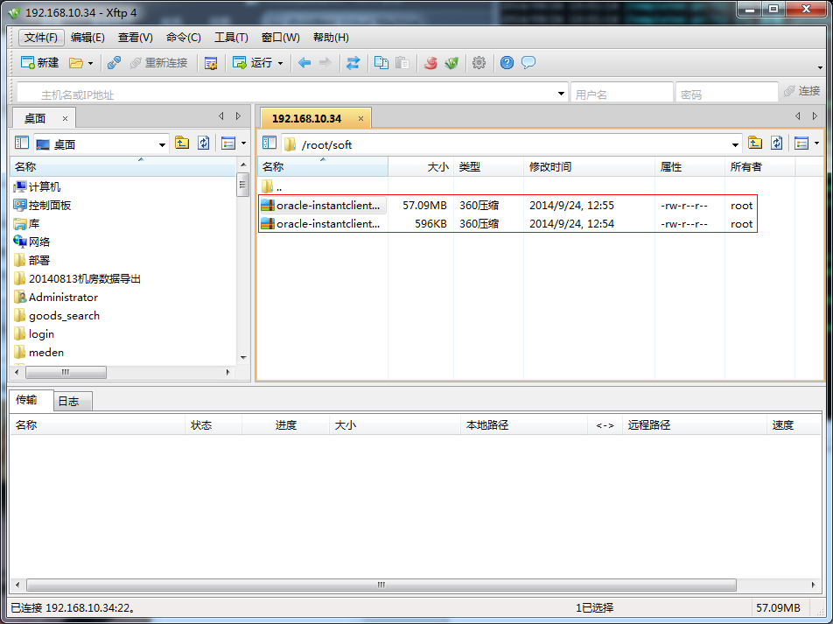
- 安装oracle客户端rpm包
rpm -ivh oracle-instantclient11.2-basic-11.2.0.4.0-1.x86_64.rpm
rpm -ivh oracle-instantclient11.2-devel-11.2.0.4.0-1.x86_64.rpm
- 添加环境变量
vim /etc/profile
添加如下内容：
#for go oracle
export CGO_CFLAGS=-I/usr/include/oracle/11.2/client64
export CGO_LDFLAGS=-L/usr/lib/oracle/11.2/client64/lib
export LD_LIBRARY_PATH=/usr/lib/oracle/11.2/client64/lib:/lib:/usr/lib:/usr/local/lib
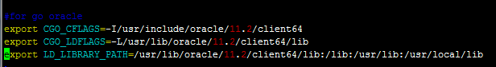
- 拷贝部署包到部署机中
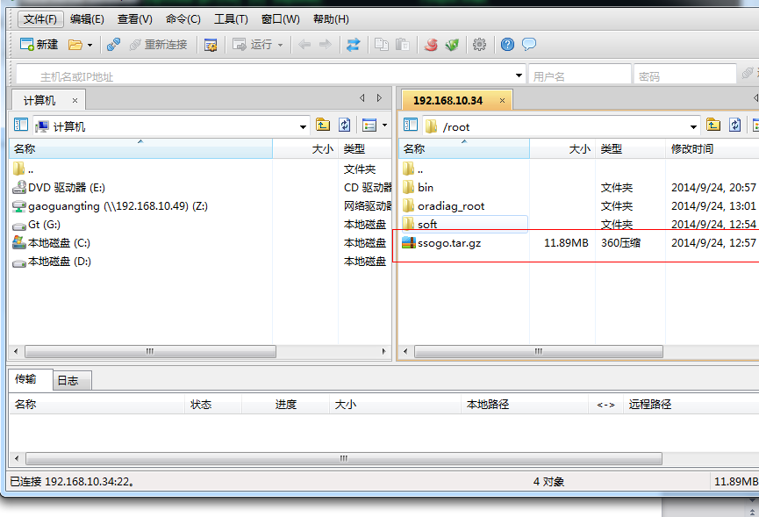
- 安装supervisor
#yum install python-setuptools
#sudo easy_install supervisor
- 解压到当前文件夹中
#tar xvf ssogo.tar.gz
#cd ssogo
- 创建supervisor配置
#pwd
/root/ssogo
# echo_supervisord_conf > ./supervisord.conf
# vim ./supervisord.conf
尾部添加以下内容
[program:ssogo]
command=/root/ssogo/ssogo
autostart=true
autorestart=true
startsecs=10
stdout_logfile=/root/ssogo/ssogo_server.log
stdout_logfile_maxbytes=1MB
stdout_logfile_backups=10
stdout_capture_maxbytes=1MB
stderr_logfile=/root/ssogo/ssogo_server.log
stderr_logfile_maxbytes=1MB
stderr_logfile_backups=10
stderr_capture_maxbytes=1MB
执行
#/usr/bin/supervisord -c /root/ssogo/supervisord.conf

- 查看运行日志
# tail -f ssogo_server.log
