AI-Powered Intrusion Detection Solution
with Real-Time Threat Detection
Assignment 1 - Course: Information Security
Aligned CLO 4: Create solutions to real-life scenarios using security-related tools

Name: ______________________
Student ID: ______________________

Dataset: UNSW-NB15 | Final model: LightGBM (RF, XGBoost, MLP, Deep NN, TabNet compared)

Executive Summary
SecureNet Corp. needs a proactive layer on top of its signature-based NIDS. Using the UNSW-NB15 dataset, we built a machine-learning pipeline (cleaning, one-hot encoding, robust scaling, SMOTENC class balancing) and trained several classifiers to label traffic as Normal or one of nine attack families. LightGBM was selected as the deployed model. On the unseen UNSW-NB15 test partition (82,332 flows) it reaches 71% overall 10-class accuracy. As an attack-versus-normal detector it flags 98.9% of malicious flows (only 496 of 45,332 attacks were labelled Normal) at the cost of a 32.8% false-alarm rate on normal traffic. Rare classes (Analysis, Backdoor) are poorly identified, which is discussed as a security risk. The model is served through a FastAPI backend and a web dashboard for real-time single and batch analysis.

1. Introduction and Real-World Scenario
Firewalls and signature-based IDS tools miss novel or obfuscated attacks. As a security analyst at SecureNet Corp., the objective is a proof-of-concept classifier that inspects network-flow features and automatically flags malicious traffic, reducing analyst workload and detection latency. The solution is judged with security-relevant metrics, particularly recall on attack classes, because a missed attack is far costlier than a false alarm.

2. Methodology

2.1 Dataset and Scenario Justification
UNSW-NB15 (Australian Centre for Cyber Security) was created with the IXIA PerfectStorm tool to blend modern normal activity with synthetic contemporary attacks. It is more realistic than older sets such as KDD99/NSL-KDD. Its nine attack families map to real threats against enterprise networks:
- Exploits, Backdoor, Shellcode, Worms: host compromise, persistence and propagation.
- DoS and Fuzzers: availability attacks and vulnerability probing of services.
- Reconnaissance and Analysis: port scans, spam and web-application probing that precede attacks.
- Generic: cryptographic collision attacks against block ciphers.
The official partitions were used: 175,341 records for training and 82,332 for the final unseen test. Each record has 45 columns (flow duration, protocol, service, state, packet/byte counts, TTL, loads, connection-tracking counters) plus attack_cat and a binary label.

2.2 Data Preprocessing
- Loaded both CSVs with pandas; verified shapes, dtypes and absence of null values (info(), describe()).
- Dropped the id column (identifier only) and the binary label, so the target is the multi-class attack_cat (Normal + 9 attacks).
- EDA: value counts of attack_cat show heavy imbalance. Normal and Generic dominate, while Worms (44 test flows), Shellcode (378), Backdoor (583) and Analysis (677) are rare.
- Removed redundant/low-value features (sload, dload, rate, sloss, dloss, is_ftp_login, ct_ftp_cmd, ct_flw_http_mthd, trans_depth, response_body_len).
- Encoded categorical fields (proto, service, state) with one-hot encoding; test columns were aligned to the training columns.
- Balanced classes with SMOTENC (categorical-aware SMOTE); after an 80/20 stratified internal split, each class has 11,200 validation rows (112,000 total).
- Normalised numeric features with RobustScaler, chosen because network features are heavy-tailed with extreme outliers.

2.3 Machine-Learning Tool Design
Six classifiers were built on the same preprocessing pipeline: Random Forest, XGBoost, LightGBM, scikit-learn MLP, a Keras deep neural network (batch-norm + dropout) and TabNet. Gradient-boosted trees suit tabular flow data: they model non-linear feature interactions, tolerate mixed-scale features, train quickly and give fast inference, which matters for real-time detection. LightGBM was chosen as the final model because it matched XGBoost on accuracy while being faster, and it clearly beat the neural networks on the unseen test set.

3. Results and Security Analysis

3.1 Model Comparison (unseen test set, 82,332 flows)
Model | Validation accuracy | Test accuracy | Test macro F1 | Test macro recall
LightGBM | 0.78 | 0.71 | 0.48 | 0.62
XGBoost | 0.78 | 0.71 | 0.48 | 0.61
MLP (sklearn) | 0.77 | 0.67 | 0.42 | 0.53
Deep NN (Keras) | 0.56 | 0.51 | 0.29 | 0.44

3.2 Per-Class Precision / Recall (LightGBM, test set)
Class | Precision | Recall | Support
Analysis | 0.03 | 0.15 | 677
Backdoor | 0.04 | 0.22 | 583
DoS | 0.33 | 0.41 | 4089
Exploits | 0.80 | 0.61 | 11132
Fuzzers | 0.28 | 0.62 | 6062
Generic | 1.00 | 0.97 | 18871
Normal | 0.98 | 0.67 | 37000
Reconnaissance | 0.87 | 0.82 | 3496
Shellcode | 0.18 | 0.91 | 378
Worms | 0.18 | 0.80 | 44

3.3 Confusion Matrix and ROC
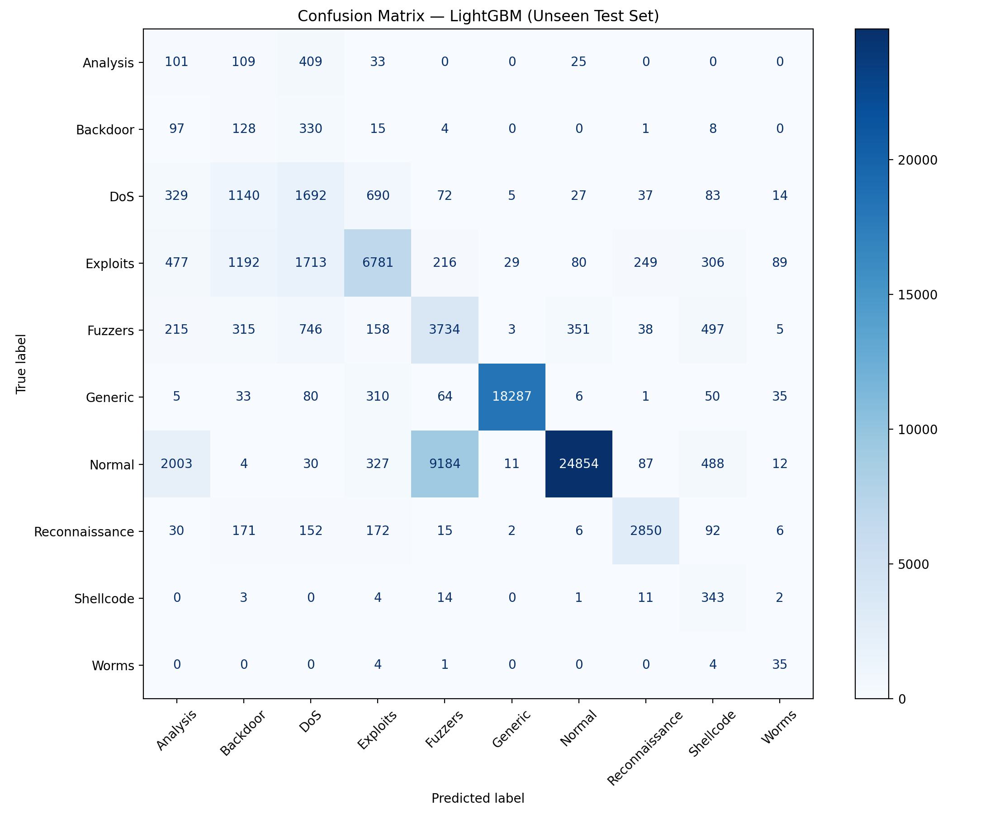
Figure 1. LightGBM confusion matrix on the unseen test set.
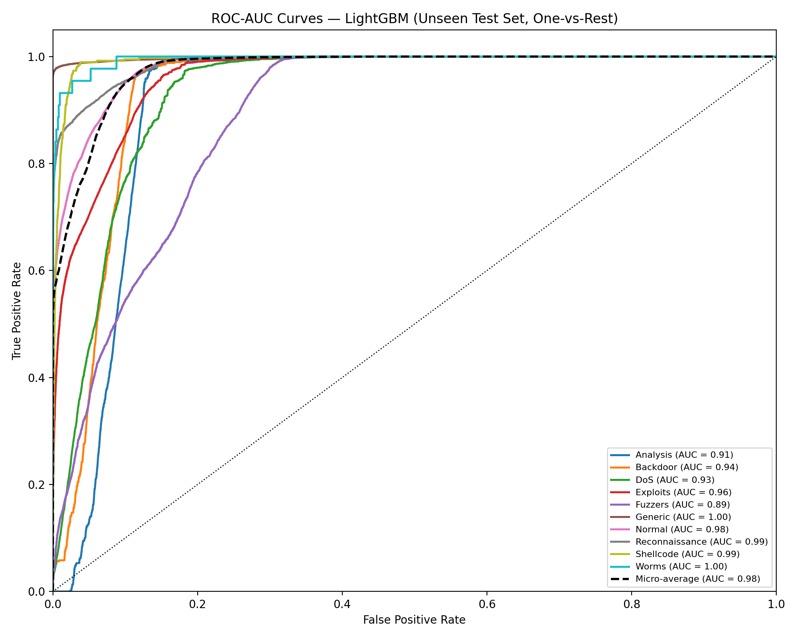
Figure 2. One-vs-rest ROC curves (LightGBM, test set).

3.4 Critical Analysis
- Attack-vs-normal detection is strong. Only 496 of 45,332 malicious flows were predicted as Normal (about 98.9% recall when all attack classes are merged). Most errors are between attack families, which still raise an alert.
- False alarms are high. 12,146 of 37,000 normal flows (32.8%) were flagged, mostly as Fuzzers (9,184) and Analysis (2,003). Analysts would face alert fatigue; threshold tuning or a two-stage design is needed before production use.
- Low recall on Analysis (15%) and Backdoor (22%): these were mostly confused with DoS. Backdoors give persistent attacker access, so mislabelling them could send responders down the wrong playbook and leave the compromise in place, which is a critical flaw.
- DoS (41% recall) and Exploits (61%) overlap in feature space: 1,713 exploit flows were labelled DoS and 1,140 DoS flows as Backdoor, so incidents may be mis-triaged.
- Generic (recall 97%), Reconnaissance (82%), Shellcode (91%) and Worms (80%) are detected well, although Shellcode/Worms precision is low because so few real samples exist.
- The gap between validation accuracy (78%) and test accuracy (71%) shows distribution shift between the official partitions and the effect of synthetic oversampling; the validation score is optimistic.

4. Real-Time Deployment
The trained pipeline (preprocessing + LightGBM) is served by a FastAPI backend with API-key authentication and CORS restrictions, offering single-record and batch CSV endpoints. A dark-mode web dashboard lets a SOC analyst submit a flow or upload a CSV and see predicted classes and distribution charts, demonstrating real-time threat detection.

5. Conclusion and Future Enhancements
The proof of concept shows ML can augment the NIDS: it catches nearly all malicious flows and identifies common attack families accurately, answering the CISO's viability question. Its false-positive rate and weak rare-class recall prevent unsupervised deployment. Future work: cost-sensitive learning and threshold tuning to trade recall against false alarms; a two-stage model (binary detector followed by a family classifier); better feature engineering; cross-dataset validation (CIC-IDS2017); sequence/deep models; SHAP explainability; and continuous retraining on live traffic.

References
- Moustafa, N., Slay, J. (2015). UNSW-NB15: a comprehensive data set for network intrusion detection systems. MilCIS.
- Chawla, N. et al. (2002). SMOTE: Synthetic Minority Over-sampling Technique. JAIR 16.
- Ke, G. et al. (2017). LightGBM: A highly efficient gradient boosting decision tree. NeurIPS.
- Pedregosa, F. et al. (2011). Scikit-learn: Machine learning in Python. JMLR 12.

GitHub Profile Link
https://github.com/ijaz-student021/AI-Powered-Intrusion-Detection

