CLOUD COMPUTING
Assignment No-3 (OWN CLOUD)
ORBIT CLOUD
Your files. Your cloud. Anywhere.
Student Name | Ijaz Ahmad
Reg No. | 83500
Enrolment # | 03-134231-021
Group | 3
Instructor | Dr Nadeem Sarwar
Date | 6 November 2026
Question 1 · Tool selection | Question 2 · Own cloud | Question 3 · Diagram

Summary
This assignment builds a working private cloud named ORBIT CLOUD. Clients store files in it and can ADD, UPDATE, DOWNLOAD and DELETE them from home, from the office or from a phone, through a web browser, a desktop/mobile app or any WebDAV client, over encrypted HTTPS.
Question | Answer in one line
Q1 Tool | Nextcloud 34.0.5 (open-source private-cloud platform) running on Docker Compose, chosen after comparing seven tools.
Q2 Own cloud | ORBIT CLOUD: gateway + application + database + cache + background worker, a provider account and two client accounts (home, office) with storage quotas, version history, trash bin and backups.
Q3 Diagram | An architecture diagram (Figure A) and a request-lifecycle diagram (Figure B) show how a request travels through the cloud.
Evidence | 31 checks passed, 0 failed in the automated test; backup and restore proven by recovering a permanently deleted file.

Question 1 — Tool to create the cloud

1.1 What the tool must do
Question 2 asks for a cloud that the owner can reach from home or the office and use to download, delete, add and update files, offering services that cloud providers give to clients. So the tool must:
- store real files for separate user accounts (a provider and clients), not only simulate load;
- be reachable over a network through a web interface and standard protocols;
- run on one ordinary computer, quick to deploy, with our own name and branding (the “TIGER CLOUD” idea of the question).

1.2 Tools compared
Tool | What it is | Fit for this assignment | Verdict
Nextcloud | Open-source, self-hosted file storage, sync and sharing platform (web, desktop, mobile, WebDAV). | Real uploads/downloads, accounts, quotas, versions, trash, sharing, theming. Runs on one machine. | Selected
ownCloud | Older project from which Nextcloud was forked (2016); same idea. | Would work, but a smaller feature and app ecosystem. | Alternative
Seafile | File sync and share server focused on speed. | Good for files; fewer built-in cloud-style management features. | Alternative
OpenStack | Full IaaS cloud (compute, network, storage, identity) — studied in Assignment 1. | Needs several servers/VMs and a lot of RAM; far more than one laptop can host comfortably. | Too heavy
CloudSim | Java simulator of data centres, VMs and schedulers. | Simulates behaviour only — no real files, no users, no remote access. | Cannot meet Q2
LocalStack | Local emulator of AWS APIs (S3, etc.) for developers. | API-only, no end-user portal; imitates AWS rather than being our own named cloud. | Not suitable
MinIO | S3-compatible object storage server. | Strong storage engine, but a building block, not a ready cloud for end users. | Not suitable

1.3 Decision
Nextcloud 34.0.5 was selected because it is the only option that satisfies every requirement at once: real file operations, accounts and quotas, a web portal plus mobile/desktop apps, custom branding, and light enough to run on one computer. It is also widely used in practice, so the skills transfer.

1.4 Supporting tools
Tool | Why it is used
Docker + Docker Compose | Virtualisation at operating-system level. The whole cloud is described in one file (docker-compose.yml) and can be built, stopped, moved or rebuilt with one command.
PostgreSQL 17 | Database service holding users, file index, shares and quotas (more robust than the default SQLite).
Redis 7 | Cache and file-locking service so two clients cannot corrupt the same file.
Caddy 2 | Gateway: terminates HTTPS with a certificate from a private certificate authority and forwards requests to the application.

Question 2 — Our own cloud: ORBIT CLOUD

2.1 Identity of the cloud
The cloud carries its own name, slogan, colour and logo (theme settings applied automatically at start-up): ORBIT CLOUD — “Your files. Your cloud. Anywhere.”. The name is a single setting (CLOUD_NAME in .env), so it can be changed to the group’s own name at any time.
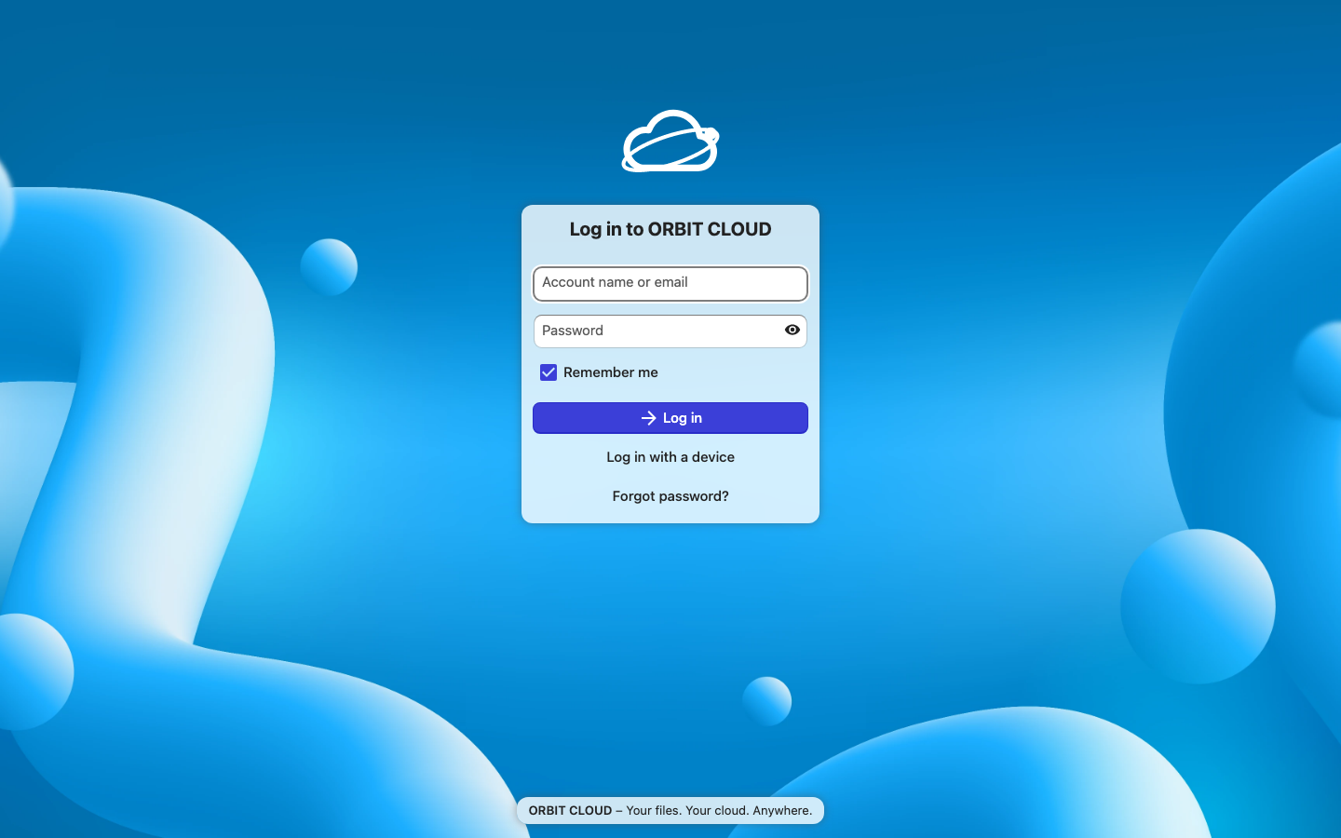
Figure 1 — ORBIT CLOUD login page with its own name, logo and slogan.
The cloud has the two roles the question describes — a provider and clients:
Role | Account | Purpose
Provider (administrator) | orbitadmin | Runs the cloud: creates clients, sets quotas, monitors services.
Client — home | home | Uses the cloud from home. Storage quota: 5 GB.
Client — office | office | Uses the cloud from the office. Storage quota: 10 GB.

Passwords are generated randomly during set-up and kept only in a private .env file (permissions 600); they are not written in this report or in the source code.
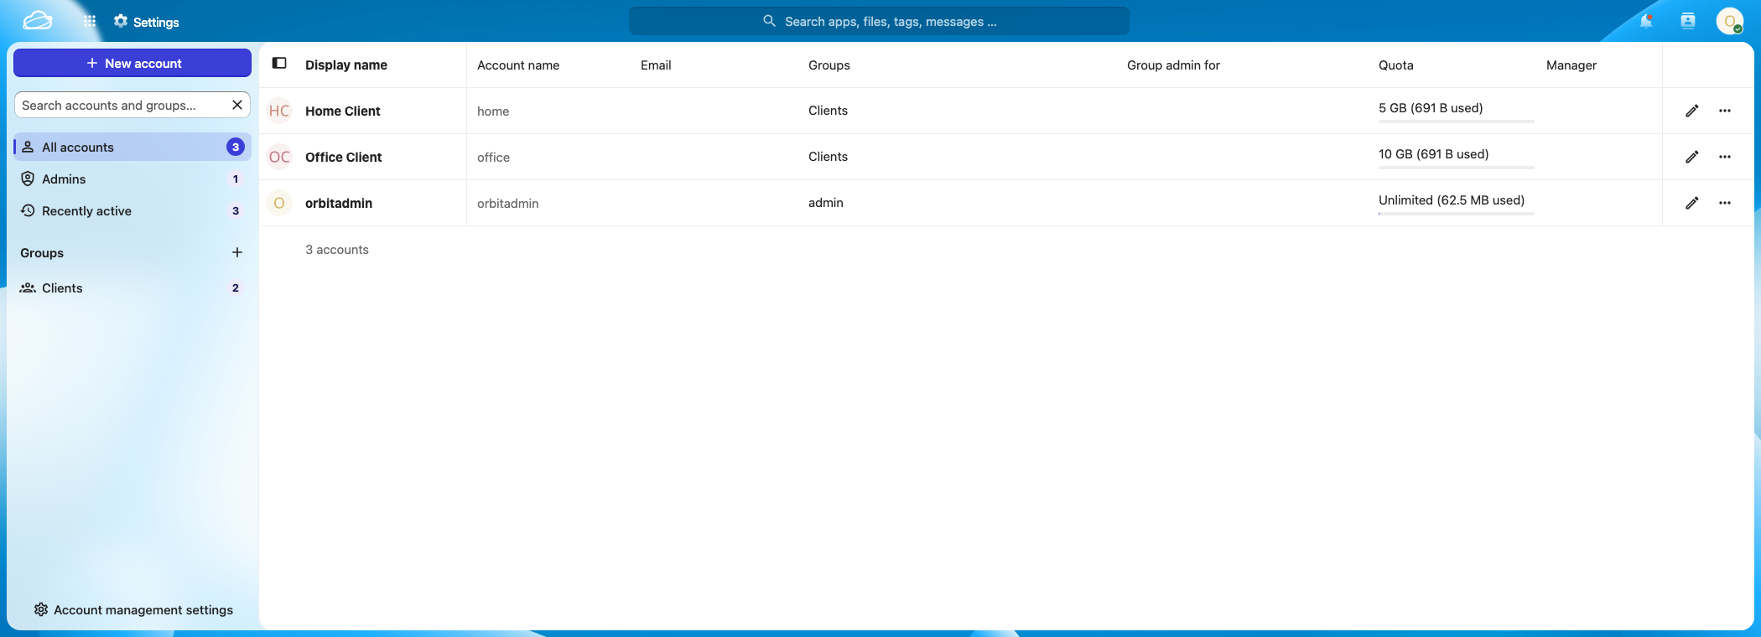
Figure 2 — Provider view: the administrator sees every client account with its storage quota.

2.2 Services provided and how they relate to Assignment 1
Assignment 1 listed the building blocks of a cloud platform (OpenStack components, Docker and Compose, web/proxy servers, databases, SSL/TLS, quotas, backup tools). The cloud below is built from the same kinds of services, scaled to one machine:
Service in the cloud | Technology | Model | Comparable service from Assignment 1
File storage & sharing (the main service) | Nextcloud Files | SaaS | OpenStack Swift (object storage) and Manila (shared file system)
Web portal | Nextcloud web UI | SaaS | OpenStack Horizon (dashboard)
Identity & access (accounts, groups, passwords) | Nextcloud users | — | OpenStack Keystone (user management)
Metering & quotas | Quota + usage report | — | OpenStack Ceilometer (usage measurement); disk quota
Database service | PostgreSQL 17 | DBaaS | OpenStack Trove; PostgreSQL server
Cache / locking service | Redis 7 | — | Redis server
Virtual network | Docker network orbit-net | IaaS | OpenStack Neutron; Docker network basics
Reverse proxy + TLS | Caddy 2 | — | OpenStack Octavia; Nginx reverse proxy; self-signed SSL/TLS
Compute (virtualisation) | Docker containers | IaaS | OpenStack Nova; Docker
Block storage | Docker volumes | IaaS | OpenStack Cinder; external storage for containers
Images | Docker images | IaaS | OpenStack Glance
Orchestration | Docker Compose | — | OpenStack Heat; Docker Compose
Backup & recovery | ./orbit backup / restore | — | Cinder Backup; rsync

The comparison is by function: ORBIT CLOUD is not OpenStack, but a small private cloud that delivers the same kinds of services from one computer.

2.3 How it was built
Everything is automated by one control script (./orbit) so the cloud can be rebuilt on any computer with Docker:
./orbit setup # create .env with random passwords
./orbit up # download, install, brand, create clients and quotas
./orbit credentials # show the logins
./orbit test # prove ADD / UPDATE / DOWNLOAD / DELETE work
What ./orbit up does, step by step:
- Detects the computer’s network address and lists every name the cloud will answer to.
- Starts five containers on a private network: gateway, app, db, cache, cron. Only the gateway publishes a port (8443); the database and cache are unreachable from outside.
- Waits until the database, cache and application report healthy.
- Applies the branding, enables background jobs, and trusts the gateway as a proxy.
- Removes the product-tour pop-up and installs ORBIT CLOUD’s own welcome files for new clients.
- Creates the group “Clients”, the two client accounts and their quotas.
- Exports the HTTPS root certificate so devices can trust the cloud.

2.4 Access from home or office
The cloud listens on HTTPS port 8443 of the server computer. Any device that can reach the server opens:
From | Address
The server itself | https://localhost:8443
Home or office (same Wi-Fi / LAN) | https://192.168.100.181:8443
Anywhere on the Internet | Through a private VPN or tunnel (e.g. Tailscale): add the VPN name to ORBIT_EXTRA_HOSTS, run ./orbit up, open https://<vpn-name>:8443.
Android phone (e.g. Google Pixel) | Same Wi-Fi: open the address in Chrome, accept the one-time certificate notice, log in. Optionally install the Nextcloud app from Google Play and enter the same address.

The browser shows a certificate notice the first time, because the certificate comes from the cloud’s own certificate authority. ./orbit trust-ca exports that certificate, and ./orbit share-ca lets a phone download it over Wi-Fi, so each device can trust it once.
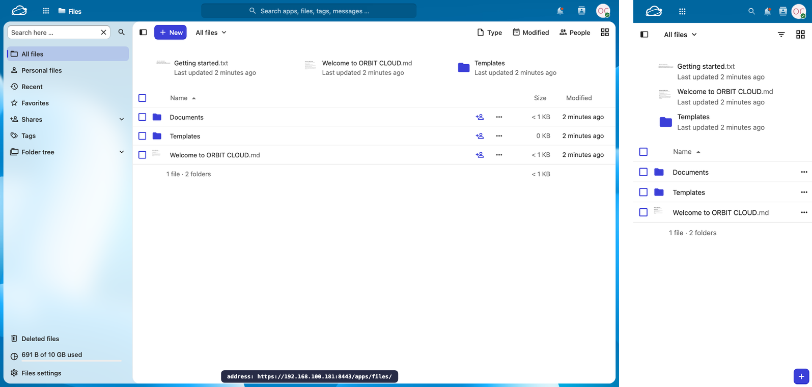
Figure 3 — Left: client “office” signed in through the network address (192.168.100.181), the way an office device reaches the cloud. Right: the same cloud in a phone-sized window (mobile layout, emulated in the browser).
Scope of testing: access was verified through localhost and through the computer’s LAN address on this machine. A second physical device on the same network uses the identical LAN address; Internet access additionally needs the VPN/tunnel step above, which was documented but not exercised here.

2.5 File operations: ADD, UPDATE, DOWNLOAD, DELETE
The four operations the question asks for were performed in two independent ways: through the web interface (screenshots below: ADD and DELETE were done by clicking in the browser) and through an automated test that talks to the cloud exactly as the desktop and mobile apps do (WebDAV over HTTPS, certificate verified).

A. ADD — upload a file
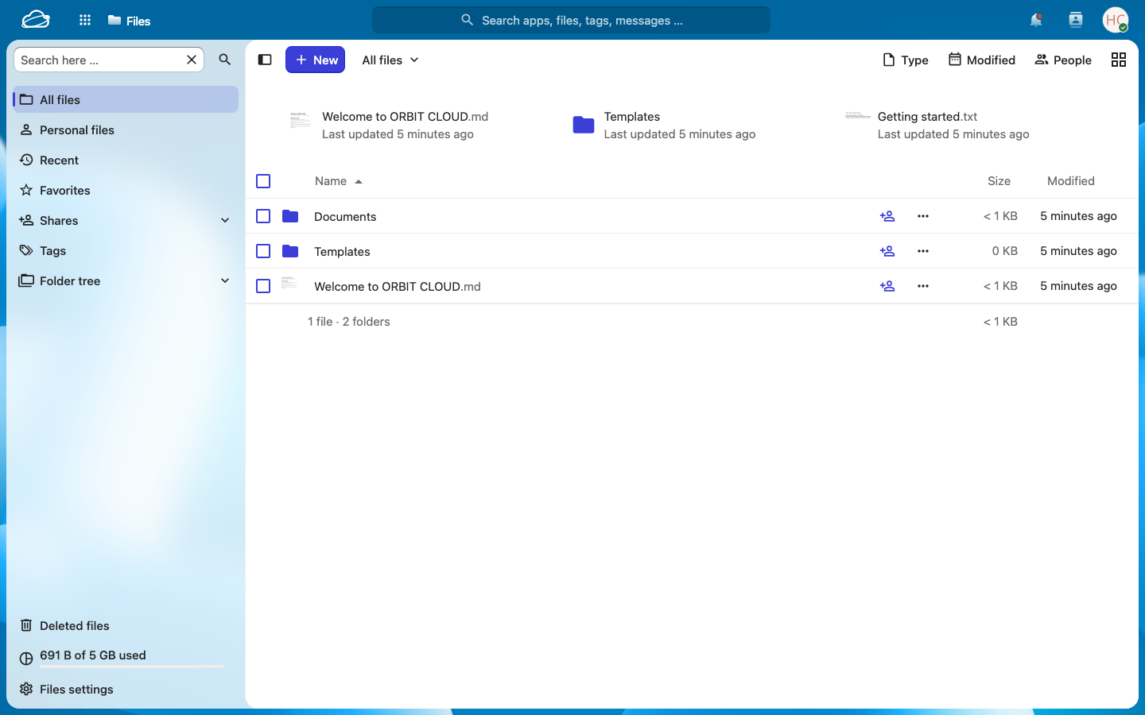
Figure 4 — Client “home” signed in: the personal file area.
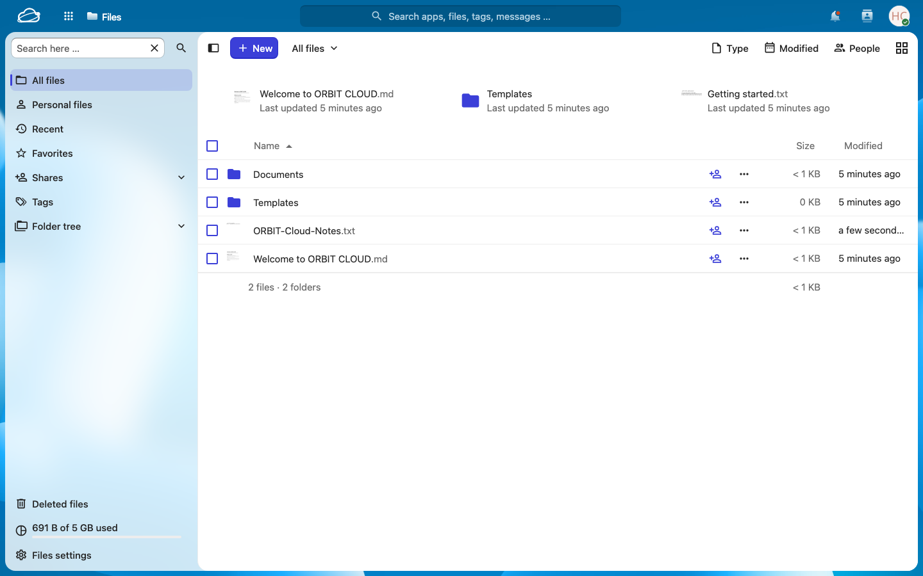
Figure 5 — ADD: a new file uploaded through the web interface appears in the list immediately.

B. UPDATE — change a file (old version is kept)
Uploading new content under the same name replaces the file, and the cloud keeps the earlier copy in the version history so a mistake can be undone. Here the update was sent with the same WebDAV request the desktop and mobile apps use, and the web interface then shows the history.
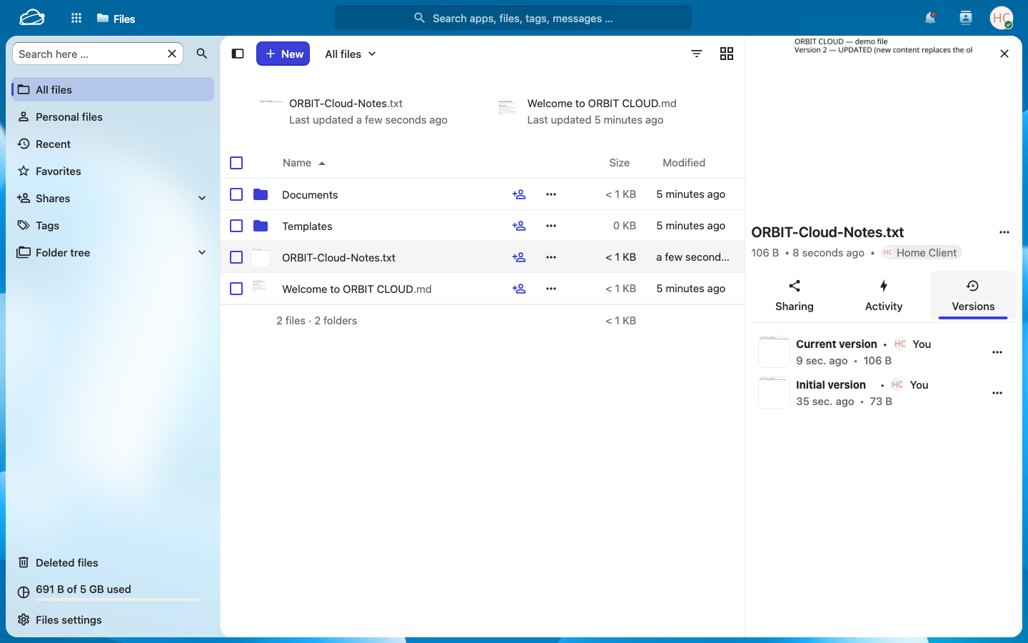
Figure 6 — UPDATE: version history after the second upload — “Current version” (106 B, the new content) and “Initial version” (73 B, the original, still stored).

C. DOWNLOAD — fetch a file
The automated test downloads each file and compares its SHA-256 checksum with the original; they were byte-identical (see Appendix B).

D. DELETE — remove a file (recoverable)
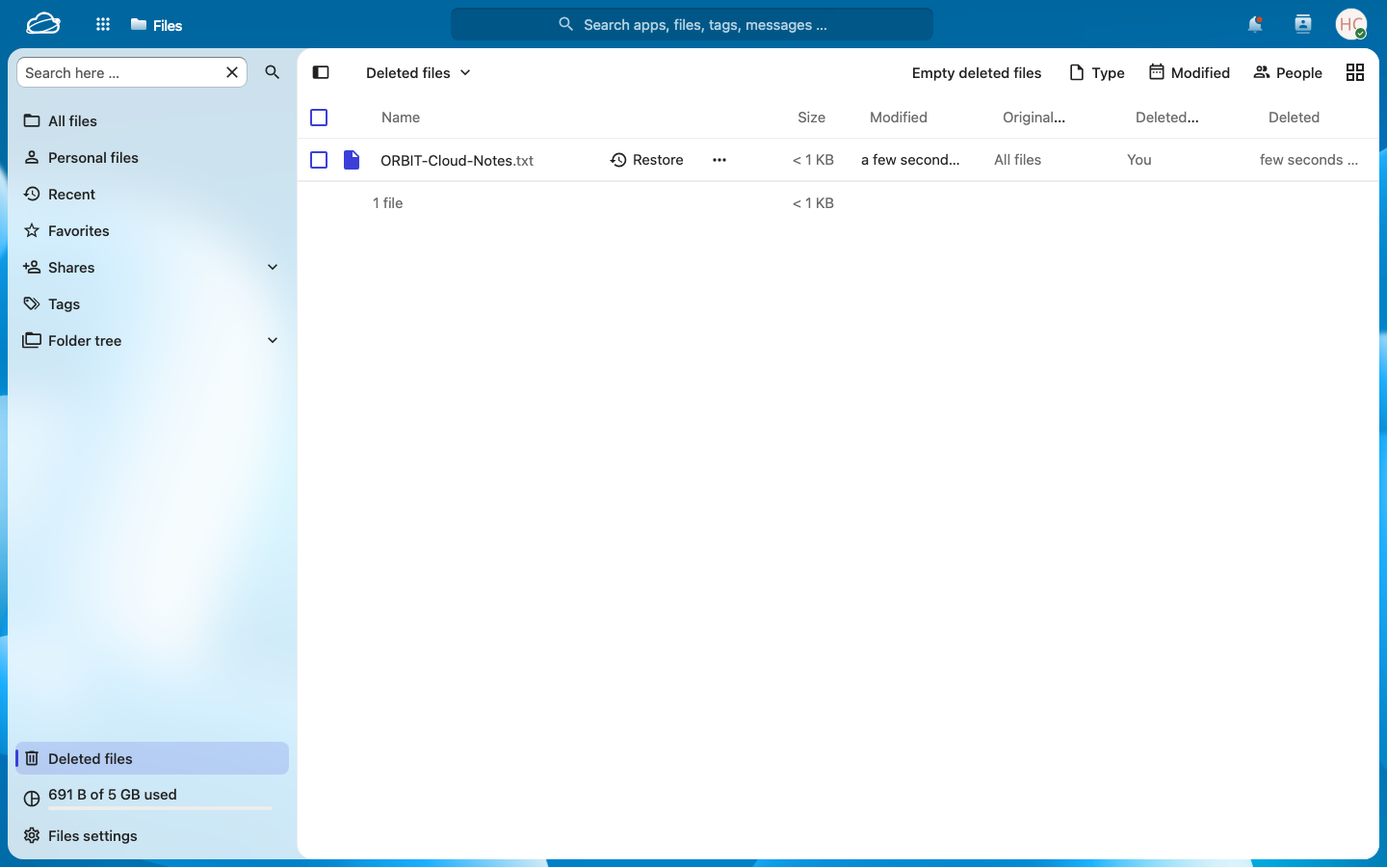
Figure 7 — DELETE: a removed file moves to “Deleted files” and can be restored until the trash expires.

2.6 Automated verification
The test ./orbit test acts as two clients: “home” connects through localhost, and “office” connects through the LAN address like a second device. Result: 31 checks passed, 0 failed
Test | What was proved
1 | Security: requests without credentials or with a wrong password are rejected (HTTP 401); valid credentials are accepted.
2 | ADD: a folder and a file are created and listed.
3 | DOWNLOAD: the file comes back byte-identical (SHA-256 match).
3b | Isolation: the Office client cannot read, write, delete or list the Home client’s files (HTTP 404 / 404 / 404 / not listed); Home’s file is untouched afterwards.
4 | UPDATE: the new content is served, and the earlier version is stored and downloads byte-identical to the original upload.
5 | Large file: a 25 MB upload and download are byte-identical.
6 | SHARE: Home shares a file read-only with Office; Office downloads it from the LAN address, cannot modify it (HTTP 403), and loses access when the share is removed.
7 | DELETE: the file disappears (HTTP 404), appears in the trash bin, and is restored with the latest content.
8 | METERING: each client has a storage quota; used and available space are reported.
9 | Clean-up: test data and trash are removed.

2.7 Security and reliability features
Feature | How it is provided
Encryption in transit | All traffic uses HTTPS; the test connects with TLS 1.3 and verifies the certificate chain.
Authentication | Every request needs a valid login; wrong or missing credentials get HTTP 401.
Isolation between clients | Each client sees only their own files; sharing is explicit and permission-controlled. Tested: another client’s attempts to read, write, delete or list files all fail.
Reduced attack surface | Only port 8443 is published; the database and cache live on the private orbit-net network.
Secrets handling | Random passwords generated per installation, stored in .env with mode 600, never in code.
Mistake recovery | Version history for updated files and a trash bin for deleted files.
Consistency | Redis file locking and database transactions prevent two clients from corrupting one file.
Backup & restore | ./orbit backup pauses writes, dumps the database, archives configuration and user files and writes SHA-256 checksums to backups/<date-time>/; ./orbit restore verifies the checksums first. Tested: a file was permanently deleted (trash emptied), the backup was restored, and the file returned byte-identical.
Metering | Per-client quotas (5 GB / 10 GB) and usage reports (./orbit status).

2.8 Limitations and possible improvements
- Single server: if the host computer is off, the cloud is unavailable (a cluster with replicated storage would remove this single point of failure).
- Private certificate: devices must trust the cloud’s certificate authority once; a public domain with a public certificate would remove the notice.
- Internet access needs a VPN or tunnel (opening router ports to the Internet is deliberately avoided). Production hardening would add two-factor authentication, HSTS, off-site backups and regular image updates.

Question 3 — Diagram of the cloud and how it works

3.1 Architecture diagram
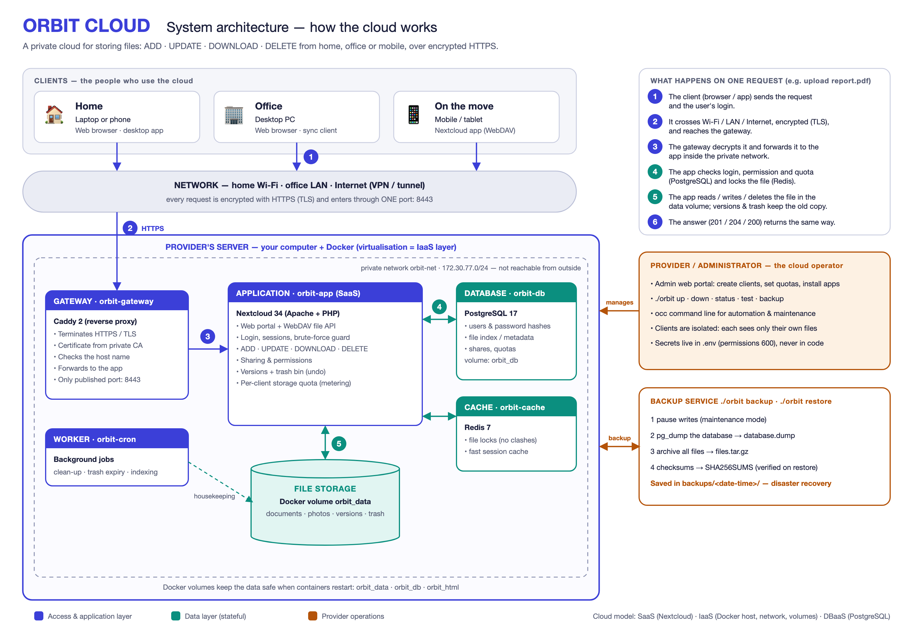
Figure A — Architecture of ORBIT CLOUD and the path of one request (numbers 1–6).

3.2 Request lifecycle diagram
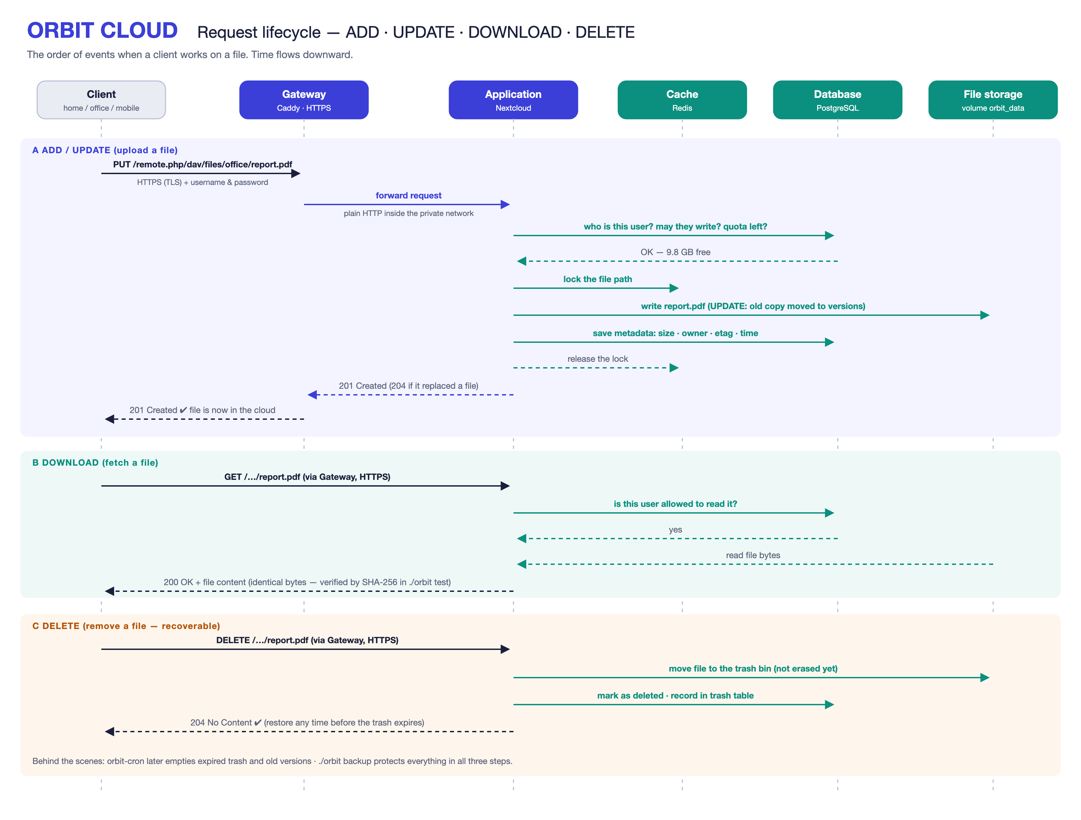
Figure B — Order of events for ADD / UPDATE, DOWNLOAD and DELETE.

3.3 Reading the architecture diagram
Step | What happens
1 | A client (home laptop, office PC or phone) sends a request, for example “upload report.pdf”, together with the user’s login.
2 | The request crosses the network (home Wi-Fi, office LAN or a VPN) encrypted with HTTPS, and enters the provider’s server through the single published port 8443.
3 | The gateway (Caddy) decrypts it, checks the requested host name and forwards it to the application over the private network orbit-net.
4 | The application (Nextcloud) checks the login, the permissions and the quota in PostgreSQL, and locks the file in Redis.
5 | The application adds, updates, reads or deletes the file in the data volume; old versions and deleted files are kept for recovery, and the metadata is saved in PostgreSQL.
6 | The result (HTTP 201 / 204 / 200) returns along the same path to the client.

Besides the request path, the cron worker does housekeeping (expired trash, old versions, indexing), the administrator manages the cloud through the web portal and the ./orbit script, and the backup service protects the database and files.

3.4 Cloud characteristics demonstrated
Characteristic (NIST) | Where it is visible in this cloud
On-demand self-service | Clients log in and manage files themselves; the provider creates a new client with a single command.
Broad network access | Browser, desktop app, mobile app and WebDAV, from any network that can reach the server.
Resource pooling | One server, database and storage pool shared by several isolated clients (multi-tenancy).
Rapid elasticity | A client’s capacity changes instantly with one command (occ user:setting <user> files quota "20 GB").
Measured service | Per-client quota and usage reporting (./orbit status), like metering in a public cloud.

Deployment model: private cloud (hosted on our own hardware for our own users). Service models used: SaaS (file-storage application) running on an IaaS-style container platform, with a database service (DBaaS) behind it.

3.5 Design trade-offs
Decision | Benefit | Cost
Private, self-hosted cloud | Full control and privacy; no subscription. | We maintain updates, backups and uptime.
Containers instead of virtual machines | Light, quick to start, one-file description. | Weaker isolation than full VMs.
Single host | Simple to build and explain. | Single point of failure (mitigated by backups).
HTTPS-only gateway with a private CA | Encrypted, one controlled entry point. | Certificate must be trusted once per device.
Nextcloud instead of custom code | Mature features: sharing, versions, apps. | Less freedom to change internals.

Appendix A — Project contents
Assignment3_ICC/
Assignment3_ICC_Report.docx / .pdf this report
Q3_Diagrams/ architecture + request-flow diagrams (PNG, SVG)
Screenshots/ screenshots used in the report
Video/ step-by-step video: opening the cloud on an Android phone
VIVA_NOTES.md preparation notes for the viva
docs/ diagram sources, screenshots and test output
README.md how to run the cloud
orbit control script (setup, up, down, status, backup, restore, test)
docker-compose.yml the five services, private network and volumes
caddy/Caddyfile gateway configuration (HTTPS + reverse proxy)
branding/ logo and welcome files for new clients
tests/file-ops.sh end-to-end ADD/UPDATE/DOWNLOAD/DELETE test
tools/ diagram and report generators

Appendix B — Output of `./orbit test`
Captured on 6 November 2026. A green tick marks each check that passed.
ORBIT CLOUD — end-to-end test 2026-11-06 15:12:59
home client → https://localhost:8443 (user: home)
office client → https://192.168.100.181:8443 (user: office)
transport → SSL connection using TLSv1.3 / AEAD-CHACHA20-POLY1305-SHA256 / [blank] / UNDEF

1. Security — only authenticated clients get in
✔ No credentials is rejected [HTTP 401]
✔ Wrong password is rejected [HTTP 401]
✔ Home client logs in with valid credentials [HTTP 207]

2. ADD — upload a folder and a file from Home
✔ Create folder 'orbit-e2e' [HTTP 201]
✔ Upload hello.txt [HTTP 201]
✔ File appears in the folder listing

3. DOWNLOAD — fetch it back and verify integrity
✔ Download hello.txt [HTTP 200]
✔ Downloaded copy is byte-identical to the original [sha256 b92222a72be8…]

3b. Isolation — one client cannot touch another client's files
✔ Office cannot READ Home's file [HTTP 404]
✔ Office cannot WRITE into Home's folder [HTTP 404]
✔ Office cannot DELETE Home's file [HTTP 404]
✔ Office cannot LIST Home's files
✔ Home's file is untouched after the intrusion attempts [HTTP 200]

4. UPDATE — overwrite the file, old version is kept
✔ Upload new content over hello.txt [HTTP 204]
✔ Download returns the NEW content [sha256 d4320b3b60a1…]
✔ Earlier version is kept: 1 stored version(s), and version 1 downloads byte-identical to the original upload

5. Large file — 25 MB round trip
✔ Upload 25 MB file [HTTP 201]
✔ 25 MB download is byte-identical [sha256 09f29568d9f6…]

6. SHARE — Home shares a file read-only with Office (Office connects from another device)
✔ Create share Home → Office (read-only) [HTTP 200]
✔ Office client downloads the shared file via https://192.168.100.181:8443 [HTTP 200]
✔ Office copy matches Home's latest version [sha256 d4320b3b60a1…]
✔ Office cannot modify a read-only share [HTTP 403]
✔ After un-sharing, Office loses access [HTTP 404]

7. DELETE — remove a file, then recover it from the trash bin
✔ Delete hello.txt [HTTP 204]
✔ File is gone from the cloud [HTTP 404]
✔ Deleted file is held in the trash bin (trash/hello.txt.d1793959992)
✔ Restore hello.txt from trash [HTTP 201]
✔ Restored file has the latest content [sha256 d4320b3b60a1…]

8. Metering — each client has a storage quota
✔ Home quota: 62 MB used, 5057 MB still available (limit 5 GB)

9. Cleanup
✔ Remove test folder [HTTP 204]
✔ Empty trash [HTTP 204]

Result: 31 passed, 0 failed

