We are using these services in Azure to send data from raspberry pi to cosmos DB.  
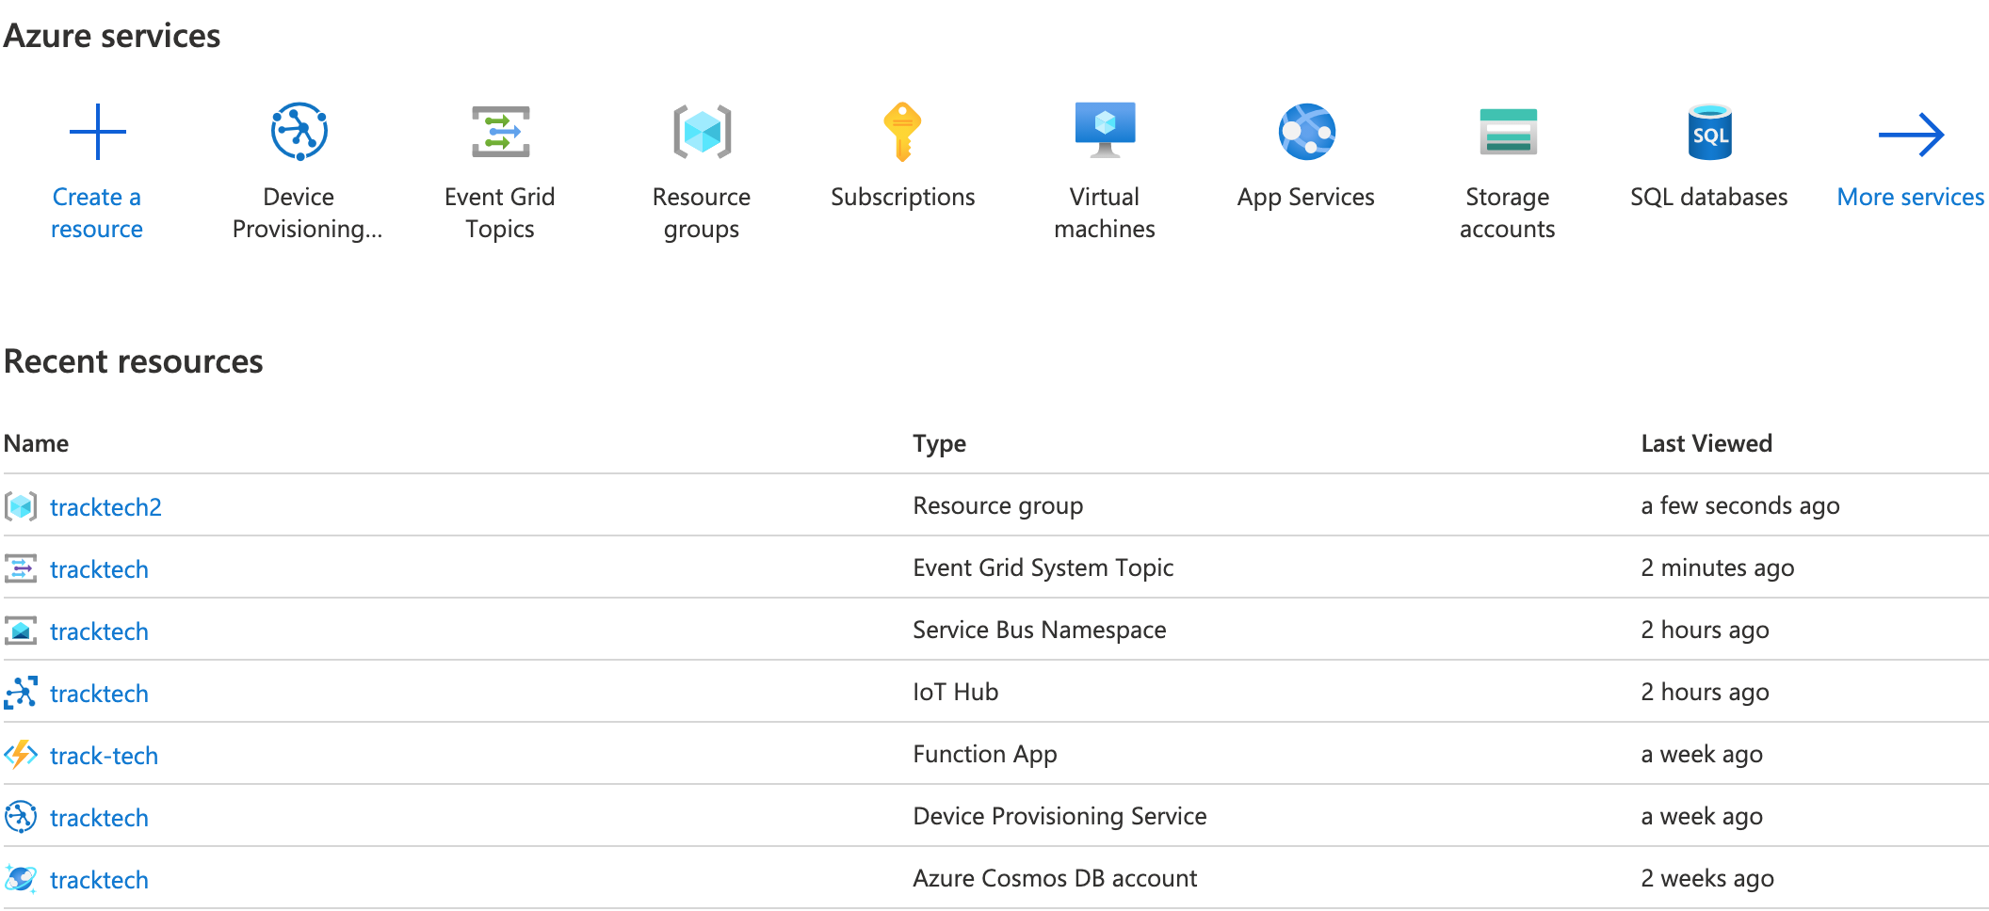

* Iot Hub DPS (named tracktech)

Iot Hub connected

* IotHub (named tracktech)

Event Grid System Connected

* Event Grid System (named Tracktech)

Service Bus Name connected (Queue named track-tech)

* Service Bus Name (tracktech)

Azure Function Connected

* Azure Function (tracktecg)

Azure CosmosDB connected

This is track how our data will move:  
Raspbarry pi Iot Hub DPS Iot Hub

Iot Hub Service Bus (Queue) Azure Function CosmosDB