**Data Factory to Function to Data Lake**

This is the documentation of whole requirements of our work, and these Azure resources we use:

1. Azure Resource Group (AZResourceGroup)
2. Azure Function App (vin-data => Python 3.8)
3. Azure Data Factory (ADFactoryServ => Version2)
4. Azure Blob Storage (azresourcegroupdiag506 => Data Lake Gen2)
5. Azure Application Insight (vin-data => For Logging)

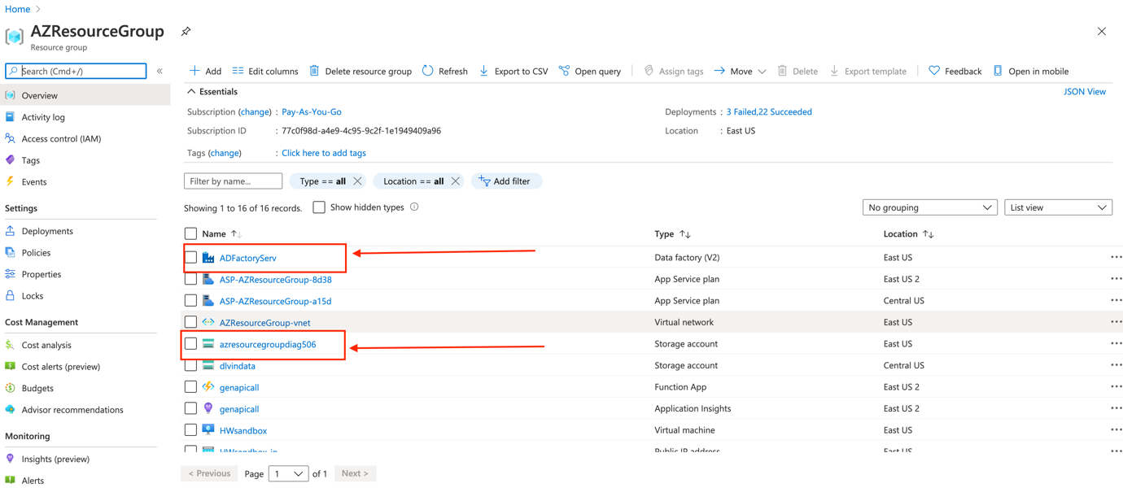

And other is

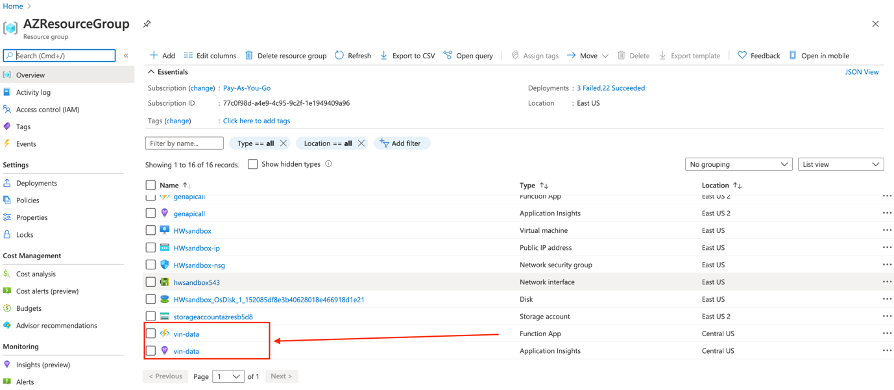

This is the work flow:

* **Azure Data Factory** will hit the **Azure Function** and Params are using by **global parameters** in Azure Data Factory

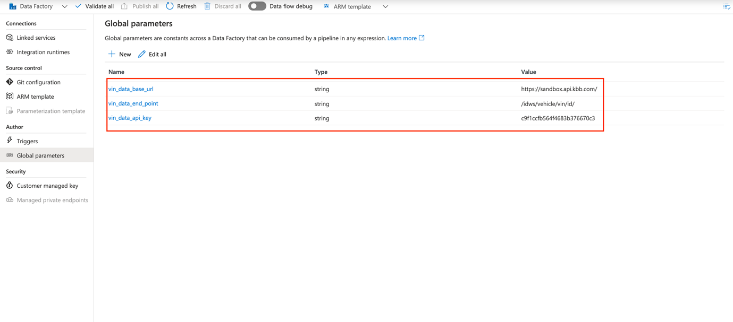

* Azure Data Factory will hit Azure Function by activity of Azure Function with body parameters

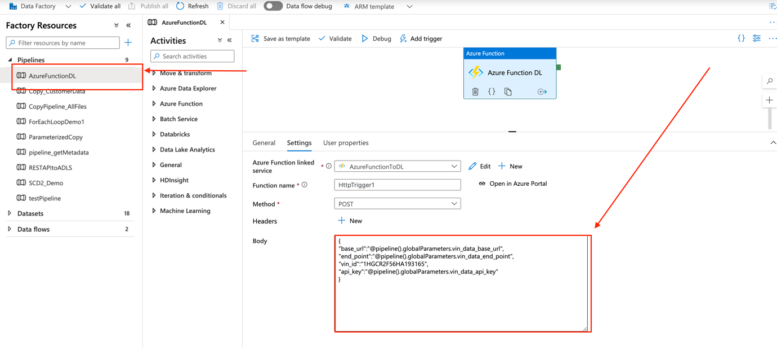

* Azure Function will hit the desired API and put the json response to Data Lake

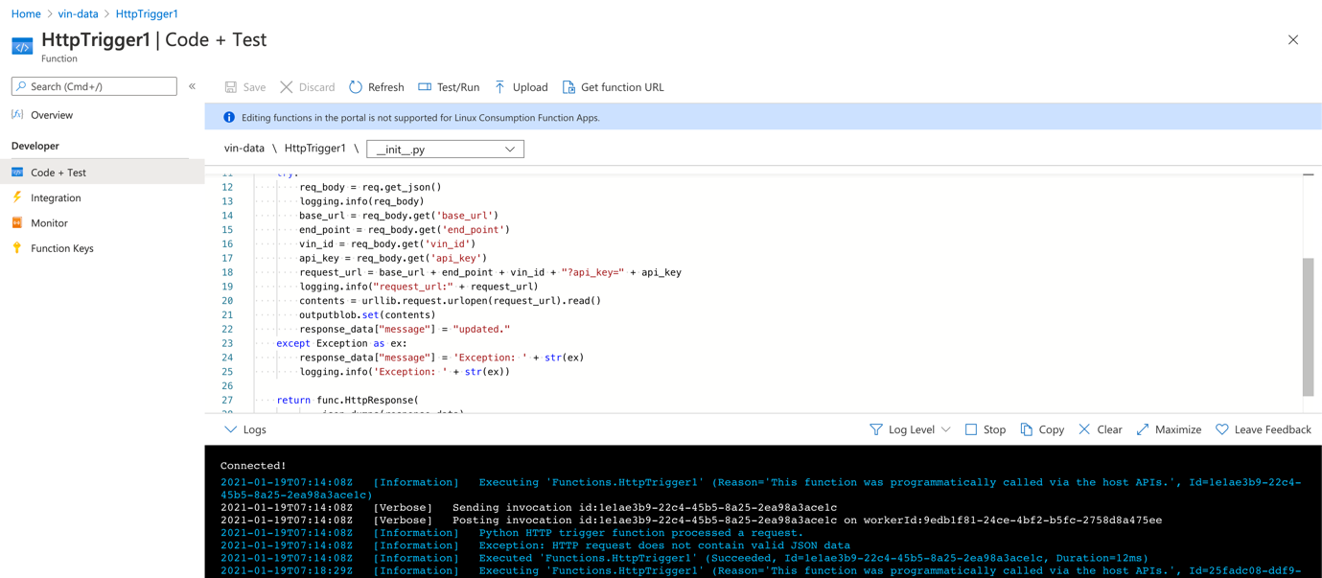

This is bindings with Azure Data Lake:

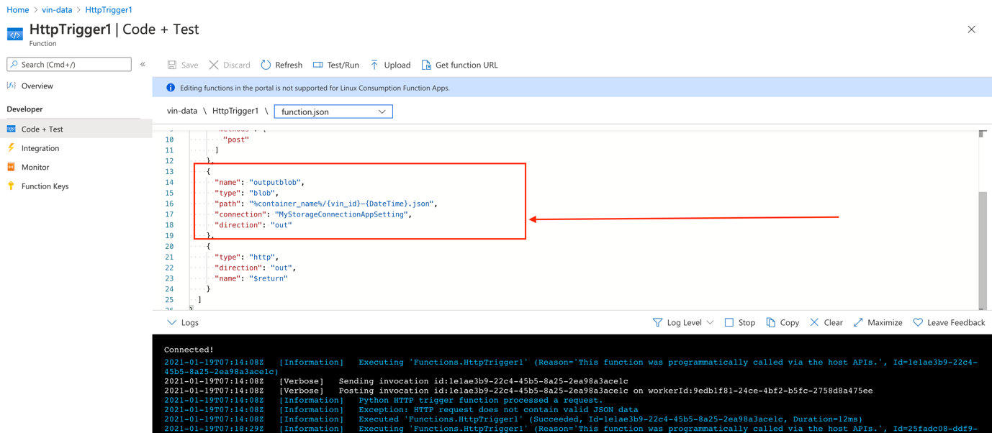

Data is present in Json format on Data Lake:

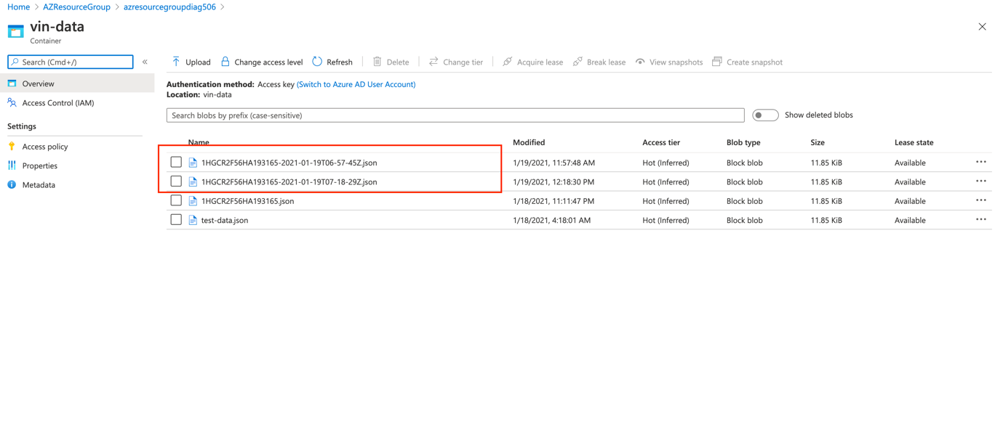

**Limitations:**

We can put Container path on Application Configuration level rather than on body paramters.