VENUS AESTHETICS | IT'S ABOUT YOU

FINAL CREATIVE AND ACTIVATION PLAN
VENUS K-GLOW
A modern Korean beauty experience, unmistakably Venus.
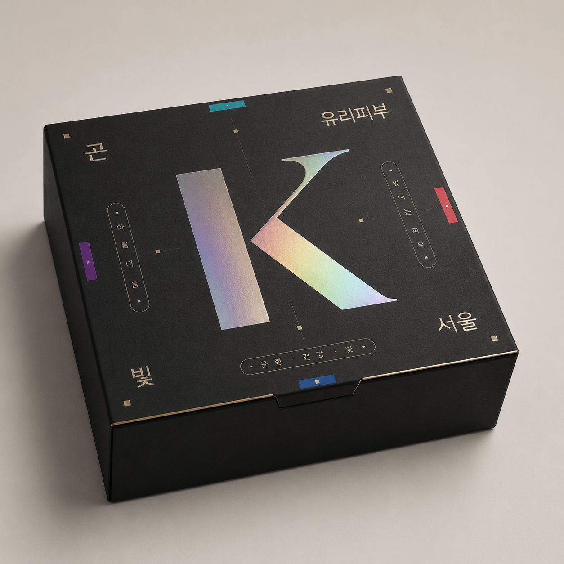
Final team approval edition | Packaging, clinic activation, event and social system
NON-NEGOTIABLE The PR box contains zero treatment cards. The first opening reveals one oversized message card; underneath are only the T-shirt, chrome K prop and sticker sheet.

01 | APPROVAL SNAPSHOT

What the team is approving
FINAL DIRECTION Venus black, cream, taupe and champagne remain the brand foundation. Korean energy comes from restrained coral, teal, violet, cobalt and holographic chrome, bilingual typography, portrait-led props and food—not from rebuilding the clinic.

Approved scope
- PR box. Two-stage reveal: one oversized message card, then exactly three contents.
- Clinic. Existing reception and rooms remain unchanged; all additions are removable or freestanding.
- Props. Seven suspended portrait signs and seven matching handheld portrait props, each bilingual.
- Event. One portable Korean snack bar in the lounge plus the portable photo set.
- Campaign. Three Korean-model social key visuals using the Venus feed language.

Removed from final scope
- All treatment/photocards inside the PR box and every narrow card slot.
- Prize wheel, gift bags and glow-match desk.
- Clinical icon-only treatment signs and the old framed-card wall.
- Wave patterns, flowing-line motifs, swirls, marbling and every launch-date reference.
- Permanent clinic redesign, new built-ins, repainting or structural lighting changes.

Production truth
Generated portraits are visual direction and layout references. Final print assets must use a licensed real Korean-model shoot or properly licensed photography, native-speaker Korean proofing, and the supplied official Venus master logo file.

02 | VISUAL SYSTEM

Venus foundation. Korean-modern accent.
The system is deliberately simple enough for local vendors to reproduce across paper, vinyl, acrylic, apparel and digital media.
ROLE | COLOR | APPLICATION
Venus black | #191919 | Primary backgrounds, box wrap, apparel and signs
Cream / white | #F5F2EC / #FFFFFF | Negative space, model wardrobe, label fields
Light grey | #E1DFE0 | Studio and clinic-neutral backgrounds
Champagne gold | #D5BF94 to #F9E2B8 | Logo application, rules, foil and premium finish
Taupe | #9A9895 to #B6AF9E | Secondary neutral and support text
Korean accents | Coral / teal / violet / cobalt | Small edge bands, tabs, props and digital UI accents
GRAPHIC LANGUAGE Use clipped corners, straight grids, rounded labels, small color tabs, clean portrait crops and holographic chrome. Do not use waves or flowing-line patterns.
- Typography. Use the official Haboro Contrast / Zona Pro system for production; pair with a licensed Korean sans serif after native-speaker proofing.
- Logo. Use only the supplied official master files. AI-rendered marks in concepts are placement references, not production artwork.
- Photography. Natural skin texture, restrained retouching, adult Korean models, modern wardrobe and no celebrity likenesses.

03 | PR BOX

Exterior: Korean intrigue, modern Venus finish
Final closed-box concept. Korean typography and holographic K create intrigue; production remains soft-touch, foiled and locally achievable.
- Build. 250 x 250 x 80mm internal; 1200gsm greyboard; magnetic flap; matte lamination and soft-touch coating.
- Exterior. Large holographic K, chrome Korean type and small straight accent tabs; no launch date.
- Production. Keep geometric spacing and crisp foil registration; no wave or flowing-line pattern.
LOGO RULE Follow the approved exterior layout; use the official logo only where the final artwork calls for it.

04 | PR BOX

First reveal: one oversized message card
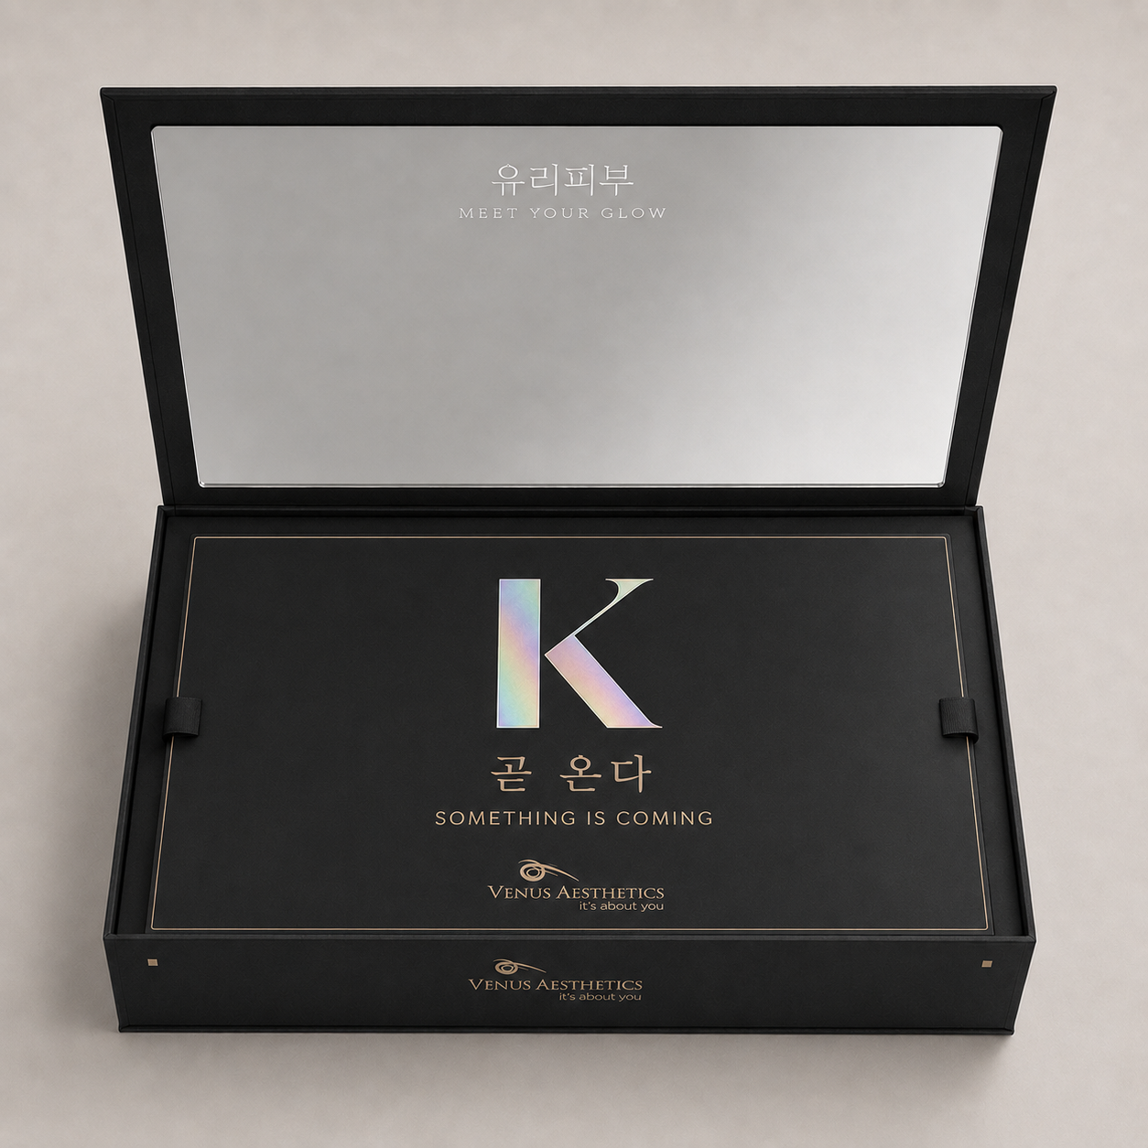
The mirror opens to one full-tray card. There are zero treatment cards and no other contents visible at this stage.
- Mirror. 2mm acrylic, 220 x 200mm, polished edges; message confined to the top third so the face remains visible.
- Reveal card. Approx. 232 x 232mm, 600gsm black board, foil border, finger-pull tabs and the message 'SOMETHING IS COMING'.
- Experience. The card must cover the full lower tray and create a deliberate pause before merchandise is revealed.
ABSOLUTE RULE ZERO treatment cards, ZERO narrow cards and ZERO treatment-card slots inside the PR box.

05 | PR BOX

Second layer: exactly three contents
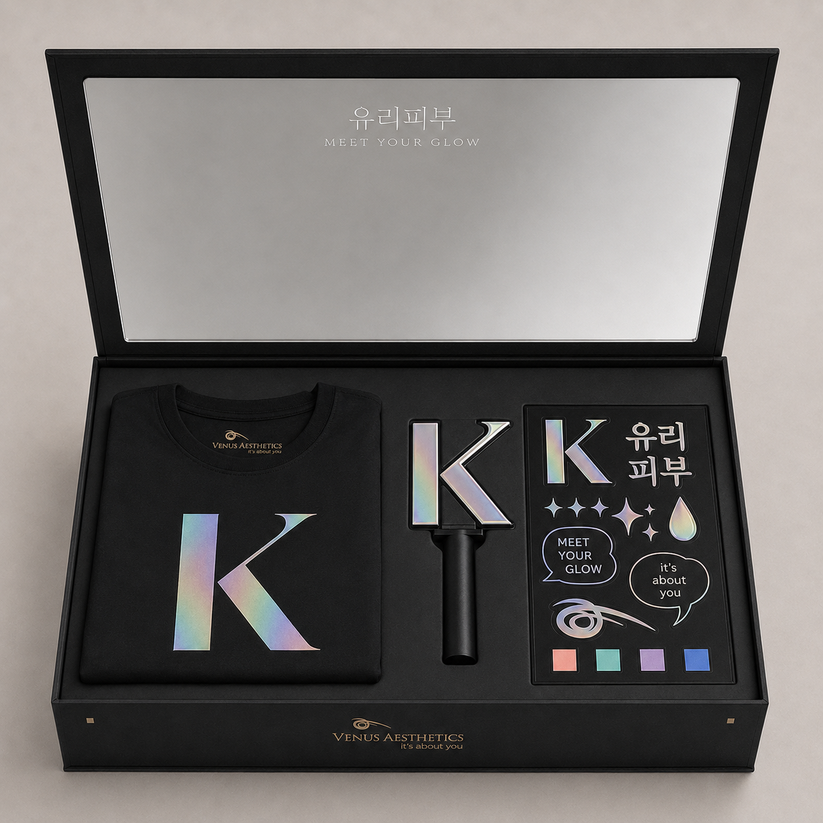
After lifting the oversized card, the recipient sees only the T-shirt, chrome K prop and sticker sheet.
- T-shirt. Black oversized 220-240gsm cotton; large chrome K; small official Venus logo at the back neck.
- Chrome K. 120mm laser-cut mirror acrylic on a short matte-black handle.
- Sticker sheet. A5 holographic vinyl with K, Korean words, sparkles, droplet, speech bubbles and Venus mark.
INVENTORY Exactly three contents. Do not add photocards, treatment cards, samples, vials or gift items.

06 | CLINIC PROPS

Seven suspended portrait treatment signs
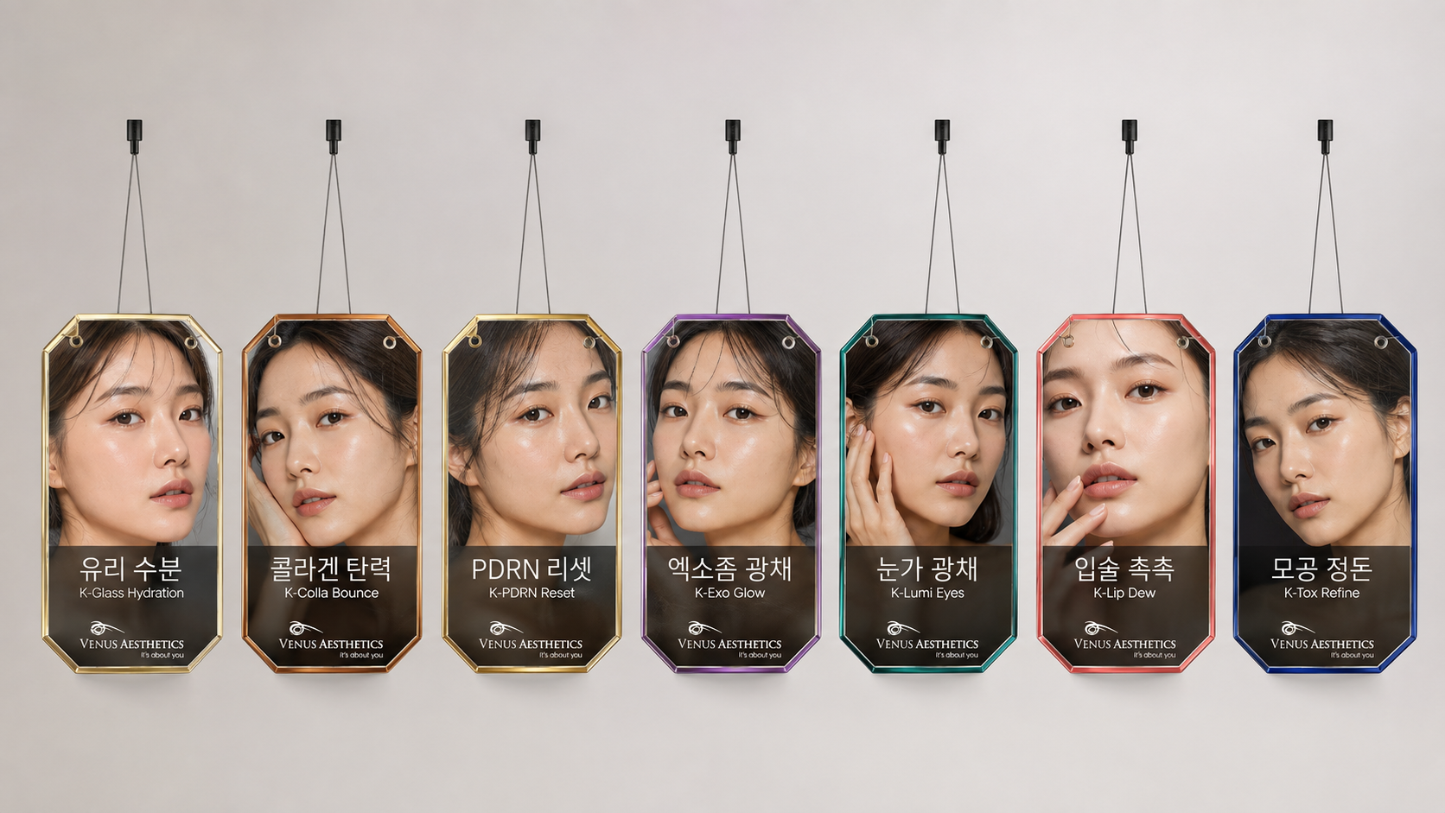
Final portrait-led sign family: fine cord suspension, clipped acrylic edges, Korean first and English second.
- Construction. Approx. 300 x 430mm layered clear acrylic, two drilled holes, fine braided cord or clear monofilament and removable clips.
- System. Seven treatments use champagne, bronze, pale gold, violet, teal, coral and cobalt edge codes.
- Photography. Replace concept portraits with licensed real Korean-model imagery before print.
BILINGUAL RULE Every sign carries the Korean name prominently and the exact English treatment name directly beneath it.

07 | CREATOR PROPS

Seven matching handheld portrait props
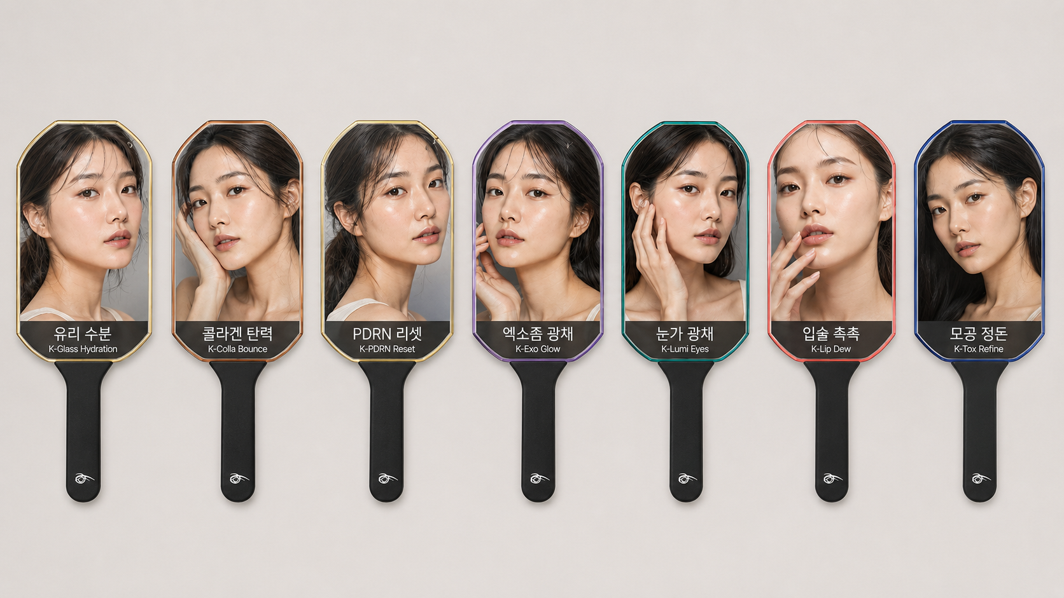
Selfie-friendly portrait paddles match the suspended sign system without looking like clinical information cards.
- Construction. Approx. 180 x 260mm portrait cutout in 5mm acrylic on a 200mm matte-black handle.
- Use. One complete set at creator shoots; additional sets rotate through clinic events.
- Copy. Korean and English treatment names remain readable in guest photography.
FINISH STANDARD Use licensed photography and restrained skin retouching so the final props feel editorial, not AI-generated.

08 | CLINIC APPLICATION

Existing clinic, removable Korean styling
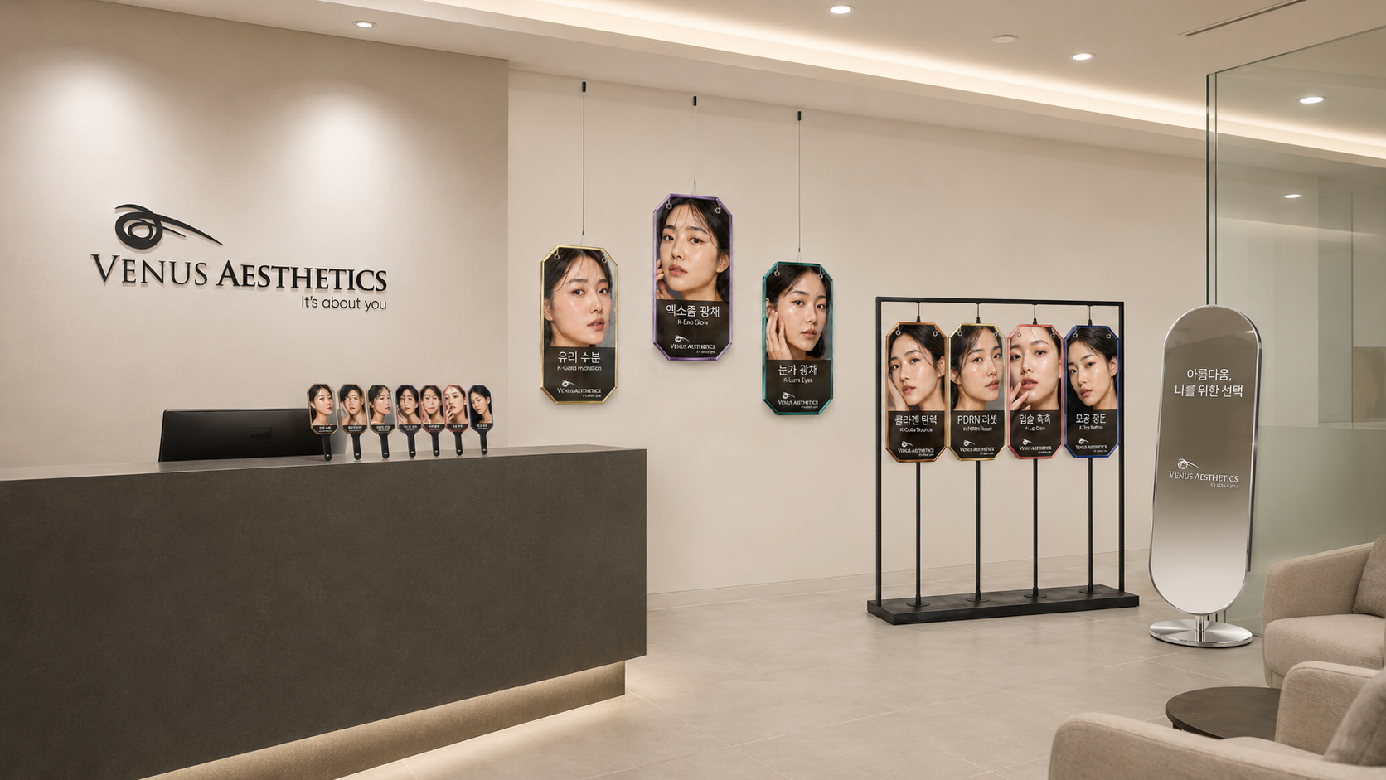
Final application: the existing reception remains intact while portrait signs, a portable rack, paddles and a mirror create the Korean layer.
- No renovation. Keep walls, desk, floor, ceiling, furniture and permanent Venus branding unchanged.
- Installation. Three lightweight signs may hang from approved removable clips; four use a freestanding weighted rack.
- Counter. Seven matching paddles sit in one compact holder; keep desk operation clear.
SAFETY Where ceiling suspension is not permitted, place all seven signs on freestanding weighted racks.

09 | EVENT HOSPITALITY

Korean snack bar: modern, practical, lounge-only
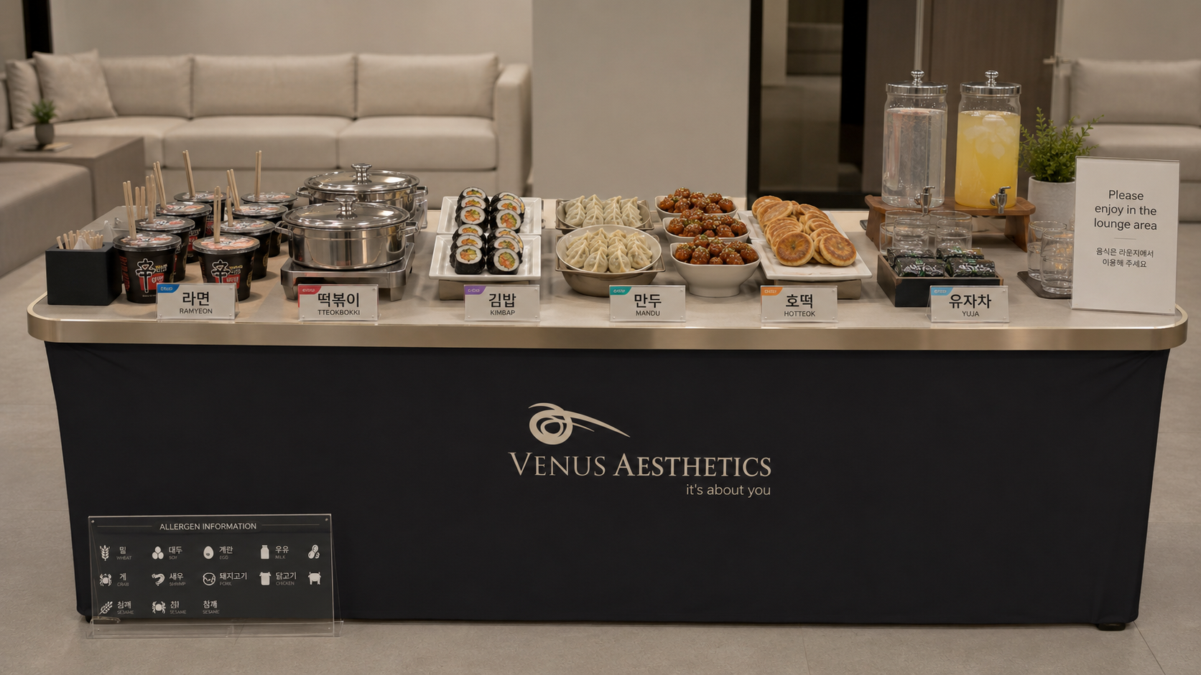
Portable Korean catering station with bilingual labels, reusable serving ware, allergen information and lounge-only service.
- Food. Ramyeon, tteokbokki, mini kimbap, mandu, Korean chicken bites, hotteok and seaweed snacks.
- Drinks. Yuzu, Korean pear and water in reusable glass dispensers.
- Controls. Use a halal-capable caterer, vegetarian options, covered hot holding, allergen cards and no food in treatment rooms.
REMOVED No prize wheel, gift bags or glow-match desk. Hospitality is the event interaction.

10 | TRAVELLING SET

Portable Korean-modern photo set
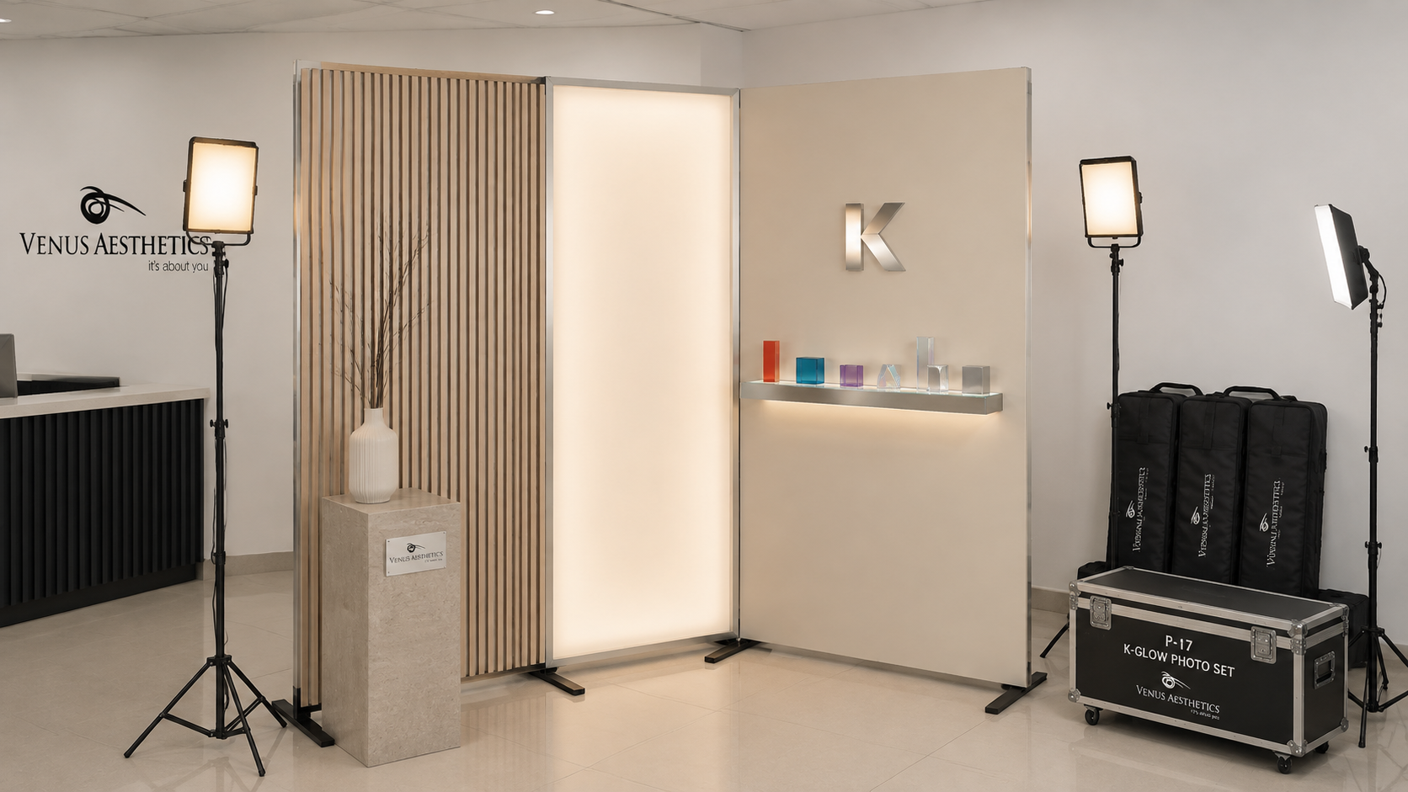
Three-panel set with visible folding feet, lighting stands, padded covers and flight case for realistic transport between clinics.
- Panel 1. Pale oak vertical slats on a light two-person-carry frame.
- Panel 2. Warm-white dimmable diffuser panel.
- Panel 3. Plain cream panel with mirror K and straight lit glass shelf.
INSTALLATION The set occupies one clinic corner only and does not alter the building.

11 | SOCIAL MASTER 01

Meet Your Glow
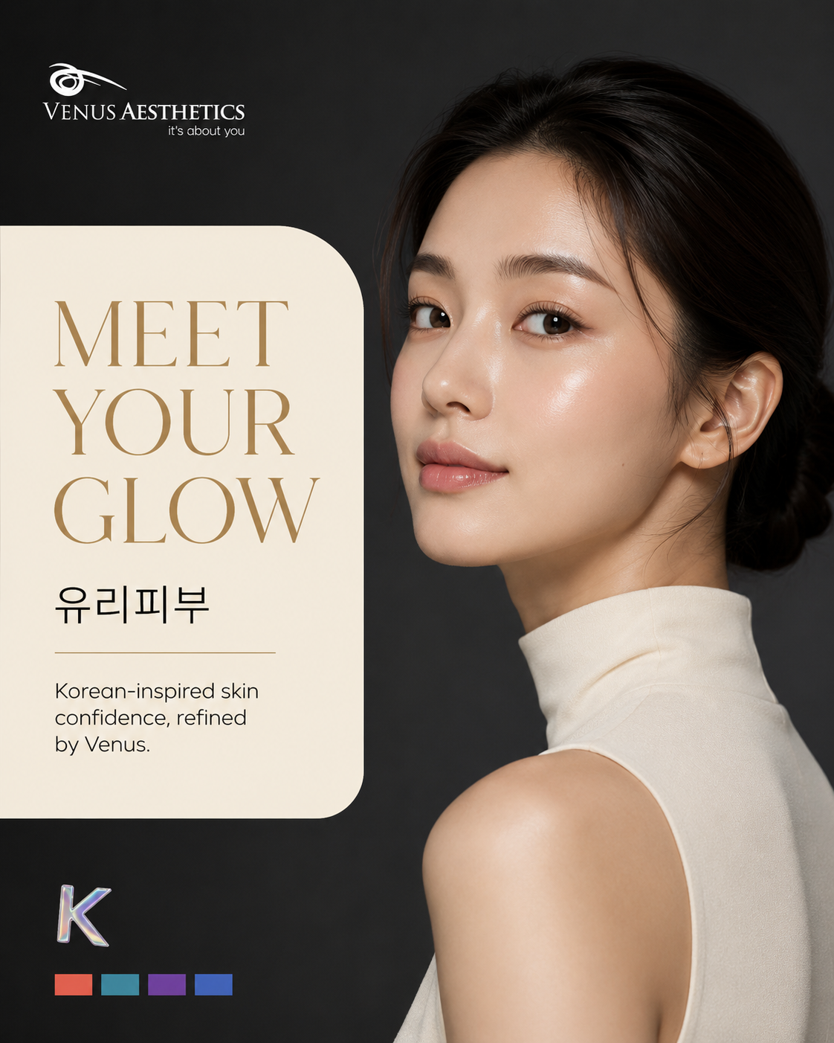
Hero campaign visual: Venus black/cream editorial structure, Korean model, bilingual beauty cue and restrained accent tabs.
- Use as the campaign introduction, clinic screen visual and creator briefing cover.
- Crop from the master for feed, story and vertical screen formats.
- Replace concept model with licensed final photography while preserving composition and lighting direction.

12 | SOCIAL MASTER 02

Your Glow, Personalised
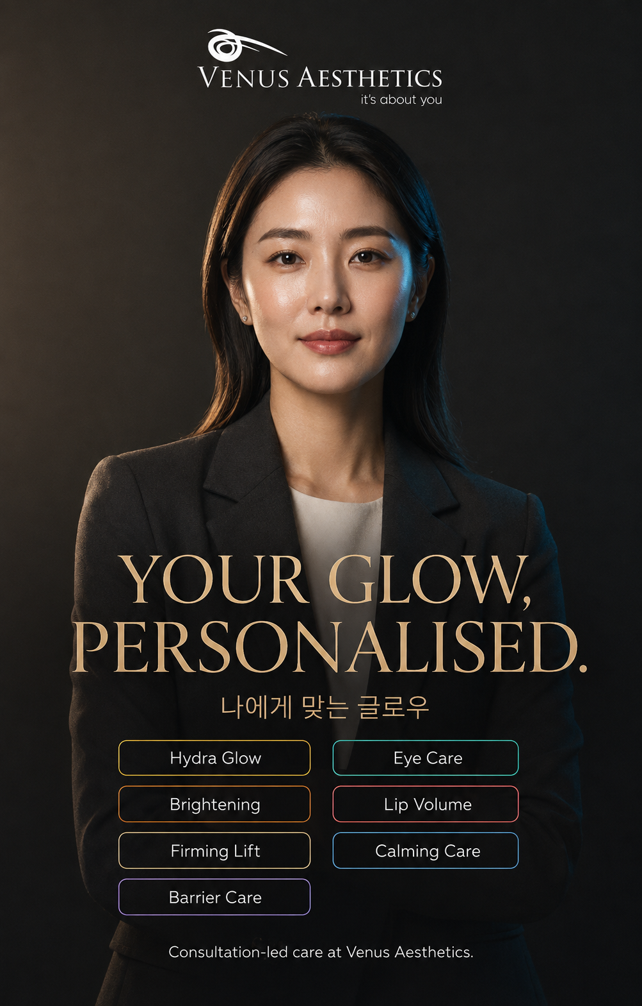
Treatment-system visual: consultation-led care presented in a modern Venus feed language.
- Use for education, consultation messaging and pinned campaign explanation.
- Keep treatment tabs as digital navigation labels; these are not physical cards and are not included in the PR box.
- Medical and advertising claims require internal clinical and legal review before publication.

13 | SOCIAL MASTER 03

Glass Skin, Your Way
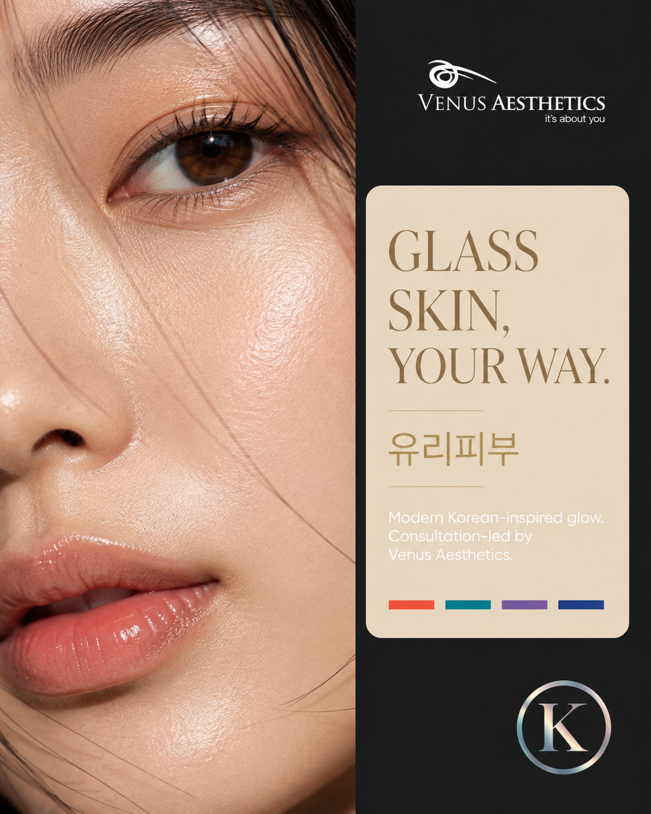
Close-up skin editorial: realistic texture, clean split composition and direct Venus ownership.
- Use for teaser, skin-quality storytelling and in-clinic digital screens.
- Retain natural pores and texture; avoid plastic retouching or exaggerated glow claims.
- No date, countdown, before/after comparison or procedure imagery.

14 | PRODUCTION QUANTITIES

Recommended procurement list
Quantities below retain the original six-clinic working assumption. Confirm clinic count before issuing purchase orders.
ITEM | PRODUCTION SPECIFICATION | QTY
Rigid PR box | 250 x 250 x 80mm; magnetic flap; soft-touch black wrap | 15
Acrylic mirror insert | 2mm; 220 x 200mm; printed top third | 15 + 2 spare
Oversized reveal card | Approx. 232 x 232mm; 600gsm black board; foil | 20
Oversized T-shirt | 220-240gsm cotton; chrome K; official back-neck logo | 25
Chrome K box prop | 120mm; 5mm mirror acrylic; black handle | 20
Sticker sheet | A5 holographic vinyl; kiss cut | 500
Suspended portrait signs | Seven designs; 300 x 430mm; cord + clips | 42
Handheld portrait props | Five sets of seven; 5mm acrylic | 35
Portable display rack | Weighted black frame for four signs | 6
K standee | 1700mm; mirror vinyl; weighted base | 2
Korean snack bar | Reusable table, vessels, signage and allergen kit | 1 kit
Travelling photo set | Three panels, lighting, covers and flight case | 1 set
Social key visuals | Three masters plus platform crops | 3 masters
SCOPE CONTROL Do not add treatment cards, gift bags, a prize wheel or a glow-match desk to any vendor quotation.

15 | EXECUTION AND APPROVAL

What happens next
1. Brand master handoff
Provide official vector logos, Haboro Contrast, Zona Pro and approved production color values.
2. Korean-language proof
A native Korean speaker signs off every phrase before artwork release.
3. Real-model photography
Cast adult Korean models or license appropriate photography; secure releases and usage rights.
4. Physical prototypes
Produce one box, one reveal card, one hanging sign and one handheld prop for review.
5. Clinic fit test
Confirm ceiling-clip policy, cord length, rack footprint, access routes and weighted-base safety.
6. Catering trial
Use a halal-capable caterer, confirm vegetarian choices, allergens, holding temperatures and lounge-only service.
7. Final production
Release quantities only after prototype, photography, Korean proof and clinic fit test are approved.

Vendor acceptance checklist
- ZERO treatment cards and ZERO narrow card slots in the PR box.
- First reveal is one full-tray message card; underneath are exactly three items.
- No date, countdown, wave pattern, swirl or marbling on any approved asset.
- Official vector logo replaces all concept-rendered logo approximations.
- All Korean wording and line breaks are proofed before print.
- All model images are licensed and naturally retouched; no AI-generated faces in final print.
- All suspended props use load-rated removable fixings or freestanding racks approved by the clinic.
- Food is served only in the lounge with allergen, halal and hygiene controls.
APPROVAL GATE The creative direction is ready for team sharing. Production files begin only after the seven execution steps above are assigned to named owners.

