# Ijaz Mohammed

**Mail@ -** [**talktoijaz@gmail.com**](mailto:talktoijaz@gmail.com) **Contact - 8921086692**

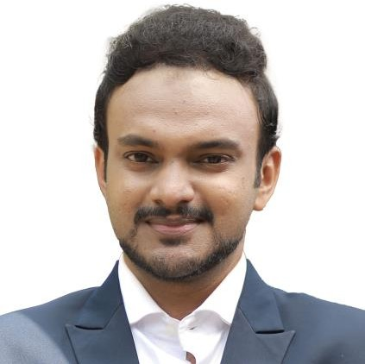

# Summary

Technical Skills

Git/Azure Repo – Administration and Project management

Jenkins - Administration

Free style projects Pipeline Projects

Integration with various tools

Docker - Dockerfile

Multistage builds Docker Volumes Docker Compose

Kubernetes - Namespace, Pods, Services Deployments , Volumes, HPA, ConfigMaps Secrets, Rolling Updates, Ingress controller.

Ansible - Adhoc commands

Azure - Virtual Machine, App Services, SQL Managed Instance, MySQL Flexible server, Application Gateway, Vnets, Application Gateway, Azure Firewall, AKS

Monitoring Tool - Prometheus

Grafana, Azure Monitor

# Seasoned DevOps Engineer with a proven track record of designing, implementing, and optimizing CI/CD pipelines to streamline software delivery processes.

Education – **B.Tech CSE**

Experience

Junior Devops Engineer

Gnrgy : Jan 2019 – Present, Bengaluru

* Designed, implemented, and migrated on-premises infrastructure to scalable, resilient, and secure Azure infrastructure solutions.
* Utilize Docker for containerization and Kubernetes for container orchestration to streamline application deployment and scaling.
* Implemented and enforced security best practices, ensuring compliance with industry standards and network security using Azure Firewall, WAF and NSG.
* Managing both Linux and Windows deployment environments including system updates, security configurations, and performance tuning.
* Set up and maintain monitoring and logging solutions to ensure the health and performance of servers and applications.
* Collaborated with development teams to establish and enhance CI/CD pipelines using Azure DevOps
* Developed and maintained CI/CD pipelines using Jenkins.
* Document infrastructure architecture, processes, and procedures.
* Database Management: Working knowledge database operations and administration.
* M365 administration and security implementation.

Linux Server Administrator



SBL Knowledge Services

Kochi, Kerala

Jan 2017 – Dec 2018

* + Installed and setup Web Servers (Apache, Tomcat, Nginx),

DB Server (MySQL, PgSQL).

* + SSH server hardening.
  + Manage website hosting (CPanel) and WordPress sites.
  + Fortinet UTM firewall management
  + Maintaining server performance through a regular server health check using bash scripts.
* Perform daily backups operations, ensuring all required file systems and system data are successfully backed up to the appropriate media.
* Window Server installation and configuration, Activate Directory, Domain, IIS Server.
* VMWare Esxi server management.
* Troubleshooting application related issues by log verification.

PROJECTS

|  |  |  |
| --- | --- | --- |
| Name | Environment | Role |
| Sirius EVCS | Git, Jenkins, Docker, Sonarqube, Nexus, Kubernetes, Azure MySQL and VM | Deployment (CI/CD) |
| Azure Infrastructure with Hub and Spoke topology | Azure VM, Azure Managed Instance, Azure MySQL, Application gateway, WAF, Vnet Peering, Azure Firewall, AKS, Container Registry, Docker | Migration from on-premises to Azure |

Areas of interests

* Cloud computing.
* Devsecops
* Ethical Hacking