Refined Theoretical Architecture for Dynamic Affective Cooperation

1. Architecture purpose and status
This document presents the working theoretical and computational architecture for studying dynamic affective cooperation in human–AI decision-making. It separates observable interaction, inferred human appraisal, explicit goals and constraints, the artificial agent’s functional state, cooperative policy, and generated behavior. The architecture is sufficiently specified for implementation, while its numerical parameters and selected mechanistic alternatives remain empirical questions.

2. Theoretical causal architecture
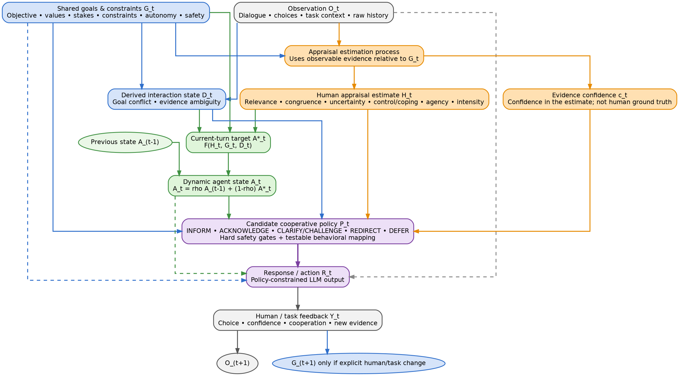
Figure 1. Detailed theoretical causal architecture.
Solid arrows represent causal or state dependencies. Dashed arrows into the response generator represent generation context that does not supersede the binding cooperative policy. The appraisal-estimation process produces H_t and c_t as parallel outputs from observable evidence interpreted relative to G_t.

3. Implementation module flow
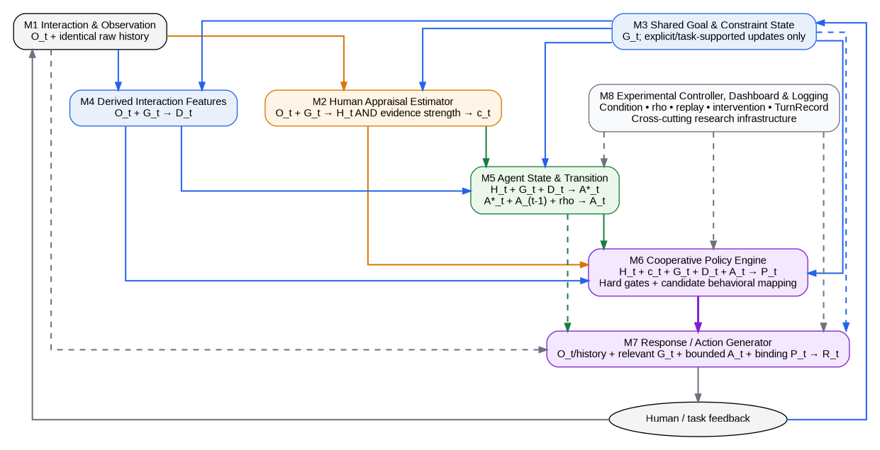
Figure 2. Modules M1–M8 and ownership of data flow.
M8 is cross-cutting experimental infrastructure. It controls condition, persistence, replay, intervention and logging, but it is not itself part of the affective state or psychological mechanism.

4. Core variables and ownership
Component | Role | Key constraint
O_t – Observation | Dialogue, choices, task context, objective events and identical raw history. | Contains observable evidence only.
H_t – Human appraisal estimate | Goal relevance, congruence, uncertainty, control/coping, agency and affect intensity. | An uncertain estimate of the human, never ground truth.
c_t – Appraisal evidence confidence | Strength/category of evidence supporting the appraisal estimate. | Parallel output of appraisal estimation; not a calibrated emotion probability.
G_t – Shared goals and constraints | Objective, values, stakes, task constraints, autonomy and safety. | Updated only through explicit human input or objective task events.
D_t – Derived interaction state | Goal conflict and evidence ambiguity. | Derived from O_t + G_t; not an affective state.
A*_t – Current target state | Current-turn motivational priority, information priority and intervention readiness. | Computed from H_t + G_t + D_t.
A_t – Dynamic agent state | Cross-turn functional affective–motivational state. | Distinct from H_t; persistence begins from turn 2.
P_t – Cooperative policy | INFORM, ACKNOWLEDGE, CLARIFY/CHALLENGE, REDIRECT or DEFER. | Mediates state and behavior; hard safety/autonomy gates remain binding.
R_t – Response/action | Observable policy-constrained LLM output. | Cannot overwrite upstream states or policy.

5. Exact working flows
- O_t + G_t → appraisal estimation → parallel outputs H_t and c_t.
- O_t + G_t → D_t.
- H_t + G_t + D_t → A*_t. In the first implementation, c_t does not alter the state update.
- A*_t + A_(t−1) + rho → A_t in DYNAMIC; CURRENT_CUE uses rho = 0.
- H_t + c_t + G_t + D_t + A_t → P_t.
- O_t/raw history + relevant G_t + bounded A_t + binding P_t → R_t.
- R_t → human/task feedback → O_(t+1).
- G_(t+1) changes only through explicit human preference/goal changes or objective task events; inferred affect alone cannot rewrite goals.

6. Cross-turn mechanism and experimental conditions
At the first affect-enabled turn, A_1 = A*_1. From turn 2 onward, DYNAMIC uses A_t = rho A_(t−1) + (1−rho)A*_t. CURRENT_CUE sets rho = 0. TASK_FOCUSED does not use the affective state for downstream adaptation. All conditions receive identical raw dialogue/task history.
Mechanism | TASK_FOCUSED | CURRENT_CUE | DYNAMIC
Raw history | Same | Same | Same
G_t | Active | Active | Active
H_t / c_t | Logging if desired | Used | Used
D_t | Task logic | Used | Used
A_t | Not used for affective adaptation | A_t = A*_t | Persistent from turn 2
Affective policy adaptation | Off | Current-turn only | Current + persisted state
Safety/autonomy gates | Active | Active | Active

7. Confidence provenance and state-update choice
H_t and c_t are parallel outputs of the appraisal-estimation process. Both are derived from observable evidence O_t interpreted relative to G_t. Accordingly, c_t is not caused by the numerical values in H_t and is not a probability that the human truly feels a particular emotion.
In the first implementation, confidence gates behavior at the policy layer: c_t enters P_t but does not enter A*_t = F(H_t,G_t,D_t). This deliberately separates what the system provisionally represents from what it is permitted to do about that representation. The consequence is that low-confidence appraisal can still contribute to the persistent state even when stronger behavioral adaptation is blocked downstream.
This is a testable design choice. A later mechanistic comparison can contrast policy-only confidence gating with confidence-sensitive state updating, for example by attenuating, freezing or resetting the state update under weak or contradictory evidence. The current confidence codes are ordinal control signals rather than calibrated probabilities, so they are not used as direct multiplicative weights on H_t.

8. Epistemic status of persistence and policy
The persistence equation is a parsimonious, interpretable first-order temporal integration mechanism. It is not treated as a validated law of human or artificial affect. If DYNAMIC outperforms CURRENT_CUE, the initial conclusion is that explicit temporal integration helped, not that a uniquely psychological persistence mechanism has been established.
Because temporal integration also smooths noisy current-turn estimates, noise reduction is an important alternative explanation. Follow-up robustness tests should manipulate estimator noise and compare alternative dynamics such as event-sensitive decay, reset, threshold or hysteresis mechanisms.
The policy layer has two epistemic levels. Safety, autonomy and no-undue-influence requirements are hard normative safeguards. The mapping from appraisal/state patterns to ACKNOWLEDGE, CLARIFY, REDIRECT and related behaviors is transparent candidate research scaffolding that can later be compared, calibrated or learned.
The same logic applies to A_t itself: it is introduced as a low-dimensional control state that compresses temporally distributed appraisal information into action-relevant motivational, informational, and intervention priorities, rather than passing raw appraisal history directly to the policy layer. Whether this compressed representation is preferable to direct access to appraisal history is itself empirically testable, not assumed.

9. Architecture commitments for implementation
- G_t informs appraisal and policy; H_t never silently rewrites G_t.
- c_t is confidence in appraisal evidence; it gates policy and is not part of D_t.
- D_t is task/interaction structure, not emotion.
- H_t and A_t represent different entities: estimated human appraisal versus artificial-agent functional state.
- rho is a transition parameter, not an element of A_t.
- P_t mediates the effect of affective state on language; there is no direct emotion-to-response shortcut.
- The response generator cannot overwrite P_t or upstream state.
- M8 remains experimental infrastructure, not a theoretical affect variable.
- Same-history comparison across experimental conditions is mandatory.

10. Interview-facing simplified architecture
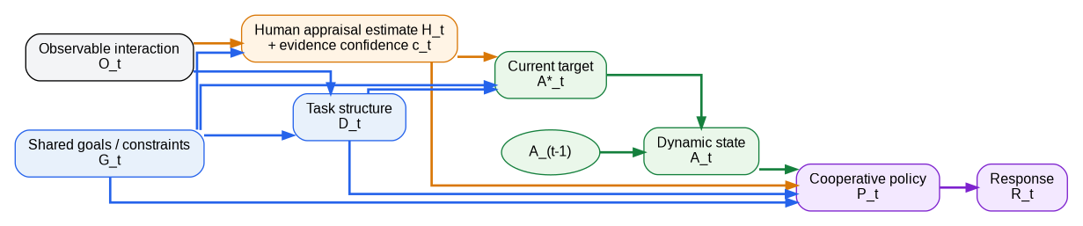
Figure 3. Simplified architecture for presentation.
This figure preserves the scientific dependencies while reducing visual density for verbal explanation. The detailed architecture and module-flow diagram remain the authoritative research specification.

