Software Requirement Specification Document

Software: ASSET Lab Resource Adequacy Model (assetra)
Contact: ijbd@umich.edu
Date: January 10th, 2022

1. Introduction

1.1 Purpose
The reliability of an energy system is fundamental to its operation and value. Researchers in the ASSET Lab and in institutions globally need usable research-grade tools for quantifying resource adequacy as part of their multi-dimensional studies. This document specifies the ASSET Lab Resource Adequacy (assetra) model, as it should be implemented in an accessible Python library. The overarching goal of this software is to quantify the resource adequacy of an energy system while being flexible, extensible, and easy-to-use.

1.2 Intended Audience
This document is intended for contributing developers to the assetra library. It may also provide context to folks looking to use or modify this software in the future.

1.3 Intended Use
This document is not static. External validation is an important milestone for this project, and maintaining this document will offer guidance during journal submission, i.e. to the Journal of Open-Source Software.

1.4 Definitions and Acronyms
Components are defined such that the structure of an object-oriented program naturally follows from their composition.
Energy Source
An energy source is the atomic type used in assetra. An energy source is any feature contributing to the net generation of an energy system, e.g. loads and generators.
Energy System
An energy system is a discrete set of energy sources.
Resource Adequacy
Resource adequacy is a property of energy systems, specifically, the ability of an energy system to maintain positive net energy. Several metrics exist to define resource adequacy,, including loss-of-load expectation (LOLE), loss-of-load days (LOLD), loss-of-load frequency (LOLF) and expected unserved energy (EUE). The variety of metrics highlight different vulnerabilities in an energy system and inform the response of planners.
Resource Contribution
Resource contribution is a property of two energy systems, often one composed of a single energy source and the other an existing energy system. The resource contribution of the first energy system to the second energy system is the quantified increase in resource adequacy due to the additional generation.

2. High-Level Description

2.1 User Needs
The assetra software is being developed for two classes of research studies: (1) those which require novel methods unaccounted for in existing reliability models, and (2) those which are not primarily concerned with reliability but want to include reliability as part of their multi-dimensional analyses.
The first class of study requires an easily-understood programming framework which can be extended and controlled with high precision.
Suppose a research group wants to integrate demand response into their reliability study. Demand response is not included in the assetra model, so the researchers must extend the assetra model without changing the public code base. Unlike thermal generators, which are sampled stochastically, demand response operates in a state-dependent manner. The software must provide the researcher with an interface to (1) add demand response to the set of energy sources, and (2) safely access state-variables which dictate demand response operation.
The second class of study is not concerned with extension, but instead derives value from a simplified interface.
Suppose a research group has successfully modeled future hourly load predictions under likely scenarios of climate change. They want to understand how climate change affects the reliability contributions of near-term solar and wind investments. Their application does not require extension of assetra. The software must provide reliability metrics with minimal computation and programmer effort.

2.2 Assumptions and Dependencies
- Users operate Windows, Linux, or Mac operating systems.
- Users provide necessary data for all energy sources. A set of optional interfaces will be included to parse data from:
- EIA-860
- EIA-930
- MERRA-2 (processed using the merra-power-generation tool)

3. System Features and Requirements

3.1 Functional Requirements
The assetra library should be able to perform the following tasks.
- Calculate resource adequacy of an energy system.
- Calculate resource contribution of one energy system to a secondary energy system.
- Calculate optimal transmission between a set of energy systems.
Resource adequacy calculations should account for:
- Time-varying energy sources (e.g. demand).
- Time-varying stochastic energy sources (e.g. thermal generators with temperature-dependent forced outage rates).
- State-dependent energy sources (e.g. storage).
Parameters should include:
- Number of Monte Carlo trials.
- Number of hours per trial.
Additionally:
- Outage resampling should be avoided where possible.
- Class properties should protect internal model state.

3.2 Interface Requirements
The primary interface will be fully data-source agnostic. Pre-processing modules will be included, for example, to calculate time-varying equivalent forced outage rates based on external thermal models, prepare data from specific datasets, etc.

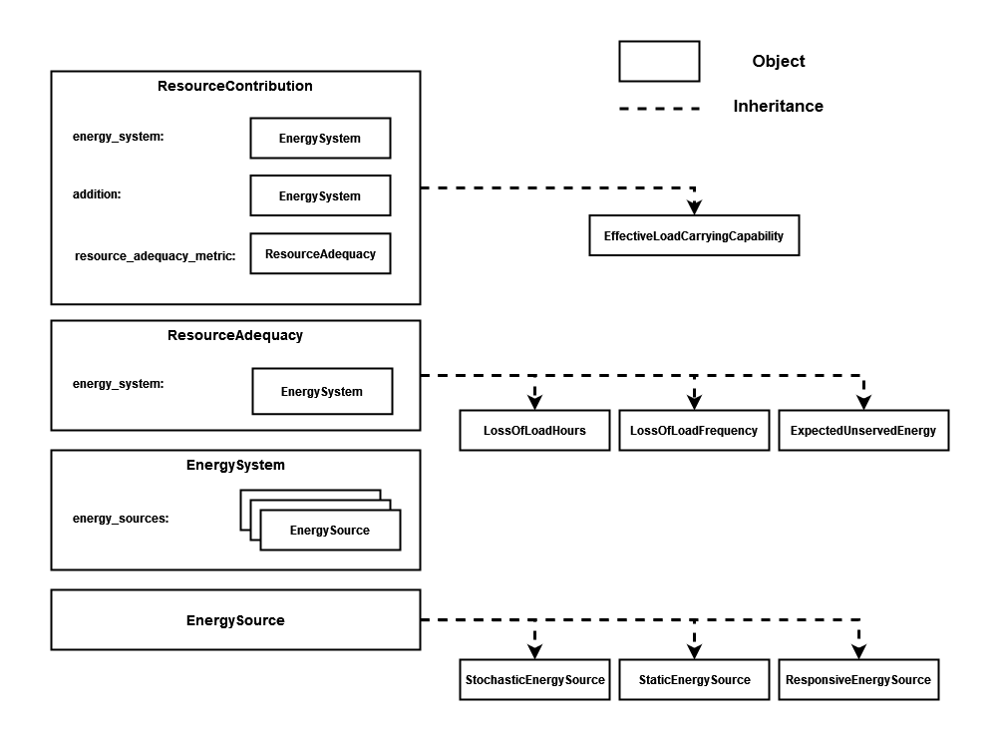
Figure 1: High-level class interface.

https://www.perforce.com/blog/alm/how-write-software-requirements-specification-srs-document
https://joss.theoj.org
https://gridops.epri.com/Adequacy/metrics
https://www.epri.com/research/products/000000003002023230
https://www.eia.gov/Survey/index.php
https://www.eia.gov/Survey/index.php
https://github.com/ijbd/merra-power-generation

