VIRAL FUSION
BLUEPRINT → FLYWHEEL → VELOCITY → WHY MUSK?
Editor Template for Jeetu

PURPOSE OF THIS DOCUMENT
This is a production-ready handoff for the transition out of the strategy-map section and into the Musk chapter. It includes Slide A, Slide B, the title reveal for THE ACCELERATION LAYER / WHY MUSK?, the approved visual direction, voiceover, and timing/motion guidance. The goal is clarity: Jeetu should be able to edit from this document without needing to infer the sequence.

Overall Progression
THE BLUEPRINT
↓
THE FLYWHEEL
↓
THE MISSING VARIABLE
↓
VELOCITY
↓
THE ACCELERATION LAYER — WHY MUSK?

SLIDE A — THE BLUEPRINT, NOW IN MOTION

THE FLYWHEEL IS FORMING
EDITOR OBJECTIVE
This is not a static recap. The audience should feel the architecture becoming a living system. Build the flywheel in real time with the voiceover. Every animation must communicate cause, connection, or compounding value.

ON-SCREEN VISUAL
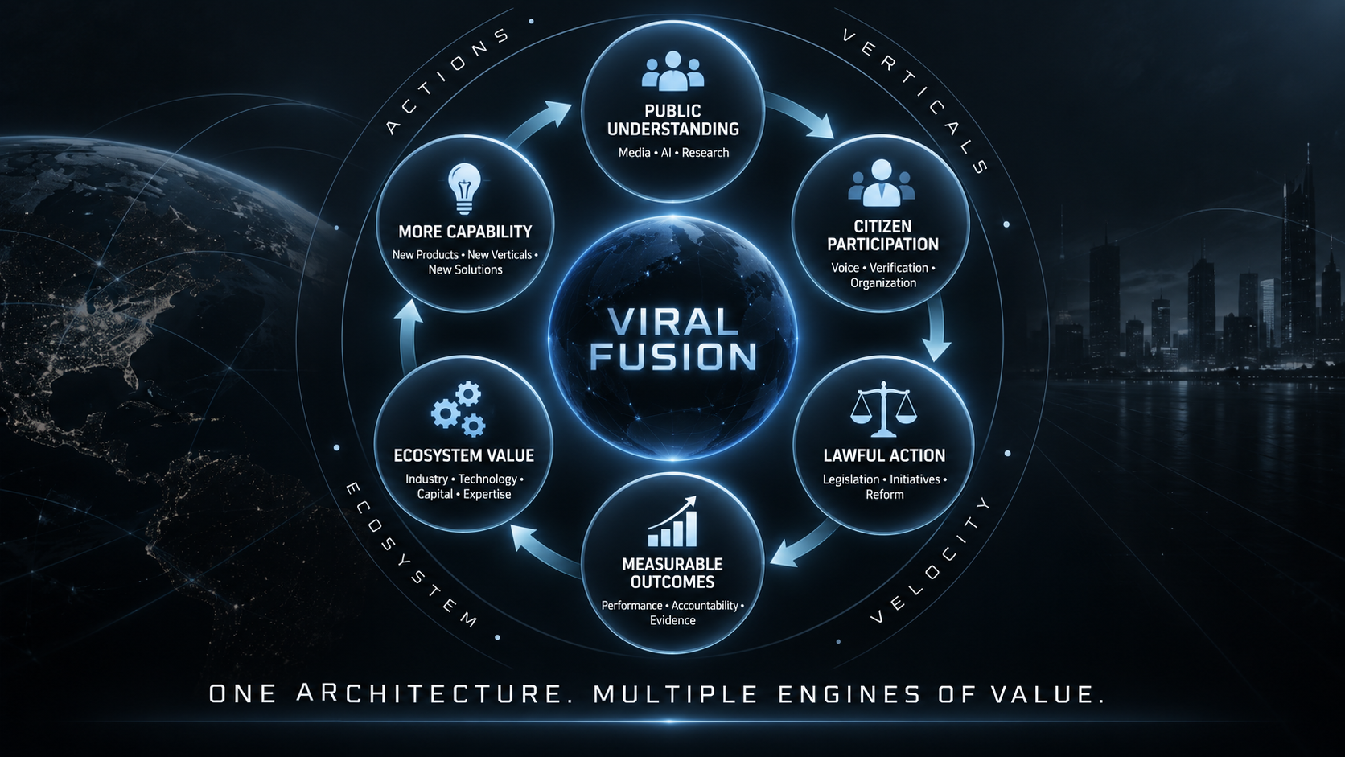
ONE ARCHITECTURE. MULTIPLE ENGINES OF VALUE.

Flywheel Structure
- PUBLIC UNDERSTANDING — Media • AI • Research
- CITIZEN PARTICIPATION — Voice • Verification • Organization
- LAWFUL ACTION — Legislation • Initiatives • Reform
- MEASURABLE OUTCOMES — Performance • Accountability • Evidence
- ECOSYSTEM VALUE — Industry • Technology • Capital • Expertise
- MORE CAPABILITY — New Products • New Verticals • New Solutions
- Return to PUBLIC UNDERSTANDING

SLIDE A — VOICEOVER
[NARRATOR] (Deep, controlled; revelation rather than recap)
Earlier, we showed you the Blueprint.
Actions.
Verticals.
Ecosystem.
Velocity.
But after everything we have examined since then—
something else becomes visible.
These are not separate pieces.
They can become a flywheel.
[GEORGE] (Measured, increasingly consequential)
Public understanding creates participation.
Participation creates verified demand.
Verified demand creates lawful action.
Action creates measurable outcomes.
Outcomes create credibility.
Credibility creates trust.
Trust brings more people into the system.
And greater participation attracts:
industry—
technology—
capital—
experts—
and new opportunities.
Those participants create more solutions.
More products.
More legislation.
More information.
More value.
And the cycle begins again—
stronger than before.
[NARRATOR]
That matters because the most durable systems are rarely built around one product.
They are built around reinforcing capabilities.
Every layer makes the next layer more valuable.
And every new participant can strengthen the whole.
[GEORGE]
That is the potential moat.
Not one app.
Not one piece of technology.
Not one media company.
Not one political campaign.
The integration.
Citizen participation.
Media.
AI.
Physical infrastructure.
Legislation.
Trust.
Industry.
Commercial systems.
And a growing ecosystem capable of connecting all of them.
A competitor can copy a feature.
It is much harder to copy a flywheel.
[NARRATOR]
And that is what the preceding conversations were designed to do.
Not simply collect interviews.
Add capabilities.
One conversation strengthens AI and humanity.
Another adds physical infrastructure.
Another adds resilience.
Another adds transportation.
Energy.
Healthcare.
Public safety.
Trust.
Media.
Every participant brings something the architecture did not have before.
Every relationship can create another relationship.
Every solution can create another vertical.
Every successful outcome can create another reason for citizens and industry to participate.
That is how an ecosystem compounds.

SLIDE A — EDITOR ANIMATION / TIMING
CORE VISUAL CONCEPT
The slide should feel like a machine slowly coming online. Avoid decorative motion. Build the logic of the system, then show it compounding.

Movement 1 — Assembly
- Start dark. Show only the slide title. Keep the flywheel barely visible at approximately 10–15% opacity.
- On “Earlier, we showed you the Blueprint,” bring in ACTIONS, VERTICALS, ECOSYSTEM, VELOCITY around the outer ring.
- On “something else becomes visible,” illuminate the VIRAL FUSION center core.
- On “They can become a flywheel,” activate PUBLIC UNDERSTANDING and begin the clockwise build.
- As George names each causal step, illuminate the next node and animate the connecting arrow traveling to it. Do not simply pop the arrow on screen.
- On “stronger than before,” complete the loop and illuminate the entire flywheel together for the first time. Hold 1.5–2 seconds.

Movement 2 — Compounding / Moat
- Dim the six outer nodes slightly while keeping VIRAL FUSION bright on “The most durable systems are rarely built around one product.”
- On “That is the potential moat,” strengthen the connecting ring or subtly pull nodes inward 3–5% to make the integration feel tighter.
- As George lists citizen participation, media, AI, physical infrastructure, legislation, trust, industry, and commercial systems, pulse the relevant existing nodes rather than adding eight new text boxes.
- On “A competitor can copy a feature,” isolate one node briefly.
- On “It is much harder to copy a flywheel,” return the entire connected system to full illumination.

Movement 3 — Strategy Map Feeds the Flywheel
- As the narrator references AI & humanity, physical infrastructure, resilience, transportation, energy, healthcare, public safety, trust, and media, feed subtle light pulses into the flywheel from outside the perimeter.
- Do not clutter the slide with guest names. The strategy map already established them.
- The visual message should be: the preceding conversations added capabilities to the machine.

Movement 4 — Hand-off to Velocity
- At “That is how an ecosystem compounds,” hold the completed flywheel.
- Begin dimming ACTIONS, VERTICALS, and ECOSYSTEM.
- Leave VELOCITY brighter than the other outer-ring terms.
- Carry a faint ghost of the flywheel into the transition to Slide B if possible.
CRITICAL EDITOR NOTE
DO NOT animate every object simply because it exists. Animation must follow the logic of the voiceover. No spinning logos, no constant particle motion, no excessive zooms, and no “PowerPoint animation” feel. Every movement should communicate cause, connection, compounding value, or the transition toward velocity.

SLIDE B — THE MISSING VARIABLE

VELOCITY
EDITOR OBJECTIVE
Slide A proves the architecture can compound. Slide B isolates the one unresolved factor that changes the scale of everything that came before it: velocity. This slide should feel simpler, quieter, and more consequential than Slide A.

ON-SCREEN VISUAL
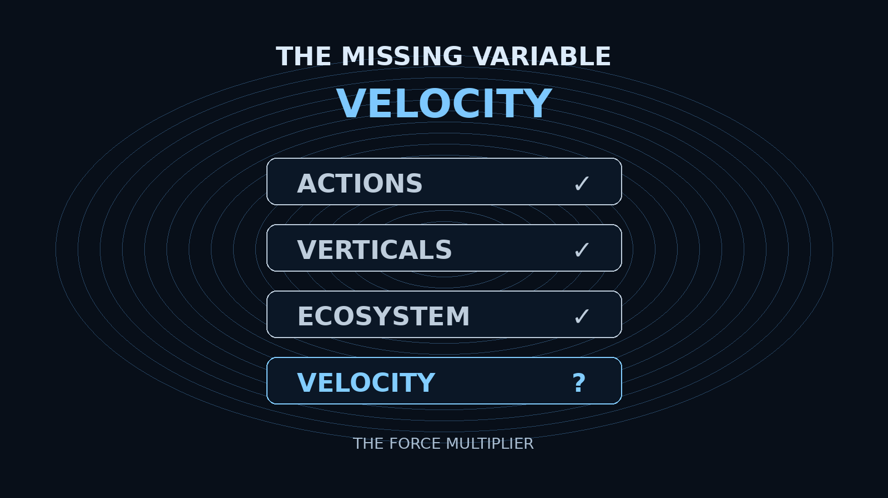

Primary On-Screen Elements
- ACTIONS ✓
- VERTICALS ✓
- ECOSYSTEM ✓
- VELOCITY ?
- THE FORCE MULTIPLIER

SLIDE B — VOICEOVER
[NARRATOR] (Minimal, deliberate)
The Blueprint began with four components.
Actions.
Verticals.
Ecosystem.
Velocity.
We now know how the first three can begin coming together.
[GEORGE] (Controlled)
Actions—
give citizens a way to move from voice to consequence.
Verticals—
create new places for the architecture to produce value.
The ecosystem—
brings together the people, technology, capital, institutions, and expertise capable of moving each piece.
But the fourth component changes the scale of everything that came before it.
[NARRATOR] (Pause)
Velocity.
[GEORGE]
Because velocity compounds.
The faster a system learns—
the faster it improves.
The faster it improves—
the more value it creates.
The more value it creates—
the more people and partners it attracts.
And the stronger the flywheel becomes.
So after everything we have assembled—
one question remains.
How fast can this move?
[NARRATOR] (Widening)
And that leads us to an entirely different kind of ecosystem.
One already operating across:
artificial intelligence—
global communications—
energy—
transportation—
manufacturing—
physical infrastructure—
human-machine interfaces—
and the frontier beyond Earth itself.
[GEORGE] (Quiet, deliberate)
If Viral Fusion is building a civic and economic flywheel—
what happens when it connects to one of the most powerful technology flywheels ever assembled?

SLIDE B — EDITOR ANIMATION / TIMING
- Start with all four Blueprint components visible, but subdued.
- As narrator says Actions / Verticals / Ecosystem, let each receive a subtle confirmation pulse/check.
- Do not check VELOCITY. Leave the question mark.
- On “But the fourth component changes the scale…,” dim the first three and enlarge VELOCITY slightly.
- On the narrator’s single word “Velocity,” let the word occupy the visual center with the subtitle THE FORCE MULTIPLIER appearing beneath it.
- As George explains “velocity compounds,” use a restrained pulse or expanding ring behind VELOCITY. Avoid literal speed effects.
- As narrator lists Musk-adjacent technology domains, do not yet reveal company logos. Use abstract keywords or very subtle iconography only.
- On George’s final question, cut all motion. Hold a clean beat before going to black.

TITLE REVEAL — BEGINNING OF THE MUSK CHAPTER
IMPORTANT
No additional voiceover on this title reveal. Let the silence create the transition.

THE ACCELERATION LAYER
WHY MUSK?

Editor Direction
- Cut to black after the final line of Slide B.
- Hold black for approximately 1–2 seconds.
- Reveal THE ACCELERATION LAYER first.
- Bring in WHY MUSK? underneath after a short beat.
- No logos yet. No company list yet. This is the chapter-title reveal only.
- Hold long enough for the audience to register that the presentation has changed scale.
- The next slide will begin explaining what Musk has, what Viral Fusion has, and why the two systems may be strategically complementary.

Sequence Summary for Jeetu
STAGE | EDITORIAL PURPOSE
THE BLUEPRINT | Original architecture established
THE FLYWHEEL | Architecture is now shown as compounding
THE MISSING VARIABLE | Three components have been assembled; one remains unresolved
VELOCITY | The force multiplier is isolated
WHY MUSK? | Begin the acceleration chapter
FINAL CREATIVE PRINCIPLE
The audience should feel that Slide A explains the machine, Slide B identifies the missing force, and WHY MUSK? asks what happens when that machine connects to extraordinary technological velocity.

