VIRAL FUSION — MUSK CHAPTER TRANSITION
EDITOR TEMPLATE FOR JEETU | WHY MUSK + WHY VIRAL FUSION
PURPOSE
These two slides begin the Musk chapter immediately after THE ACCELERATION LAYER / WHY MUSK? title reveal. The message must feel like a strategic convergence, not another guest introduction.
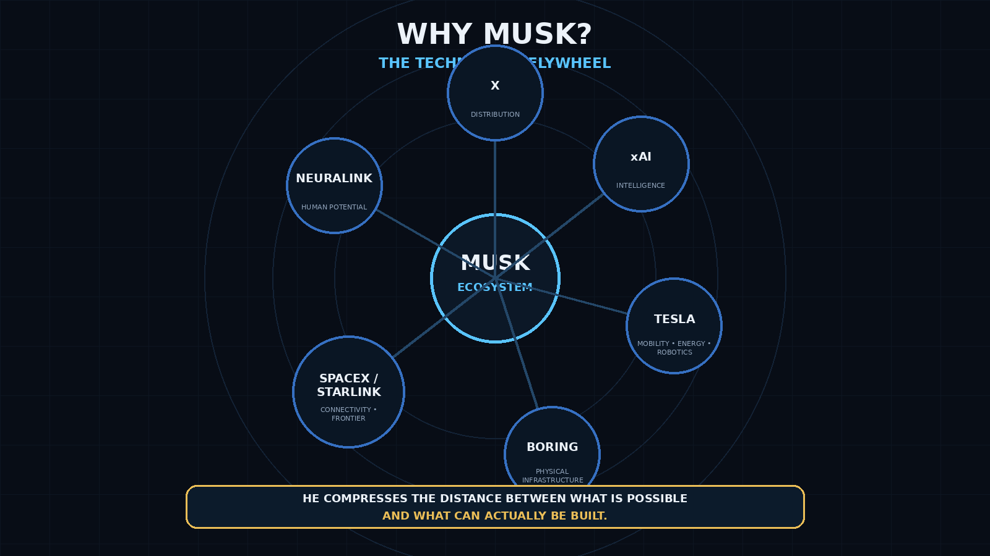
EDITOR NORTH STAR

MUSK = TECHNOLOGICAL VELOCITY | VIRAL FUSION = CIVIC VELOCITY
The chapter should ask what happens when the two flywheels connect — while citizen sovereignty remains independent and protected.

SLIDE 1 — WHY MUSK?
THE TECHNOLOGY FLYWHEEL
ON-SCREEN COPY

- WHY MUSK?
- THE TECHNOLOGY FLYWHEEL
- X — Distribution
- xAI — Intelligence
- Tesla — Mobility • Energy • Robotics
- The Boring Company — Physical Infrastructure
- SpaceX / Starlink — Connectivity • Frontier
- Neuralink — Human Potential
HE COMPRESSES THE DISTANCE BETWEEN WHAT IS POSSIBLE — AND WHAT CAN ACTUALLY BE BUILT.

SLIDE 1 — WHY MUSK?
VOICEOVER + PERFORMANCE
[NARRATOR] (Measured; reveal the ecosystem, not the celebrity)
There is a reason the missing variable leads here.
Elon Musk has not built one company.
He has assembled capabilities that increasingly reinforce one another.
Distribution.
Intelligence.
Connectivity.
Energy.
Mobility.
Robotics.
Physical infrastructure.
Manufacturing.
And access to the frontier beyond Earth itself.
[GEORGE] (Controlled; pivot from capability to constraint)
That is what makes this conversation different.
Elon has spent decades compressing the distance between what humanity imagines—
and what engineers can actually build.
But every transformative technology eventually reaches another system.
Society.
Laws.
Regulation.
Public understanding.
Infrastructure.
Institutions.
And ultimately—
the people expected to live with the consequences.
[NARRATOR] (Minimal, consequential)
Technology can move at extraordinary speed.
Public systems usually do not.
And that gap may become one of the defining problems of the next technological era.
[GEORGE] (Slow into the question)
So the question is not simply:
What else can Elon build?
The question is:
What kind of architecture helps society understand, challenge, adopt, and responsibly scale the best technologies faster—without surrendering the citizen’s authority over the future being built around them?
[NARRATOR] (Hard button; 1-second pause afterward)
That is where Viral Fusion enters.

SLIDE 1 — WHY MUSK?
EDITOR TIMING + ANIMATION
TARGET DURATION

Approximately 70–90 seconds
ANIMATION BUILD

- 0:00–0:06 — Hold WHY MUSK? / THE TECHNOLOGY FLYWHEEL. Keep the ecosystem faint, almost dormant.
- 0:06–0:28 — Reveal the center MUSK ECOSYSTEM, then activate company/capability nodes one at a time as the narrator names the capability: X → xAI → Tesla → Boring → SpaceX/Starlink → Neuralink.
- 0:28–0:40 — As George says “reinforce one another,” illuminate the connecting lines. The visual should become one system, not six logos.
- 0:40–0:58 — On “But every transformative technology eventually reaches another system,” dim the company nodes slightly. Introduce a subtle outer boundary labeled SOCIETY or show faint words: LAW / REGULATION / INFRASTRUCTURE / PUBLIC UNDERSTANDING / INSTITUTIONS.
- 0:58–1:12 — On “Technology can move at extraordinary speed. Public systems usually do not,” create visual separation: the inner flywheel has energy/motion while the outer societal boundary remains slower/static.
- Final question — Keep the whole ecosystem visible, then progressively strip the visual back until the audience is left with the unresolved gap between TECHNOLOGICAL VELOCITY and SOCIETY.
- On “That is where Viral Fusion enters.” Cut cleanly to black for ~0.5–1.0 second, then reveal Slide 2.
EDITOR PRINCIPLE

Do not make this a montage of Musk companies. Make it feel like a flywheel being discovered.

SLIDE 2 — WHY VIRAL FUSION?
THE MISSING CIVIC FLYWHEEL
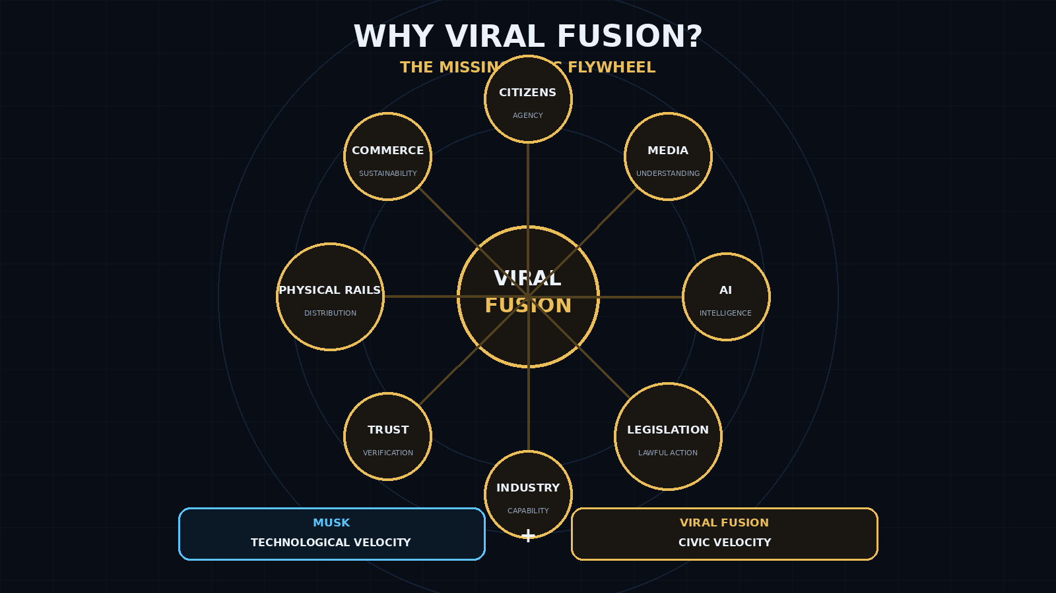
ON-SCREEN COPY

- WHY VIRAL FUSION?
- THE MISSING CIVIC FLYWHEEL
- Citizens — Agency
- Media — Understanding
- AI — Intelligence
- Legislation — Lawful Action
- Industry — Capability
- Trust — Verification
- Physical Rails — Distribution
- Commerce — Sustainability
MUSK: TECHNOLOGICAL VELOCITY + VIRAL FUSION: CIVIC VELOCITY

SLIDE 2 — WHY VIRAL FUSION?
VOICEOVER + PERFORMANCE
[NARRATOR] (Quiet confidence)
Musk’s ecosystem can accelerate technology.
Viral Fusion is designed around a different problem.
How does society responsibly accelerate with it?
[GEORGE] (Clear distinction; no rush)
Viral Fusion does not build the rocket.
We do not build the reactor.
We do not build the tunnel.
And we do not decide which technology deserves to win.
We build the architecture through which citizens can understand the opportunity—
experts can challenge it—
industry can demonstrate its value—
policy can be modernized—
and the public gains a lawful mechanism to participate in what happens next.
[NARRATOR] (Build the flywheel node by node)
Citizen agency.
Public understanding.
Artificial intelligence.
Legislative pathways.
Independent verification.
Physical distribution.
Industry capability.
Commercial sustainability.
Separate capabilities become reinforcing capabilities.
[GEORGE] (Strong; sovereignty is the safeguard)
And that is the opportunity.
Not to build a political system around Elon Musk.
Not to give one company control over the public square.
The opposite.
Connect extraordinary technological velocity to a civic architecture that keeps the citizen at the center.
Let the technology compete.
Let the evidence be challenged.
Let the public understand the tradeoffs.
And where the people choose to move—
create a lawful pathway capable of moving with them.
[NARRATOR] (Cinematic)
One flywheel expands what humanity can build.
The other expands society’s ability to understand, authorize, and benefit from what gets built.
[GEORGE] (Final, restrained)
Technological velocity.
Civic velocity.
The question is what becomes possible when they begin reinforcing one another.

SLIDE 2 — WHY VIRAL FUSION?
EDITOR TIMING + ALIGNMENT
TARGET DURATION

Approximately 85–105 seconds
ANIMATION BUILD

- 0:00–0:10 — Reveal WHY VIRAL FUSION? with only the center VIRAL FUSION core visible.
- 0:10–0:36 — As George defines what Viral Fusion does NOT build, keep the screen restrained. This contrast is conceptual, not visual clutter.
- 0:36–0:58 — Build the civic flywheel clockwise as the narrator names each capability: Citizens → Media → AI → Legislation → Industry → Trust → Physical Rails → Commerce.
- 0:58–1:15 — On “Separate capabilities become reinforcing capabilities,” illuminate all connections for the first time. Give the full flywheel a subtle pulse.
- 1:15–1:32 — During George’s sovereignty passage, do not add more objects. Instead keep CITIZENS / AGENCY slightly brighter than every other node. That visually establishes who remains at the center of authority.
- 1:32–1:42 — Split the frame or reveal a lower comparison band: MUSK = TECHNOLOGICAL VELOCITY / VIRAL FUSION = CIVIC VELOCITY.
- Final line — Bring the two terms toward the center without merging ownership or logos. Use connecting light/energy between them, not one swallowing the other. Hold 2 seconds.
EDITOR MESSAGE TEST

- If the audience leaves Slide 1 thinking “Musk has a remarkable interconnected technology engine,” it worked.
- If the audience leaves Slide 2 thinking “Viral Fusion supplies a different missing engine — citizen-centered civic velocity,” it worked.
- Do not imply X/xAI controls elections, legislation, or Viral Fusion. The creative should communicate acceleration + interoperability, not control.

HANDOFF TO THE NEXT SLIDE
TWO FLYWHEELS → THE MOAT
FINAL HOLD

TECHNOLOGICAL VELOCITY + CIVIC VELOCITY
Next slide recommendation: TWO FLYWHEELS — WHAT HAPPENS WHEN THEY CONNECT?
Then: THE MOAT — accumulated execution becomes harder to replicate.
FACT-CHECK / SOURCE NOTES FOR EDITOR

- PBD / Valuetainment transcript supplied by George: sequencing, flywheel, moat, and the idea of Musk’s capabilities reinforcing one another (approximately 9:14–17:27 in the supplied transcript).
- Tesla official materials describe AI/robotics work and energy hardware/software; SpaceX official materials describe Starlink connectivity and launch infrastructure. Use current official brand assets only if cleared for editorial use.
- Avoid speculative products or claims unless separately sourced and approved. The slide intentionally focuses on existing venture categories and strategic capabilities.

