# Features

Below is a list of features in our Music Manager application

## File Manager Features

* The file manager consists of 3 panels, the Library view, Folder Content view and a File Tree tab view(Figure 1)

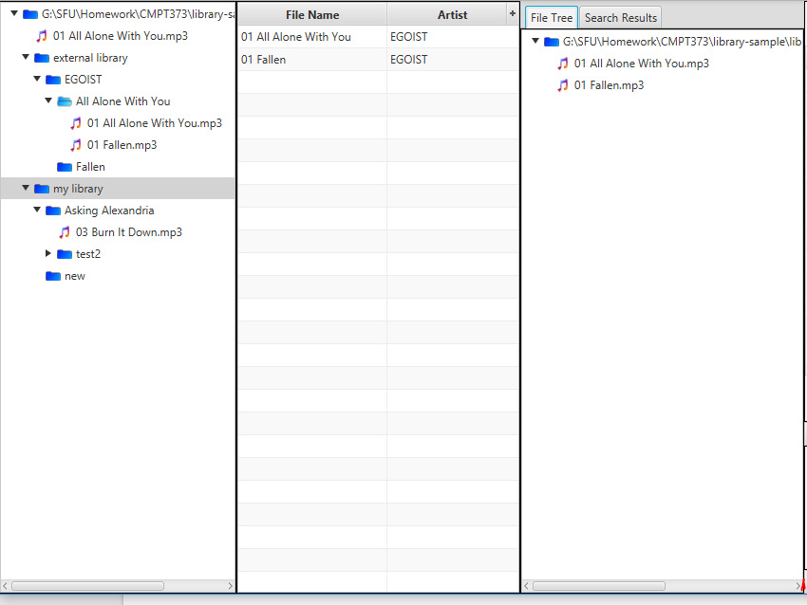

*Figure 1: Library view, Folder Content view and File tree view, in order from left to right*

* A new library can be added through File > Add Library
* The Library, Folder Content and File tree views will be saved between application sessions

### Library View

* Double clicking a folder will display it’s music files inside the Folder Content view
* Double clicking on a song in this panel will play it
* Right click > “Show in Right Pane” will display the file tree of the folder in the File Tree View
* Options > Left Pane > “Show folders only” will show only folders in the file tree
* Libraries can be removed from view using Right Click > “Remove This Library”
* A new folder can be created by right-clicking a folder and selecting “Create New Folder”
* Right click on a song will display the menu in Figure 2

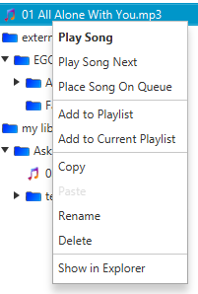

*Figure 2: Right click menu for a song*

* Right clicking on a library folder will display the menu in Figure 3

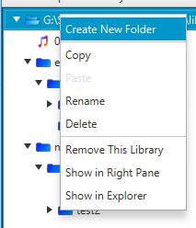

*Figure 3: Right click menu for a library*

* Right clicking on a folder will display the menu in Figure 4

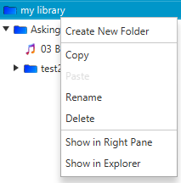

*Figure 4: Right click menu for a folder*

### Folder Content View

* Displays song information for music files under a selected folder
  + The default displays only songs directly under a folder, this can be changed in Options > Center Panel > “Show files in subfolders”
* Right clicking on a song will display the options in Figure 5

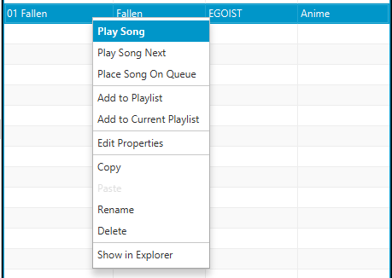

*Figure 5: Right click menu for a song in Folder Content view*

* Additional columns can be displayed by selecting the Plus symbol beside the column headers (Figure 6)

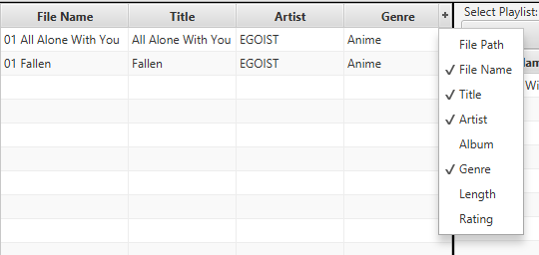

*Figure 6: Select columns to show in Folder Content view*

### File Tree Tab View

* This view can be accessed by choosing the File Tree tab in the right-most panel in Figure 1
* Double clicking on a song in this panel will play it
* Right clicking on a folder will display options similar to Figure 4
* Right clicking on a song will display options similar to Figure 2

### File System Actions

* Copying or moving a file or folder through the file system (Windows file explorer) will update the application UI
* Deleting through the file system will also update the application UI

## Playlist Features

* Shuffle the playlist entirely (when no song in the playlist is playing) or only unplayed songs (when a song in the playlist is playing)
* Shuffle and reset the playlist entirely by Right Click > Shuffle All Songs

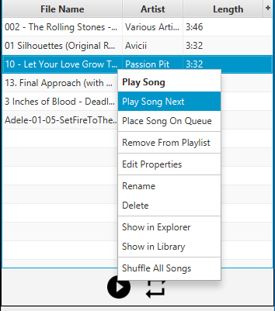

*Figure 7: The Playlist Menu Options*

* Rename playlist(s)
* Remove playlist(s)
* Customize displaying columns (Figure 8)

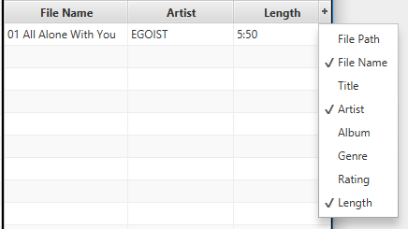

*Figure 8: Select columns to show in the playlist*

* Add song to playlist (either drag and drop or right click on a song in file manager view)
* Remove song from playlist (right click on a song in the playlist view)

## Music Player Features

### Playback Overview:

There are 3 different playback locations that you could be playing from:

* **Song History:** If you are playing something from history then you will be moving around your history. The next song will move you to the next song in the history list, similarly with the previous song. If you are playing something off the history list, the song should be bolded and italicized. Expanding the History Tab will show you what is currently in the history

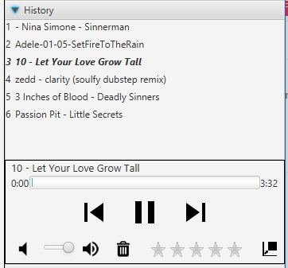

*Figure 9: A song that is being played from history*

* **Playback Queue:** If you place a song on the playback queue then it should be played as the next song if you are not playing off the history queue. Anything under the Playing Next tab is what is currently in the Playback Queue

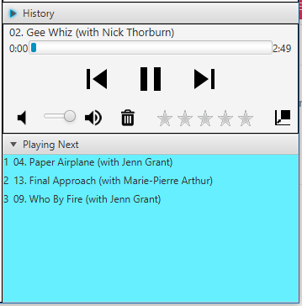

*Figure 10: A song that is on the Playback queue will be played next if you are not playing a song from history*

* **Playlist:** If you are playing a playlist then the following songs in the selected playlist will play. You can repeat playlist by selecting the repeat playlist mode icon. Upon switching playlist the Playback Queue will be reset. Clicking “Play Playlist” on a different playlist will save the current playlist location and time and will resume where you have left off on the new playlist if possible.

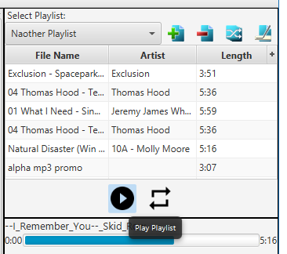

*Figure 11: Clicking the circle play button will play the current playlist selected*

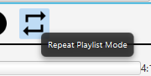

*Figure 12: Selecting the repeat playlist mode will allow you to restart the playlist after it is done finishing*



*Figure 13: The left icon indicates that the Repeat Playlist Mode is activated while the right icon indicates it is not activated*

* Right clicking on the History will bring up the following menu

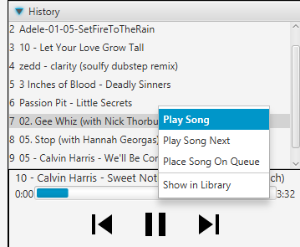

*Figure 14: Right click on a song to bring up History Menu*

* + **Play Song:** Will Play the song right away
  + **Play Song Next**: Will place the song at the front of the playback queue so that it will play next after the current song is done
  + **Place Song On Queue:** Will place song on the back of the playback queue
  + **Show in Library :** Show the current song based on the location of the library. This will show it the song in the center panel.
* Right clicking on the Playback queue will give the same options as the history but with an additional option to remove the song from the queue

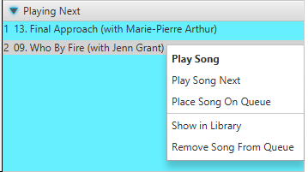

*Figure 15: The Playback Queue Menu Options*

* Previous Song Button will play the previous song which can be any song you have played. Hovering over it should show you the name of the song if there was one found in the metadata or the file name if there wasn’t. If the song is the last one in the history list then it the previous song will just restart the song.
  + If the song that is currently playing is less than 5 seconds into its playback then the player will move to the previous song.
  + If the song that is currently playing is more than 5 seconds into its playback then the current song will restart.

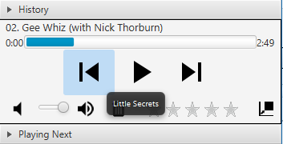

*Figure 16: Hover over previous song icon will show the previous song or itself if it is the oldest song*

* The Next Song button will play the next song that is available if there is one. Similarly hovering over it will show you the name of the next song

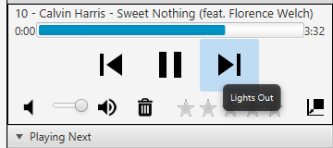

*Figure 17: Hover over next song icon will show the next song*

* Hovering over the seek bar will show the current playback time of the song. Clicking on the seek bar will move the currently playing song to that location

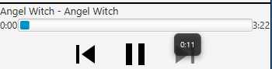

*Figure 18: Playback time of the Song is shown by hovering the seekbar*

* You can drag the volume slider to set the volume level. Alternatively selecting the volume icons will either mute or set the volume to the max level.

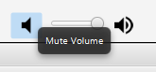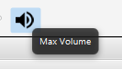

*Figure 19: Volume Control options*

* Selecting the Trash Icon will delete the current song that is playing

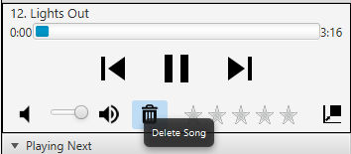

*Figure 20: Delete Current Song Playing Icon*

* You can rate the current song that is playing by selecting the star icons in the player. The rating range from 0 - 5 Stars.

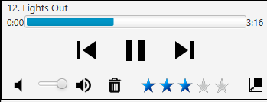

*Figure 21: Song Rating for Current Song*

* You can easily switch to mini mode with a click of a button in the player. Selecting the Icon on the very right of the player will enable and disable minimode

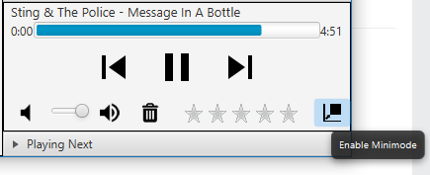

*Figure 22: The Enable Minimode Icon*

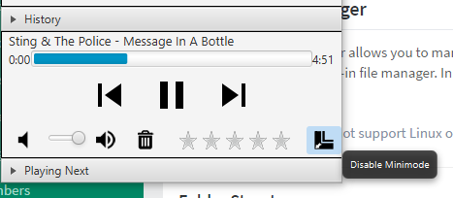

*Figure 23: The Disable Minimode Icon*

## Search

We have implemented a simple search function in the application. If you look at the top right corner of the application you should see a textbox for searching. Searching is a case insensitive search on file names. So if you search for “Bob Dylan” then the search will find any file or folder that contains “Bob Dylan” case insensitive. All search results are shown under the “Search Results” tab and should automatically appear when you search.

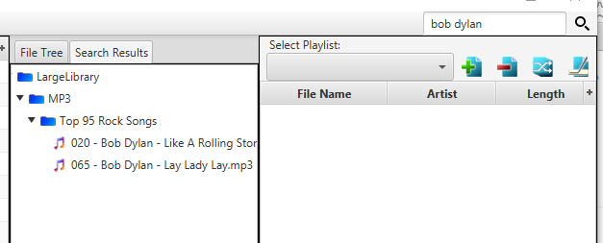

*Figure 23: The Search Results for “bob dylan”*

* Searching on a empty string will clear the search results and place the results to its initial state.

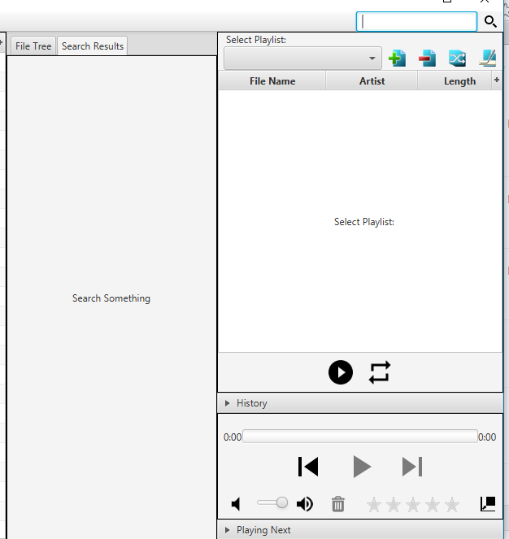

*Figure 24: The initial search results mode*

* Pressing **CTLR-F** will automatically place your cursor on the Search box.
* If you want to see all the files in a folder that matches your search then you go into the menu and enable the configurable option to do so

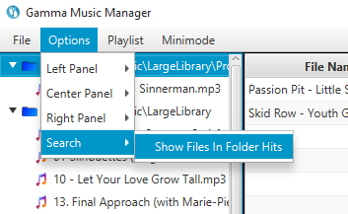

*Figure 25: The Menu Option to Show Files in Folder Hits*

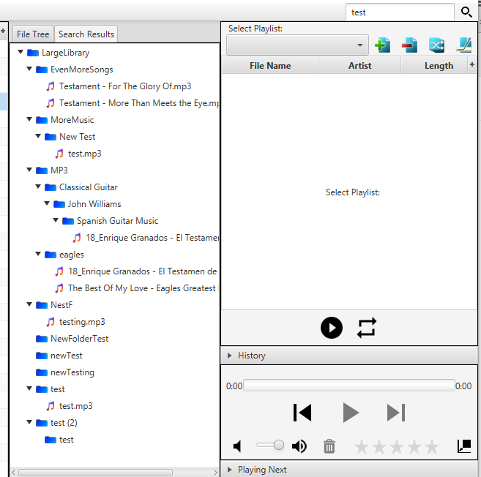

*Figure 26: The results of the search when Show Files in Folder Hits is off.*

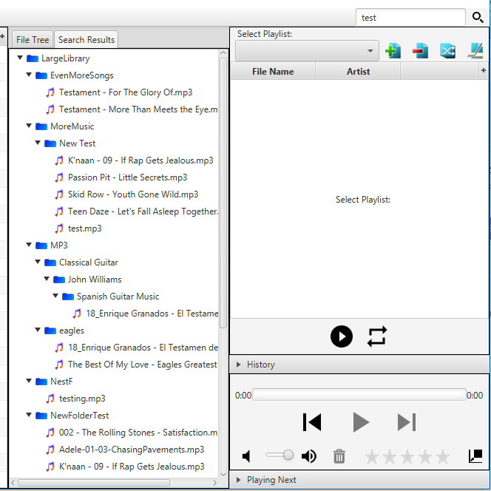

*Figure 27: The results of the search when Show Files in Folder Hits is on.*

## Menu Bar

### File

* This menu contains an option to add a library to the application (Figure 28)



*Figure 28: Add Library option in File menu*

### Options

* The Options menu offers customizations for several features in the application (Figure 29) including the following:
  + Library panel: show folders only
  + Folder contents: show files in subfolders
  + Tabs panel: hide the tabs panel
  + Search: show files in folder hits

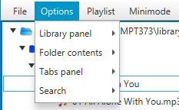

*Figure 29: The Options menu*

### Playlist

* The playlist menu (Figure 30) offers the following actions:
  + Creating a new playlist
  + Removing a playlist
  + Exporting a playlist

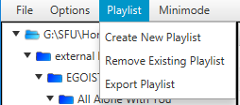

*Figure 30: The Playlist menu*

### Minimode

* This option can be used to toggle the application between normal viewing mode and minimode (Figure 31)

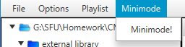

*Figure 31: The Minimode menu*

## 

# Appendix

### Surround Sound Support

For surround sound support in our application we recommend to configure your sound system using the Volume Control in Windows. You can configure Windows to output audio on all speakers in your surround sound system. Normally MP3 do output audio in a surround sound configuration unless it is a special type of MP3. By configuring your speakers properly you can get audio output on all speakers for any audio output. The following are steps to configure your Windows system to have surround sound support. All screenshots have been taken on a Windows 8 environment.

1. Right click on the speaker icon in your Windows toolbar and select “Playback devices”

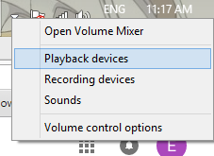

*Figure 32: The menu for Windows Volume Control*

1. Select the “Speakers” option and right click on it and select the “Configure Speakers” option or select the “Configure” button.

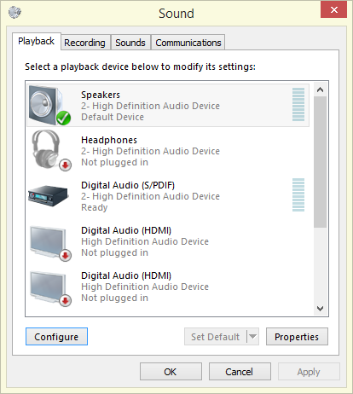

*Figure 33: The options dialog for Playback devices*

1. Ensure that your speaker setup is for either 5.1 or 7.1 configuration. If you do not see an option for a 5.1 or 7.1 configuration then make sure your system is configured properly to support surround sound.

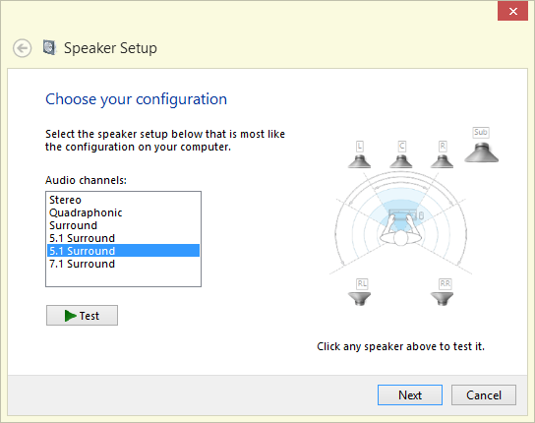

*Figure 34: The surround sound speaker configuration*

1. After configuring your speakers to be in a 5.1 or 7.1 configuration go Playback devices menu and either right click on “Speakers” and select the “Properties” options or select the “Properties” button.

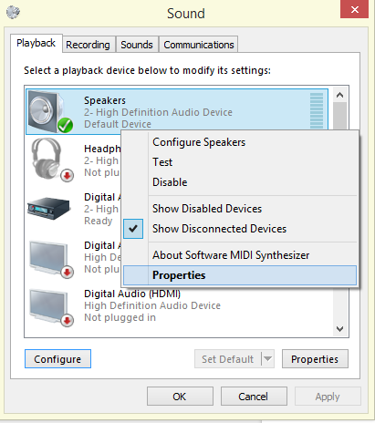

*Figure 35: Selecting the Speaker Properties*

1. Navigate to “Enhancements” tab in your Speakers Property and enable “Speaker Fill” option. Click “OK” to save the settings. Your system should now be configured to have surround sound support for the application.

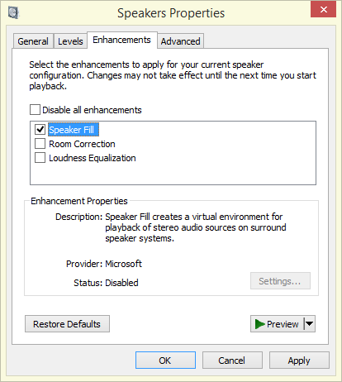

*Figure 36: Enabling the Speaker Fill option*