**PRE-ASSIGNMENT**

1. Measure the cost of a minimal function call in C/C ++ (e.g., X seconds). The minimal cost can be emulated by measuring a bare function call that neither takes any parameter nor does anything inside the function.

The cost of the minimal function call was measured by calling the function 10 times and then taking the average.

AVERAGE TIME: 0.0009874ms (milliseconds)

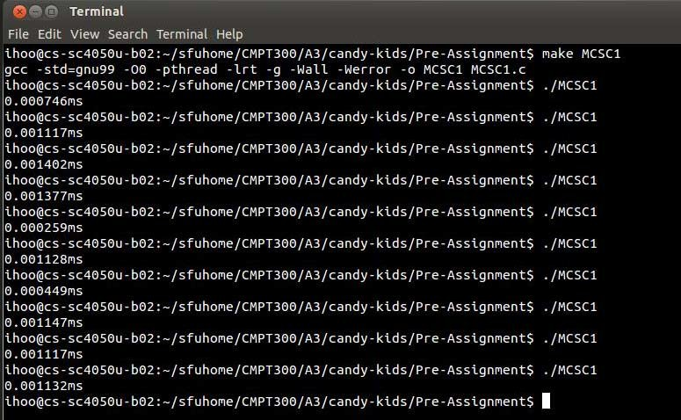

1. Measure the cost of a minimal system call in C/C+ +. Unlike a regular function call, a system call traps into the operating system kernel. The minimal cost can be emulated by measuring the cost of getpid() which doesn't really do anything

The cost of the system call was measured by calling the getpid() function 10 times and then taking the average.

AVERAGE TIME: 0.0035331ms (milliseconds)

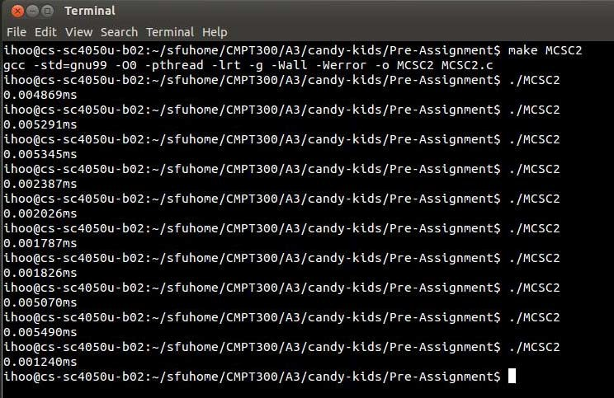

1. Measure the cost of a process switching.

The cost of context switching for processes was measured by recording the time it took to run 10 times and then taking the average. The process of measuring the context switch was achieved by piping the times from one process to the other and then finding the difference it took to start the first process and to start the second process.

AVERAGE TIME: 0.1218365ms (milliseconds)

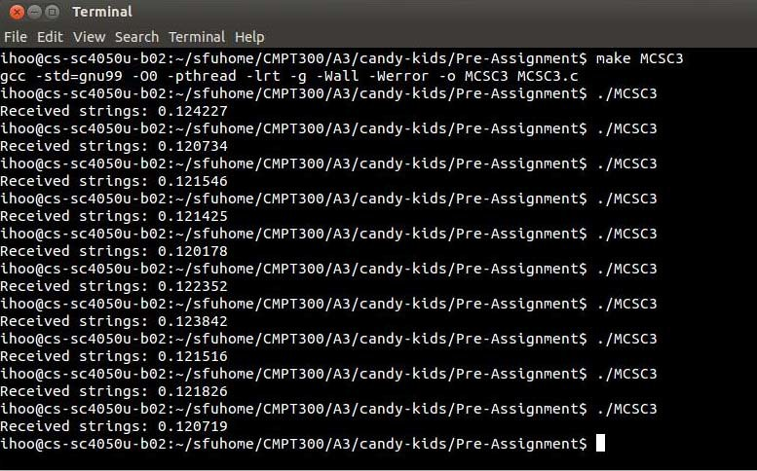

1. Measure the cost of a thread switching. A possible measurement strategy

The cost of context switching for threads was measured by recording the time it took to run the cost of switching the threads when both were programmed to increment/decrement the shared variable. We run the timing 10 times and take the average.

AVERAGE TIME: 0.192966ms (milliseconds)

