Tournament Info:
Location: IMA, 3924 Montlake Blvd. NE, Seattle, WA – 98195
Events: WS, WD, MS, MD and MXD
Format: Standard drop-flight format (A-B-C-D brackets) International scoring rules apply.
Eligibility: All participants must be at least 16 years of age by February 7th, 2015.
Fees: $25 per participant for 1st event. $10 for 2nd event, $5 for 3rd event;
Fees cover shuttlecocks, refreshments, tournament t-shirt and awards.
Entry deadline: Entries with guaranteed T-shirts ends January 20th, 2015
All entries end January 30th, 2015
(first come, first serve on payment received- NO REFUNDS)
Schedule: (The schedule may be subject to changes. The final schedule will be posted prior to the tournament.)
2/7/2015 (Saturday) | 9:30 AM | Registration | 10:00 AM | Men’s Singles
 | 12:00 PM | Women’s Singles | 1:00 PM | Men’s Doubles
 | 4:00 PM | Women’s Doubles
2/8/2015 (Sunday) | 11:30 AM | Registration | 12:00 PM | Mixed Doubles
 | 3:00 PM | Semi-Finals & Finals
Contact: For more info, please contact Cheryl Mok (mokc92@uw.edu).
Participant Info:

Name: ____________________________________________________________ Gender: M / F T-Shirt Size: S / M / L / XL
Phone: (_______) ___________-_____________ Email: ____________________________________________________________________________
Event(s): MS ________ MD ________ WS _________ WD __________ MXD ___________
Partner Name(s): ___________________________________________________________________________________________________________
Payment:
- Check or Money Order
Payable to: University of Washington

Mail to: Attn: Badminton Club
University of Washington
IMA Building, Box 354090
Seattle, WA 98195-4090
- Visa/Mastercard
Fax Entry Form to: 206-685-4661 (VISA/MASTERCARD PAYMENTS ONLY)
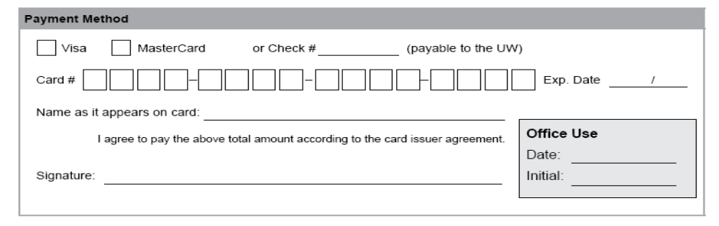

Waiver Form:
- Participants under 18 years of age:
I am the parent or legal guardian of________________________, and I consent to his/her participation in the Husky Badminton Open Tournament held at the University of Washington on February 7 & 8, 2015.

I acknowledge that his/her voluntary participation in any sports activity involves inherent hazards and risks of serious personal injuries such as, but not limited to: paralysis, brain damage, loss of vision or limb function, permanent scarring, disability and/or death. I agree to be responsible for assuring that my child has the necessary abilities and conditioning to safely participate in this sport.

I understand the Department of Recreational Sports Programs or the University of Washington does not provide accident/medical coverage for club sports or tournament participants. I further understand that it is my responsibility to ensure that my child has appropriate accident/medical insurance to provide for the possible future medical expenses, which may be required by my child as a result of any injury sustained in the Husky Badminton Open Tournament, hosted by the Husky Badminton Club at the UW IMA Building on February 7 & 8, 2015.

_________________________________________________________________________________________________ ____________________________
Parent or Legal Guardian Signature Date

_________________________________________________________________________________________________ _____________________________
Participants Name (Print) Date

- Participants 18 years of age or older:
In consideration of the acceptance of this entry and intending to be legally bound, I hereby waive and release the University of Washington, its agents and employees, tournament sponsors, and the Husky Badminton Club and their officers, coaches, and representatives from any and all liability for personal injury or property damages or loss arising from my participation in this event whether such loss results from my own negligence or that of other participants, or any other cause. My release includes tournament competition, practice, use of equipment, facilities and related social functions and associated activities.

I acknowledge that my voluntary participation in a sports activity involves inherent hazards and risks of serious personal injuries such as, but not limited to: paralysis, brain damage, loss of vision or limb function, permanent scarring, disability and/or death, and I assume such hazards and risks. I represent that I have the necessary physical abilities and conditioning to safely participate in this sport.

I acknowledge that the University of Washington or tournament sponsor does not provide accident/medical coverage for tournament participants. I further understand that it is my responsibility to ensure that I have the appropriate accident/medical coverage to participate in the Husky Badminton Open Tournament, hosted by the Husky Badminton Club at the UW IMA Building on February 7 & 8, 2015.

I have read this document, understand it to be a binding contract and sign it of my own free will. I further agree to abide by all UW and Club Policies and Tournament Rules and Regulations regarding my participation.

________________________________________________________________________________________________ ____________________________
Print Name Date

________________________________________________________________________________________________ ____________________________
Signature Date

