Remember, when you create a flexbox, all items inside that container become a flexbox-item, (previously paragraph, h1, images etc)

<https://appbrewery.github.io/flex-layout/>

min width is always of the longest word

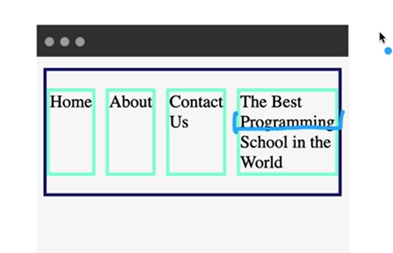

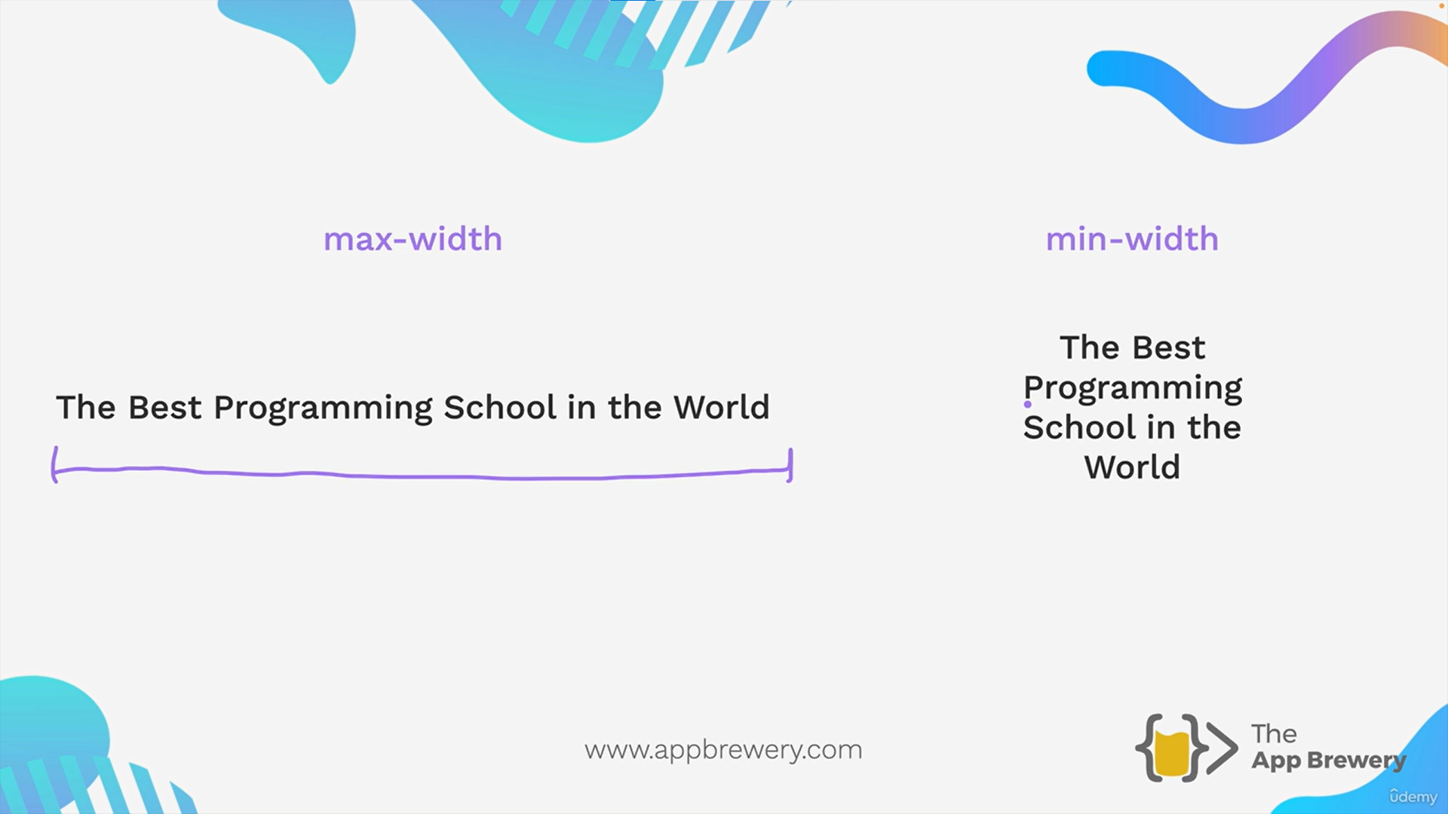

Flex basis is always intitalstarting value

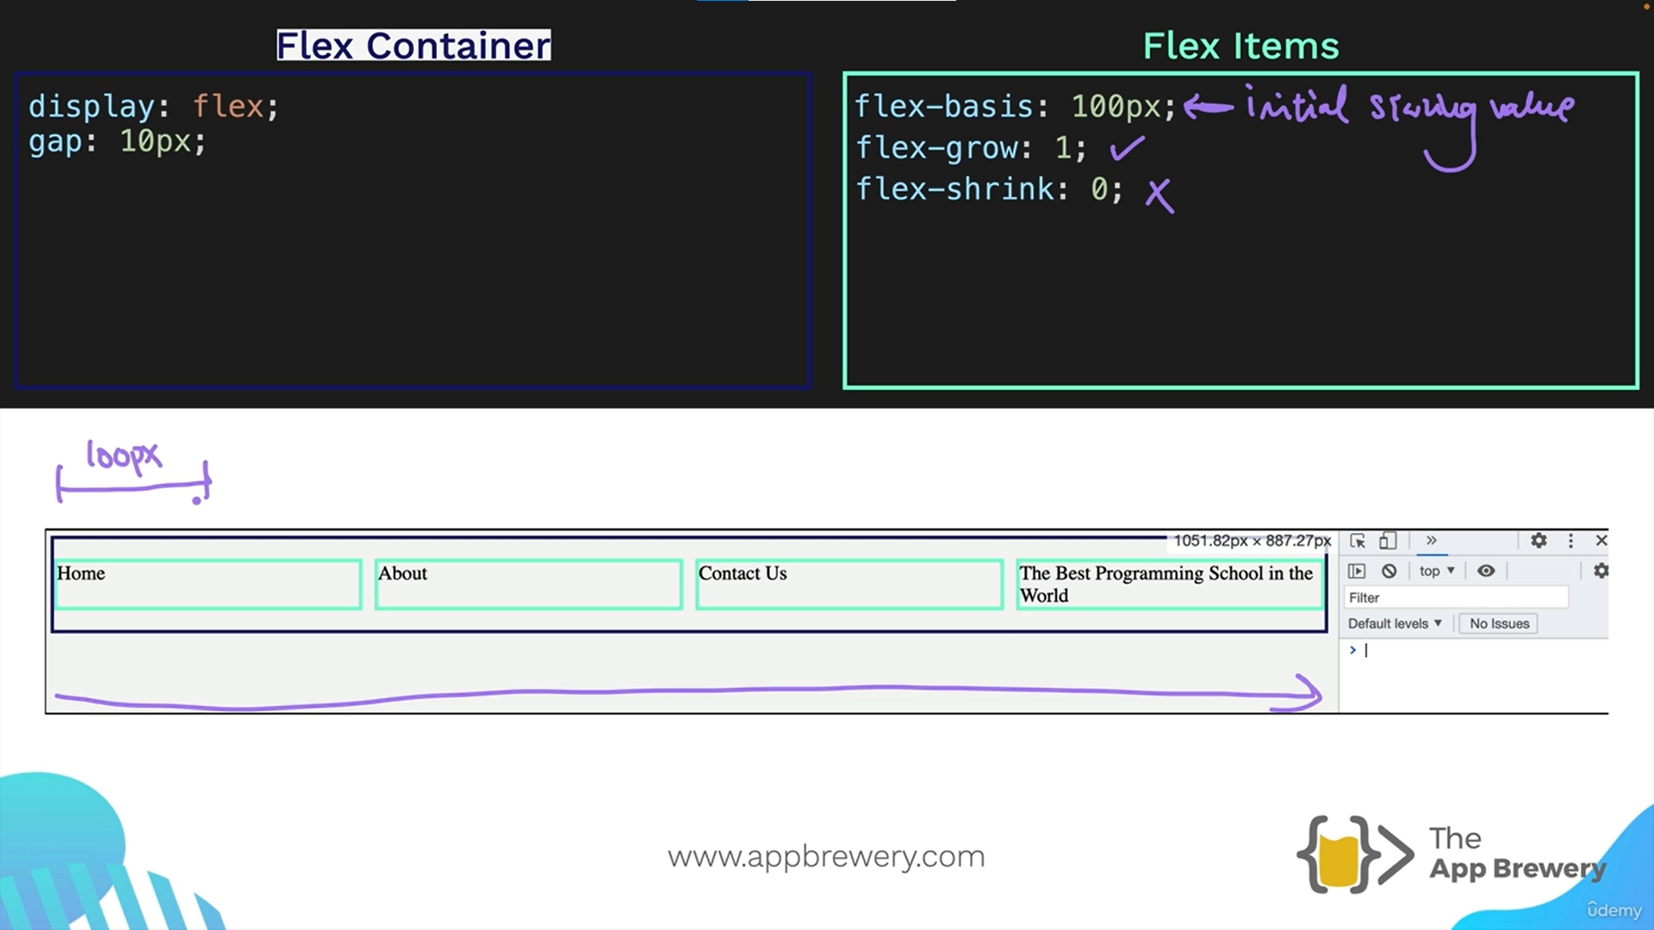

<https://appbrewery.github.io/flexbox-sizing-exercise/>

how flex sizing works  
  
  
