產生ipa檔案

1.為App新建一個App IDs

點選App IDs，按＋號

[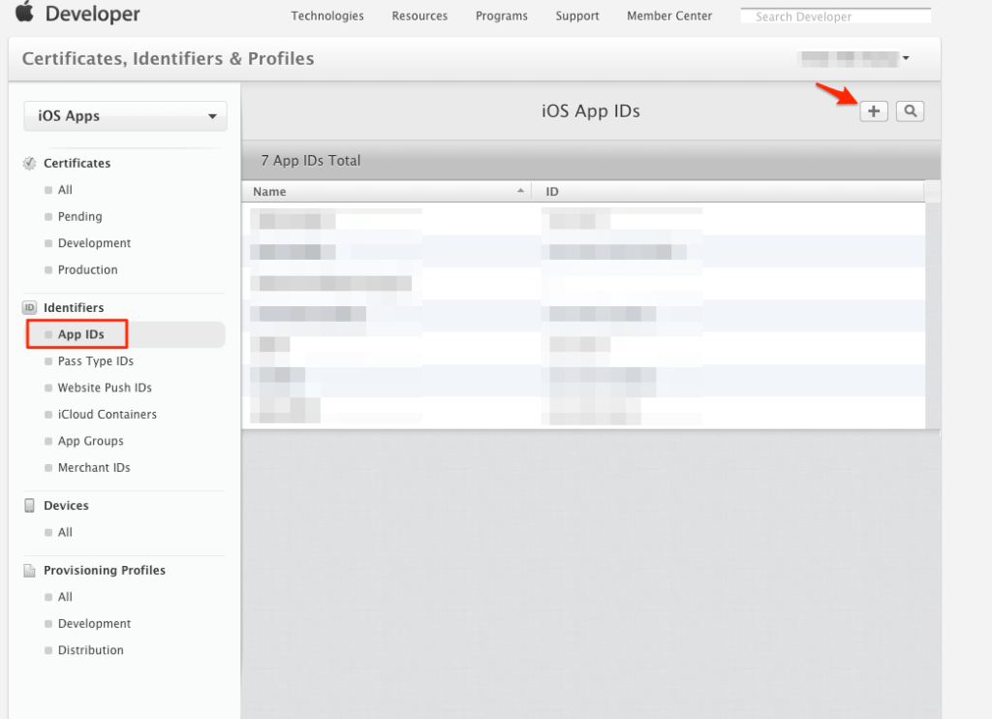](http://i2.wp.com/likeabossapp.com/wp-content/uploads/2015/06/AB26362F-4EDC-4A67-95C7-0FBE7B1A7595.png)

輸入Name與Bundle ID

[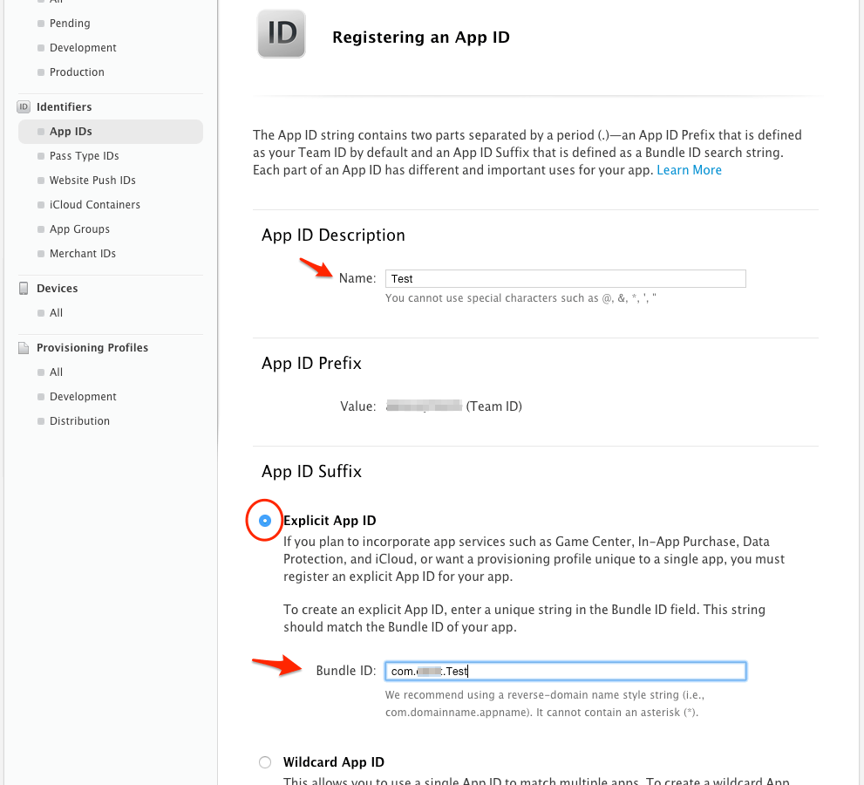](http://i2.wp.com/likeabossapp.com/wp-content/uploads/2015/06/0575689befd8b88493772f05b2b9dbdc4.png)

該勾的勾一勾，按Continue

[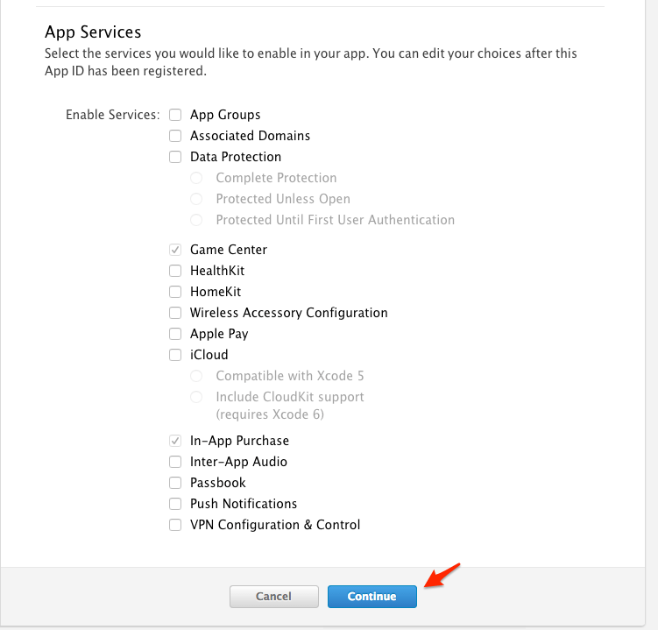](http://i1.wp.com/likeabossapp.com/wp-content/uploads/2015/06/9129a813d0d5f9c83ea48ae2b72f48311.png)

按Submit

[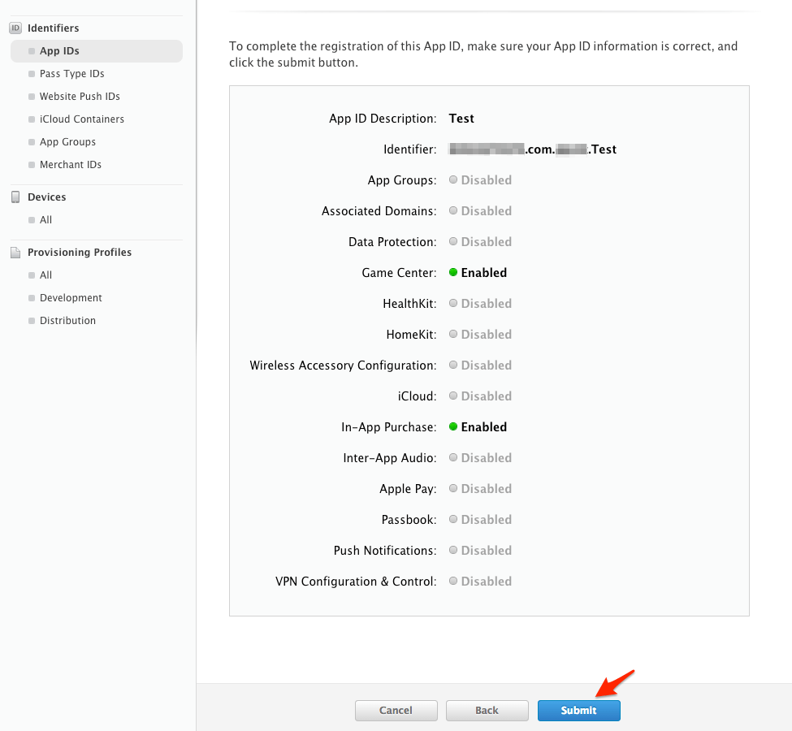](http://i2.wp.com/likeabossapp.com/wp-content/uploads/2015/06/47f79e40e86d43bded0cd21f9bbc23681.png)

App ID建立完成

[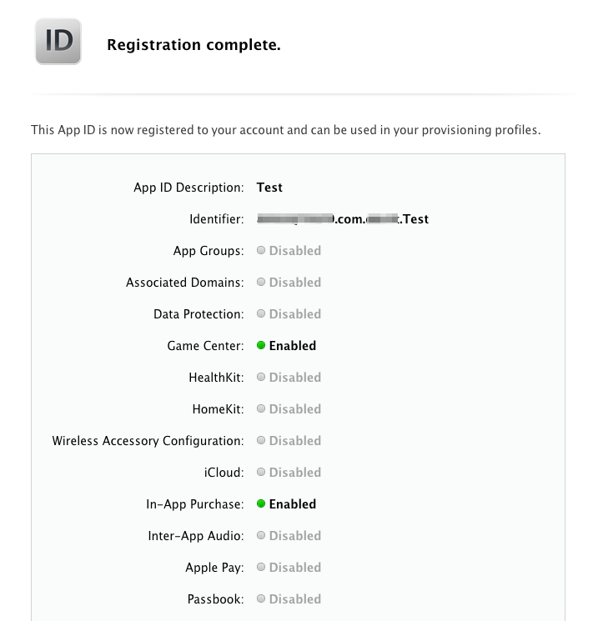](http://i1.wp.com/likeabossapp.com/wp-content/uploads/2015/06/03f70d5d0e87c7469cf7ed7c9bb364f61.png)

2.建立Provisioning Profiles

點選Provisioning Profiles，按＋號

[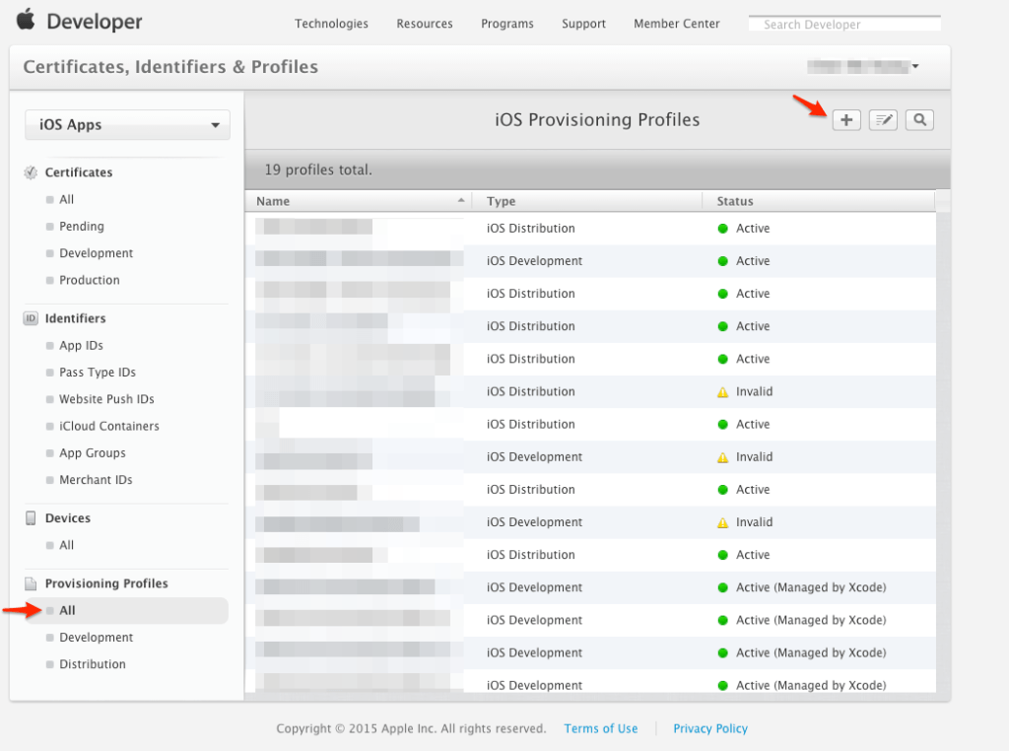](http://i0.wp.com/likeabossapp.com/wp-content/uploads/2015/06/78C04AB6-E416-452A-B031-A2C528365314.png)

選擇Ad Hoc，按Continue

[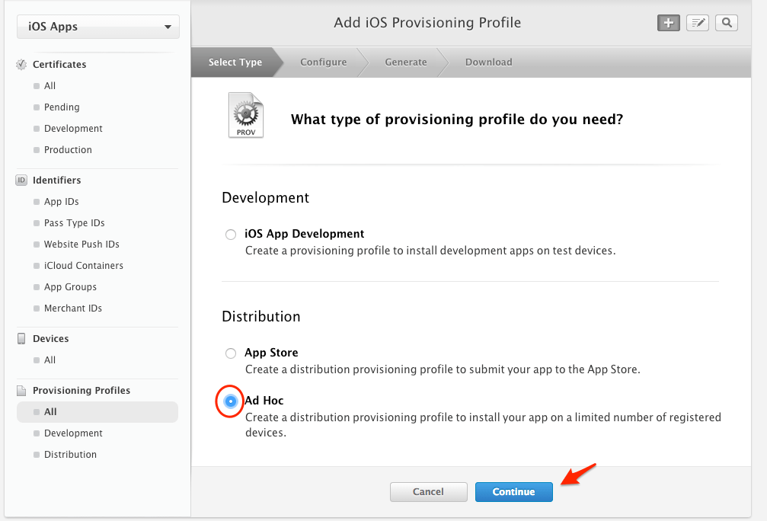](http://i2.wp.com/likeabossapp.com/wp-content/uploads/2015/06/BF247091-FBE1-4F6D-B54E-5D23B954E43C.png)

選擇剛剛建立的App ID，按Continue

[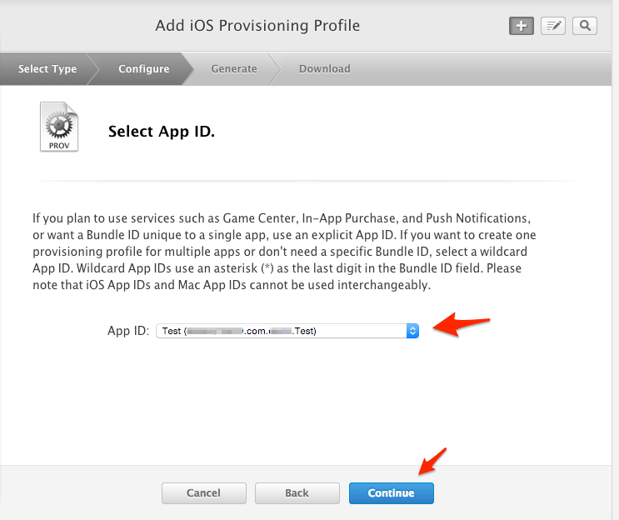](http://i0.wp.com/likeabossapp.com/wp-content/uploads/2015/06/4E2FE34F-2700-4F0F-89C6-779C06368982.png)

選一個certificates，按Continue

[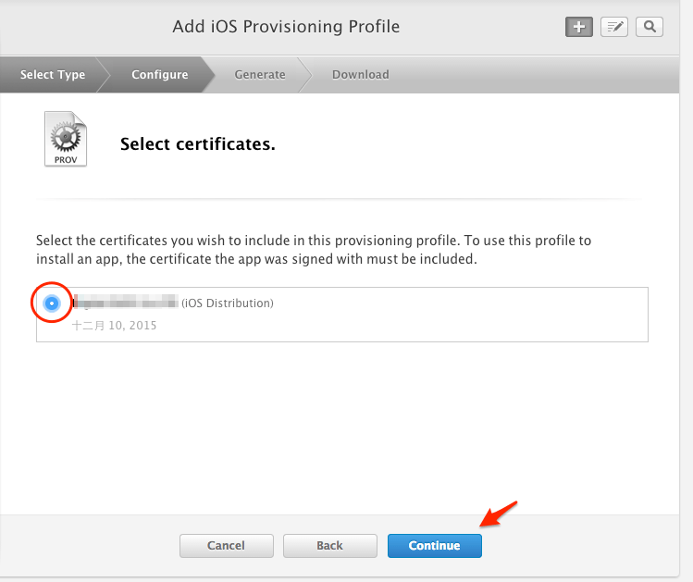](http://i2.wp.com/likeabossapp.com/wp-content/uploads/2015/06/7151F785-B626-405A-B151-BBF5FAAC7946.png)

選擇要裝這個App的裝置，按Continue

[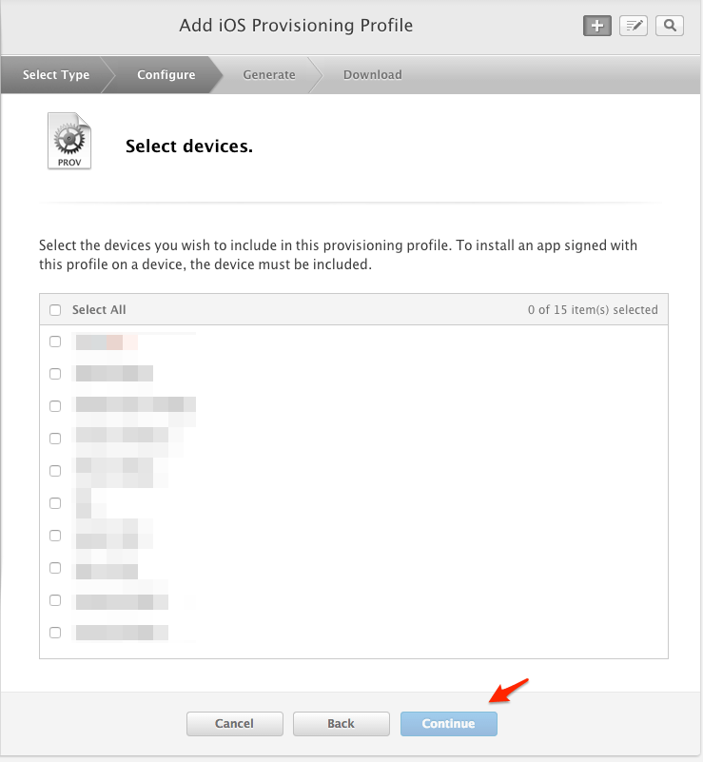](http://i1.wp.com/likeabossapp.com/wp-content/uploads/2015/06/520B1205-79E6-4DD4-A6F3-ABCD29021E17.png)

輸入Profile Name，按Generate

[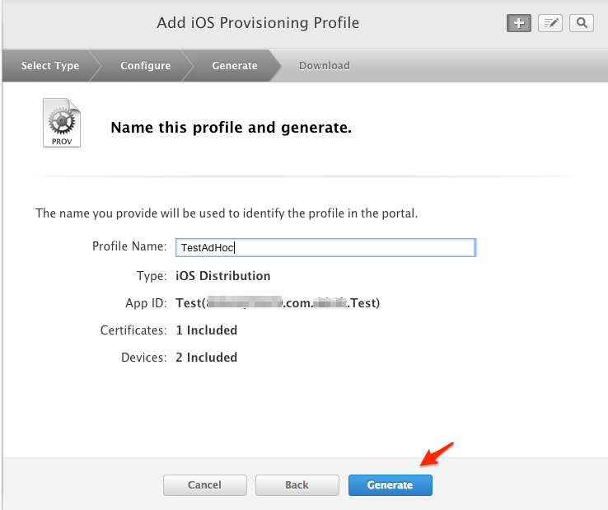](http://i2.wp.com/likeabossapp.com/wp-content/uploads/2015/06/9D7B83BE-2F23-4400-A4E3-7C3EA3F42AD8.png)

Generate後按Download

[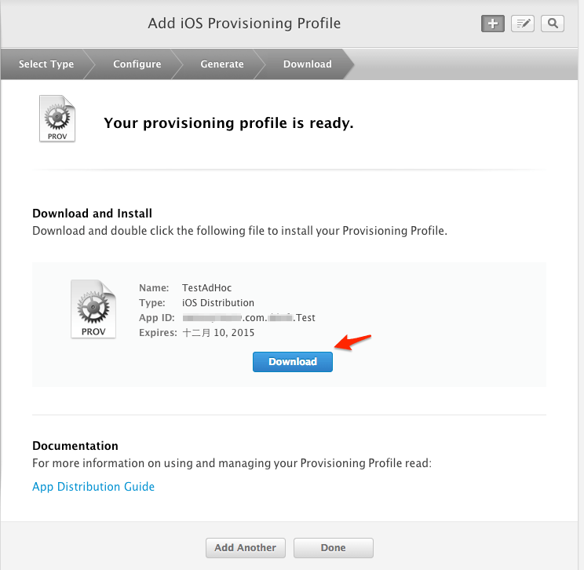](http://i0.wp.com/likeabossapp.com/wp-content/uploads/2015/06/E158D036-5FD0-41C5-8D16-BD4D318F2855.png)

打開剛下載的檔案

[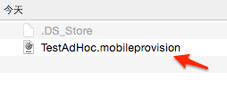](http://i0.wp.com/likeabossapp.com/wp-content/uploads/2015/06/9887D788-2142-49BE-B10A-C3F0AF04B6C6.png)

此時Xcode專案會自動被開啟，這個步驟就完成了

[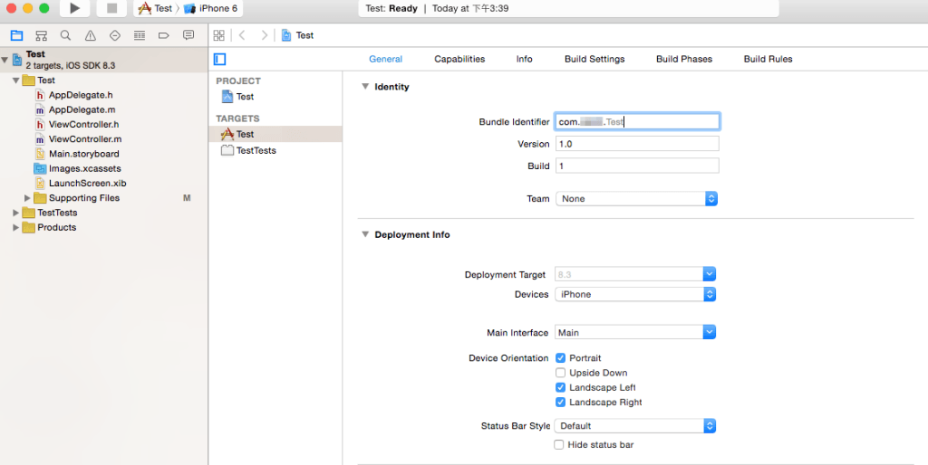](http://i1.wp.com/likeabossapp.com/wp-content/uploads/2015/06/045D939E-7E6B-4119-8EEF-6413F28E3898.png)

3.設定Xcode

選擇專案PROJECT -> Info -> 在Configurations按＋號

[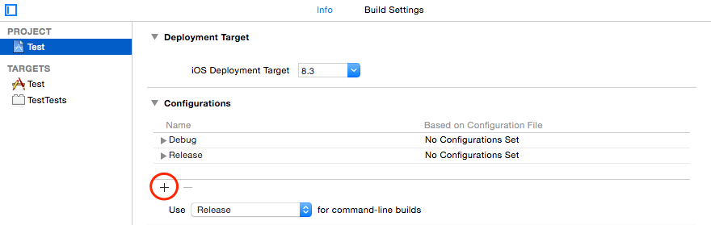](http://i2.wp.com/likeabossapp.com/wp-content/uploads/2015/06/CB2494D2-F1A7-47C3-BF15-044DC6F0D570.png)

按＋號後，選擇Duplicate"Release" Configuration，名稱打AdHoc

[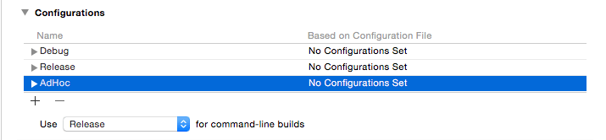](http://i2.wp.com/likeabossapp.com/wp-content/uploads/2015/06/28EE7FCB-A5CF-4E70-874A-4CB8DB2DAAE6.png)

點選上排工作列Product -> Scheme -> Edit Scheme…

[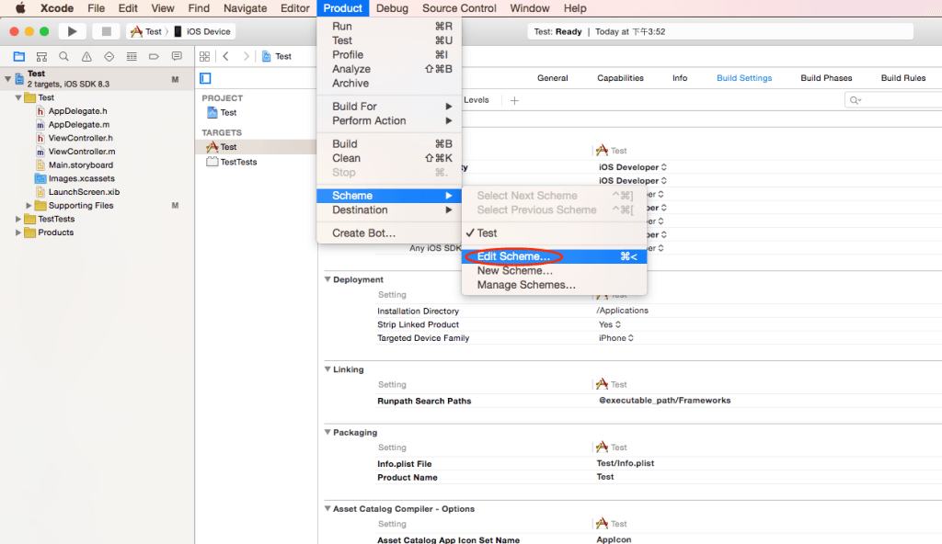](http://i0.wp.com/likeabossapp.com/wp-content/uploads/2015/06/17F6A1EE-AC43-4A45-B0B4-AAAE429CE136.png)

點選Archive，Build Configuration選AdHoc，設定就完成了

[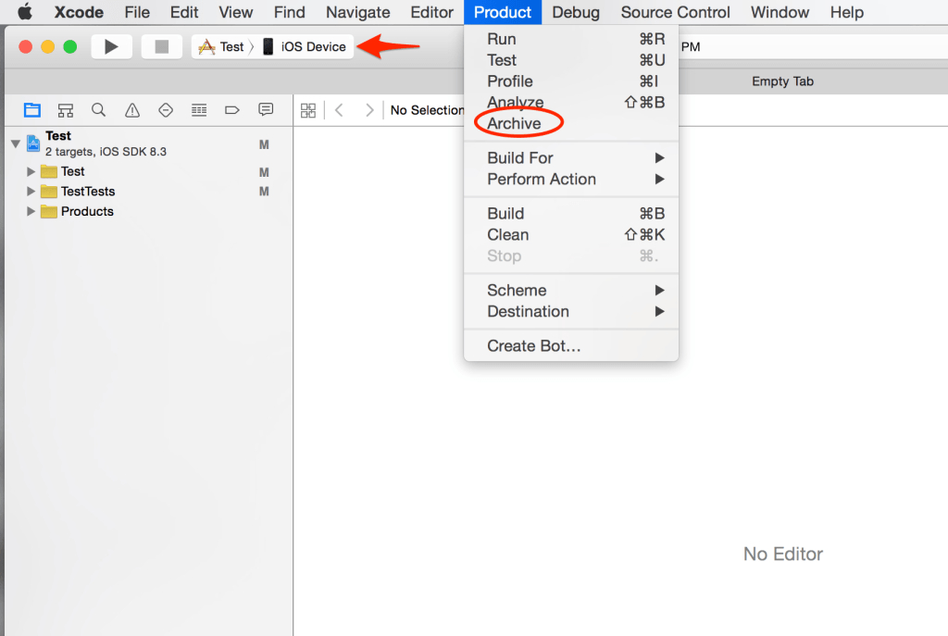](http://i2.wp.com/likeabossapp.com/wp-content/uploads/2015/06/Screen-Shot-2015-06-04-at-4.05.55-PM.png)

4.Archive產生ipa檔

注：這個步驟只有擁有Distribution權限的電腦才能夠進行

選擇iOS Device，點選工作列Product -> Archive

[](http://i2.wp.com/likeabossapp.com/wp-content/uploads/2015/06/Screen-Shot-2015-06-04-at-4.05.55-PM1.png)

點選Export

[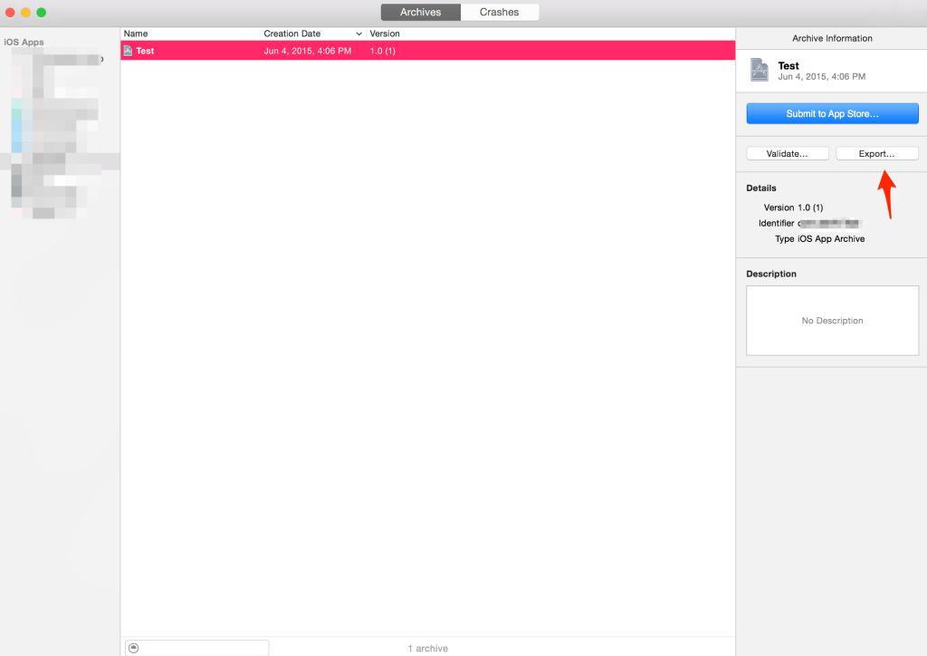](http://i0.wp.com/likeabossapp.com/wp-content/uploads/2015/06/Screen-Shot-2015-06-04-at-4.06.15-PM.png)

選擇Save for Ad Hoc Deployment，按Next

[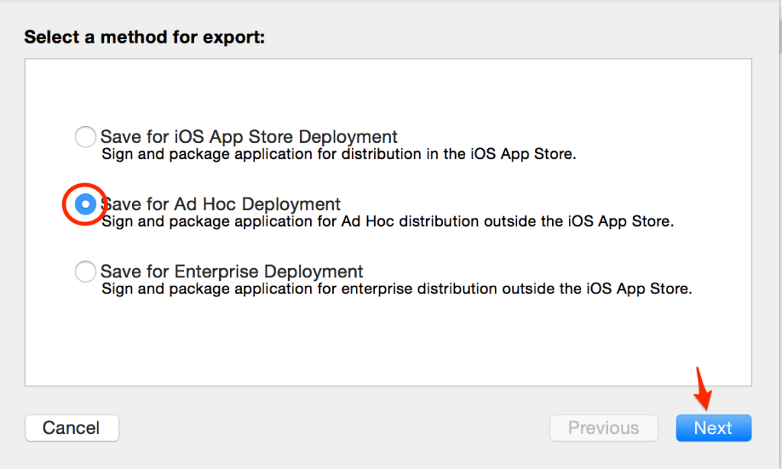](http://i1.wp.com/likeabossapp.com/wp-content/uploads/2015/06/Screen-Shot-2015-06-04-at-4.06.41-PM.png)

選一個Development Team，按Choose

[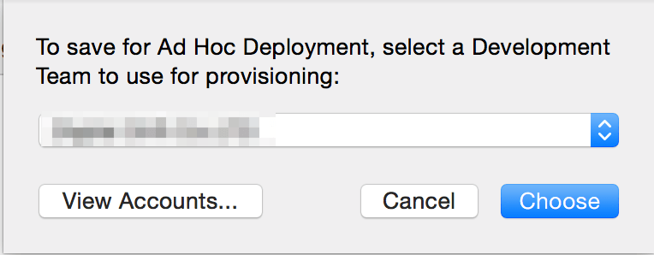](http://i2.wp.com/likeabossapp.com/wp-content/uploads/2015/06/Screen-Shot-2015-06-04-at-4.06.52-PM.png)

確定好後按Export

[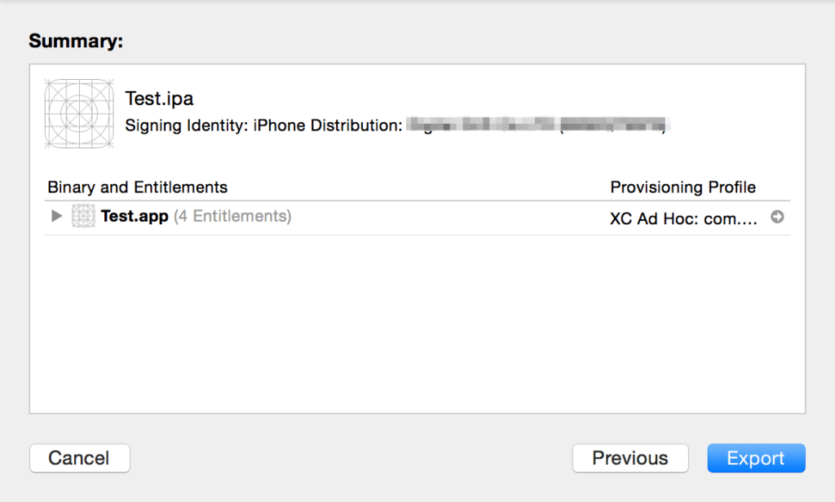](http://i0.wp.com/likeabossapp.com/wp-content/uploads/2015/06/Screen-Shot-2015-06-04-at-4.07.04-PM.png)

ipa檔案就會產生在指定的位置

[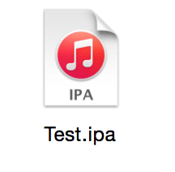](http://i1.wp.com/likeabossapp.com/wp-content/uploads/2015/06/Screen-Shot-2015-06-04-at-4.08.19-PM.png)